TEESSIDE UNIVERSITY  
SCHOOL OF COMPUTING, ENGINEERING   
AND DIGITAL TECHNOLOGIES

**FINAL YEAR PROJECT PROPOSAL**

**Craig Martin (Q5031372)**

**BSc Computer Science**

# Developing an Arduino IoT sensor system to record the temperature and GPS location of ladle shells used in metallurgy.

# Outline Description/Research Question

My project is to create a software application that can record ladle shell temperatures and display the live data for a company called Material Processing Institute (MPI, 2019).   
Material Processing Institute create bespoke melts and casts of metals on a small scale to the client’s specification.

In metallurgy, a ladle is a vessel used to transport and pour molten metals into moulds to produce the casting (Ladle (metallurgy), n.d.) (Szekely, 2012). Material Processing Institute want to be able to record the temperature of this vessel and see live data in a software application.

Material Processing Institute wish to have a windows device that runs an application that displays up to eight channels of live data on graphs for end users to engage with. The application will communicate with eight Arduino’s to retrieve the temperature and GPS position of each sensor, each second. Once the data has been retrieved, the data will then be sent to a database for storage.

# Proposed Project Artefact/Deliverable(s)

The artefact I will be creating will be comprised of both hardware and software components. The hardware will be up to eight Arduino Uno microprocessors which will each have a Bluetooth, GPS and thermocouple module connected. The thermocouple is a component that is used to record temperatures between -200°C and +700°C with an accuracy of ±2°C. To connect the thermocouple to the Arduino Uno a thermocouple breakout board and thermocouple connector are required.   
A GPS module will be connected to each microprocessor in order to retrieve the geographical location of each device. The GPS location will then be stored in a database alongside the temperature each second.  
The Arduino’s will communicate with a nearby PC using Bluetooth.

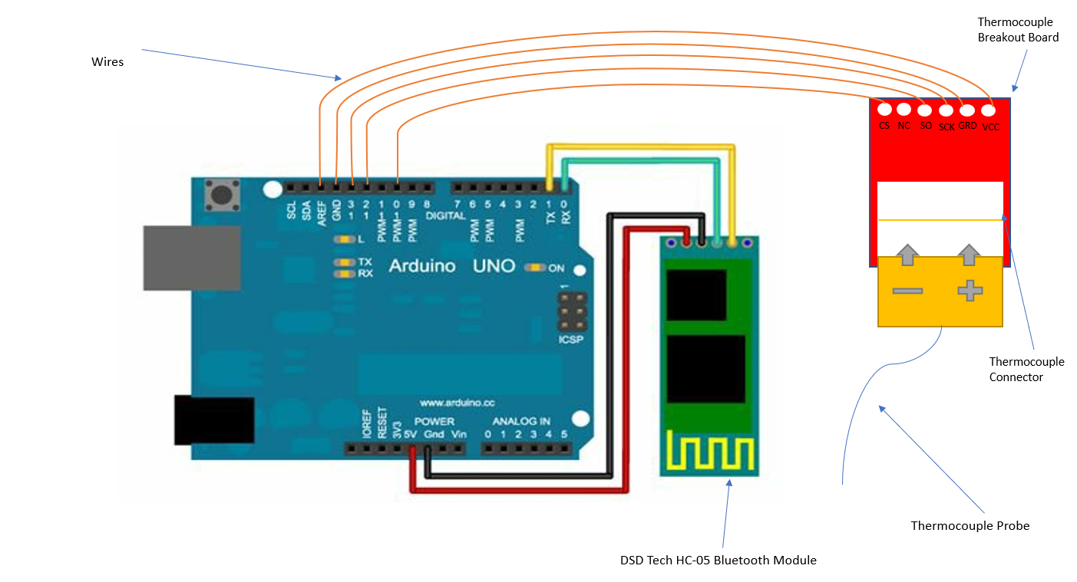

*Figure 1.0 – Shows an illustration of how the hardware components connect together to create the temperature sensor system. (Not to scale)*

SD Card

Arduino/Elegoo Microcontroller

GPS Shield

GPS Antenna

Real Time Clock Module

Bluetooth Module

Battery Pack

Thermocouple Breakout & Connector

Thermocouple

The software component of my artefact will be a WPF (Windows Presentation Foundation) application that follows a N-Tier architecture design. The application will display eight channels of live ladle and historical shell data on graphs and as text. The WPF application will be developed using the Model-View-ViewModel pattern to cleanly separate the business and presentation layers of the application from the user interface (UI) (The Model-View-ViewModel Pattern, 2017). I intend to use design patterns where appropriate, such as the repository pattern to create well-structured code that is adaptable for future needs.

The WPF application will connect to the Arduino boards using Bluetooth. The data from each will be read in and added to a collection to be displayed as text and on graphs. Additionally, the data from each board will be added to a database table.

# Hardware/Software Platforms

Below is a list of software and hardware parts I will require to complete the project. I have labelled all pieces of hardware with (Hardware).

|  |  |
| --- | --- |
| **Name** | **Description and Image** |
| Visual Studio 2019 | Visual Studio is my chosen IDE I will use to develop the WPF application |
| Arduino IDE | Arduino is an open source IDE environment that can be used to upload code to Arduino circuit boards. |
| Microsoft SQL Management Studio | Needed to create and manage the database where the temperature and GPS locations will be saved. |
| Thermocouple Type-K – Stainless Steel (Hardware) | PTFE Single Shot IEC Exposed Junction Thermocouple with Miniature Plug - Type KThe Thermocouple is a module that can record the environment temperature |
| Arduino Uno or Elegoo Uno (Hardware) | Arduino Uno is a microcontroller where developers can upload code to in order to make environmental  ARDUINO UNO REV3 [A000066] |
| Thermocouple Breakout – MAX31855K (Hardware) | The breakout is a hardware component that allows the thermocouple to connect to the Arduino circuit board  MAX6675 Breakout |
| Thermocouple Connector – PCC-SMP-K (Hardware) | The connector is a hardware component that connects to the breakout board. The thermocouple connects to the breakout, which connects to the breakout board.  Thermocouple Connector - PCC-SMP-K |
| DSD Tech HC-05 Bluetooth Module (Hardware) | The Bluetooth module allows for the Arduino circuit board to connect to other Bluetooth devices wirelessly.  Image result for dsd tech hc-05 |
| DS3231 Real Time Clock | Allows the Arduino board to read the current time. It uses the time the code was uploaded to the board the increments by a second each tick.  DollaTek Tiny DS3231 AT24C32 I2C Module Precision Real Time Clock Module For Arduino |
| GPS Shield, RoyalIted ITEAD 1.1 | GPS Breakout Shield to record the GPS location of the microcontroller. Has SD card slot.  Arduino GPS shield is a GPS module breakout board designed for Global Positioning System receiver with SD interface. It's easy to record the position data into SD card. |
| Azure | I will be using both a local SQL database for development purposes. But when the system is running live, it will need to store the data in a database on a hosted server in the cloud. I will use Azure to create a cloud database. |
| Anaconda, TensorFlow and Azure ML | An issue with thermocouples is it can sometimes give inaccurate readings that should be clast as outliers. I plan on using machine learning to be able to automatically detect these outliers and mark them accordingly. |
| An Arduino GPS Module (Hardware) | As I need to record the GPS location, I will need a GPS module. |

# Rational for Project Choice

I have decided to pursue this project because I believe creating and programming the temperature sensors will be interesting and something unique.   
Additionally, during university and my placement experience I haven’t had any experience working with this type of hardware and it will be a new challenge for me.

Our homes are changing and becoming “smart homes”, where hardware such as temperature sensors that can communicate with other devices are becoming more common. In 2020, the number of connected devices, is 38.5 billion which is an increase of 13.4 billion from 2015. With this projection, the demand for these systems will likely increase as well as the demand of skilled programmers. Therefore, I believe this project will help me stand out from the crowd and gain a more in-depth knowledge that others may not have.

# Background Research

To begin with I reached out to the company and engaged in an initial meeting to discuss the project and outline a specification.  
After the discussion I have begun researching online about Arduino’s and completed some beginner tutorials. (SIK Experiment Guide for Arduino - V3.2, n.d.) (What is Arduino, n.d.) (Getting started with Arduino products, n.d.)

Online, I have found many tutorial guides and videos on how to create the Arduino temperature sensor with similar parts. I will use these guides, which I have included in my reference list, for inspiration for my project.

For the WPF application, I have a good understanding and pre-existing knowledge from my placement year on how to create visually appealing and good, clean WPF applications. For additional help, I will consult the Microsoft documentation provided online which I have included in my references list.

# Areas for Investigation

* How to allow communication between the sensors and the windows device -

Each sensor must communicate with the windows device, I will need to investigate how to establish an effective communication method and how to successfully read the latest temperature data from the Arduino boards. I will also need to research different methods of communication aside from Bluetooth, to see if there is a more efficient way to allow the devices to communicate with each other.

* How to differentiate between the different sensors that communicate with the windows device-

As there will be eight temperature sensors that are communicating with the application, it will be important to be able to uniquely identify each sensor. Additionally, I will need to consider multithreading and memory usage for the PC running the machine.

* How to record the GPS location of the sensors -

Another issue that I will need to investigate will be how to record the GPS location of the sensor each hour and the best component module for doing so.

* How to store data locally in memory on each sensor and effective memory management -

A requirement for the project is for the sensors to store the temperature data locally if the connection between the sensor and the windows device has dropped. When the connection is available again, the data must be removed from the sensor and transferred to the windows device. I will need to check how to achieve this functionality, and the most effective ways to manage the memory of each temperature sensor.

* Considerations for power optimization of the sensors -

As each sensor runs from a battery, I will need to consider the best way to maximize battery time.

* Outliers – Online, I have discovered that temperature sensors can occasionally record data ineffectively and give an inaccurate reading. For example, the readings could be consistent for a period and suddenly spike and then return to the consistent temperature recording. This should be clast as an outlier and marked accordingly. The application should have a feature to allow users to display and review outliers.

# Research Ethics

One of the main ethical issues I will need to consider will be the recording and safe storage of the temperature data. As this temperature data could be considered sensitive, I may need to restrict access and ensure the data is stored safely in the SQL database.  
Additionally, I will also need to consider issues that may arise whilst recording the temperature data such as the connection between the sensor and the windows device dropping and how I can professionally handle the data in this case.

# Review of Reference Materials

I have included a list of references below that may be useful to start and refer to through my final year project experience.

*Get started with WPF –* This is a good resource to refer to, to begin to understand the benefits and drawbacks of WPF projects.

*Getting started with Arduino products –* An interesting article on how to setup and begin to understand Arduino’s

*SCRUM Methodology –* A guide on what the scrum methodology is

*The MVVM Pattern –* Describes what the Model-View-ViewModel pattern is and why it’s well suited to XAML applications.

# References

*Get started with WPF*. (2018, 04 16). Retrieved from Microsoft Docs: https://docs.microsoft.com/en-us/visualstudio/designers/getting-started-with-wpf?view=vs-2019

*Getting started with Arduino products*. (n.d.). Retrieved from Arduino: https://www.arduino.cc/en/Guide/HomePage

James, M. (n.d.). *Scrum Methodology*. Retrieved from scrum methodology: http://scrummethodology.com/

*Ladle (metallurgy)*. (n.d.). Retrieved from Wikipedia: https://en.wikipedia.org/wiki/Ladle_(metallurgy)

Magic, C. (2019, 7 6). *Temperature Sensor with Arduino - k-Thermocouple Sensor MAX6675 Module*. Retrieved from Youtube: https://www.youtube.com/watch?time_continue=3&v=0KJ8H_SUWp0&feature=emb_title

*MPI*. (2019, 11 03). Retrieved from MPIUK: https://www.mpiuk.com/institute.htm

*N-tier architecture style*. (2018, 08 30). Retrieved from Microsoft Azure: https://docs.microsoft.com/en-us/azure/architecture/guide/architecture-styles/n-tier

*SIK Experiment Guide for Arduino - V3.2*. (n.d.). Retrieved from Sparkfun: https://learn.sparkfun.com/tutorials/sik-experiment-guide-for-arduino---v32/experiment-7-reading-a-temperature-sensor

Szekely, J. C. (2012). *Ladle metallurgy.* Springer Science & Business Media.

*The Model-View-ViewModel Pattern*. (2017, 07 08). Retrieved from Microsoft Docs: https://docs.microsoft.com/en-us/xamarin/xamarin-forms/enterprise-application-patterns/mvvm

*What is Arduino*. (n.d.). Retrieved from Arduino: https://www.arduino.cc/en/guide/introduction

# Methodology

Before I begin development, it is important for me to have a clear understanding what the company expects from the final artefact. Before I start development, I need to have a clear development specification devised to ensure the requirements are achievable in the timeframe.

In my project I expect to complete several large tasks that will make up the overall artefact. One of these tasks will be setting up the temperature sensors that will retrieve the ladle temperature and communicate with the windows device the current live temperature every second. In order to complete this task, I will need to communicate with my tutor and the company’s IT professionals to clearly understand how to complete this in the best possible way.  
  
After setting up the sensor, I will need to establish the communication connection between the sensors and the windows device. I will research online the best possible method on how to effectively and most securely transfer the data.

For my project I plan on adopting the Agile methodology.  
Agile is a method that helps continuous iterations in development for a project. Being agile in development will allow for concurrent implementation and testing for the product and allows for the artefact to be broken down into smaller components.   
SCRUM is a form of the agile project management approach, that aims to deliver new software features each iteration. Using the SCRUM approach will allow for rapid development and strong communication between myself, my tutor and the company. (James, n.d.)

# Project Plan

|  |  |  |
| --- | --- | --- |
| **Sprint Week** | **Date Range** | **Tasks** |
| **1** | **20th-26th Jan** | * Develop app UI design * Meet the MPI team * Proposal writing |
| **2** | **27th Jan - 2nd Feb** | * Setup the WPF project with all necessary class libraries for the N-Tier project structure. The ViewModelBase and RelayCommand classes should be implemented. * Application flow diagram * Sequence Diagrams * Data structures and flow   **Proposal Hand-in 27th Jan**  **Panel Meet 29th Jan**  **Proposal Feedback 30th Jan** |
| **3** | **3rd- 9th Feb** | * Create one Arduino circuit board, connecting all the components together and fully soldered. The device should read data into the Arduino IDE using the Serial Port. * Develop the code to read the temperature in degrees from the thermocouple and upload to the Arduino circuit board. * Develop a basic UI skeleton. * Create and develop all base stylings for the WPF application. * Setup the dependency injection feature in the App.xaml.cs class. |
| **4** | **10th – 16th Feb** | * Read in the live temperature data via Bluetooth from the Arduino circuit board to the WPF application * Display the temperature data in a list collection on the UI * Add graphing functionality to the UI to display the currently live temperatures on a line chart * Create the database on the pc’s local SQL server to store the temperature data. |
| **5** | **17th – 23rd Feb** | * Add the ability to view previous temperature data (Ladle shell temperature history) * Allow users to see the previous temperature data in a list on the screen * Allow users to see the previous temperatures on a line chart * Create custom date time picker to handle date time selections   **Progress Review 18th Feb**  **Presentation 20th Feb** |
| **6** | **24th Feb – 1st Mar** | * Add debug logging to the project * Fix any known bugs that have occurred * Create 1-6 more Arduino temperature sensor circuit boards (Range is based on availability of parts) * Handle the extra Bluetooth devices in the WPF application. The WPF application should now read from multiple Bluetooth devices on different threads. |
| **7** | **2nd – 8th Mar** | * Allow users to select and change the data being displayed on the WPF application. The live and history sections. |
| **8** | **9th – 15th Mar** | * On the WPF application create a settings page where users can configure the number of sensors to search for and that are in use * Allow users to change and add Bluetooth devices to search for * Add GPS modules to each Arduino circuit board to be able to record the GPS position of the sensor |
| **9** | **16th – 22nd Mar** | * Display the GPS location of each sensor on the WPF application * Store the GPS location of each sensor in the SQL database * Develop method for detecting outliers if any. |
| **10** | **23rd – 29th Mar** | * Create SQL Server and database on azure to store live data when the system is in production * Create unit tests with a good range of scenarios |
| **11** | **30th Mar – 5th Apr** | * Develop a machine learning model or statistics models that could be used to analyse the recorded data. For example, at what GPS location is the temperature the lowest/highest? Or perhaps predicting future temperatures. |
| **12** | **6th – 12th Apr** | Application testing Machine learning model development Report Writing  **Easter Break** |
| **13** | **13th – 19th Apr** | Application testing Machine learning model development Report Writing  **Easter Break** |
| **14** | **20th – 26th Apr** | Application testing Machine learning model development Report Writing  **Easter Break** |
| **15** | **27th Apr – 3rd May** | **Artefact Hand-in 29th April** |
| **16** | **4th – 10th May** | **Report Hand-in 4th May**  **VIVA 5th - 15th May** |
| **17** | **11th – 15th May** | **ExpoTees 12th May**  **VIVA 5th-15th May** |

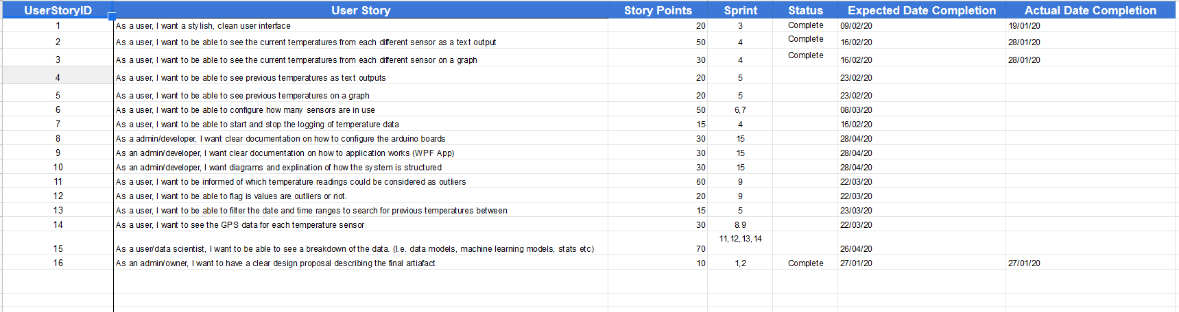

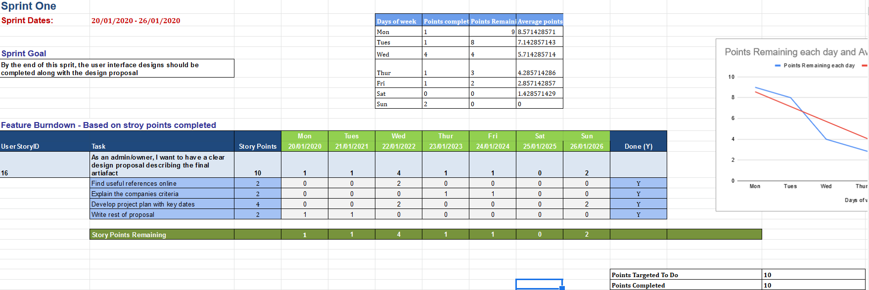

*Figure 2.0 – Shows the product backlog and the first sprint backlog from the excel spreadsheet. A sprint backlog will be completed each week to review the progress that week. Please view the Product & Sprint Backlog excel file.*