**Team Joey -**

Craig Oliver / George Renzi / Hugh Lacy / Jason Krause

Deployed site - <http://mist7570workticket-app-xphpzfcbk3.elasticbeanstalk.com/login.jsp>

Submit Ticket - <http://mist7570workticket-app-xphpzfcbk3.elasticbeanstalk.com/submitTicket.jsp>

**Schemas/ Database**

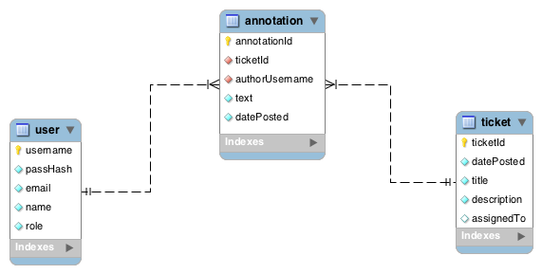

**Work Break Down**

(Everyone touched all the code. We set it up on GitHub so we could all work on the files at the same time)

**George**

Coded - TicketDTO.java & TicketDTOTest.java

Coded - UserDTO.java & UserDTOTest.java

Coded - editUser.jsp

Coded - listUsers.jsp

Coded - confirmTicket.jsp

Reviewed - Comments

**Jason**

Coded - TicketHelper.java & TicketHelperTest.java

Coded - UserHelper.java & UserHelperTest.java

Coded - listTickets.jsp

Coded - submitTicket.jsp

Coded - notFound.jsp

**Hugh**

Coded - AnnotationDTO.java & AnnotationDTOTest.java

Coded - WorkTicketDAO.java & WorkTicketDAOTest.java

Coded - UserTicket.java & UserTicketTest.java

Coded - viewTicket.jsp

Document - Sevlet Workflow

Document - Schema/ Database

Document - Final Submission

**Craig**

Configure AWS beanstalk

Coded - PasswordHash.java

Coded - Login Controller.java

Coded - TicketController.java

Coded - login.jsp

Coded - loginFailed.jsp

Coded - notAuthorized.jsp

**Servlet Workflow**

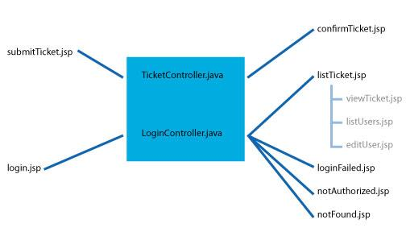

|  |  |  |  |
| --- | --- | --- | --- |
| **Use case** | **Controller** | **Outcome** | **Destination** |
| Client has an issue | TicketController | client submits ticket | confirmTicket.jsp |
| Worker/ Manager wants to login | LoginController | manager enters correct information | listTicket.jsp  (All tickets) |
|  | LoginController | worker enters correct information | listTicket.jsp  (Tickets assigned to user) |
|  | LoginController | worker/ manager mis-enter information | loginFailed.jsp |
| Manager wants to add a user | command | manager taken to new page | editUser.jsp |
| Manager wants to see all users | command | manager taken to new page | listUsers.jsp |
| Worker/ Manager wants to view a ticket | command | worker/ manager is taken to ticket page | viewTicket.jsp |
|  |  |  |  |
| Some tries to access part of site that requires being logged in |  | not able to access | notAuthorized.jsp |
| Someone enters in unknown url on site |  | not able to access | notFound.jsp |

**JavaDocs**

Attached separately.