DevOps (CM - Notes)

Differing methods of delivery; Waterfall against Agile:

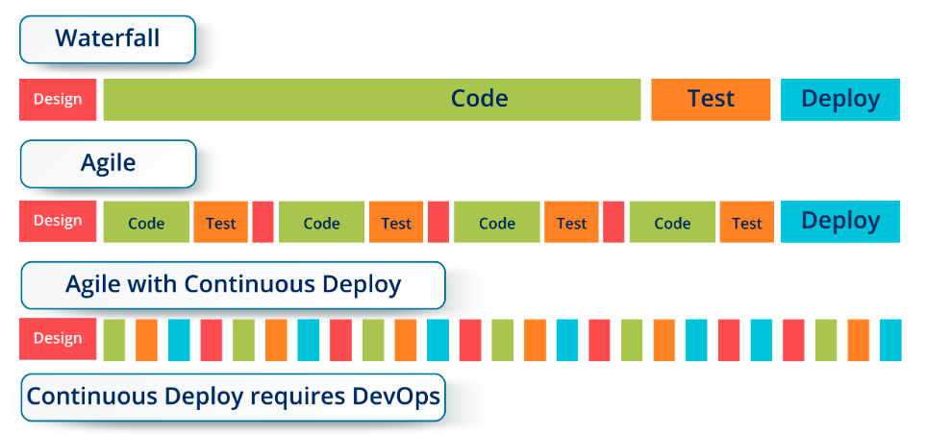

Typical DevOps Life Cycle is seen as: each Phase and Tools Set will be shown in this document:

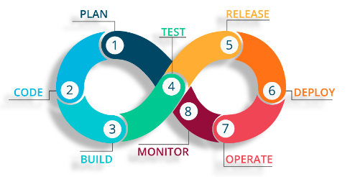

Reactive and Auto-Scaling Infrastructure with DevOps:

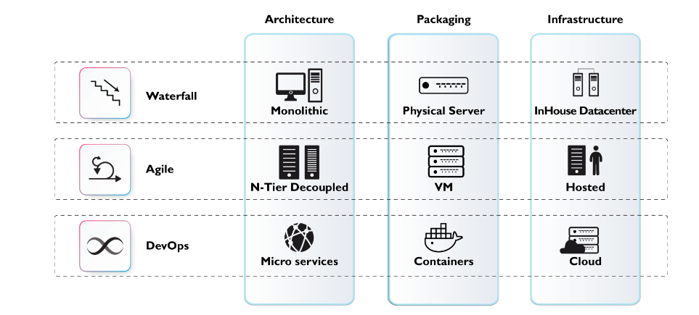

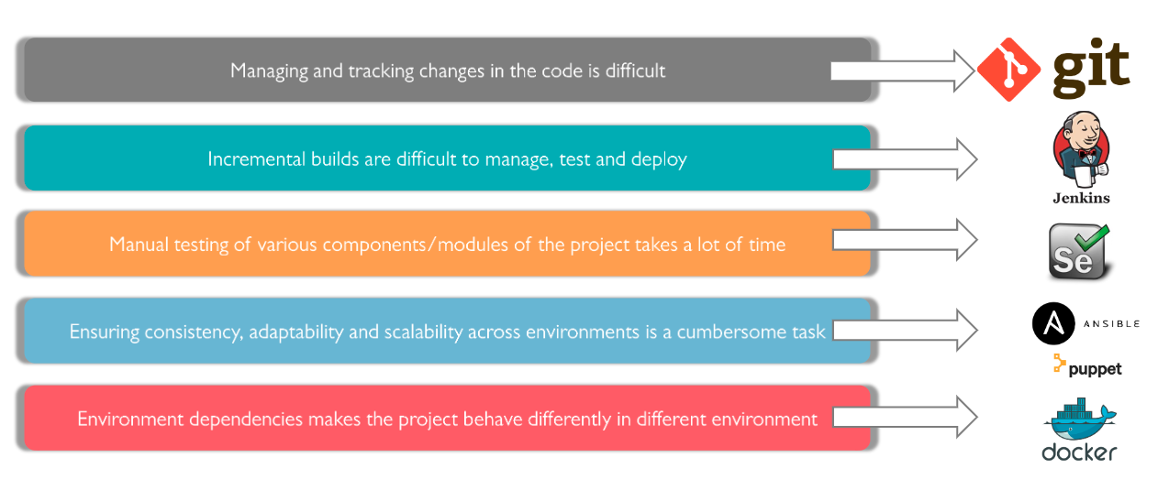High Level Tools:

Overview of Some Tools:

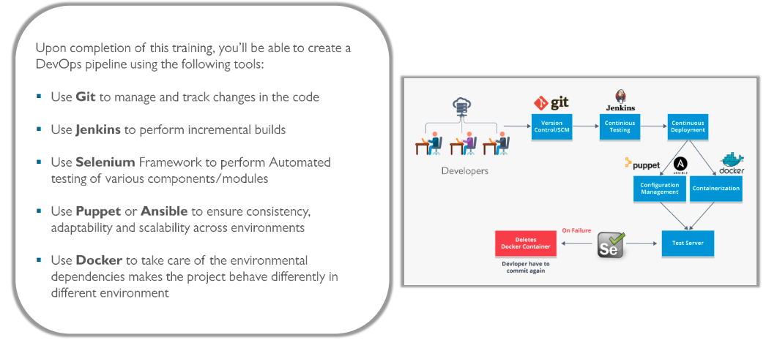

Source Code Management:

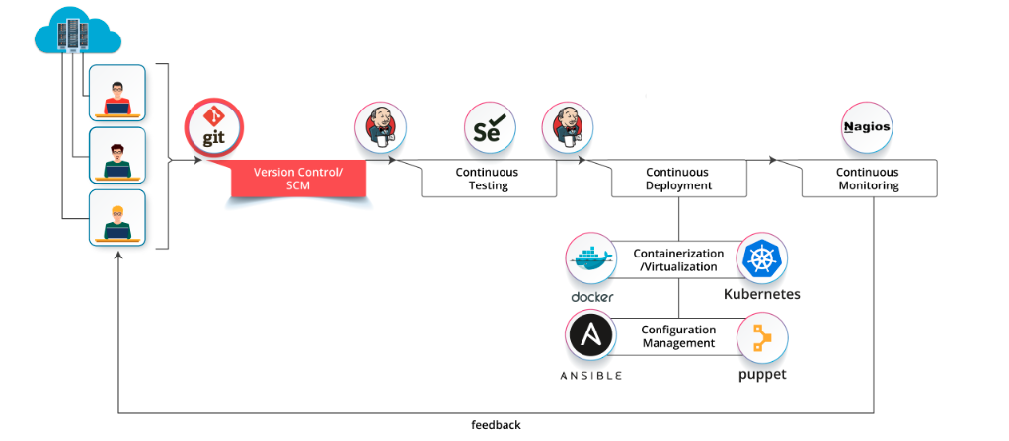

*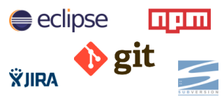Some other tools:*

Version Control in SCM (Source Code Management):

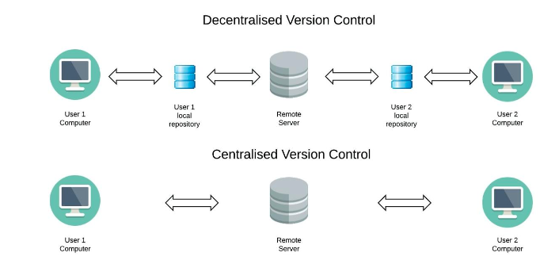

GitHub Personal SCM Location: *<https://github.com/craigmoss-so/moss.so>*

*Installing Git (Ubuntu):*

sudo apt update

sudo apt install git

git --version

git version 2.25.0

git config --global user.name "craigmossso"

git config --global user.email ["craig@moss.so"](mailto:\"craig@moss.so\")

Move to required dir

git init

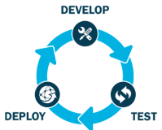

Release, Continuous Integration:

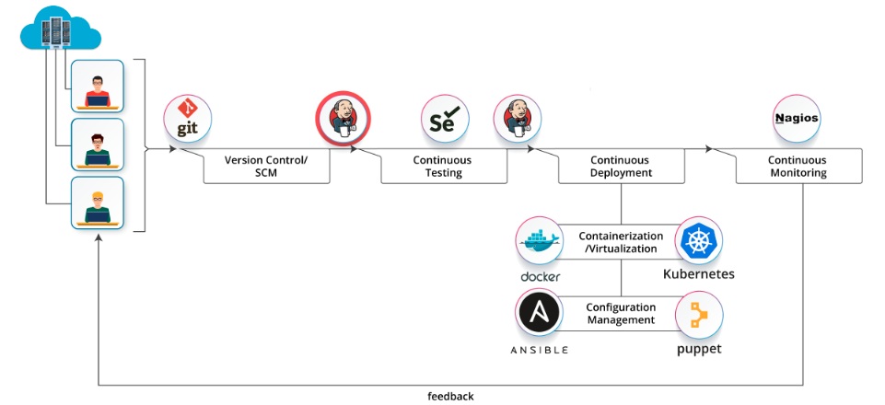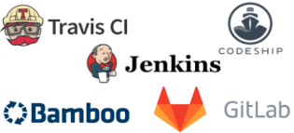

*Other Tools CI:*

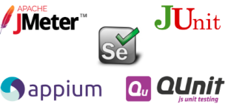

*Other Tools Test:*

*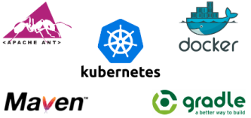*

*Build:*

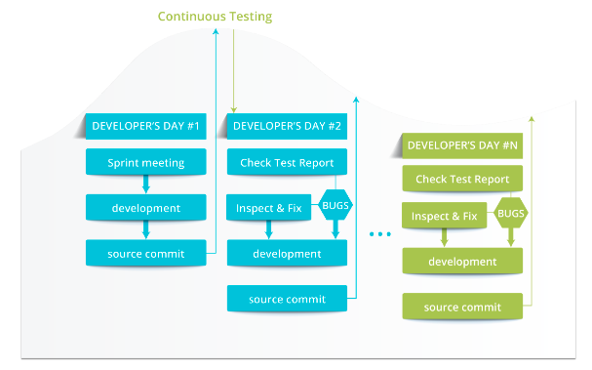Continuous Testing, Automated testing that provides feedback via the pipeline:

Continuous Deployment:

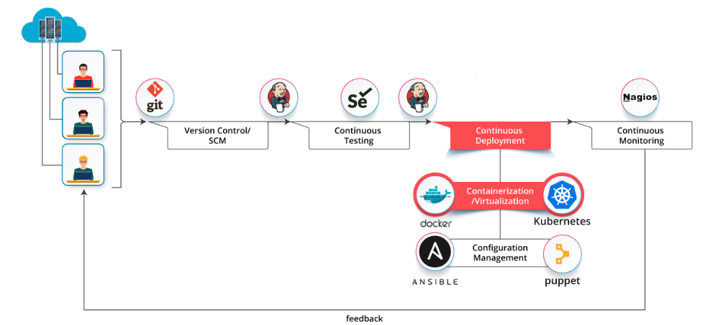

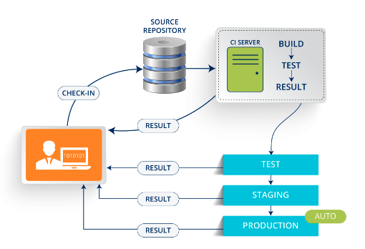

*Build -> Test -> Prepare for Production*

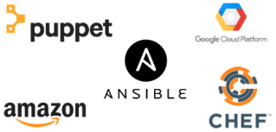

*Configuration Management:*

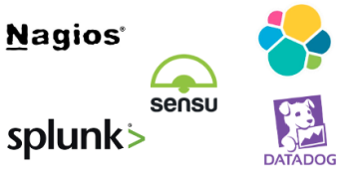

*Monitor:*

Continuous Monitoring:

