Key points part 1:
- Code has been amended to remove rolling window for all variables and to remove lag present in prior results. In addition, CP is picked up once it reaches certain threshold determined by user. Checked on test dataset, happy with performance.
- Window length too small leads to noise being identified as a change point. Too large leads to data being smoothed out too much, therefore missing change points: recommended window length for NO2 variables = 25 days (performs better as there is a gradient shift between each CP i.e. blue line)
- For threshold factor that determines a CP, it being too small picks up noise and cannot differentiate it between noise and CPs. To determine upper limit, CPD model to be performed on more normalised NO2 time series

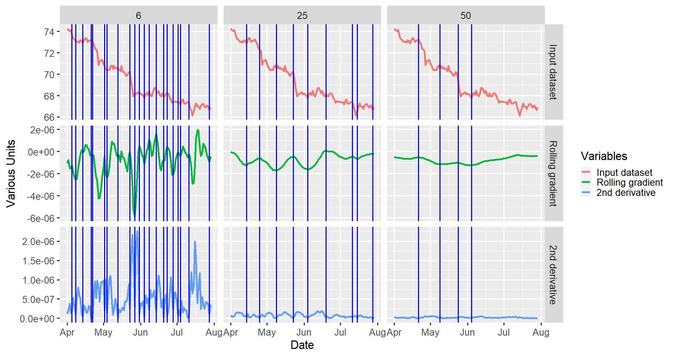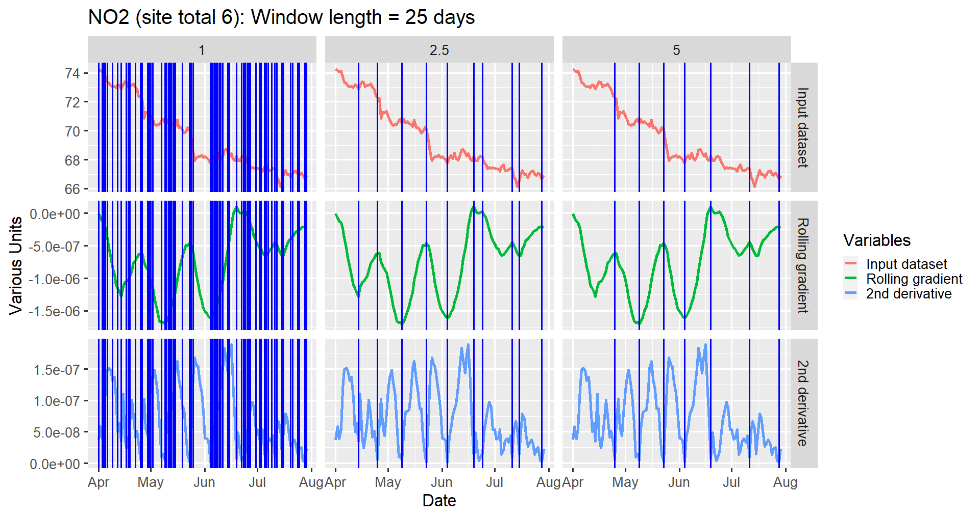

Key points part 2:
- Running CP on normalised PM2.5 provides further evidence that using too small of a window or threshold value is not a suitable option. Recommendation: pick window length based on data sets similar to the one you’re trying to identify new CPs for
- Likewise, for variables that cover similar/same parameter space (e.g. normalised pollutants across same sites and time frame), CP inputs (i.e. window length/cp threshold) can be used to identify CPs across multivariant time series (for this case, cp_factor = 2.5, window length = 25). Next step to test this theory using additional datasets.
- Finally, for sanity check, use rolling gradient and 2nd derivative to determine how sensible a CP is, 2nd derivative shows a peak indictor for all CPs show in results, signalling new gradient shift.

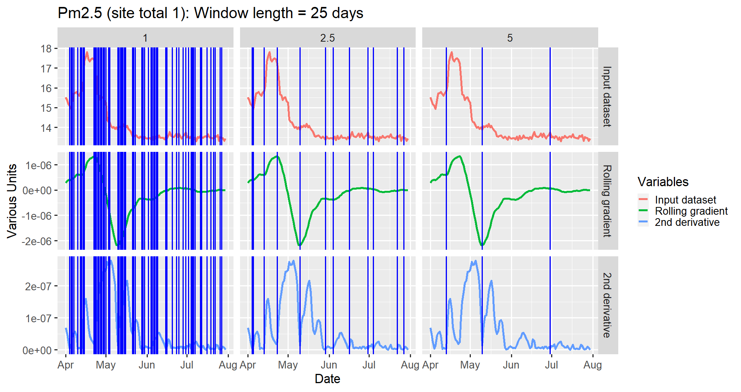
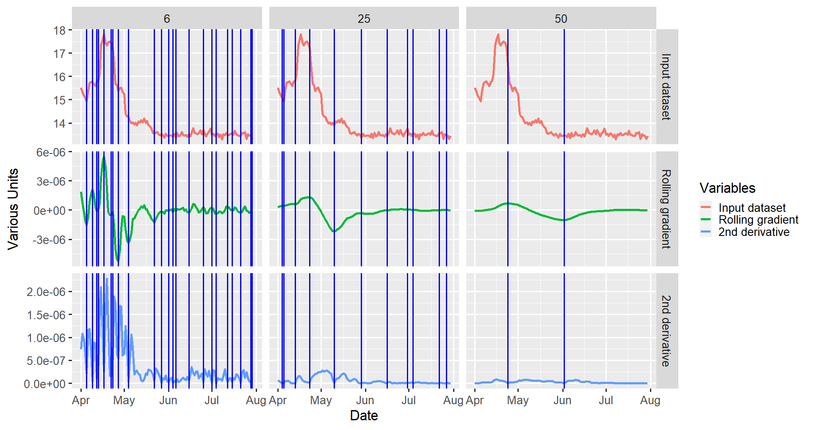
Key points part 3:
- Although the CPs may be true in the traffic count, they could be influenced by the weekly variation of cars entering the ULEZ (peaks do not include the weekends). Recommendation: compare identified CPs alongside variables such as NO2.
- Would not suggest doing a rolling average, however, will explore whether trend term could be removed potentially using this method https://machinelearningmastery.com/remove-trends-seasonality-difference-transform-python/
- To constrain suitable window length/threshold, more data with similar data signatures are required (only showing window length for this example). Next step to find said dataset

