**Water Tips Arduino Guide**

This guide will discuss all the necessary steps in getting an Arduino board set up with the Water Tips back-end program.

1. **Hardware Specifications**  
   The following is a list of necessary hardware:
   * DFRobot Bluno SKU: DFR0267  
     https://www.dfrobot.com/product-1044.html
   * Data Logging Shield
   * Battery for Real Time Clock (part of Data logging shield)
   * SD card (most micro-SD cards come with a full-size SD card adapter which can be used to plug into the data logging shield). Any size 8 GB or higher is ok.

The Bluno can be wired to up to 4 tippers on pins 2, 3, 6, and 9. To wire a tipper to the Bluno, one pin should go to one of the four numbered pins and the other should go to any ground pin.

1. **Downloading and setting up the Arduino IDE Software**
   * The first thing needed to set up the software is to go to the Arduino homepage and follow their Getting Started Guide to download and install the Arduino Desktop IDE. The Arduino Desktop IDE can be installe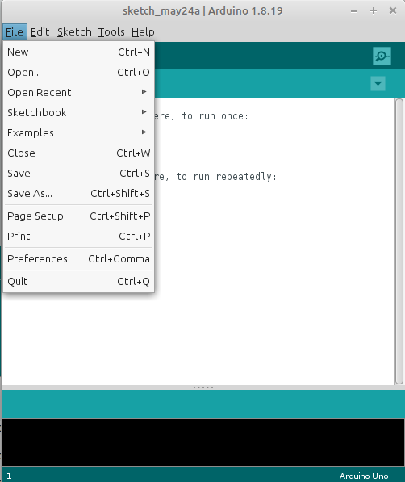d on any Linux, Mac, or Windows computer.  
     https://www.arduino.cc/en/Guide
   * Make a folder called ***tippers*** and copy the ***tippers.ino*** file into this folder. *Note that the .ino file has to be in a folder with the same name as the program (minus the .ino).*
   * 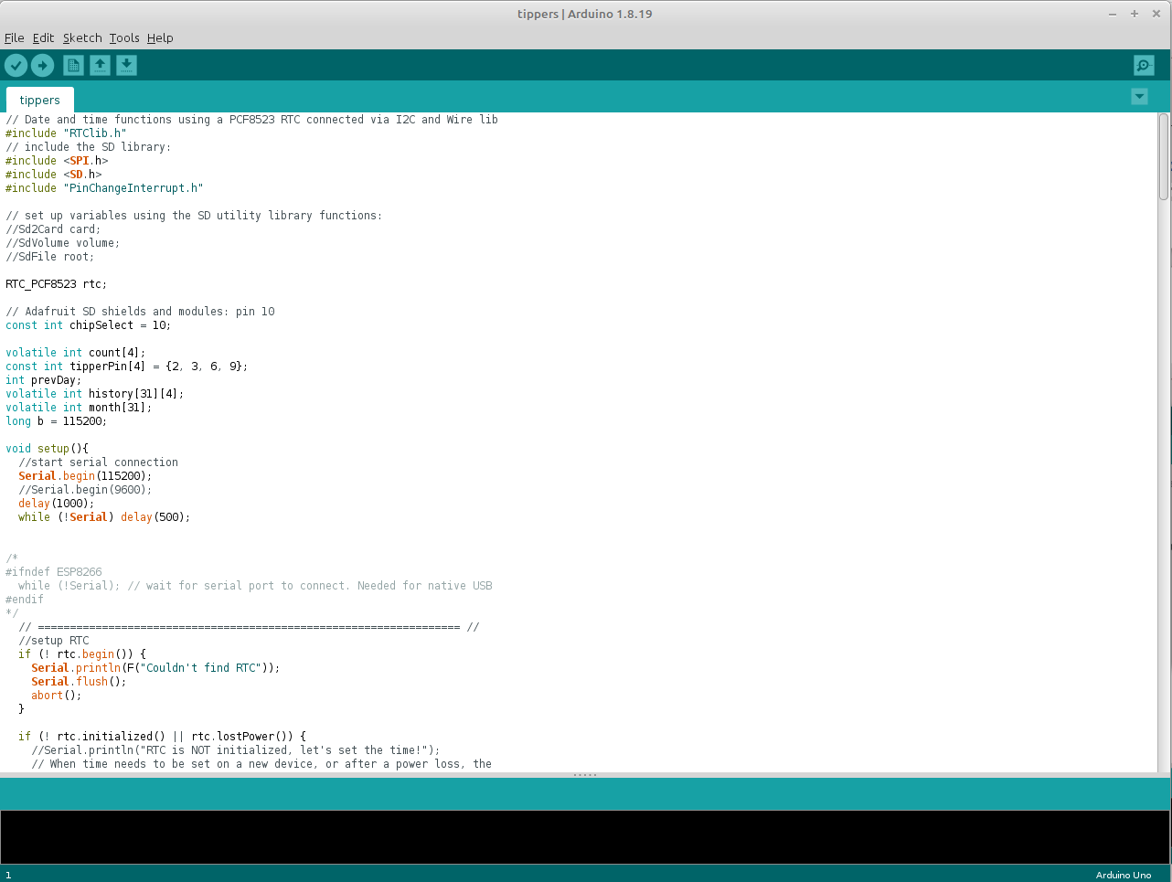Open the Arduino IDE. Select File – Open and then navigate to the ***tippers.ino*** file and open it.
   * ***The first time you install the Arduino IDE ONLY, you will need to download a couple of libraries:***
     + From the top navigation menu, select Tools – Manage Libraries. The *Library Manager* will pop up.
     + In the box labeled *Filter your search*, type **Rtclib**. You will see a library 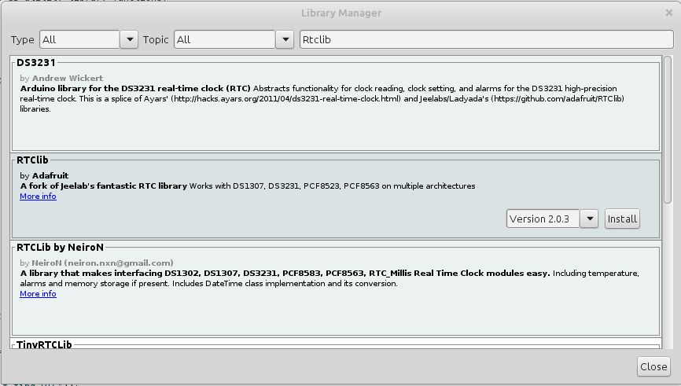called **RTClib** by **Adafruit**. Mouse over it and you will see an install button. Click this. It may pop up a dialgo saying that the library **RTClib** needs some other library dependencies not currently installed. If so, click **Install all**.
     + Repeat this process searching for **Pinchangeinterrupt**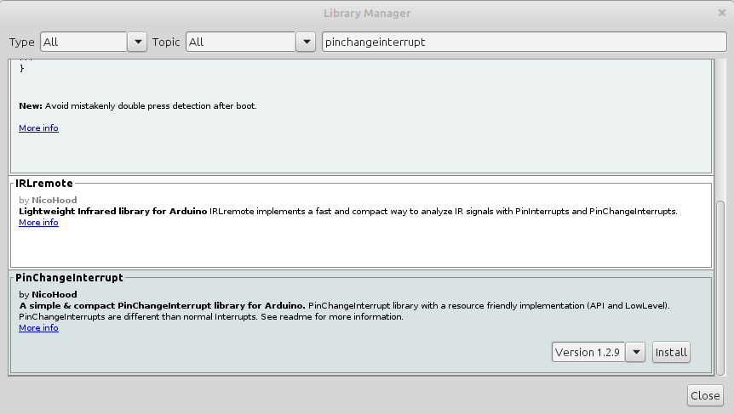. Click the install button on **PinChangeInterrupt** by **NicoHood.**
     + After these 2 libraries are installed, you may close the Library Manager.
2. **Installing the Tippers.ino program**
   * After the Arduino IDE has been installed, simply start it and use the top menubar to select File – Open and browse to the **tippers.ino** file and open it.
   * **Verify** the program by clicking on the checkmark button in the top left of the Arduino IDE. You should see a message “Compiling sketch” and the it should change to “Done compiling.” at the bottom in the green bar. In the black you should see informational messages and **no errors** if it compiled properly.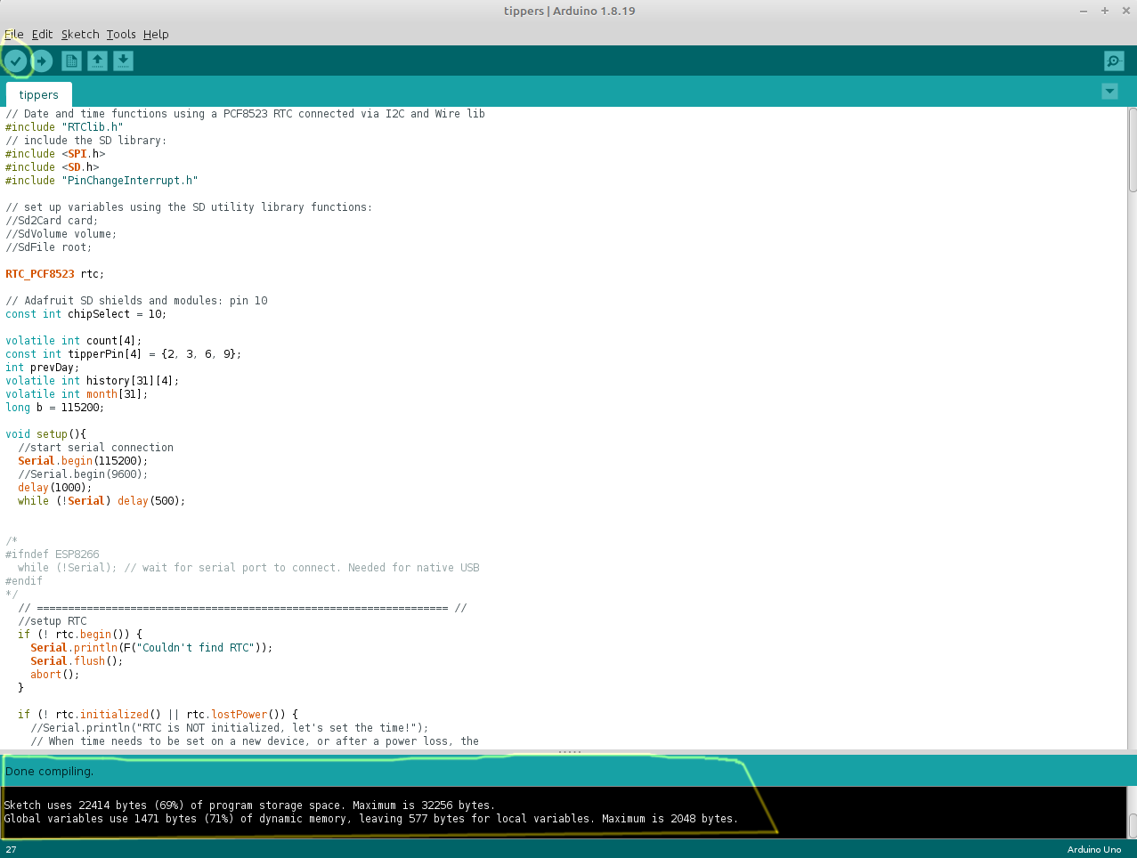 If so we can move onto installing.
   * **Plug the Arduino into the computer via micro USB cable**. You should now be able to select Tools – Port from the menubar and see a serial port listed. *Note that serial port names vary between Windows, Linux, and Mac, but select whatever is listed there – it should be the only thing in the menu.*
   * 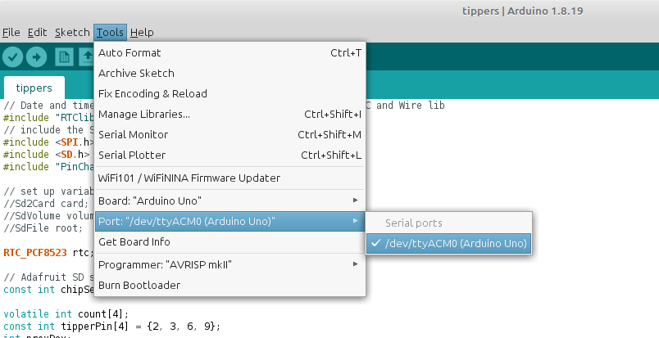Under Tools – Board, **Arduino Uno** should be selected. This is the default so it should not require any action but it is good to verify that the proper board is selected.
   * **Install the program by clicking the right arrow next to the check mark.** You should see the bottom label in the green bar say “Uploading”. When it is done after a few seconds it should say “Done uploading.” and the black area should show informational messages with **no errors.** If this is correct, **your program is now installed!**
   * 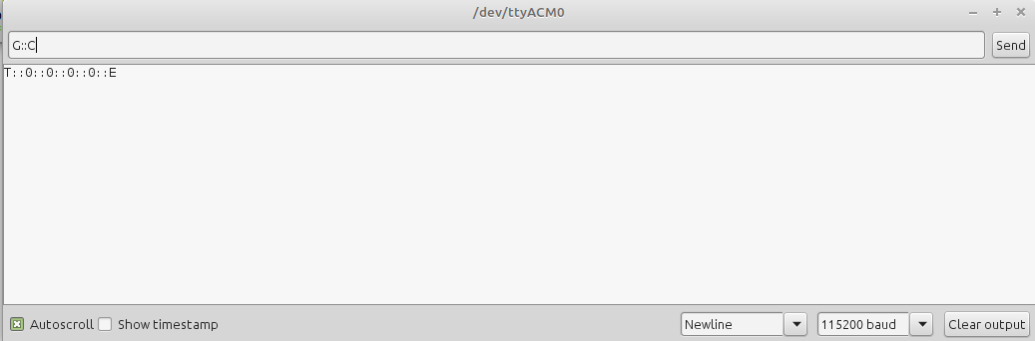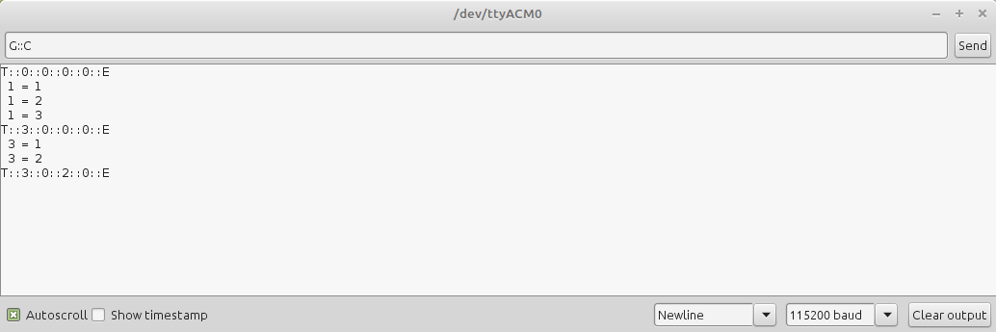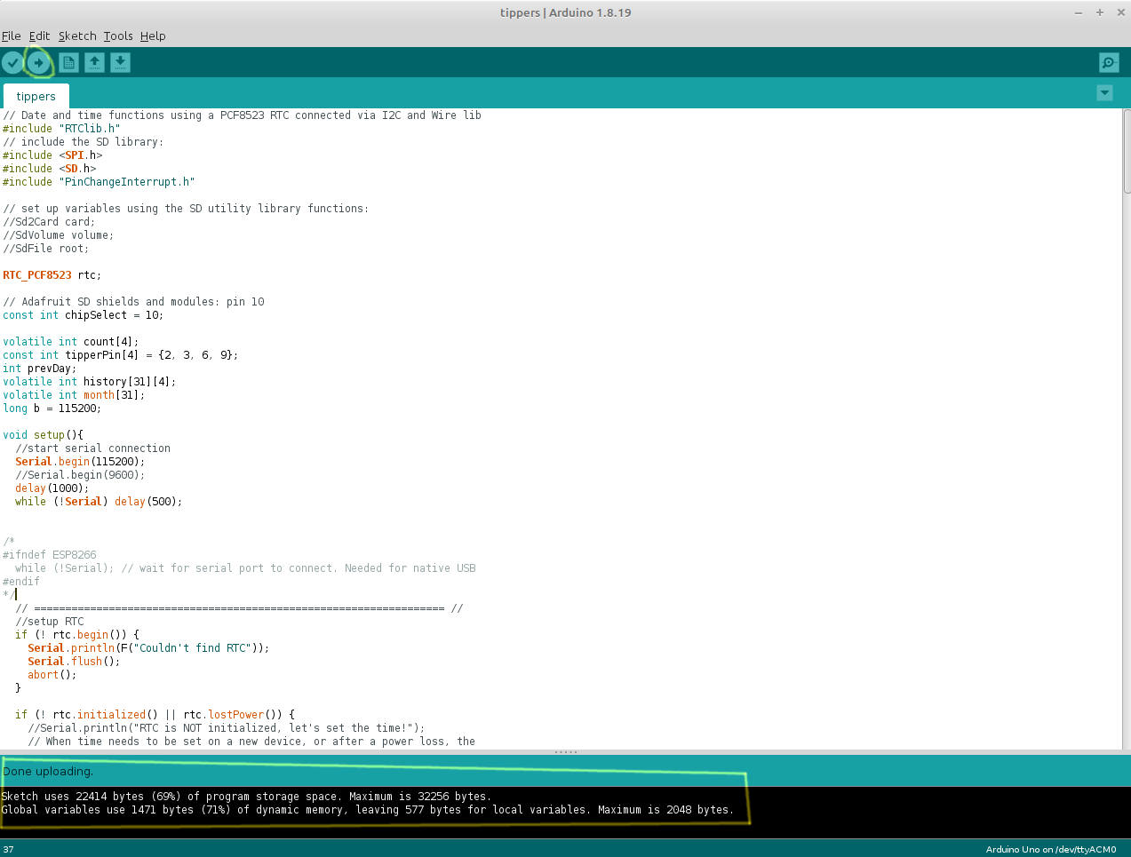**Testing the output:** If you select Tools – Serial Monitor to bring up the Serial Window, you can verify that the program is installed. When the Serial Monitor comes up, change the baud rate pulldown in the bottom right to be 115200 baud. Then type **G::C** into the text field at the top and click Send. You should see a reply **T::0::0::0::0::E**. If you do, the program is working. You may then try tipping a tipper and you should see the counts displayed (tipper number = total tips for that unit). If you enter G::C again you should see the zeros replaced by whatever the tipper values are for tippers 1, 2, 3, and 4 (hooked up to pins 2, 3, 6, 9). You may now close the Arduino IDE and open the **WaterTips** app on your Android phone and it should connect to the Arduino.
   * You may now repeat this process for additional Arduino units.