SDS MIDI MERGE 3X3
Stand-Alone Unit

I. Introduction pg.2

A. Functions

B. Setup Examples

II. Panel pg.3

A. Jacks

B. Buttons

C. LED's

III. Settings Menus pg.4

A. USER Configurations

B. MIDI Routing

C. SPLIT Keyboard Setup

D. CLOCK Routing pg. 5

E. Program Change Output Disable

F. Transport Output Disable

G. MIDI CC Output Disable

H. Name a Configuration pg. 6

I. Save Configuration

III. Specs Etc. pg.6

I. Introduction

A. Functions

The SDS MIDI Merge has Channel translation, PC blocking at outputs, 1 triple-splitter on each Input, Clock router with Auto MIDI transport take-over priority, routes all SysEx inputs (one at a time!) except SDSMM SysEx (pending), and has sufficient drive to split MIDI to two receivers per output.

Feature List:

-Up to 10 Named User Configurations can be created / saved
-3 isolated MIDI Inputs, 3 driven 25mA Outputs for possible fan-out of 2 or 3 receivers.
-Any Input's MIDI Channels can be routed to different channels on any of the 3 Output Ports.
-MIDI Clock can be routed to Outputs with Input exclusivity to assigned output(s).
-Transport Messages, MIDI CC's, or PC's can be enabled or blocked for Input# to Output#
-Triple "Keyboard" Split ( 1 per input) distributes regions to other channels, or Output Ports.
-Split regions have note offsets for transpose (octaval 12's, or any note)
-Split regions can overlap up to 14 notes into next region
-Low latency merging (typically <1mS but may be up to 3mS) to a single Port
-Simultaneous Port Splitting with <1mS latency with inputs.
-Easy to navigate Settings and lists using large Display Characters and scrolling Lists
-Standby Screen (After 1 minute no button) displays User Name, Clock Routing, and Power-up Time.
-Runs on guitar pedal power 6-15 Volts (+Barrel, - tip), or 9 Volt Battery (EXT. or BATT switch)
-Estimated 6 hour run time on a 9 Volt Battery. Run Time indication.
-In-line Rectifier protection and non-grounded MIDI jacks prevent any mis-powering issues/noise

B. Setup Examples

3 MIDI in, 3 MIDI out opens up a lot of possible configurations. Here is an example with a connection diagram and possible ways to configure the Merger.

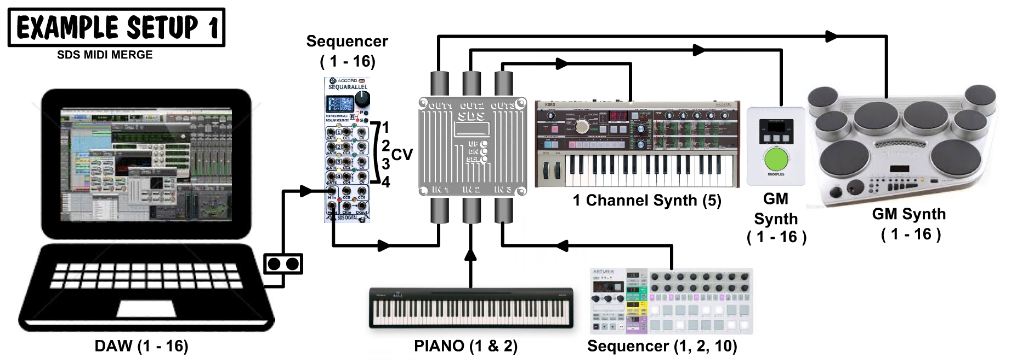
By default, a new configuration will assign each input to all output ports on identical channels, i.e.
MIDI IN 1, 2, 3 Channels 1-16 → MIDI OUT 1, 2, 3 on Channels 1-16
So a Note on Input 1 Channel 1 will play out of outputs 1, 2, & 3 at the same time on Channel 1.
With this setup shown, channel 1 & 2 would be very crowded with 3 instruments playing the same notes.

Sequarallel / DAW:
The Sequarallel sequencer may have channels 1-4 blocked for CV exclusive playing on the modular system, but other channels are passed through. If there is a melody sequence on channel 5, and a lead synth is needed, then the channel is already correct for the 1 channel synth.
*Set Input 1's Output 3 to send all channels. The Korg synth will only "see" 5 but pass the rest to MIDI thru
..also block Program Changes from Output 3 so the synth isn't affected by the sequence PC setting.
The Sequarallel's percussion would preferably go to the V-Drum synth, along with perhaps perc.FX on ch.15
*Set Input 1's Output 1 to send only channels 10 and 15
The Sequarallel has backing chords as pads on channels 7 and 8. The MIDIplus (green knob) is best for those.
*Set Input 1's Output 2 to send only 6 and 7, but as Channels 2 and 3 on the MIDI plus
Setup Examples cont….

Piano:
The Piano is to play along with sequences but only can be on channel 1 or 2. A full rich piano/string combo from channel 1 to both the MIDIplus strings and the V-Drums GM synth piano.
*Set Input 2's Output 1 to pass Channel 1 for piano and Output 2 Channel as Channel 8 strings on MIDIplus.
The piano can easily be switched to channel2 so will be split twice to control 3 channels on the MIDI plus.
*Set Input 2's Output 1 to SPLIT channel 2 at notes 36, 48 and start notes at L:24, M:48,H: 48
Split Channels to Bass on Channel 12, Piano on Channel2, Harp on Channel 14.
Set L/M/H PC's to Bass guitar, Piano Bright, and Harp, or leave M as "--" to select PC from keyboard

BeatStep Pro:
As a primary rhythmic play-along, the MIDIplus's drums can be used, or if the BSP was being clocked by the DAW or the modular clock, then drum sequences can be selected to play to the MIDIplus.
*Set Input 3's Output 2 for channel 10 output. Disable Outputs 1 & 3 channel 10
If SEQ1 & SEQ2 on the BSP are to be used also, these (channel 1&2) can be routed anywhere.

More patches:
The Korg Synth has MIDI thru so that could be patched back around to the DAW or replace the DAW MIDI input to the Sequarallel for MIDI layer recording. The BSP CV & Trigger outputs can of course run to the modular rack, could also be the master modular clock source if Input 3's clock out's are disabled.

II. Panel

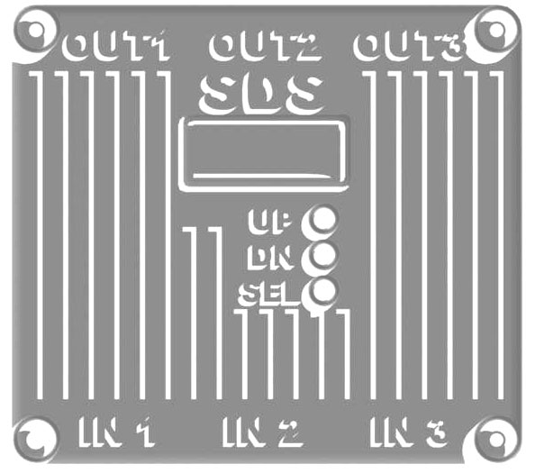

The panel as shown above is the original 3-D printed panel with 3 buttons and OLED (128x32) Screen.

A. Jacks

The Power Jack is tip (-) and outside barrel (+). There is a protection diode and none of the other jacks are grounded so reverse connection will not damage the unit. Max input Voltage should be 15V.
Switch must be in EXT. position to use external power, or BAT position for internal 9V battery.

The 3 IN jacks are optically isolated, and the 3 OUT jacks are 5V driven @200 ohms so can be split once.

B. Buttons

The UP/DN buttons navigate to a point on display to SELect. In Menus or Lists, the UP/DN are proper direction but when selecting a List, may seem reversed. The UP button will progress through the selected big words.
SEL is used to select a List, a line of a List, or enter/exit a line in a List.

Holding Buttons:
Holding UP/DN is the same as stepping through 3 steps/second. This is good for long Lists or high numbers.
Holding the SEL button while in a List will EXIT the list. When not in a list, holding SEL does nothing.

C. LED's

The LED's (Blue on inputs, Yellow on Outputs) indicate MIDI activity. They are time-buffered to stop flickering.
The LED's will glow dimly when there is a MIDI clock present without any other data. This is useful for checking clock flows from/to various jacks.
*Note: MIDI Active Sensing pulse is ignored completely so will not be indicated on any LED.
III. Settings Menus

A. USER Configurations

The MIDI Merge 3X3 can hold up to 10 User Configurations in permanent EEPROM memory. (2048 bytes)
The presently loaded configuration's name will scroll across the screen when in standby ( USER:n selected or no touch for 60 seconds) On power-up, the last used configuration will load.

*The display also shows which inputs are sending clock through to outputs, and occasionally the
run time since power-up (useful when on battery power!)

Use the SEL button to step through the configurations from USER:01 to USER:10. If not in standby SELect :EXIT: from each level and USER:x in the top menu. The following SEL button click will step through config's.

B. MIDI Routing

There are several MIDI elements that can be routed and controlled from within the SDS MIDI Merge:

Input Channels→Output Channels: Channels can be mapped to other channels
Input Ports → Output Ports: MIDI Merging and "Splitting" to selected Output Ports
Note Range (Split Keyboard): 3 ranges from/to any MIDI Channels and/or Outputs on each Input
*Auto-PC messages for Split: Set Instruments for each split, or non-modify
*Note Transpose for each Split : Set Start notes for each section of Split
*Note Overlap for Low & Mid Splits: 0 to 14 notes above split zone combine next section with last
Clock, Transport, PC and CC routing: Enable / disable certain types of MIDI messages per input/output

C. SPLIT Keyboard Setup

The incoming notes can be divided off into channels and the 3 Port Outputs. One split configuration can be assigned to each of the 3 Inputs at once. This is not only useful for playing a keyboard, but also to ban certain notes from playing, or to actively distribute octaves to the same synth and instrument.

To Access the Split Settings list, from standby display SELect which M.INput you are using, then UP/DN to SPLIT n. & SEL.
The 16 parameters to be set for a Spit are:

IN:x SPLIT CH:nn | x=Input Port being configured. nn=Channel that will be split. 1-16 or OFF (--) (Default after factory)
SPLIT LOW:< nnn | nnn=Notes below this will be assigned to the Low Split (default 36)
SPLIT HIGH:= nnn | nnn=This note up to 127 will be assigned High Split. Ones below are Mid. Split (default 48)
MID START NOTE:nnn | nnn=Note that low range will be output from. i.e. if 24, a 36 will play note 60 (default 36)
LOW START NOTE:nnn | nnn=Note that MID range will start at i.e. if mid=36, start=48, a 36 will play note 48 ( default 36)
HIGH START NOTE:nnn | nnn=Note the HIGH range will start at. (default 36)
LOW CHANNEL:nn | nn=Channel for low part of split (default channel 1, Output 1)
MID CHANNEL:nn | nn=Channel for middle part of split (default channel 2, Output 2)
HIGH CHANNEL:nn | nn=Channel for high part of split (default channel 3, Output 3)
LOW INSTR:nnn * | nnn=Instrument (PC) that will be selected for low part of split (default 001 piano1)
HIGH INSTR:nnn * | nnn=Instrument (PC) that will be selected for mid part of split (default 001 piano1)
MID INSTR:nnn * | nnn=Instrument (PC) that will be selected for high part of split (default 001 piano1)
LOW OUTPUT:n | n=Port 1, 2, 3, or off (--) for low part of split
MID OUTPUT:n | n=Port 1, 2, 3, or off (--) for middle part of split
HIGH OUTPUT:n | n=Port 1, 2, 3, or off (--) for high part of split
OVERLAP:nn | Notes (steps in 2's) of overlap between splits in upward direction 0-14

*Instruments are sent after a load, just before first Split event. This is re-armed after any transport message
(Play/Cont/Stop) Instrument PC won't be sent unless the Split channel is used. Changing settings also sends.
If set to "--" then no instrument data will be sent for this range (if you don't want this to change it!)

D. CLOCK Routing

Only one clock can be on any output so each input can fan the clock out over the 3 outputs, but exclusively.

From Standby display, UP/DN to SEL which M.Input you want to modify the MIDI clock stream for. Scroll to OPTION and SELect, then scroll to CLOCK. SELect. The window will show:

CLOCK TO:
OUT 1: Y UP/DN and SELect to toggle Y or N
OUT 2: Y *Note: Changing any of these to Yes, will set other inputs to No on the same output as only
OUT 3: Y one clock input can be assigned to an output. Hold SEL to exit

E. Program Change Output Disable

Program Changes (MIDI PC's) can be blocked selectively from each input. This is useful for maintaining a manually set synth preset, or keeping a GM synth's channel instruments consistent.

From Standby display, UP/DN to SEL which M.Input you want to modify the MIDI PC feed for. Scroll to OPTION and SELect, then scroll to MIDIPC. SELect. The window will show:

PROGRAM CHANGE TO:
OUT 1: Y UP/DN and SELect to toggle Y or N
OUT 2: Y This in no way affects other Input port's PC mappings
OUT 3: Y Hold SEL to exit

F. Transport Output Disable

It may be necessary to disable pass-through of MIDI transport Messages (Play/Cont/Stop) to prevent MIDI receivers from jumping into Play when only a delay/arp clock was needed from the source.

From Standby display, UP/DN to SEL which M.Input you want to modify the MIDI Transport feed for. Scroll to OPTION and SELect, then scroll to TRANSP. SELect. The window will show:

MIDI TRANSPORT TO:
IN:1 > OUT 1: Y UP/DN and SELect to toggle Y or N
IN:1 > OUT 2: Y This in no way affects other Input port's Transport mappings
IN:1 > OUT 3: Y Hold SEL to exit

G. MIDI CC Output Disable

This Option will disable all CC's from any input to any output. This may be required for a synth's filter/level settings to remain manually adjustable when being sequenced, or to cut down heavy traffic to a receiver or one of the outputs (minimize possible latency due to overloading the stream with CC messages)

From Standby display, UP/DN to SEL which M.Input you want to modify the MIDI CC feed for. Scroll to OPTION and SELect, then scroll to TRANSP. SELect. The window will show:

MIDI CC'S TO:
IN:1 > OUT 1: Y UP/DN and SELect to toggle Y or N
IN:1 > OUT 2: Y This in no way affects other Input port's MIDI CC mappings
IN:1 > OUT 3: Y Hold SEL to exit

H. Name a Configuration

Each of the 10 User Configurations can have a 16 character Name.
From the Standby Display, UP/DN to scroll to NAME:n (n=present loaded User Config.)
SELect it and the window will display as follows
CFG: n
USER MIDI CFG 01 (May be another name, 01 to 10)
^
UP/DN to move to a letter, SELect then UP/DN to change letters. SEL again to move to another etc.
Hold SEL to exit. *Don't forget to save the config! (See below)

I. Save Configuration

After all of these modifications it's important to save ASAP! Once the screen is playing the standby mode info, a tap on the SEL button will select the next configuration and all of your changes will be lost. Do Saves Often!
The reason the Save has been left to the user is because some changes, like a split setup, may only be temporary so this way the choice to save is yours!

III. Specs Etc.

Under the main PCB is a 100 pin break-out with ATMEGA2560. There is no USB so needs FTDI to update.

2560 PINS:

TXD1=46 RXD1=45 TXD2=13 RXD2=12 TXD3=64 RXD3=63 *{TXD0,RXD0}
XTAL1=34 XTAL2=33

FTDI: RESET(DTR w/0.1uF cap)=30 TXD0=3 RXD0=2
OLED: SDA=44 SCL=43

VCC 10 31 61 80 gnd 11 32 62 81 jumpers, to PCB= 31:+vcc 32:GND add smd Cap at 80,81
AREF=98 AGND=99 AVCC=100 << break-out PCB jumpers

LEDS: PWM! 6:ardD2, 7:ardD3, 1:ardD4, *{5:ardD5} 15:ardD6, 16:ardD7, 17:arD8, *{18:ardD9}
BUTTONS: 23:ardD10, 24:ardD11, 25:ardD12

*{ -- } indicates Port expansion for 3.5mm plugs if required (MIDI or other), LED's

MIDI Implementation at time of document (Oct23 2019)

All MIDI is passed except 0xFE (active sensing) and SysEx (although is handled so won't cause issues)
Updated "running status" is handled without issue (channel stripping works with them now!)
All enable/disable switches have been tested and seem OK
All MIDI received & processed is run through the same 3 routines for output streaming except 0xFx messages
Note-Offs will not activate output LED's
Up to 256 Notes / Output can be stored for All-Note-Off events
Up to 256 Notes / Output can be buffered (circle buffer) for heavy MIDI traffic. This could be doubled.

