The data collected for this analysis comes from 1,000 sample projects which covers a 10-year span from 2010 through 2019. There are nine parent categories used in this analysis (see Figure 1.1). Additionally, there are 24 sub-categories that make up the data used in this report (see Figure 1.2). Of the 24 sub-categories, 16 of them belong to one of three different parent categories; Film & Video, Music, and Publishing. The remaining eight sub-categories belong to one of the remaining six parent categories; meaning that there are only one or two sub-categories in those parent categories.

Figure 1.1 (Parent Category) shows that both Film & Video and Music have a lot of successful projects; 102 and 99 respectively, while Publishing only had 40 successful projects. Both Film & Video and Music consist of six sub-categories and Publishing is made up of four sub-categories. Figure 1.2 (Sub-category) shows the top contributors for Film & Video are Documentary, Drama, and Animation with 34, 22, and 21 successful projects respectively; Music’s most successful sub-categories are Rock with 49 and Indie Rock with 23; and Publishing’s success comes mostly from Translations with 14 and Nonfiction with 13. However, Theater only has one sub-category which is Plays and it has 187 successful projects. Also, Technology only has two sub-categories yet it had 64 successful projects. From this we can see that it is not the number of sub-categories alone that contribute to the success of a parent category.

Figure 1.1 (Parent Category)

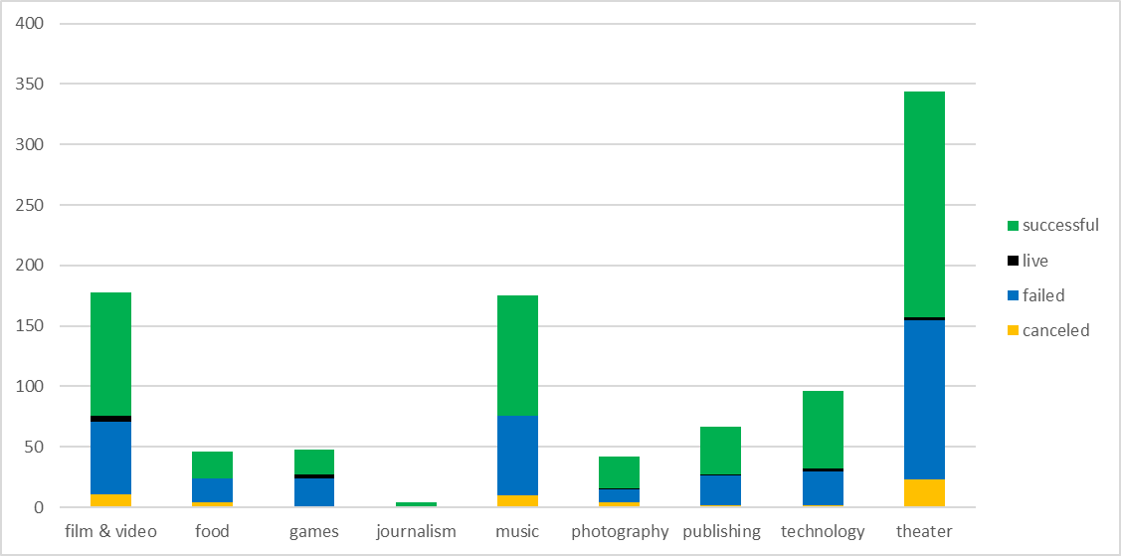

Figure 1.2 (Sub-Category)

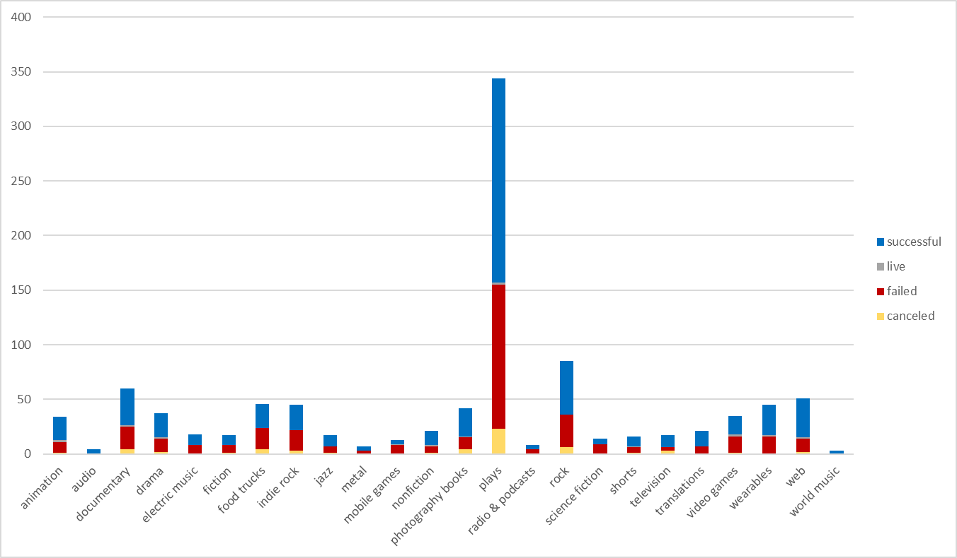

Further research shows that certain months had a higher success rate as well as other months having a lower failure rate. Figure 1.3 (Monthly Results) displays June and July as being the most successful months during the year, however, they are followed by a serious decline in August. What caused this decrease in success? It is possible that the decline in success has to do with the rise in failures during the month of August. Ironically, the high number of failures in August are followed by a decrease in failures in September but the rise in success for the month of September is minimal in comparison. However, this chart could be misleading by making it appear that June and July were the best months for success every year for the entire 10 years. The same can be said about the failures that September always experienced the least amount year after year.

Figure 1.3 (Monthly Results)

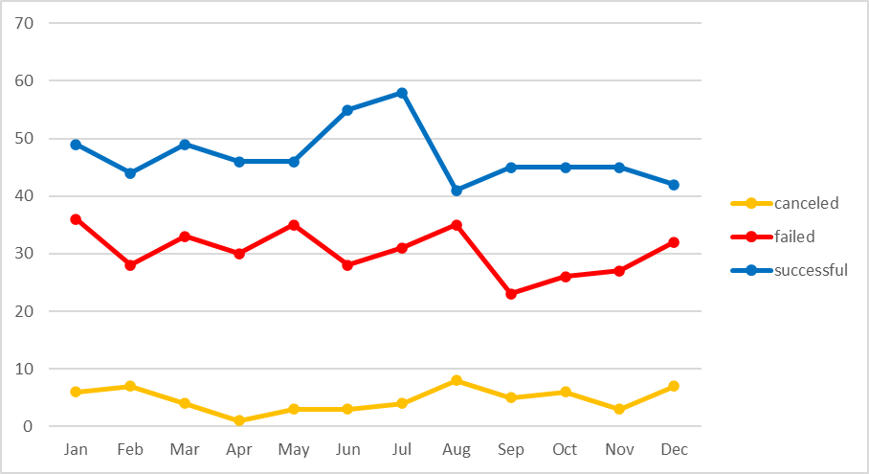

Next, we will look at the successes and failures for each year. When we look at success and failure over the years, Figure 1.4 (Annual Results) shows a good start for success in 2010 followed by a decline over the next three years. Success rises again in 2014 and once again declines for the following two years. Finally, we can see that 2017 through 2019 are all very successful years even though there is a mild decline in 2018 it is still one of the best years during the decade. As we look at the failures throughout the decade, we can see that 2015 and 2016 were the worst years and 2017 had the least number of failures. In fact, 2017 clearly stands out as being the best year during the decade as it had the most successes and the least failures compared to any other year. What factors caused 2017 to be such a good year in comparison to every other year? Further analysis would be required to help determine this.

Figure 1.4 (Annual Results)

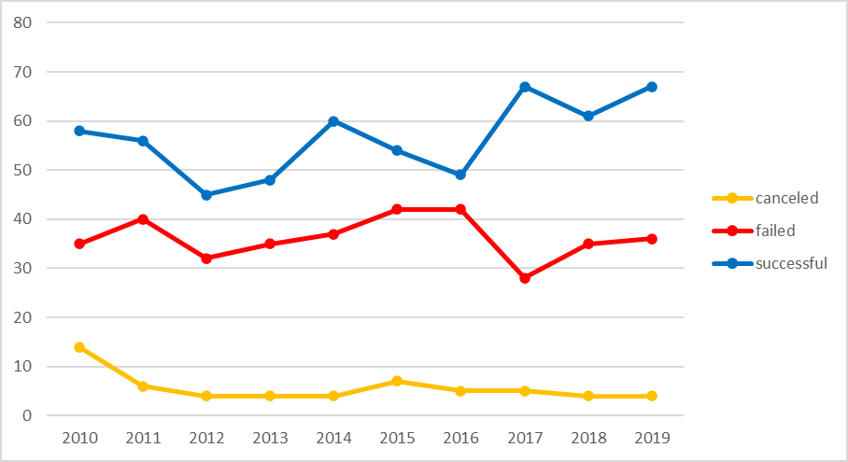

Now we will look at the comparison of outcomes based on goal to see where the most successes and failures occurred. Table 1.1 (Goal Outcomes) shows 12 different groups. The first group consists of goals less than 1,000, the next 10 groups are in increments of 5,000, and the final group is anything greater than 50,000. A visual of these outcomes is depicted in Figure 1.5 (Goal Outcomes). If we just look at the percentage of successes, we can see that there are three groups with a success rate of 100%: 15,000 to 19,999, 20,000 to 24,999, and 30,000 to 34,999. However, if we look closer, we will see that the number of successes is relatively low at 10, 7, and 7 respectively. Whereas the 1,000 to 4,999 group had an 83% success rate with 191 projects.

Table 1.1 (Goal Outcomes)



Figure 1.5 (Goal Outcomes)

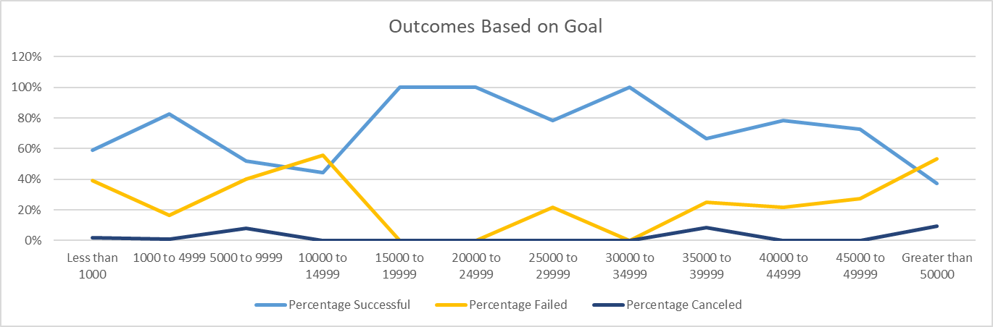

Figure 1.6 displays the measures of variability for both the successful campaigns and the failed campaigns. When looking at the minimum and maximum for each category, neither the mean nor the median does a good job of summarizing the data. However, if choosing between the two, the mean would be the better choice because it is the larger of the two numbers and there is a wide range between the min and max in this scenario.

There is a little more variability with the successful campaigns because they had larger numbers overall plus the number of successful campaigns was more than the number of failed campaigns.

A breakdown between the number of successful campaigns and the number of failed campaigns shows that 71% and 69% respectively were below each categories average. One the other hand, 85% and 87% was the total of successful and failed projects respectively. Basically, this shows that roughly 30% of the projects in both categories contributed to the majority of each category’s overall total.

Figure 1.6 (Measures of Variability)



In conclusion, we have shown both successful and failed projects broken down by parent category, sub-category, by month, by year, and by outcome based on 12 separate groups. We have also seen a breakdown in the different measures of variability. We can conclude that the number of successful projects was greater than failed projects because they had more individual contributors whose contributions were more than twice as much as those for the failed projects. With all that we have analyzed with this data, there is still more data that could be used to get a better analysis. For example, were the majority of contributors male or female; what age group made the most significant contributions (age groups could be in five-year or ten-year increments), which area of the country made the most contributions (Northeast, Southeast, Midwest, etc.), and more. The information in this report is a basic analysis which could be further analyzed with the addition of many more categories.