# Guide to run the Automated Test for the Buggy Cars Rating website

Prepared by: Chandan Rajopanth

Prepared on 04-Mar-21

Automated tests are scripted in Katalon Studio tool version 7.9.1, build 208

The following test cases have been designed to test each area / feature on the website:

**New_User_Registration**: New User Registration and Login with the newly registered user

**Popular_Make**: Navigate to Popular Make

**Popular_Model**: Navigate to Popular Model and add a Vote with a comment

**Overall_Rating**: Navigate to Overall Rating

**User_Logout**: User logout

Following Test Suite has been added to do the above end to end flow on the site:

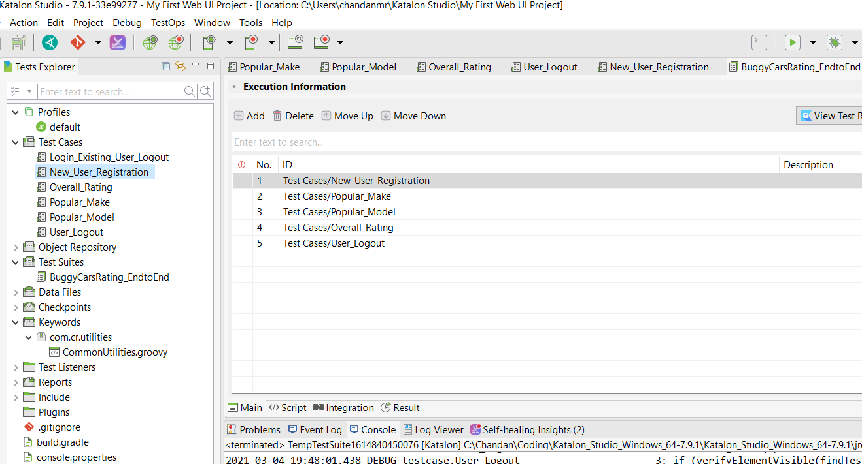

The test suite also has the following Global variable: **UniqUserID** which is used to store and pass the unique user id generated at runtime.

A common utility – **CommonUtilities** is having the method which is used to generate the unique user id.

Last successful execution results:

UserID: 1614841782587

