FREESOFTWARE FOUNDATION TAMILNADU
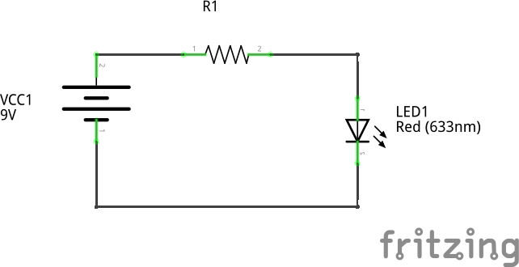
DIY HARDWARE SESSION
1) CONNECTING LED WITH BATTERY THROUGH RESISTOR

Resistor, R1: 470
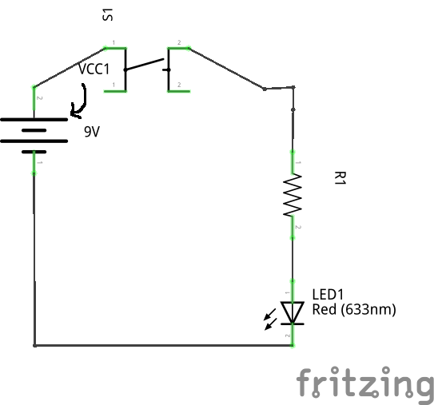
2) CONNECTING LED WITH PUSH BUTTON SWITCH

Resistor, R1: 470

3) CONNECTING LED WITH VARIABLE RESISTOR

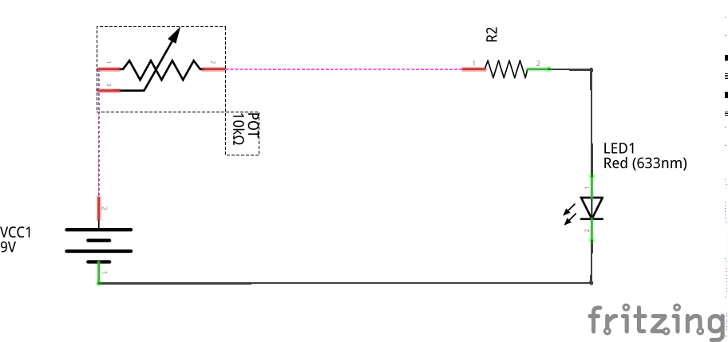

Resistor, R2: 470

4) CONNECTING LED WITH CAPACITOR

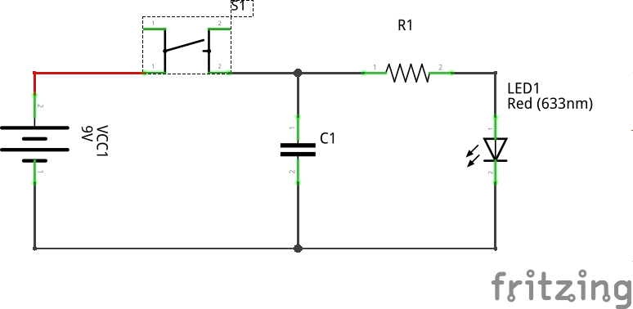

Resistor, R1: 470
CAPACITOR,C1: 100uF

5) CONNECTING LED WITH DIODE
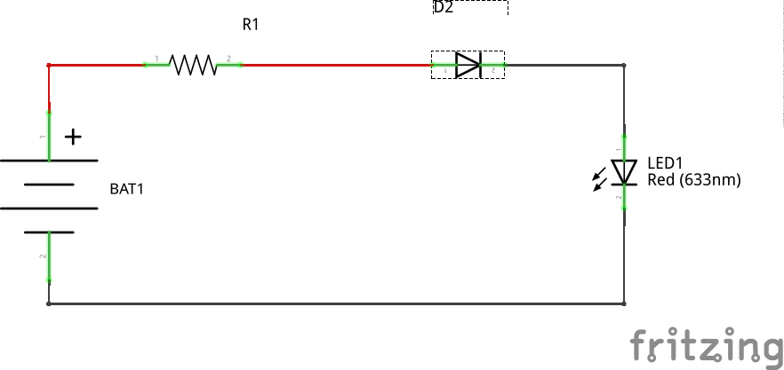

Resistor, R1: 470

6) CONNECTING LED WITH TRANSISTOR
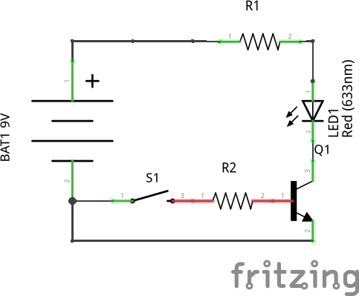
RESISTOR. R1: 470
RESISTOR, R2:10K

7) CONNECTING LED WITH LDR
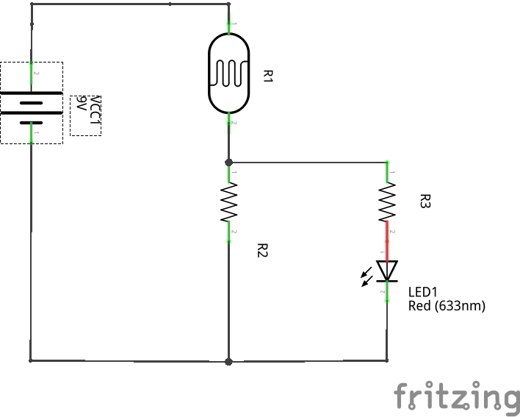
R1: LDR
R2: 10K
R3: 470

8) DARK SENSING CIRCUIT
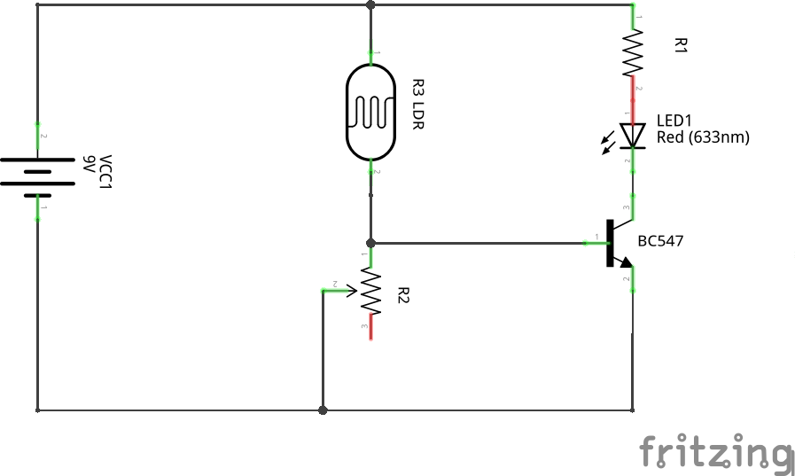
R1: 470
R2: POT
R3: LDR

9) TRANSISTOR BLINKER CIRCUIT
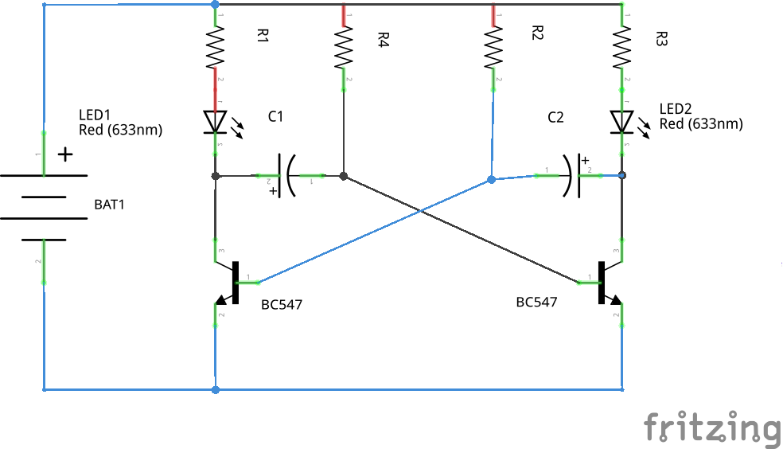
RESISTORS R1,R2,R3,R4: 10K
CAPACITORS C1,C2: 100uF
10) IC555 BLINKER CIRCUIT
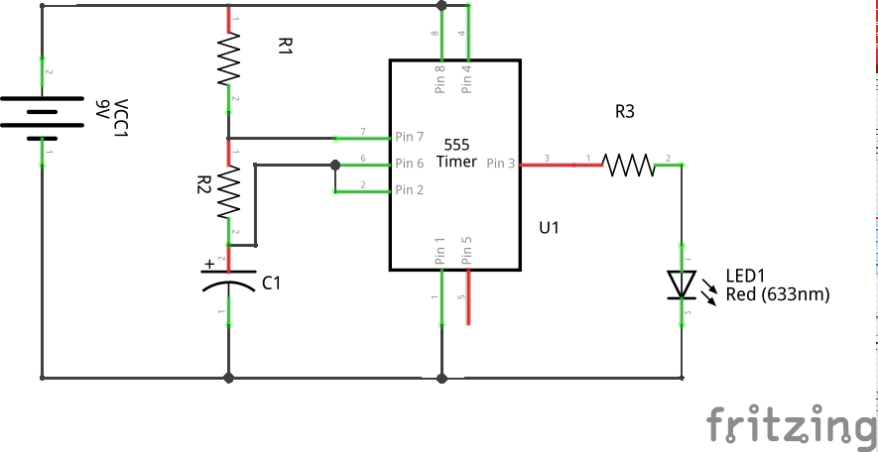
RESISTORS R1,R2: 10K
R3:470
CAPACITORS C1: 100uF
11) DEMO- DUAL LED
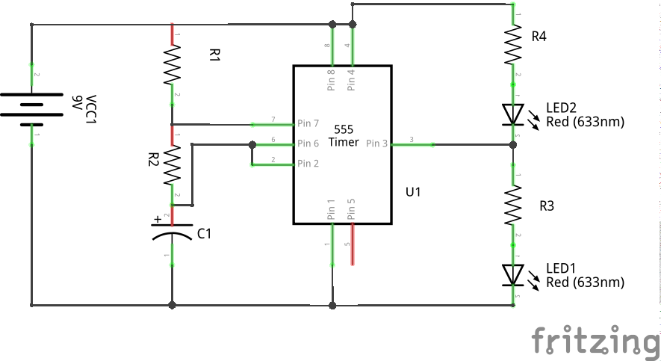
RESISTORS R1,R2: 10K
R3,R4: 470
CAPACITORS C1 100uF

