***BudgetBeast Validation Tests***

| **Test Case** | **Income** | **Expenses** | **Savings** | **Expected Behavior** |
| --- | --- | --- | --- | --- |
| **1** | **3000** | **1500** | **500** | **Shows leftover: $1000.00** |
| **2** | **0** | **500** | **200** | **Error: "Please enter positive numeric..."** |
| **3** | **-2500** | **1000** | **500** | **Error: "Please enter positive numeric..."** |
| **4** | **abc** | **1000** | **300** | **Error: "Please enter positive numeric..."** |
| **5** | **3000** | **abc** | **300** | **Error: "Please enter positive numeric..."** |
| **6** | **3000** | **1000** | **abc** | **Error: "Please enter positive numeric..."** |
| **7** | **empty field** | **1000** | **500** | **Error popup** |
| **8** | **3000.75** | **1500.25** | **250.50** | **Correct result with decimals** |
| **9** | **3000** | **1500** | **2000** | **Negative leftover: -500.00 (valid math)** |

**Working as I need it to. Will only accept Positive integers. If its negative, empty, or non-numeric then it will have error message**

1. 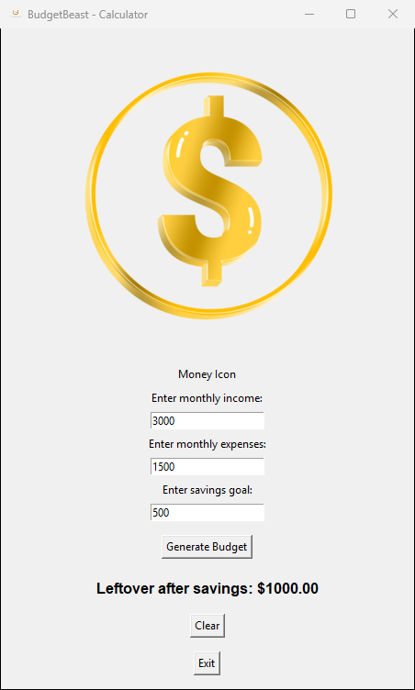**Working as expected**
2. 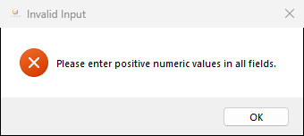**invalid because had 0**

**in income**

1. **error because had negative income**