Figures

Figure 1. Cyanobacterial ecotypes, chlorophyll, NOx- and mixed layer depth for the North Atlantic GA03 transect. Only NOx- measurements <0.3 µM are shown. The mixed layer (ML) is indicated by the dotted line.

Figure 2. Example datasets from GA03 transect section 1 (top) and section 2 across the subtropical gyre (bottom). A&F) Cyanophage/cyanobacteria ratios, the % of Prochlorococcus with nitrite assimilation gene nirA, and chlorophyll. B&G) Cyanobacterial ecotype normalized reads (ITS region) and percent of prokaryote community (rpoB; dashed bold line). Ecotypes are designated by gray crosses (HLI), blue squares (HLII), green triangles (LLI), purple diamonds (LLII), red circles (NC1), light blue filled circles (LLIV) and orange x (Synechococcus). Insert: Cyanobacterial ecotypes as % of Picocyanobacteria. Colors match the symbols. C&H) Cyanophage abundance as determined by terL normalized reads. D&I) The proportion of cyanophage with a host gene that increase with depth. E&J) The proportion of cyanophage with a host gene that decrease with depth (at least sometimes). The mixed layer (ML) is indicated by the dotted line.

Figure 3. Example dataset from HOT (top row) and the South Pacific (GP13) (bottom row). A&F) Cyanophage/cyanobacteria ratios, the % of Prochlorococcus with nitrite assimilation gene nirA, NOx- concentrations, and chlorophyll (if measured). B&G) Cyanobacterial ecotype normalized reads (ITS region) and percent of prokaryote community (rpoB; dashed bold line). Ecotypes are designated by gray crosses (HLI), blue squares (HLII), green triangles (LLI), purple diamonds (LLII), red circles (NC1), light blue filled circles (LLIV) and orange x (Synechococcus). Insert: Cyanobacterial ecotypes as % of Picocyanobacteria. Colors match the symbols. C&H) Cyanophage abundance as determined by terL normalized reads. D&I) The proportion of cyanophage with a host gene that increase with depth. E&J) The proportion of cyanophage with a host gene that decrease with depth (at least sometimes). The mixed layer (ML) is indicated by the dotted line.

Figure 4. Example dataset from ETNP ODZ (top row) and the ETSP ODZ (bottom row). A&F) Cyanophage/cyanobacteria ratios, the % of Prochlorococcus with nitrite assimilation gene nirA, NO₂⁻ concentrations (ETNP), and chlorophyll. B&G) Cyanobacterial ecotype normalized reads (ITS region) and percent of prokaryote community (rpoB; dashed bold line) and NO₂⁻ concentrations (ETSP). Insert: Cyanobacterial ecotypes as % of Picocyanobacteria. Colors match the symbols. C&H) Cyanophage abundance as determined by terL normalized reads. D&I) The proportion of cyanophage with a host gene that increase with depth (at least sometimes). E&J) The proportion of cyanophage with a host gene that decrease with depth (at least sometimes). The mixed layer (ML) is indicated by the dotted line. The top of the ODZ is the dashed line.

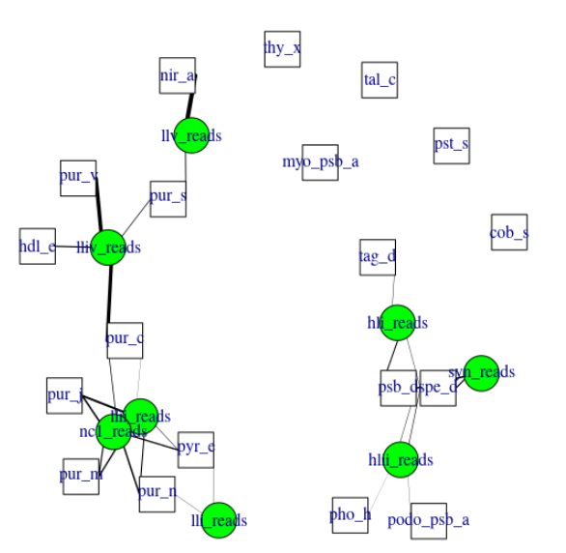
Figure 5. A lasso based association network between different cyanobacterial ecotypes and viral genes. Nodes indicate viral gene abundances (white squares), and cyanobacterial host abundances (green circles). Edges connect viral and cyanobacterial nodes that are statistically associated. Relative edge thickness relates to the relative coefficients of the lasso regressions, with thicker edges associating with stronger statistical associations. Environmental and location data were used to generate this network in order to factor out those variables, but those nodes and their associated edges are not shown to reduce complexity and to focus on the virus to host associations.
Figure 6. Myo-cyanophage core gene cobS phylotypes for A) HOT 278, B) GA03 St 20, C) ETNP, and D) ETSP. The cobS phylotgenetic tree can be seen in Figure S7.

