Human gut microbiota are associated with HIV-reactive immunoglobulin at baseline and following HIV vaccination

# Abstract

The human microbiome and immune system shape each other through lifelong interactions. These interactions have been proposed to modulate the immune system's response to vaccines. Previous studies have suggested that composition of the human gut microbiome may correlate with the efficacy of oral vaccines. Furthermore antibodies to tolerogenic commensal microbial antigens, which are structurally analogous to the human immunodeficiency virus (HIV) envelope protein glycoprotein 41 (gp41), may be cross reactive with gp41 protein and thus limit vaccine efficacy. To improve understanding of the role of the human microbiome in modulating the immune response to HIV vaccines, we associated the gut microbiota composition, via 16S rRNA amplicon sequencing, of participants in the HIV Vaccine Trials Network 096 clinical trial to their HIV vaccine immune responses at baseline, two weeks post vaccination and six months post vaccination. We observed that (a) levels of IgG antibodies to gp41 at baseline, as well as (b) post vaccination concentrations of IgG antibodies to several vaccine targets, including the gp120 envelope protein, covaried with a subpopulation of the microbiome. Participants with bacterial communities that contained higher levels of Clostridiales had higher gp41 IgG baseline measurements and lower levels of vaccine response. Conversely, participants with low levels of Clostridiales but higher levels of Bacteroides showed the opposite effect. Furthermore, gp41 baseline and post vaccination immune responses were not directly correlated, suggesting that there are effects beyond the microbiome that also contribute to immune baselines and vaccine response heterogeneity. Our findings provide promising preliminary evidence that the microbiome may constitute an important correlate of protection and may be valuable to consider in the development of vaccines for HIV and other diseases.

# Introduction

Growing evidence suggests the composition and functions of the gut microbiota play a major role in regulating the immune system and its response to both pathogens and vaccines (Collins and Belkaid, 2017; Littman, 2017; Macpherson, 2017). Regions of the human immunodeficiency virus one (HIV-1) envelope glycoprotein 41 (gp41) are frequently targeted by B cell immunoglobulins (Ig) both in vaccination and natural infection and emerging evidence suggests that antibodies recognizing gp41 cross-react with commensal bacteria in the gut (Trama et al., 2014, Williams et al. 2015). This was demonstrated in a recent HIV-1 vaccine efficacy trial of a multiclade gp140 DNA-prime and recombinant adenovirus type 5 (rAd5) boost, which elicited a dominant gp41-reactive antibody response that was non-neutralizing and cross-reactive with the intestinal microbiota (Williams, 2015). It remains an open question whether priming of gp41-reactive and possibly other HIV-1-reactive immune responses directly influence the vaccine-induced response.  The microbiome has furthermore been postulated to modulate vaccine response (Collins and Belkaid, 2017; Littman, 2017; Macpherson, 2017), and indeed has been shown to associate with vaccine response in other diseases (Zimmermann & Curtis, 2018; Huda et al. 2014; Harris et al. 2017).

The RV144 vaccine efficacy trial showed that an HIV-1 Env containing pox-vector prime and bivalent recombinant Env gp120 boost provides partial efficacy against HIV-1 infection (Rerks-Ngarm, et al. 2009). Numerous follow-up studies now support the hypothesis that Env V1V2-specific IgG was associated with decreased risk of infection among vaccine recipients (Haynes et al., NEJM 2012; Zolla-Pazner et al., Plos ONE, 2014; Yates et al. SciTransMed 2014). Follow-up analyses suggest that efficacy was >60% from 3-6 months after the first vaccination, but waned over the first 6 - 12 months (Robb et al., 2012), suggesting that improved antibody durability could be a path to improved efficacy. The HIV Vaccine Trials Network (HVTN) 096 study (Pantaleo et al., In Prep) evaluated several pox prime, gp120 boost regimens with an objective to improve upon the immune responses elicited by the RV144 vaccine. Co-administration of AIDSVAX® B/E a gp120 protein, with either a DNA plasmid or vaccinia virus containing DNA (NYVAC) containing genes encoding Env, Pol, Gag and Nef HIV-1 proteins elicited V1V2-specific and additional gp120-specific IgG, yet there was substantial heterogeneity in the response magnitude and durability among vaccine recipients (Pantaleo et al., In Prep). A critical goal of ongoing HIV-1 vaccine research is to identify factors that influence vaccine response heterogeneity, a common trait of many, if not all vaccines.

We studied the immune responses of participants in the HVTN 096 study and the composition of their intestinal microbiota using 16S-targeted sequencing of rectal secretions. We hypothesized that the gut microbial composition is associated with pre-vaccination levels of gp41-reactive antibodies. We further hypothesized that the microbiome would associate as well with post-vaccination levels of HIV-1 envelope specific antibodies (including gp41 and gp120 subunits). To test this hypothesis, we applied “global” tests that examined whether participants with similar microbiota also had similar baseline or post-vaccine levels of Env-reactive IgG. We then further characterized globally significant associations by applying “local” taxon-specific tests to identify specific bacteria that may be driving the association. We found that baseline levels of gp41-reactive IgG and post-vaccination levels of gp120-reactive IgG were globally associated with the composition of the gut microbiota and that both effects involve changes in the relative abundance of different taxa. We found no associations of microbial composition with vaccine-induced T cell responses. The results support the hypothesis that the gut microbiota modulates human immune responses, including those to HIV-1 vaccination.

# Methods

## Study Design

HVTN 096 was designed to test the safety and priming ability of either NYVAC-HIV-PT-1/NYVAC-HIV-PT-4 (hereafter NYVAC); or DNA-HIV-PT124, a trivalent bare DNA plasmid either alone or in combination with a bivalent recombinant Env gp120 protein boost (AIDSVAXⓇ B/E). (Supplement, Cite Protocol Here). The study contained four experimental groups each with primes administered at months 0 and 1, and boosts administered at months 3 and 6. Primes for each of the four experimental groups were (T1) NYVAC, (T2) NYVAC + AIDSVAX, (T3) DNA plasmid, (T4) DNA plasmid + AIDSVAX. In all treatments, the boost was a combination of NYVAC and AIDSVAX. An additional subset of control participants were administered placebo (Sodium chloride 0.9% solution for NYVAC placebos and 600mgc alum/mL for AIDSVAX) (Pantaleo et al. in prep).

We focused on immunological measurements using samples provided at three time points: Day 0 (baseline) Month 6.5, the protocol-specified Primary Immunological endpoint (two weeks after the final boost), and Month 12 (a durability time point). Analysis of the gut microbiota and immunological measures was limited to participants for whom both data were available (n = 21); the participants were divided among the experimental treatment groups (7 participants in T1, 3 in T2, 6 in T3, 5 in T4). Due to the limited number of samples, data was pooled across the vaccine groups.

## Data collection

Immune data were generated as described by Pantaleo et al. (In Prep). Briefly, antibody binding was measured with the binding antibody multiplex assay (BAMA; Tomaras et al, 2008). Intracellular cytokine staining was performed on cryopreserved peripheral blood mononuclear cells to measure CD4+ T cell responses to vaccine-matched peptide pools for each HIV-1 protein; the proportion of cells expressing interferon gamma (IFNγ) and/or interleukin 2 (IL-2) was used as the magnitude of the response; analysis was limited to Env-specific responses summed across X Env-containing peptide pools. Analysis was focused on IgG and IgA levels for a subset of BAMA antigens: gp41, gag p24, CON6 gp120 B, ZM96 gp140 protein (encoded by the DNA and NYVAC immunogens), and gp70 B CaseA V1-V2 protein. Antigen-specific IgA was measured, again with BAMA for the gp41 and p24 proteins. Response magnitudes were examined for IgGs, IgAs and HIV envelope specific CD4+ T cells. A Box-Cox transformation was used to normalize the data and decrease sensitivity to outliers. Analysis was also performed on binarized data, using the median to split participants into high and low categories.

Microbiome samples were collected and DNA extracted from rectal wecks taken at baseline (Supplement). Samples from the earliest available sample (day 0 for 3 participants, month 6.5 for 11 participants and month 12 for 7 participants) were amplified with barcoded 16S primers  that targeted the hypervariable sequence containing V3-V4 region and sequenced on a Roche 454 as described by Srinivasan et al. (2012). Microbial sequence data were demultiplexed, binned into sequence variants, given putative taxonomic identities, phylogenetic relationships between the sequences were ascertained and taxonomic clustering was carried out on those identities (Supplement).

## Analysis of microbial community structure and its relationship to vaccine-induced antibody production

A two-tiered approach was used to investigate the relationship between microbial community structure and immune responses. We employed “global” tests that identified whether overall community structure related to each immunological measurement and “local” tests, conditional on a significant global effect, to identify individual bacterial taxa underlying the effect.

To describe microbial community variability, weighted UniFrac distance was calculated between all pairs of participants. Principal coordinates analysis was conducted on these weighted UniFrac distances and site scores for each axis thereof were extracted. We refer to the first ten of these weighted UniFrac principal coordinate axes as MDS1-10 and use MDS1 in much of our subsequent analysis. Global patterns were identified with kernel regression (Zhao et al., 2015) which detected community-level associations between the microbiota and immune measurements (Supplement). For those immunological variables that associated with microbial community structure, local tests were applied to identify which taxa were related to each component (Supplement). Analysis of proportionality was applied to identify co-occurring microbial family level taxonomic groups, as well as to identify which of these family level groups associated with each immunologic variable found to relate to community structure in the global tests (Supplement).

# Results

## Heterogeneous immune responses before and after vaccination

As was seen by Pantaleo et al. (In prep), Con 6 Gp120, zm96_v1v2 and gp140 binding IgG antibodies were undetectable among all participants at day 0. Relative to baseline, responses to each antigen were increased at month 6.5, two weeks after the final vaccination. Responses decreased to an intermediate level 6 months after that (month 12). There was substantial variability between participants both in the magnitude of the 6.5-month and final time point response. In contrast, gp41 and p24 binding IgG antibodies were variable and detectable at day 0. Binding was increased at the 6.5-month time point, and decreased by the 12-month time point (Figure 1, Figure S1A). IgA gp41 and p24 antibodies varied substantially between participants at baseline and increased less and more variably in response to vaccination than did the IgG versions of those same antibodies (Figure S1B). CD4+ T cells specific to HIV Env protein, like IgGs, showed increase between the baseline and 6.5-month time-point, and some attenuation in many participants by the 12-month time-point (Figure S1B).

## Heterogeneity in gut microbiota community structure

Microbiome sequencing of participant baseline rectal wecks (day 0) generated 2100 to 10843 16S rRNA V3-V4 reads per sample. Quality filtering, denoising and chimera removal decreased the number of reads only slightly, to a final range of 2070-9688 sequences per sample, suggesting that the reads were generally of high quality. DADA2 called 960 unique SVs. After processing, there were 536 unique SVs. Agglomeration yielded 5 Phyla, 12 Classes, 17 Orders, 36 Families and 92 Genus level taxonomic groups. Principal coordinates analysis of weighted UniFrac distance indicated that 29.1% and 16.9% of the community structure variability was captured by the first and second (MDS1 and MDS2) principal coordinate axes (Figure 2). We used samples’ locations along MDS1 to help simplify and aid visualization of community structure.

The participants in our dataset had microbiota broadly typical of the human gut, with most participants’ microbiota dominated by members of the Bacteroidetes and Firmicutes phyla, and some members having strong representation from the Actinobacteria and Fusobacteria phyla and the Proteobacteria Superphylum (Figure 3A). The Firmicutes phylum was generally dominated by class Clostridia, which was in turn comprised entirely of the order Clostridiales. By arranging participants by their weighted UniFrac PCoA MDS1 score (hereafter MDS1 score), we observed that the participants with low MDS1 scores had Clostridiales communities dominated by the Ruminococcaceae and Peptoniphilaceae Families, while participants with high MDS1 scores had higher levels of Clostridiales Incertae Sedis XI (Figure 3B). These Clostridiales Incertae Sedis XI were primarily composed of six genera. The relative contributions of these genera to Clostridiales Incertae Sedis XI did not themselves appear qualitatively associated with MDS1 score (Figure 3C). Of the Bacteroidetes seen in this dataset, most were from Class Bacteroidia and all of those Bacteroidia were from order Bacteroidales. The remainder of Bacteroidetes were from a small subset of otherwise unidentified organisms. When sorted by weighted UniFrac axis one, it was evident that participants with low MDS1 scores generally had higher levels of the Family Bacteroidaceae, while participants with higher MDS1 scores tended to have higher concentrations of the family Prevotellaceae (Figure 3D). Analysis of proportionality indicated that, at the family level, there were groups of organisms that were all proportional with each other (Figure 4), indicating co-occurrence structure in our dataset.

## Microbe community structure associated with Env-reactive IgG

We used kernel regression to identify associations between microbial community structure and each immune response measurement. In the analysis, we used weighted UniFrac to measure the pairwise distances between every participant’s microbiota composition. Kernel regression tests for an association between those pairwise distances and pairwise differences in the immune response. Of all the immune responses measured at baseline, there was only detectable variability in gp41- and p24-reactive IgG and IgA binding.  Of these we found that only baseline levels of gp41-reactive IgG were significantly associated with the microbial community structure (P = 0.047; Q = 0.160, Table 1, Figure 2). As a descriptive follow-up analysis, we also evaluated the association between gp41 binding at baseline and MDS1, the first principal coordinate axis of community structure variability. The benefit of using MDS1 in this way is that it can provide an estimate of magnitude and direction of the association. We found that participants with a high MDS1 score tended to have higher gp41 binding (P = 0.015, Q = 0.007; Table 1, Figure 2). Post-vaccine levels of gp41-reactive IgG at M6.5 were also associated with community structure (P = 0.048, Q =0.160). However, compared to baseline gp41, the association of M6.5 gp41 binding with MDS1 was in the opposite direction, with participants having high MDS1 scores tending to have lower gp41 binding (P = 0.032, Q = 0.013). At the post-vaccination time points, we also assessed the associations of several additional HIV-1 Env antigens. We found that month 6.5 levels of Con6.gp120 and ZM96.gp140 were significantly associated with community structure (gp120: P =0.004, Q =0.073; gp140: P = 0.014, Q = 0.009). Binding to Con6.gp120 and gp70_B.CaseA_V1_V2 antigens was also associated with community structure at the M12.5 durability time-point. For each association of a post-vaccination Env-reactive IgG we found that participants with higher MDS1 scores tended to have lower Env-specific IgG while those with lower MDS1 scores had higher Env-specific IgG. Neither the CD4+ envelope specific T cell pool, nor any of the IgA measurements were related to community structure using the aforementioned methods.

Treating immune data as a continuous, box-cox transformed, rather than median split variable showed similar though generally less statistically significant patterns. One notable exception was IgG antibodies to Con.6.gp120B which showed a much stronger association (p<0.001 q < 0.01) when treated as a continuous, rather than binary variable (Table S1).

## Jensen-Shannon distances were not associated with immune responses without taxonomic agglomeration

As a secondary analysis, we considered using a Jensen-Shannon (JS) distance instead of weighted UniFrac: a major difference is that a Jensen-Shannon distance considers each sequence variant (SV) independently, ignoring phylogenetic relationships. Applying the JS distance to species-level SVs we found no associations with immune responses (Figure S2). We then agglomerated SVs at different taxonomic levels (Supplement) and performed kernel regression analysis on the Jensen-Shannon distance of these agglomerated groups. Significant associations between the Phylum - Genus level taxa and many of immune variables were evident. Omnibus p-values provided an aggregate of the p-values of many associations and generally provided p-values that were similar to, but slightly higher than, the results of the weighted UniFrac based kernel regression. This analysis showed that, in the absence of UniFrac’s ability to incorporate phylogenetic information, agglomeration was necessary to see patterns. That is, we detected no relationship between species level SVs and immunologic parameters when we did not consider their phylogenetic relationships. In contrast, when we did consider phylogeny though the previously described weighted UniFrac methods or by binning SVs, relationships between community structure and vaccine response became evident.

## Individual taxonomic groups were associated with gp41 and gp120-reactive IgG binding

“Local” linear regressions of each species level SV against each each IgG that showed a statistically significant global trend after q-value correction showed that no species level group associated with any specific IgG. In contrast, with taxonomic agglomeration, it was evident that each IgG was associated with multiple taxa at each of several taxonomic levels. All IgG measurement-time point combinations that were statistically associated with the overall community, according to global tests, were also associated with some family level taxa (q<0.2, p< 0.05). Thus, for our subsequent analyses, we focus on family level patterns.

Analysis of proportionality showed that, at the family level there were three main co-occurring family level proportional clusters in this dataset (Figure 4). One proportional cluster contained families that were positively associated with gp41 day 0 responses. This cluster contained one family level group named “Clostridia” in Figure 4 because it contains multiple taxa from the Clostridia class, and which included organisms from family Clostridiales Incertae XI. It also contained a family level group “Anarocococcus”, so named because if only contains taxa from genus Anarococcus. This same cluster also contained family level groups that were negatively associated with gp41 at the 6.5-month time point, and groups that were positively associated with Con.6.gp120.B, ZM96.gp140 and gp70 B.CaseA V1-V2 concentrations. In contrast, families in the other proportional cluster (which included two families from the Bacteroides phylum as well as several Clostridiales and other Firmicutes containing families that were different from the ones in the first proportional group) were negatively associated with gp41 and positively associated with the other immune variables. The third proportional cluster appeared independent of immune variation.

# Discussion

## The microbiome associates with baseline levels of gp41 IgG response

The statistical association between the microbiome and gp41 specific IgG concentration at the baseline visit in our study supports previous indications that suggest that the microbiome shapes immune system development and function (eg. Hooper 2012). To our knowledge, this paper is the first to identify a correlation between baseline gp41 binding IgG antibodies and the microbiome. Such an association may be an example of either the immune system reacting to the presence of microorganisms, or else producing IgG antibodies selecting for certain organisms, or likely a combination of both. While gp41 is believed to be specific to retroviruses (Freed & Martin 1995), evidence is mounting that the microbiome has analogues which cross-react with gp41 binding antibodies (Williams et al., 2015, 2018). Indeed, if this is the case, microorganisms with gp41 analogue proteins may elicit an immune response that is cross specific to both HIV and the microbiome (Williams et al., 2015).

## The microbiome is a correlate of vaccine immunogenicity

This study’s observed association between microbiome and immunogenicity of the NYVAC containing vaccine regimens expands on a pool of literature that suggests that the microbiome appears to influence the immune system and associates with vaccine immunogenicity. This relationship between vaccines and microbiota likely follows from the former’s well-documented role in shaping the function and development of the immune system (Hooper et al., 2012). Because the microbiome shapes immune system development and function, it should not come as a surprise that this immune system’s response to vaccines relates to the microbiome. Indeed, the efficacy of rotavirus and oral polio vaccine efficacy have been previously shown to relate to microbial community structure (Harris et al., 2017; Huda et al., 2014; Lagos et al., 1999). Recently, Collins et al. (2017) suggested that some members of the microbiome may act as “endogenous adjuvants” enhancing vaccine responses, and proposed that vaccines should be developed to account for this property.

The observation that overall microbial community structure relates generally to the concentrations of several specific IgGs may suggest that the microbial community either shapes the host’s immune system’s response to vaccines or else that hosts with immune systems that are more responsive to vaccines somehow promote growth of different bacteria than hosts who are less responsive to vaccines. There are several mechanisms by which microbiota may impact the immune system in ways that are relevant to this study: The association of the composition of the gut microbiota with HIV-1 specific antibody binding at pre- and post-vaccination time points may indicate a direct role for microbes in developing the immune response. Such a role could be broad, involving pathways of the innate response and innate lymphoid cells as proposed previously (Moro, K et al. 2015; Klose, Nat Immuno, 2016). A direct role may also involve cross-reactive epitopes in gp41 and commensal bacteria. Additionally, microbial community structure may be indirectly associated with the response to vaccination because it acts as a readout and predictor of immune status. A baseline immunogenicity predictor (BIP) like the microbiota could be valuable in vaccine development as a correlate of efficacy (Gilbert and Plotkin COR vs COP; Folman et al. BIP).

We identified groups of co-occurring organisms, which can be observed as proportional clusters of family level taxa (Figure 4) and represented as principal coordinate axes in weighted UniFrac space (Figure 2). These groups appear to associate with vaccine response, as measured by the production of a variety of antigen-specific antibodies, and are correlated in the opposite direction with baseline gp41 antibody levels. These proportional groups contain numerous organisms. Given the statistical power of our analysis (indeed, there were only 21 participants), it is not possible to assign particular importance to any one organism within those clusters. Rather than trying to identify individual taxa, we focused on identifying and describing overall trends in community structure and its relationship to vaccine response. Our observed clusters of proportional organisms contained some taxa that were statistically associated with our variables of interest while others were not. We do not contend that the taxa that passed our significance threshold are more related to the variable of interest. Which organisms in this cluster happen to fall above or below the significance threshold may ultimately be stochastic, rather than indicative of these organisms importance. Rather, we contend that any organism or set of organisms within the cluster may be the ones most relevantly related to the parameter of interest. For example, while we observe that communities with high abundance of the “Clostrida” and “Anorococcus” family level agglomerated groups (see Results Section 4.5) are characterized by high gp41 at day 0 (Figure 4), all, some, or none of the SVs within these families may relate to the immune effects identified. Indeed, it may be other organisms that are statistically (and perhaps mechanistically) associated with the families that drive the effect.

## Relating baseline and immune responses

The baseline and vaccine-induced IgG response appeared to correspond with the microbiome in opposite ways. Within the family level proportional cluster analysis, groups of families that were associated with high concentrations of gp41 binding IgG also associated with low levels of vaccine-induced antibody responses at the 6.5 and 12-month time-points. Surprisingly, microorganisms associated with high day 0 gp41 IgGs were associated with low month 6.5 gp41 IgGs. Conversely, the proportional cluster that associated with low baseline Gp41 IgGs associated with high gp120, gp140 and gp70-v1v2 IgG responses to the vaccine. This pattern does not indicate that day0 gp41 response is itself related to vaccine immunogenicity. Direct assessments of the baseline gp41 binding and post-vaccination IgG revealed no significant associations (Fisher’s exact tests, all p > 0.05). Rather it suggests that the microbial community that associates with low baseline response also associates with high vaccine immunogenicity. One possible mechanism for this relationship is the cross-reactivity of the immune system with gp41 analogues on bacteria. Bacteria that have gp41 analogues could elicit the production of antibodies that bind to gp41. These same bacteria could also cause the cross reactivity seen by Williams et al. (2015) thereby decreasing viral immunogenicity. One possible mechanism is that introducing a tolerogenic antigen (gp41 antigens through the gp140 epitope in the NYVAC) that cross-reacts with commensal microbial antigens results in enough tolerizing cytokine production and regulatory T cell activity to prevent strong vaccine immunogenicity and adjuvant responses from being generated.

## Caveats

As we have indicated, the sample size for this study is small, with only 21 participants and this limits our power to illuminate the relation between the microbiome and the immune system. Our ability to detect global level patterns for each of the immune measurements that we investigated suggests that the pattern that we did detect is likely quite strong, otherwise, it would be difficult to have statistical significance with these sample sizes. On the other hand, the small sample size limits our ability to detect “local” level patterns; and forced us to make broader comparisons, by looking at proportional family level groups and weighted UniFrac measurements that describe “overall” community structure, rather than specific organisms. We leave it to larger future studies, with larger sample sizes, to generate the statistical power to identify which microorganisms relate to vaccine response, and to test whether this observed pattern persists.

Indeed our approach in this study was exploratory. While we did test a range of hypotheses about immunological parameters that might be related to community structure, any observations of which microbes relate to these patterns are purely descriptive. This study involved many comparisons, comparing hundreds of SVs to eight immune measurements at multiple time-points. We applied several different statistical techniques and agglomerated the community structure to a range of levels to identify where patterns were strongest. We acknowledge that such an approach will necessarily generate spurious discoveries. We contend that while our data supports the hypothesis that the microbiome as a whole relates to vaccine response heterogeneity, our other observations are hypothesis generating. We provide here cohorts of microorganisms that may contain families that positively or negatively associated with vaccine response (Figure 4), allowing future studies to investigate which of these families consistently associated with vaccine response.

A key limitation of the HVTN 096 study overall was that, near completion of the clinical trial, the NYVAC vaccine was discovered to be contaminated with mycoplasma (Pantaleo et al. In Prep). It appeared that the vaccine generally worked as expected despite this contamination, but also it is likely that the mycoplasma also induced additional immune responses. This contamination could modulate the interaction between the immune system and microbiota in this study in a way that it might not with vaccines in the future.

## Implications of the microbiome for vaccine development

Our findings expand the results of previous vaccine and immune literature. While the microbiome has been shown to impact efficacy of oral vaccines (Harris et al., 2017; Huda et al., 2014; Lagos et al., 1999) this is the first study, to our knowledge, to demonstrate statistical association between microbiome structure and immunogenicity of an HIV vaccine, delivered intramuscularly rather than orally. Our findings suggest that the mechanism of the microbiome’s effect on vaccine response is likely through more systemic immune processes. This study provides key evidence that some of the variability in the immune response to an HIV vaccine is related, at least in part, to variability in the microbiome.

# Figures and tableshttps://lh3.googleusercontent.com/dvnTPVckowzofuKn9hlmv6BCqbcHIZVC5wzcAbxxdyIaGRkx7ZlhhRuLqC3JzHAjHT6nK6p9HBbE6GZjxt0Svm--ouNzpuUp5p6_a_UHuEiBS4gXUcFAnKaxQ8uWkm1Bew-I4Er5

### Figure 1: Concentration of antibodies over time among study participants whose microbiomes were sequenced. Study participants were vaccinated at four time-points, indicated by blue tick marks, following the regimen described in the methods.  Magnitude of each IgG antibody were measured using the BAMA assay. In all treatments, IgG concentrations increased over the vaccination series reaching a maximum value that varied between participants at the 6.5-month time point, two weeks after the final vaccination. Each observed IgG concentration decreased between the 6.5-month (primary) and 12-month (final) time point for all participants, again with this final IgG concentration variable between participants. In the control group, antibodies against gp41 and p24 were present at measurable levels at all time-points; the other antibodies were low or below detection throughout.

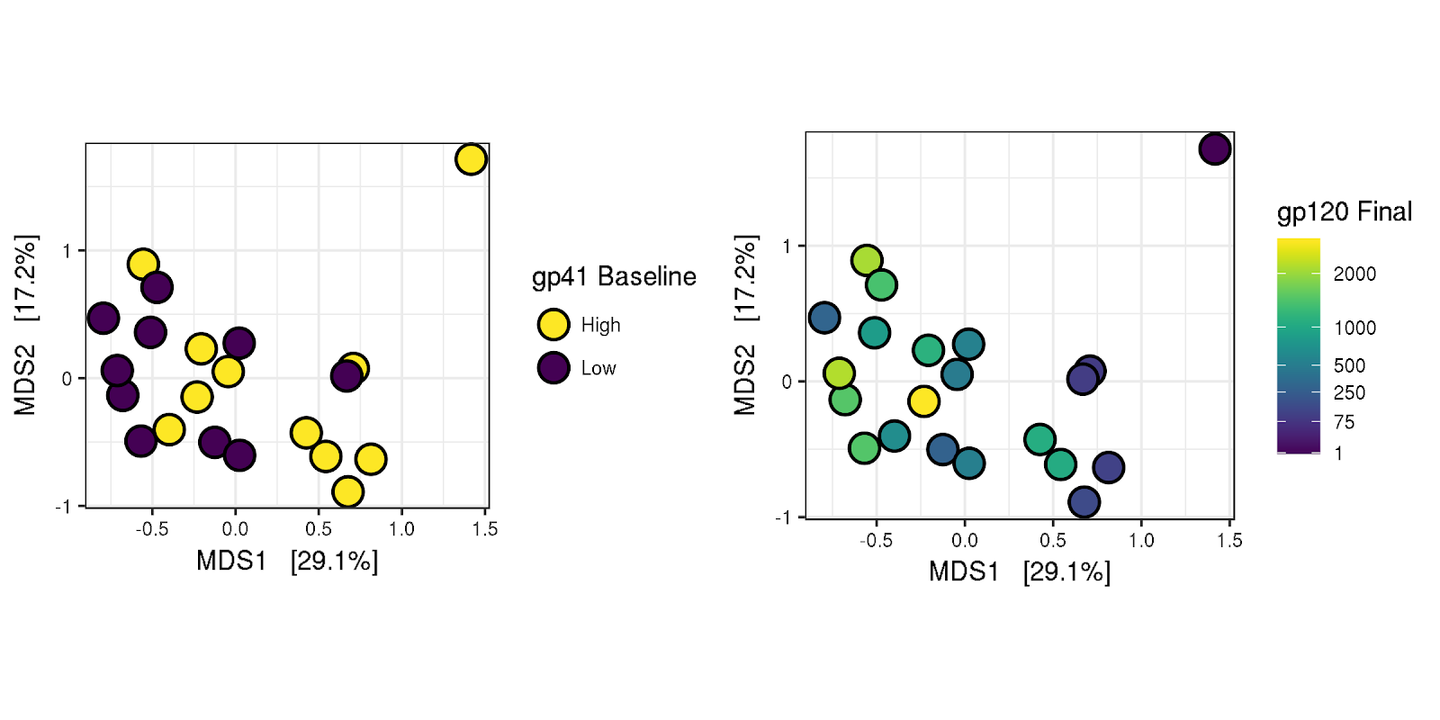

### Figure 2. Principal coordinates analysis of weighted UniFrac distance between participants. The first two weighted UniFrac principal coordinates account for 29.1% and 17.2% of variance between participants. Positions of points in subplots are identical. Points in A are color coded by whether gp41 IgG concentration at day 0 is greater than or equal to (high - yellow) or lower than the median (low - blue). B is color coded by the Con 6 gp120 IgG concentration.

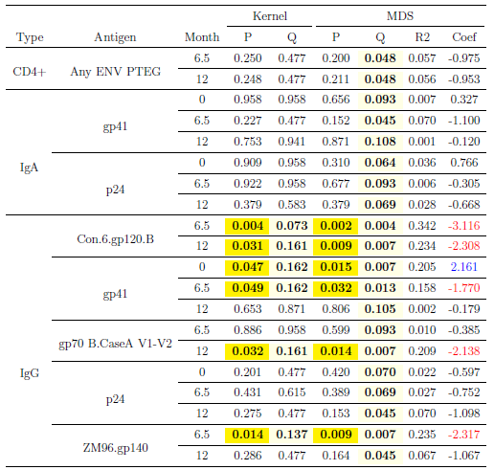

### Table 1. Significance values of kernel regression tests, and coefficients and significance values oflogistic regression models. In all cases, antibody concentrations are treated as binomial, median split variables. Kernel regressions ask whether participants that both have high or low concentrations of the antibody or T cell pool of interest have more similar microbiomes (as measured by weighted UniFrac) than participants with dissimilar concentrations of that variable of interest. Binomial GLMs ask whether the weighted UniFrac axis 1 scores (Figure 1) of the participants are statistically related the the variables of interest. Coefficients tell us of the direction and strength of the association. R22 indicates McFadden’s pseudo R22, p-values are calculated by permutation (Kernel regression) and directly (weighted Unifrac Regression), and q-values are calculated using the bioconductor q-value package (Storey, 2002). Yellow highlighting indicates statistically significant P (<0.05) and Q (<0.20) values. Regression coefficients corresponding to statistically significant p and q-value values are color-coded according to their sign.

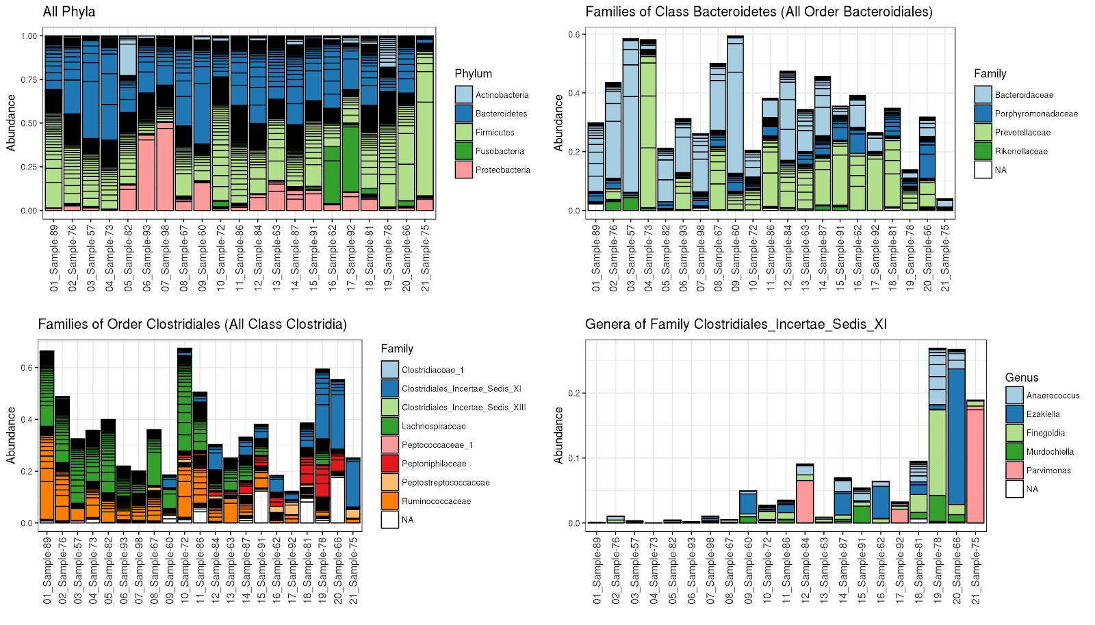

### Figure 3. Stacked bar plots showing relative abundance of taxonomic groups composing participants’ microbiota. In all cases participants are ordered from left to right according to where their microbiota falls along weighted UniFrac, PCoA axis 1 (Figure 2). **A** All taxa at phylum level. **B**. All families within Order Clostridiales, all of which fall within Class Clostridia. **C.** All families within Order Bactereoidales, all of which are in the Class Bacteroidetes. **D**. Genera within the family Clostridiales Incertae Sedis XI.

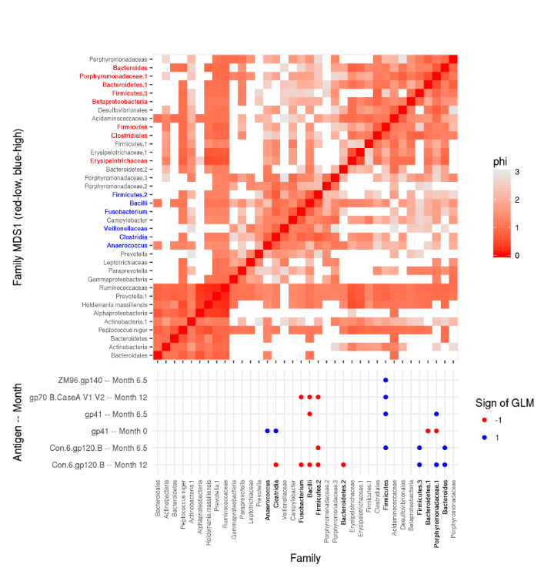

### Figure 4. Heat-map of Φ (Lovell et al. 2015), a measure of proportionality between different family level groups and a summary of which of those families appear to correlate in a statistically meaningful way with gp41 and gp120 response.  In the upper panel (heatmap), each row and column are a family level taxon. Redder cells indicate lower Φ scores, which demonstrate higher statistical association between the pair of families. The dots in the lower panel (dot-grid) indicate IgG binding antibodies specific to each antigen at each time points (y-axis) associate in a statistically significant way with each family level taxon (x-axis). Blue dots indicate that a family level group is positively associated with a particular antibody response at a given time point.

# Supplemental figures and tables and datahttps://lh6.googleusercontent.com/7XPHDLugzlN3FHtBQLc0zQNQ4PEcmYN7ymZscoOM3o02UeY2sC8HMaV-0ugU54yJeyZvsfR3JiNRI_Ugz2DUSmSsKXNc9Wd56wUcsGvMWlnbeI6JZjR6VmHs3hecq0VKmIirb5qY

### Table S1.  Significance values of kernel regression tests, and coefficients and significance values of binomial general linear models. This table mirrors Table 1, with the exception that here, antibody concentrations are treated as continuous, box-cox transformed variables, rather than binomial, median split variables. Kernel regressions ask whether participants that both have high or low concentrations of the antibody or T cell pool of interest have more similar microbiomes (as measured by weighted UniFrac) than participants with dissimilar concentrations of that variable of interest. Binomial GLMs ask whether the weighted UniFrac axis 1 scores (Figure 1) of the participants are statistically related the variables of interest. Coefficients show the strength and direction of the association. R2 inidates McFadden’s pseudo R2, p-values the significance, and q-values are calculated using the bioconductor q-value package (Storey, 2002). Yellow highlighting indicates statistically significant P (<0.05) and Q (<0.20) values. Regressions coefficients corresponding to statistically significant p and q-value values are color-coded according to their sign.

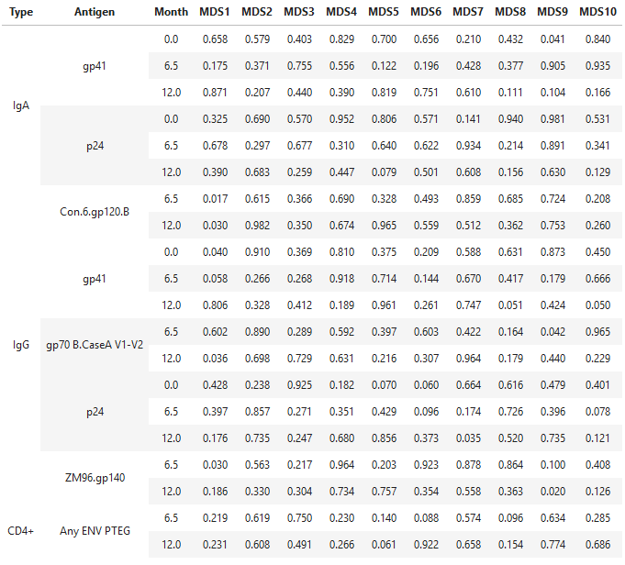

### Table S2. P-values of logistic regressions between UniFrac PCoA components 1-10 and the median split transformed concentrations of the antibodies described in Table 1.

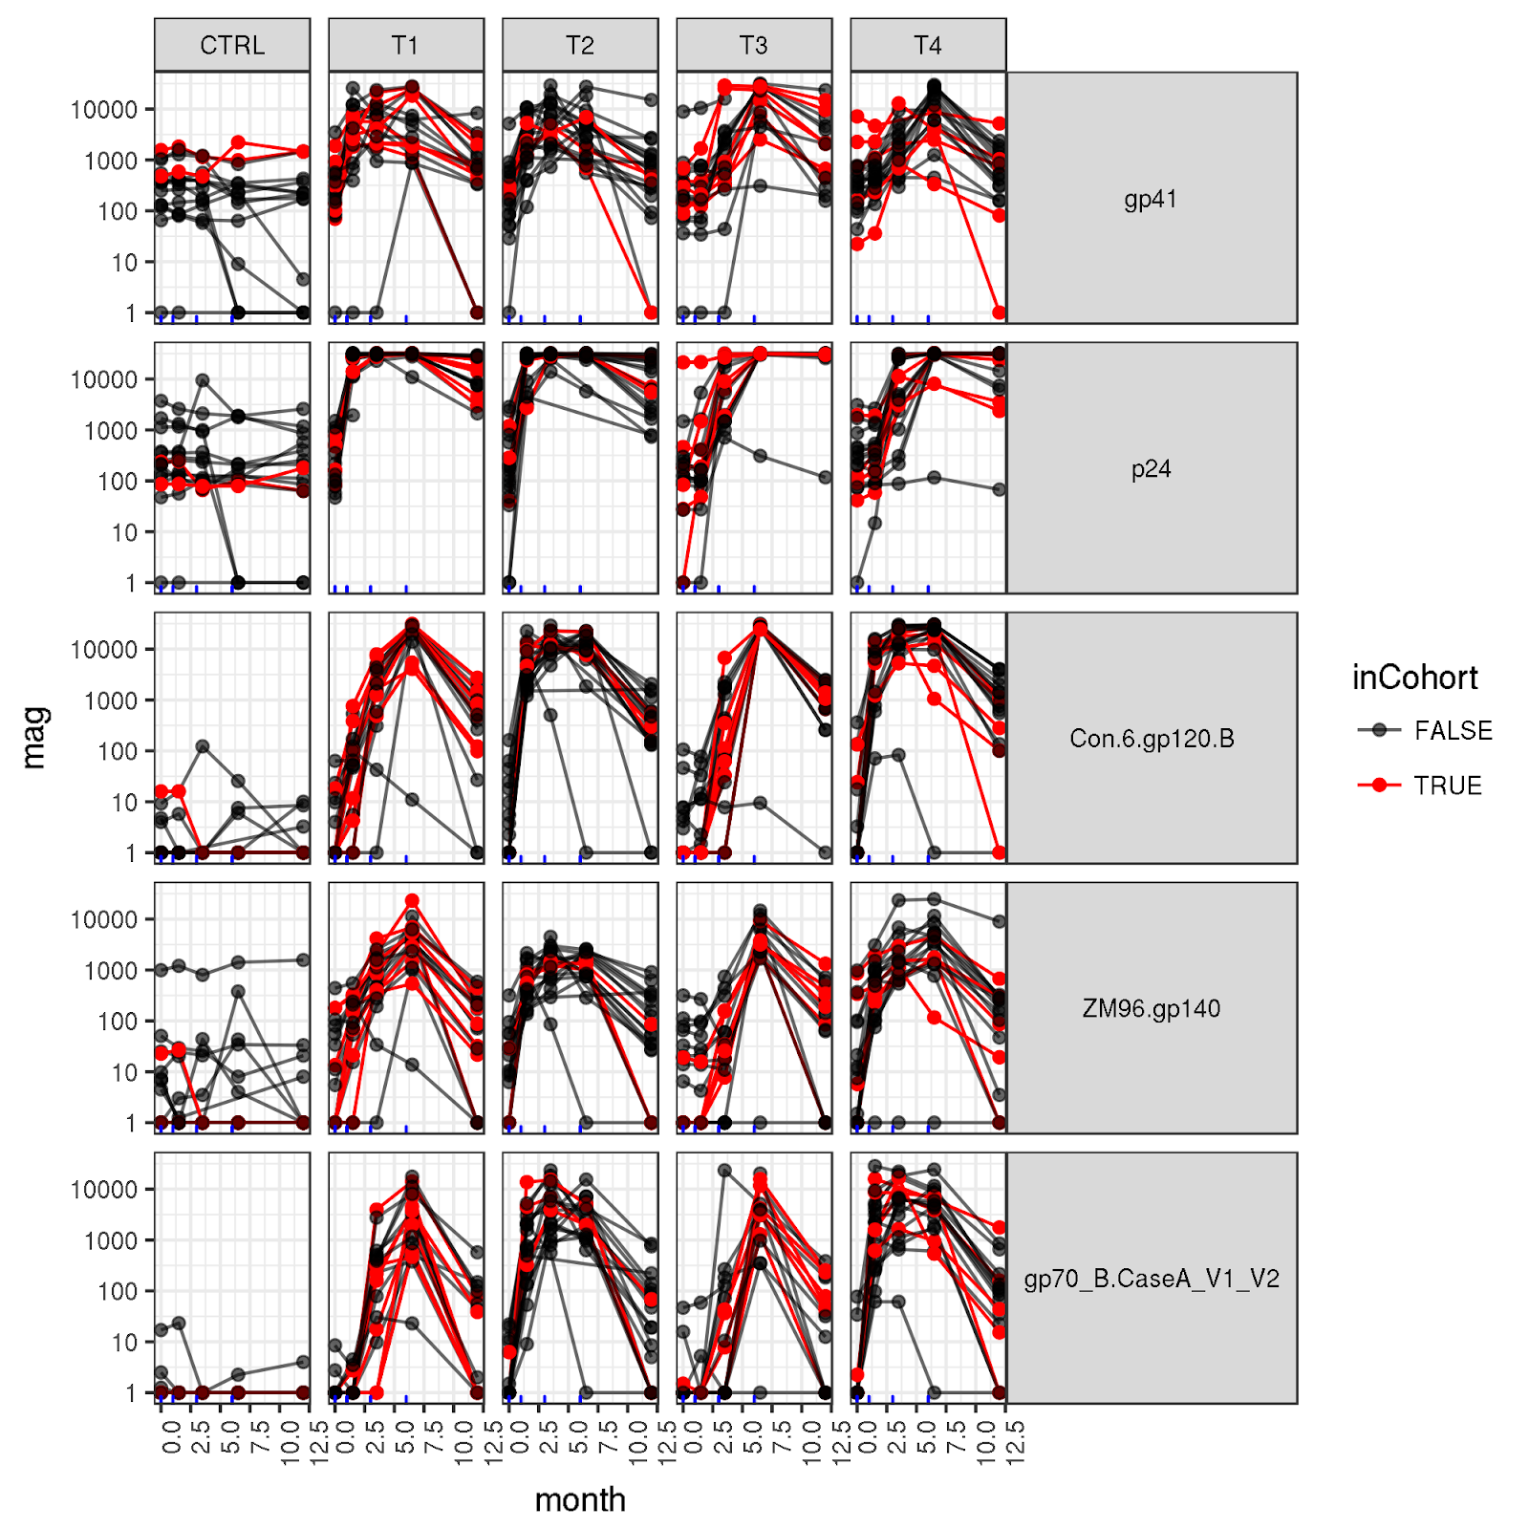

### Figure S1A. Concentration of IgG binding antibodies over time among all study participants, including those without microbiota sequencing. This figure otherwise mirrors Figure 1.

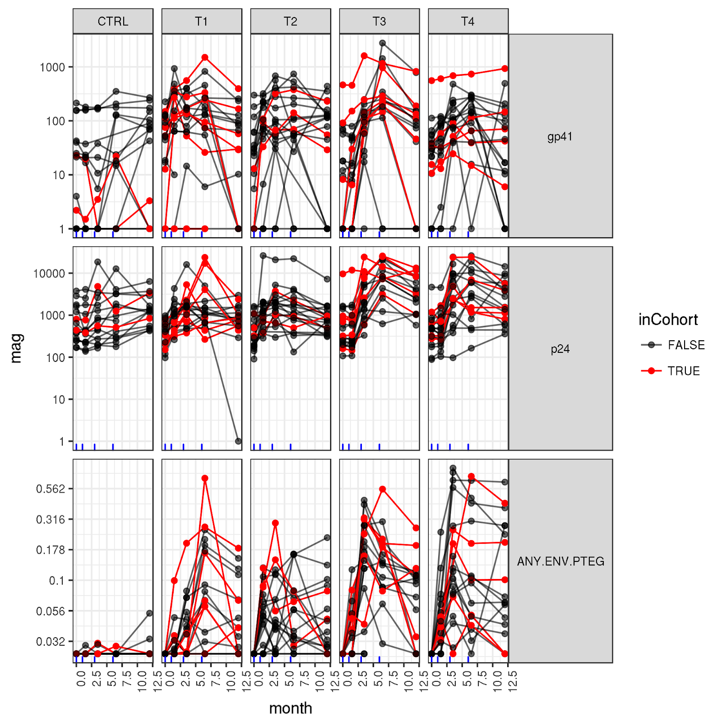

### Figure S1B. Concentration of IgA binding antibodies, and Env specific CD4+ Helper cells for all study participants

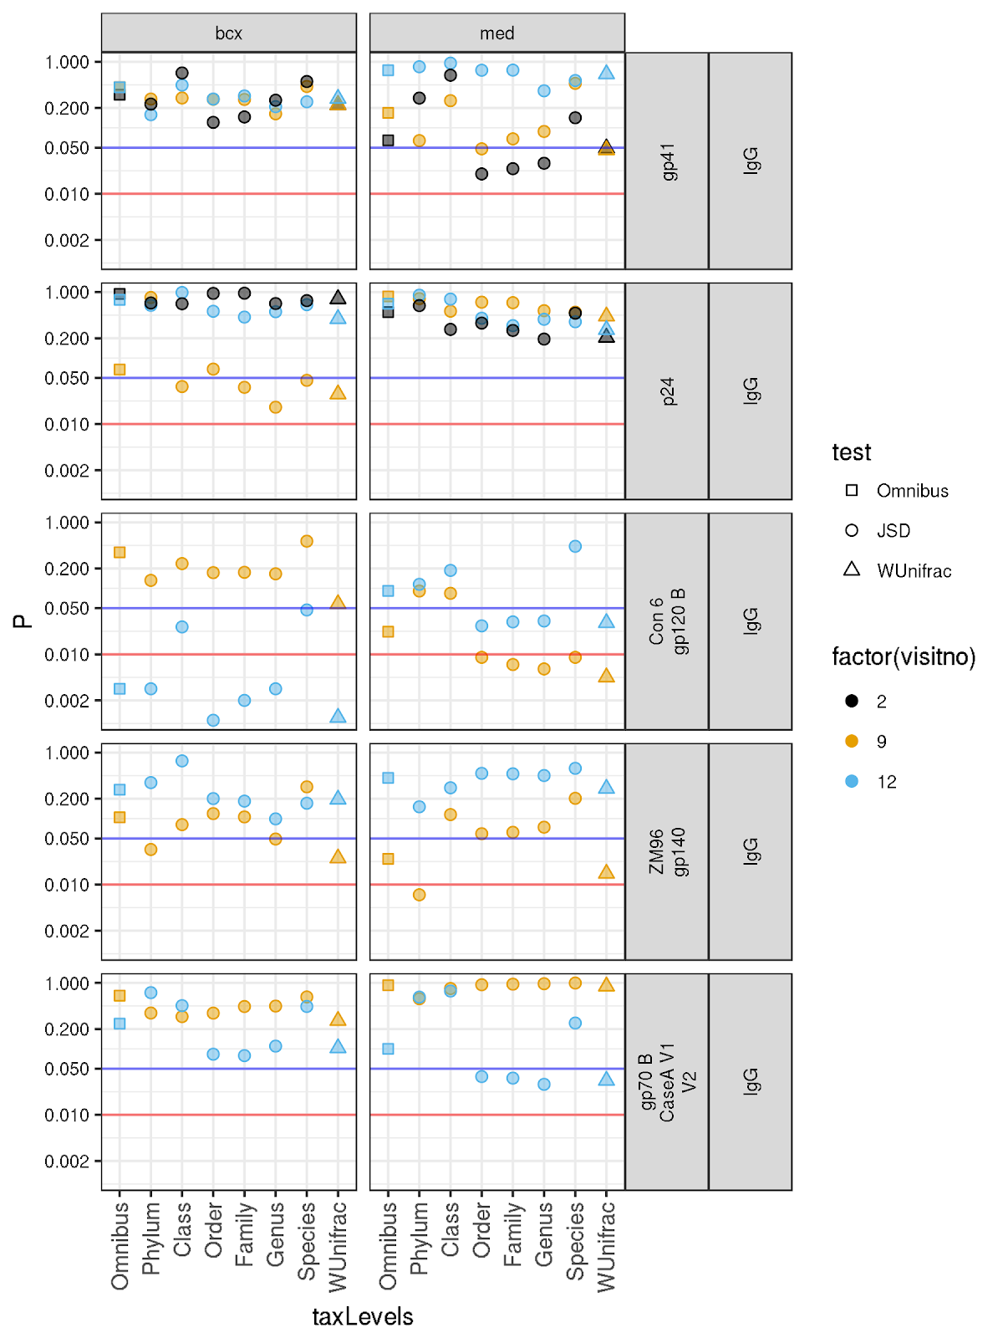

### Figure S2. Kernel regression p-values of using kernels calculated from Jensen-Shannon distance matrices calculated from SV tables that have been agglomerated to different (Phylum through species level) taxonomic levels. Squares indicate omnibus p-values, which indicate whether there is a statistically meaningful hit at any taxonomic level, adjusting for multiple comparisons (Zhao et al., 2015). Triangles indicate kernel regression p-values for weighted UniFrac scores, and are identical to ones reported in Tables 1 and S1.

A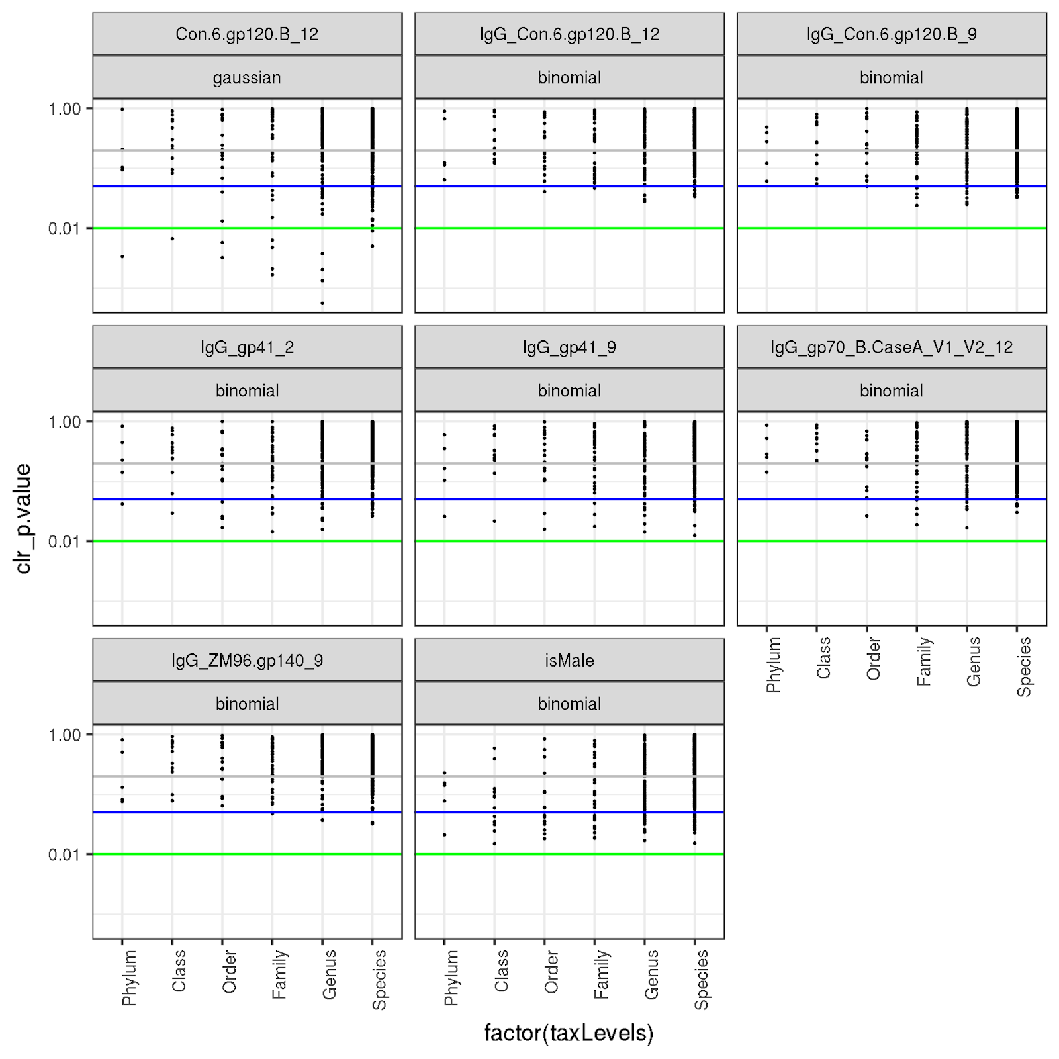

B 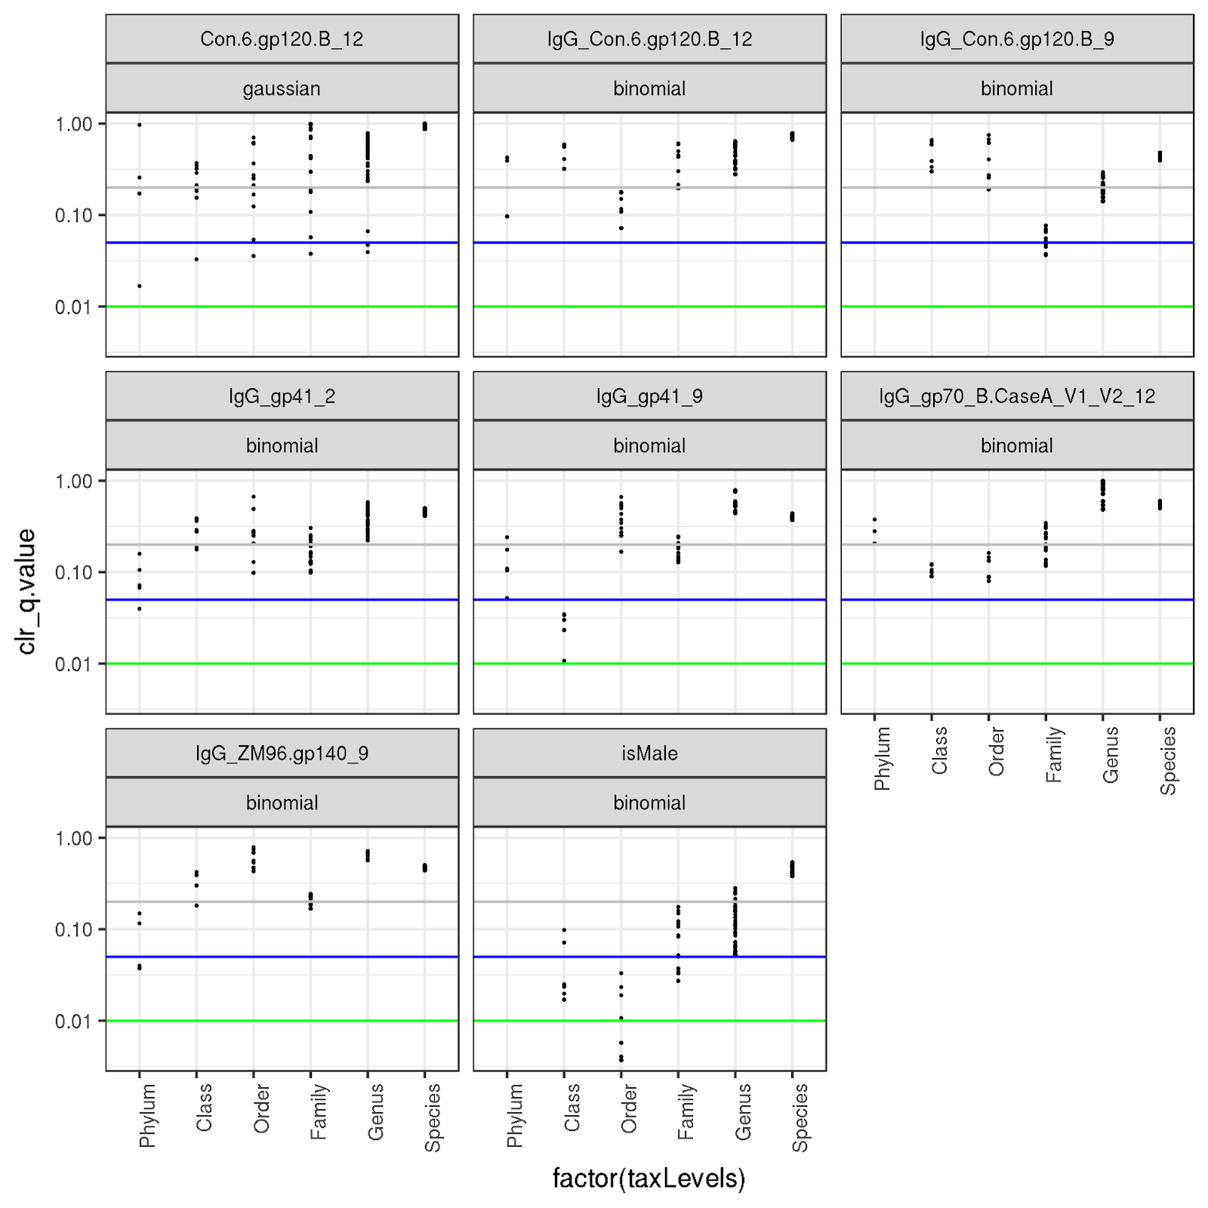

### Figure S3. Statistical significance of regressions of taxa agglomerated at a range of taxonomic levels, against each antibody found to relate to community structure in Tables 1 and S1. We report both **A** p-values and **B** q-values for each. Q-values are calculated from p-values at each antibody-taxonomic level combination.

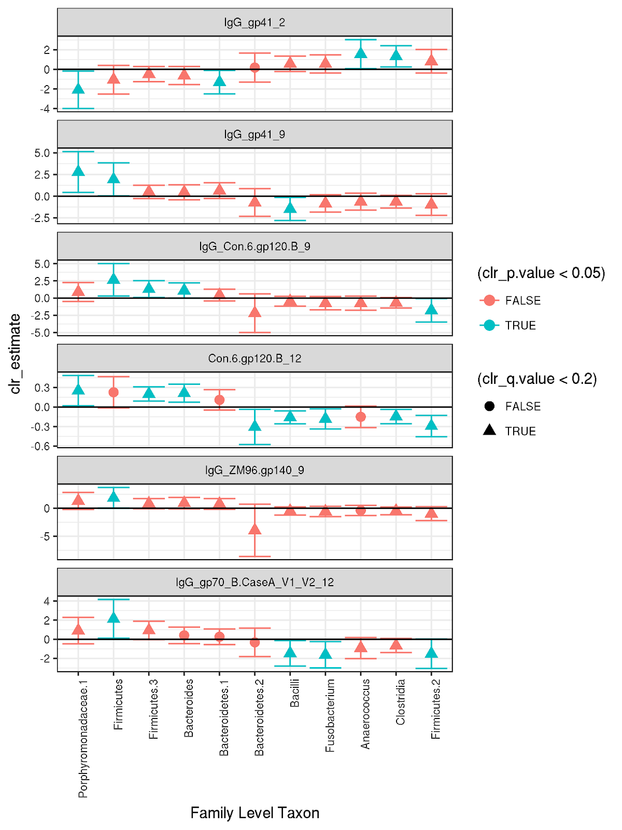

### Figure S4. Coefficients (y-axis) of general linear models relating family level taxa (x-axis) to antibody concentrations for which there was at least one statistically significant hit in Figure S3. Error bars represent two standard errors of the coefficient. Colors and shapes indicate whether models have p-values < 0.05 and q-values < 0.2, respectively. Only taxa involved in at least one statistically significant associations are shown. These same families are indicated with dots in Figure 4 when they are statistically significant.

### Supplementary Data S1. Tables showing counts of agglomerated SVs to different taxonomic levels as described in the supplement.

Supplementary Data S2. Taxonomic information about each agglomerated taxon shown in Table S4. The Kingdom-Species columns indicate consensus taxonomy of those OTUs as per the DADA2 classifier. Sequence indicates the consensus sequence from the DADA2 classifier only if this taxonomic group contains only one sequence. “oldGroups” indicate which species level SVs, as per the species table in this directory are contained in the agglomerated taxon. “tag” indicates the name used for analysis and in the tables indicated in Supplementary Data s1.

{separate file, AllLocalTest.csv}

### Supplemental Data S3. Results of binomial and gaussian regressions of family, genus, and species-level groups against concentrations of antibodies that were found to be statistically significant at time-points in Tables 1 and S1. “taxLevels” indicates the taxonomic level to which the SVs were agglomerated before the analysis was carried out (this level is “Species” if no agglomeration. “ntaxa” indicates the number of agglomerated taxa. Test indicates whether this was a logistic regression in which the immune variable was treated as median split (“binomial”) or a least squares type regression in which box-cox transformed variables were treated as continuous and normally distributed. “antigen” indicates the target of the measured IgG antibody. “Taxon” indicates the consensus name of the agglomerated taxon, as defined in table SX. “Intercept” is the y intercept of the regression. “clr_estimate” is the slope of the regression. The following columns indicate the standard error, p value and q value of that regression. Q values are calculated for each antigen as described in the Supplement. Kingdom-Species columns indicate the shared taxonomy of the members of that taxonomic group.

# Supplemental methods

## Vaccine Details

NYVAC is a combination of two attenuated vaccinia viruses, one NYVAC-HIV-PT1 contained DNA expressing HIV clade C ZM96 gp140 and the other NYVAC-HIV-PT4 contained DNA expressing clade C ZM96 Gag, ZM96 gp120 and a CN54 Pol-Nef fusion construct and two clade C gp120 proteins with MF59 adjuvant (Tartaglia et al., 1992). NYVAC was administered intramuscularly as 1mL, each at a concentration of 5 x 106 PFU/mL, of NYVAC-HIV-PT1 and NYVAC-HIV-PT4.  The trivalent bare DNA plasmid, administered at a volume of 1mL and concentration 4mg/mL, also expressed the clade C ZM96 Gag, ZM96 gp120 and a CN54 Pol-Nef fusion construct. It was developed at the Dale and Betty Bumpers Vaccine Research Center (VRC), National Institute of Allergy and Infectious Diseases (NIAID), National Institutes of Health (NIH) (Bethesda, MD, USA).  AIDSVAXⓇ, is a bivalent gp120 glycoprotein, containing sequences of the MN and A244 HIV-1 strains, currently developed by Global Solutions for Infectious Diseases. It is administered intramuscularly at a volume of 1ml and concentration of 300 mcg/ml along with 600mcg Alum/ml Aluminum hydroxide gel adjuvant.

## Microbial DNA Extraction

Rectal secretion samples were extracted along with the antibody samples from from rectal wecks as described previously (Pantaleo et al. In Prep). Briefly, weck cell sponges rinsed three times with extraction buffer (1X PBS (Invitrogen 10010-023), Protease inhibitor (539131_, and 0.25% bovine syrum albumen (Sigma A8412)) which was removed from the filter after each rinse by centrifugation on a spin-X filter at 16000 x g.  We used the MoBio Bacteremia kit to extract DNA from the rinse solution.

## Processing of sequence data

Microbial 16S V3-V4 amplicon data were processed and analyzed using a series of BASH scripts and python jupyter notebooks containing R code that are publicly available at (https://github.com/cramjaco/Nyvac_096_Microbiome). Briefly, samples were demultiplexed and barcodes and primers removed in QIIME1. Sequence variant (SV) assignment was carried out using an adaptation of the DADA2 pipeline for 454 data (<https://benjjneb.github.io/dada2/faq.html#can-i-use-dada2-with-my-454-or-ion-torrent-data>, see Supplemental methods). SVs were named with DADA2’s taxonomic identification functions and a phylogenetic tree of SVs from within all samples was generated in the R environment (v. 3.4.1) using the *phangorn* package (Schliep et al. 2011). For the purposes of this analysis, we removed 31 SVs that were unidentified to the Phylum level, 7 SVs from phyla that were found in the data set fewer than 20 times each (Verrumicrobia, Tenericutes, Elusimicrobia and Synergistetes), and 386 SVs that were present in fewer than 10% of the samples.

To test the association of microbial subpopulations with immunogenicity and vaccine response, we clustered the 16S SVs at multiple levels of phylogenetic relatedness. Because of the inconsistencies observed with taxonomic classification algorithms (Golob et al. 2017), we avoided a taxonomic approach to phylogenetic clustering, instead using the phylogenetic diversity based on multiple sequence alignment of the complete set of SVs in this study. We created a set of clusters with the goal of approximating the degree of granularity that would be achieved by clustering at the commonly accepted phylogenetic levels (e.g. Phylum, Class), while allowing our groups to be independent of any taxonomic classification algorithm.

Operationally, phylogenetic clustering was performed by (1) identifying the number of unique taxa that were predicted to be present at each taxonomic level (e.g. Phylum, Class) according to DADA2’s implementation of RDP’s naive Baysean classifier (Wang et al., 2007), (2) performing agglomerative clustering on the phylogenetic tree of SV sequences to create the number of groups identified at each of those taxonomic levels, and (3) naming the resulting phylogenetic groups according to the highest taxonomic level shared by SVs within that group.

## Global - Kernel Regression Tests

In two versions of this analysis, immunological variables were “median-split” and treated as a binary variable, and secondarily box-cox transformed.This same kernel regression method was to compare Jensen-Shannon divergence to each of the BAMA measurements. To perform this analysis, Jensen-Shannon distance matrix was derived from community structure data that had been agglomerated to each taxonomic level (Supplement Section 7.3).  MiRKAT was then provided a list of kernels, each one representing distance matrices from communities aggregated to different levels. Then for each variable of interest, MiRKAT calculated kernel regression p-values for each level of taxonomic agglomeration. For the of Jensen-Shannon kernel regression tests of different taxonomic agglomerations, MiRKAT calculated an omnibus P-value, which determines whether a family of related tests shows significance overall. This omnibus P-value essentially tells one whether any of the tests show significance, while adjusting for multiple comparisons. In the Principal Coordinate regression approach, MDS1, the major component of weighted UniFrac variability, accounted we performed logistic regression of MDS1 against both the median split transformed values (respectively) each IgG and IgA. As a secondary analysis, we performed linear regression of MDS1 against the box-cox transformed measurements.

## Local Regression Tests

For each immunologic variable that was found to be statistically significant under the global test, we performed (at each agglomeration level) logistic regression of each taxon’s centered log-ratio (clr) transformed relative abundance against median split immunological measurements. Multiplicity adjustment to control the false-discovery rate (FDR) was performed using the Q-value statistic (Storey et al. 2002) across all taxa for each immune variable at each level of agglomeration. We identified which taxonomic agglomeration level - immunologic variable combinations were associated with some Q < 0.2.

## Statistical associations between Family level groups, and between Families and Immune variables:

Because the local tests identified that family level groups had more statistically significant interactions than groups at other levels (see Results section 4.5), subsequent analysis focused on family level patterns. We report which family level taxa are associated, via binomial regression with each immunologic variable that relates to community structure via the global kernel regression tests. Gp120 binding IgG; which associated more strongly with community structure when it was treated as a discrete (Table 1), rather than a continuous (Table S1)variable; was also treated as a continuous variable, box-cox transformed, and linearly regressed against species abundances.

To understand how these local associations related to microbial community structure patterns, we investigated whether those taxa that were associated with immunological variable abundance were also associated with each other. The proportionality method (Lovel et al. 2015), was used to test for statistical associations between family level groups, while accounting for compositionality of the groups. We examined whether these co-occurring families were systematically related to relationships between the taxa and immune measurements.

# References

[STUB]

Schliep K.P. 2011. phangorn: phylogenetic analysis in R. Bioinformatics, 27(4) 592-593