Supporting Information for

Slow particle remineralization, rather than suppressed disaggregation, drives efficient flux transfer through the Eastern Tropical North Pacific Oxygen Deficient Zone

Jacob A. Cram1, Clara A. Fuchsman1, Megan E. Duffy2, Jessica L. Pretty3, Rachel M. Lekanoff3, Jacquelyn A Neibauer2, Shirley W. Leung2, Klaus B. Huebert1, Thomas S. Weber4, Daniele Bianchi5, Natalya Evans6, Allan H. Devol2, Richard G. Keil2, Andrew M.P. McDonnell3

1Horn Point Laboratory, University of Maryland Center for Environmental Science, Cambridge, MD, USA.

2School of Oceanography, University of Washington Seattle, Seattle, WA, USA.

3College of Fisheries and Ocean Sciences, University of Alaska Fairbanks, Fairbanks, AK, USA.

4School of Arts and Sciences, University of Rochester, Rochester, NY, USA.

5Department of Atmospheric and Oceanic Sciences, University of California Los Angeles, Los Angeles, CA, USA.

6Department of Biological Sciences, University of Southern California, Los Angeles, CA, USA.

Contents of this file

Figures S1 to S12

Caption for Text S1

Additional Supporting Information (Files uploaded separately)

Text S1

Introduction

This file contains supplemental figures referenced in the manuscript. It also contains a caption for a .PDF file containing mathematical equations underpinning the particle remineralization model used.

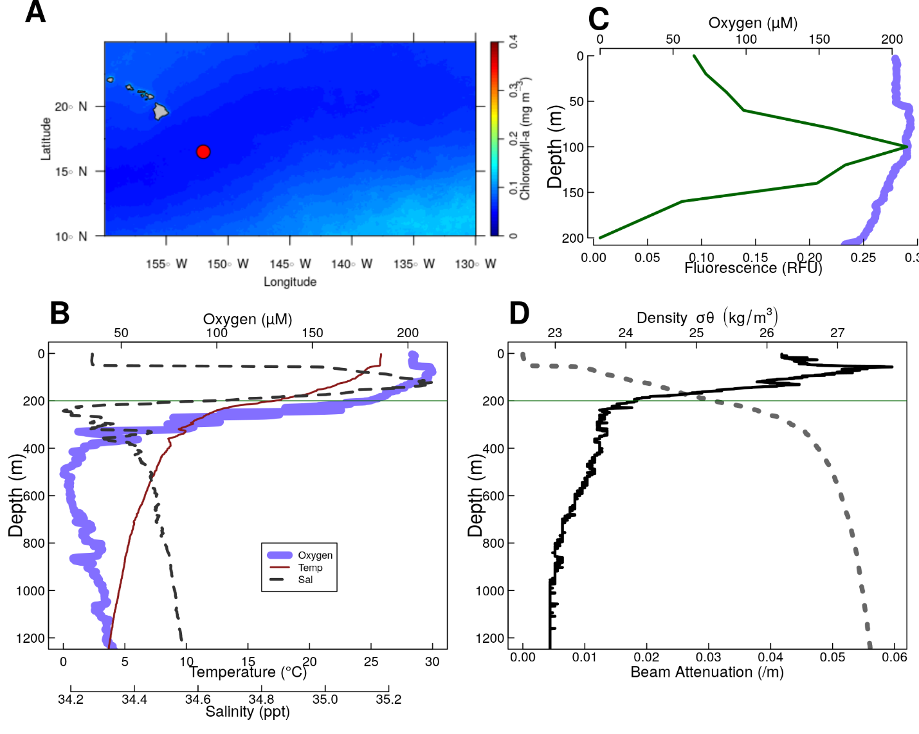

Figure S1. Physical and chemical data from P16 Station 100. Located at 16.5°N 152.0°W. (A) Map of the nearby tropical pacific station P16 Station 100. Colors indicate chlorophyll concentrations at the surface, averaged over all MODIS images. The red circle indicates the location of P16 Station 100. (B-D) Oceanographic parameters. The thin horizontal green line shows the location of the base of the photic zone (200 m). (B) Oxygen temperature and salinity. (C) Oxygen, and fluorescence. Because the fluorometer was broken on this cruise, fluorescence data were pulled from world ocean atlas (Garcia et al. 2014). (D) Beam attenuation and density, calculated from the salinity temperature and pressure data.

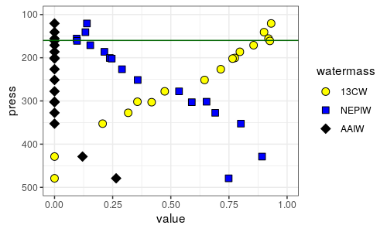

Figure S2. Water mass analysis at ETNP Station P2 indicates the relative contributions proportions of the three primary water masses at this site, water (13CW), North Equatorial Pacific Intermediate Water (NEPIW) and Antarctic Intermediate Water (AAIW). Values indicate relative contributions of each water mass and are scaled so as to sum to one. The horizontal green line indicates the base of the photic zone (160m). Data are taken directly from Evans et al. (2020).

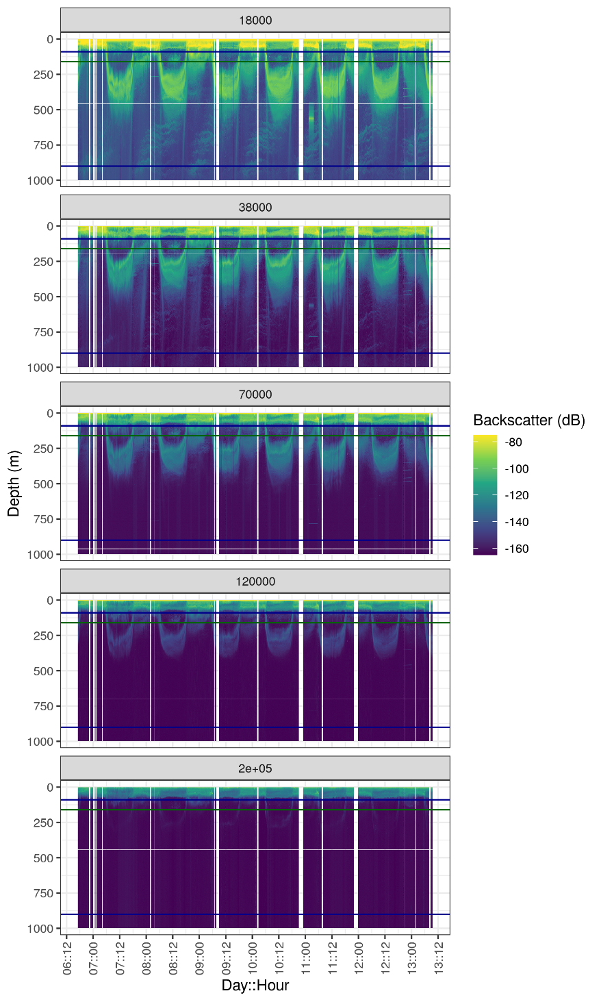

Figure S3. Acoustic data, measured by EK60, measured over the course of the experiment, at ETNP Station P2. Shown are data from all frequency bands. Values are in return signal intensity and have not been normalized to observed biomass. Horizontal blue lines indicate the top and bottom of the ODZ, while the horizontal green line indicates the base of the photic zone.

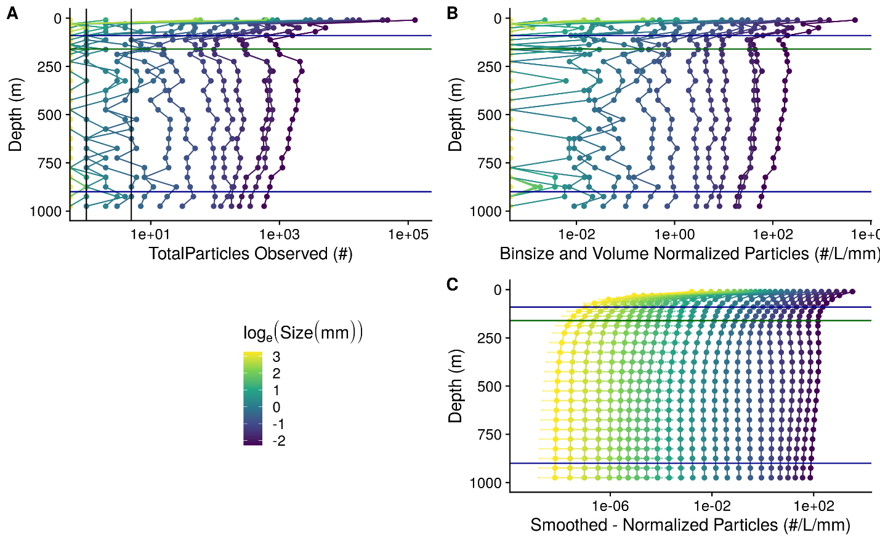

Figure S4. A profile of particle abundances at different sizes and depths, collected on January 13 beginning at 06:13 at ETNP Station P2. Horizontal blue lines indicate the top and bottom of the ODZ, while the horizontal green line indicates the base of the photic zone. (A) Numbers of observed particles. As the x axis is log transformed, zeros are indicated as points along the Y axis. Vertical black lines indicate 1 and 5 observed particles, respectively. (B) Particle numbers normalized to volume sampled and particle size bin width. (C) Smoothed and extrapolated particle abundances, based on a negative binomial GAM that predicts particle abundance form size and depth.

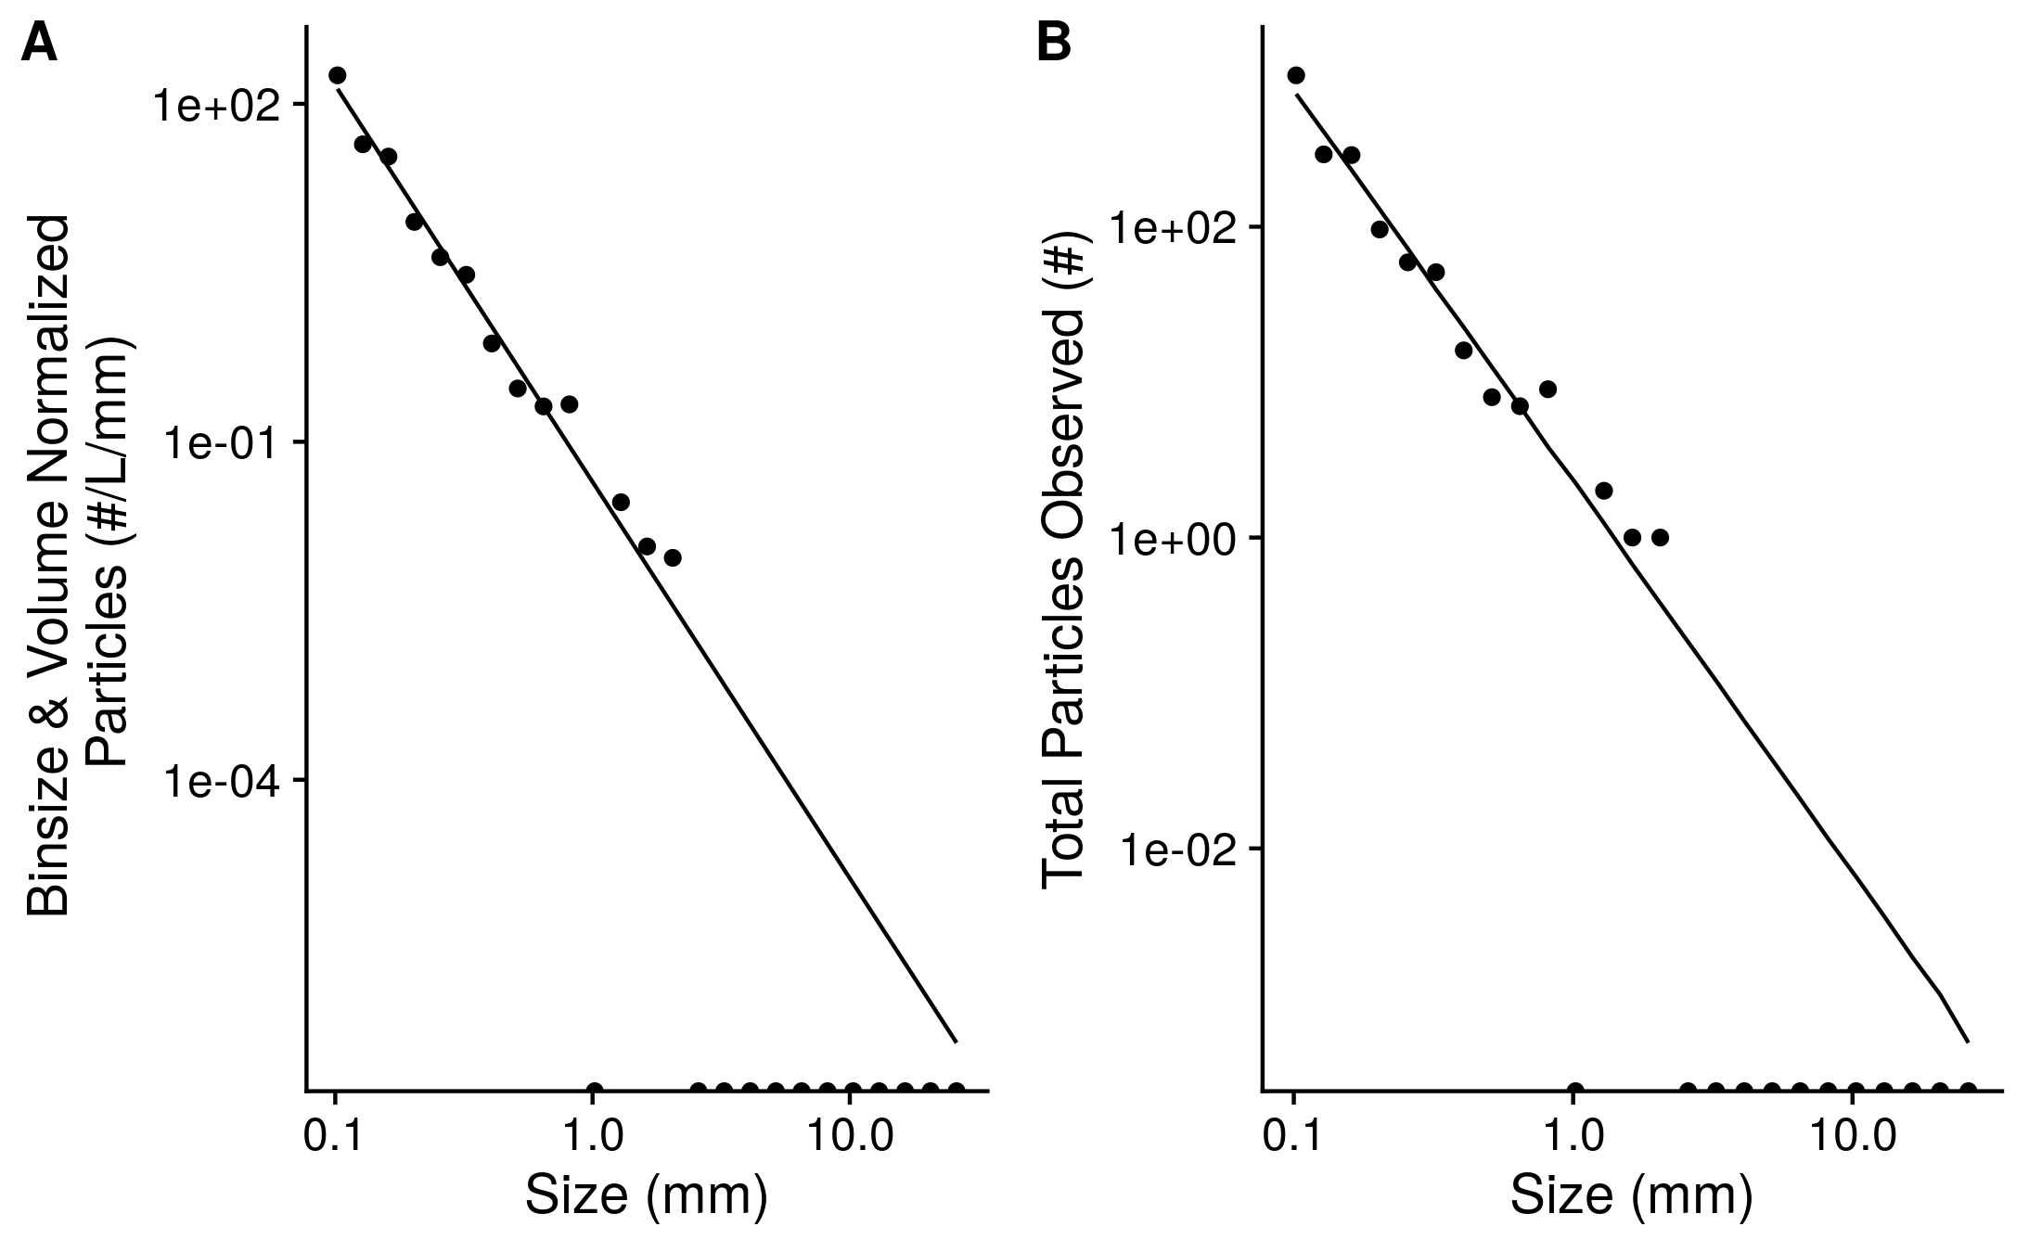

Figure S5. An example of observed particle size distribution spectra. These are depth binned data from between 150 and 175 m deep in the water column from the cast that occurred at *2017-01-13 17:51* local time at ETNP Station P2. This depth bin contains total numbers of particles that were seen across 206.8 L of merged UVP image volume. Points indicate (A) total numbers of observed particles and (B) particle numbers normalized to volume sampled and particle size bin width. Half-dots along the x axis correspond to particle size bins in which zero particles were observed. The line indicates the predicted best fit line of the data. The line was fit on the binsize and volume normalized data by a negative-binomial general linear model. The line in panel A indicates predictions from this same model, re-scaled into absolute particle space.

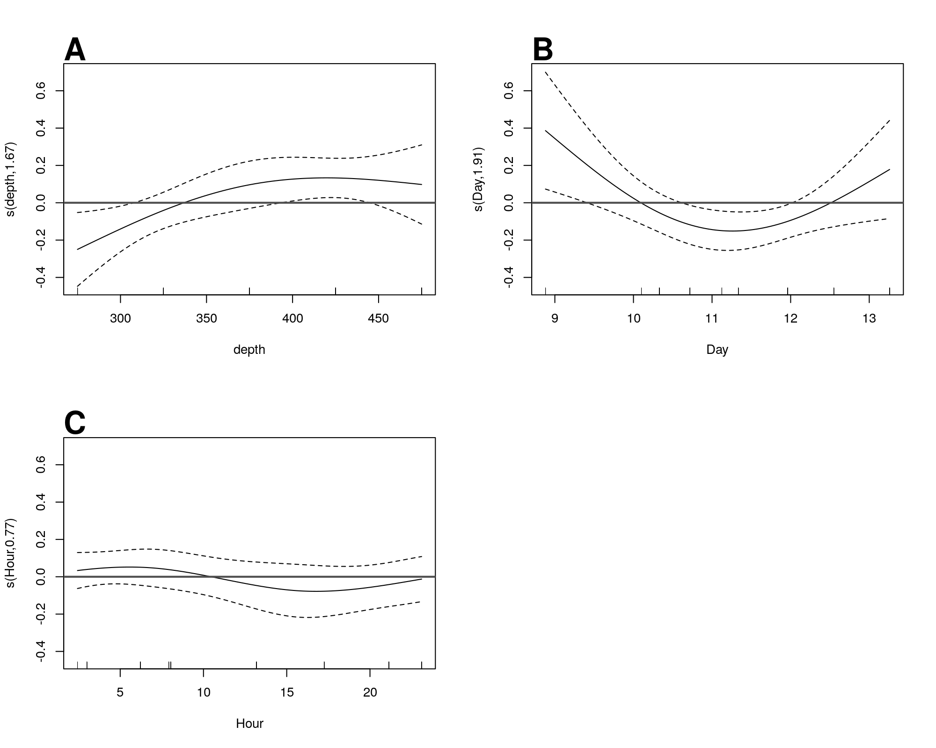

Figure S6. GAM predicted effects of A Depth, B Day of the month in January 2017, and C hour of the day on the fifth-root transformed, depth normalized, rate of change of flux at ETNP Station P2. Y axis indicates the value of the component smooth functions effect on Flux. Positive values associate with times and regions of the water column where flux is increasing, holding other factors constant, and negative ones where it is decreasing. Horizontal gray line indicates y = 0, corresponding to that parameter having zero effect, positive or on the outcome. Only Depth has a statistically significant relationship to rate of change of flux (see section 6.5).

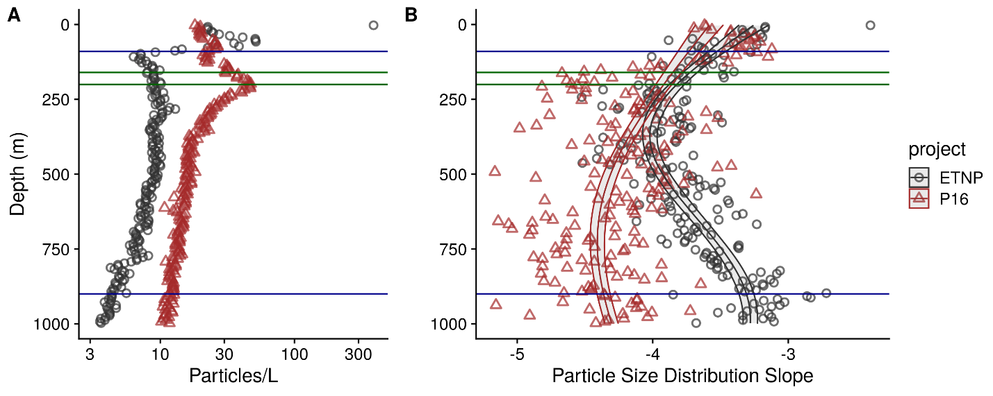 Figure S7. As above, but for the final cast taken at ETNP station P2 and the only cast collected from the P16 transect at Station 100. P16 Station 100 was chosen because it is at a similar latitude to ETNP station P2. (A) Total particle numbers, (B) Particle size distribution. Horizontal blue lines indicate the top and bottom of the ODZ at the ETNP station, while the horizontal green lines indicate the bases of the photic zone at ETNP Station P2 (160m) and P16 Station 100 (200m).

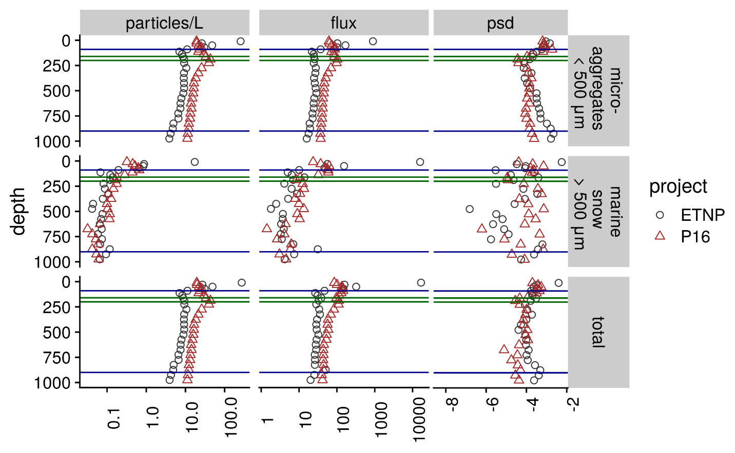 Figure S8. Depth binned particle number (volume normalized), particle size slope (PSD), and flux (estimated as in Fig. 4) for microaggregates (), marine snow () and total particles, at the oxic (P16 Station 100) and anoxic site (ETNP Station P2). Within each panel, horizontal blue lines indicate the top and bottom of the ODZ at the ETNP station, while the horizontal green lines indicate the bases of the photic zone at ETNP Station P2 (160m) and P16 Station 100 (200m).

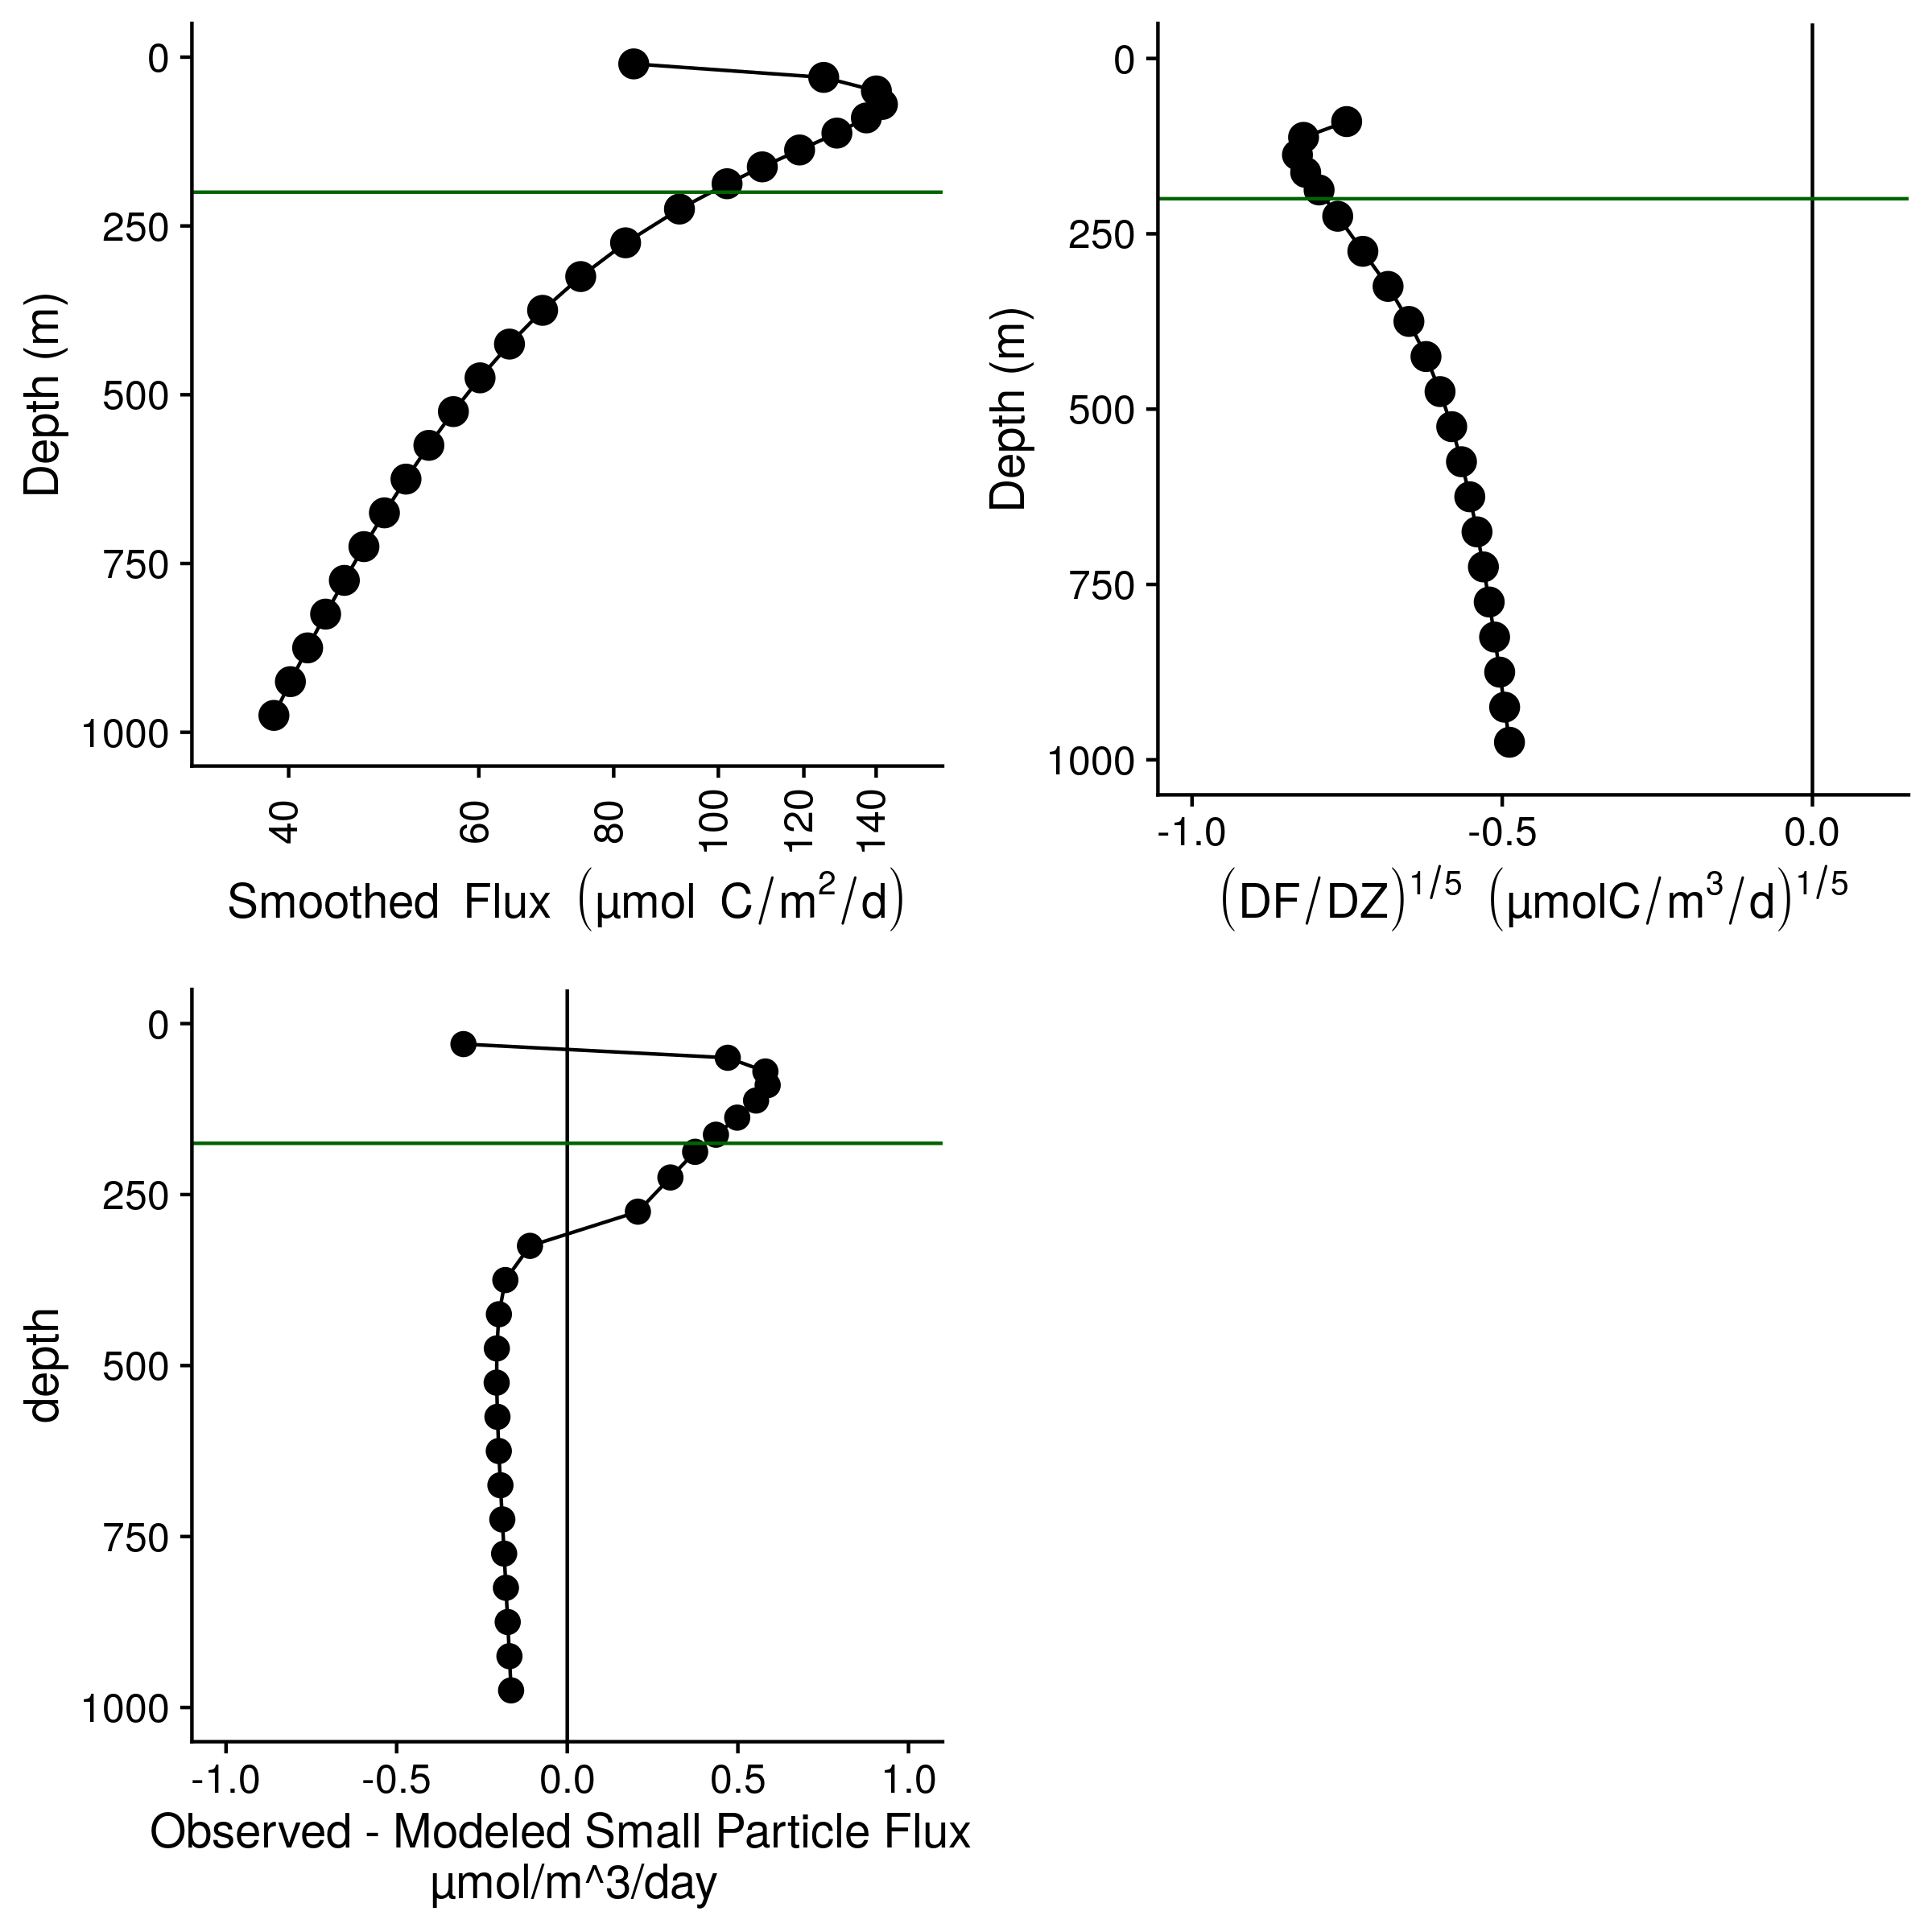 Figure S9. Flux profiles and flux attenuation at P16 Station 100. (A) Flux profile (B) Fifth-root transformed depth normalized rate of flux decrease. (C) Difference between observed and modeled results. Higher values suggest more disaggregation-like processes. The horizontal green line at 200 m indicates the base of the DCM as estimated by World Ocean Atlas data for this site.

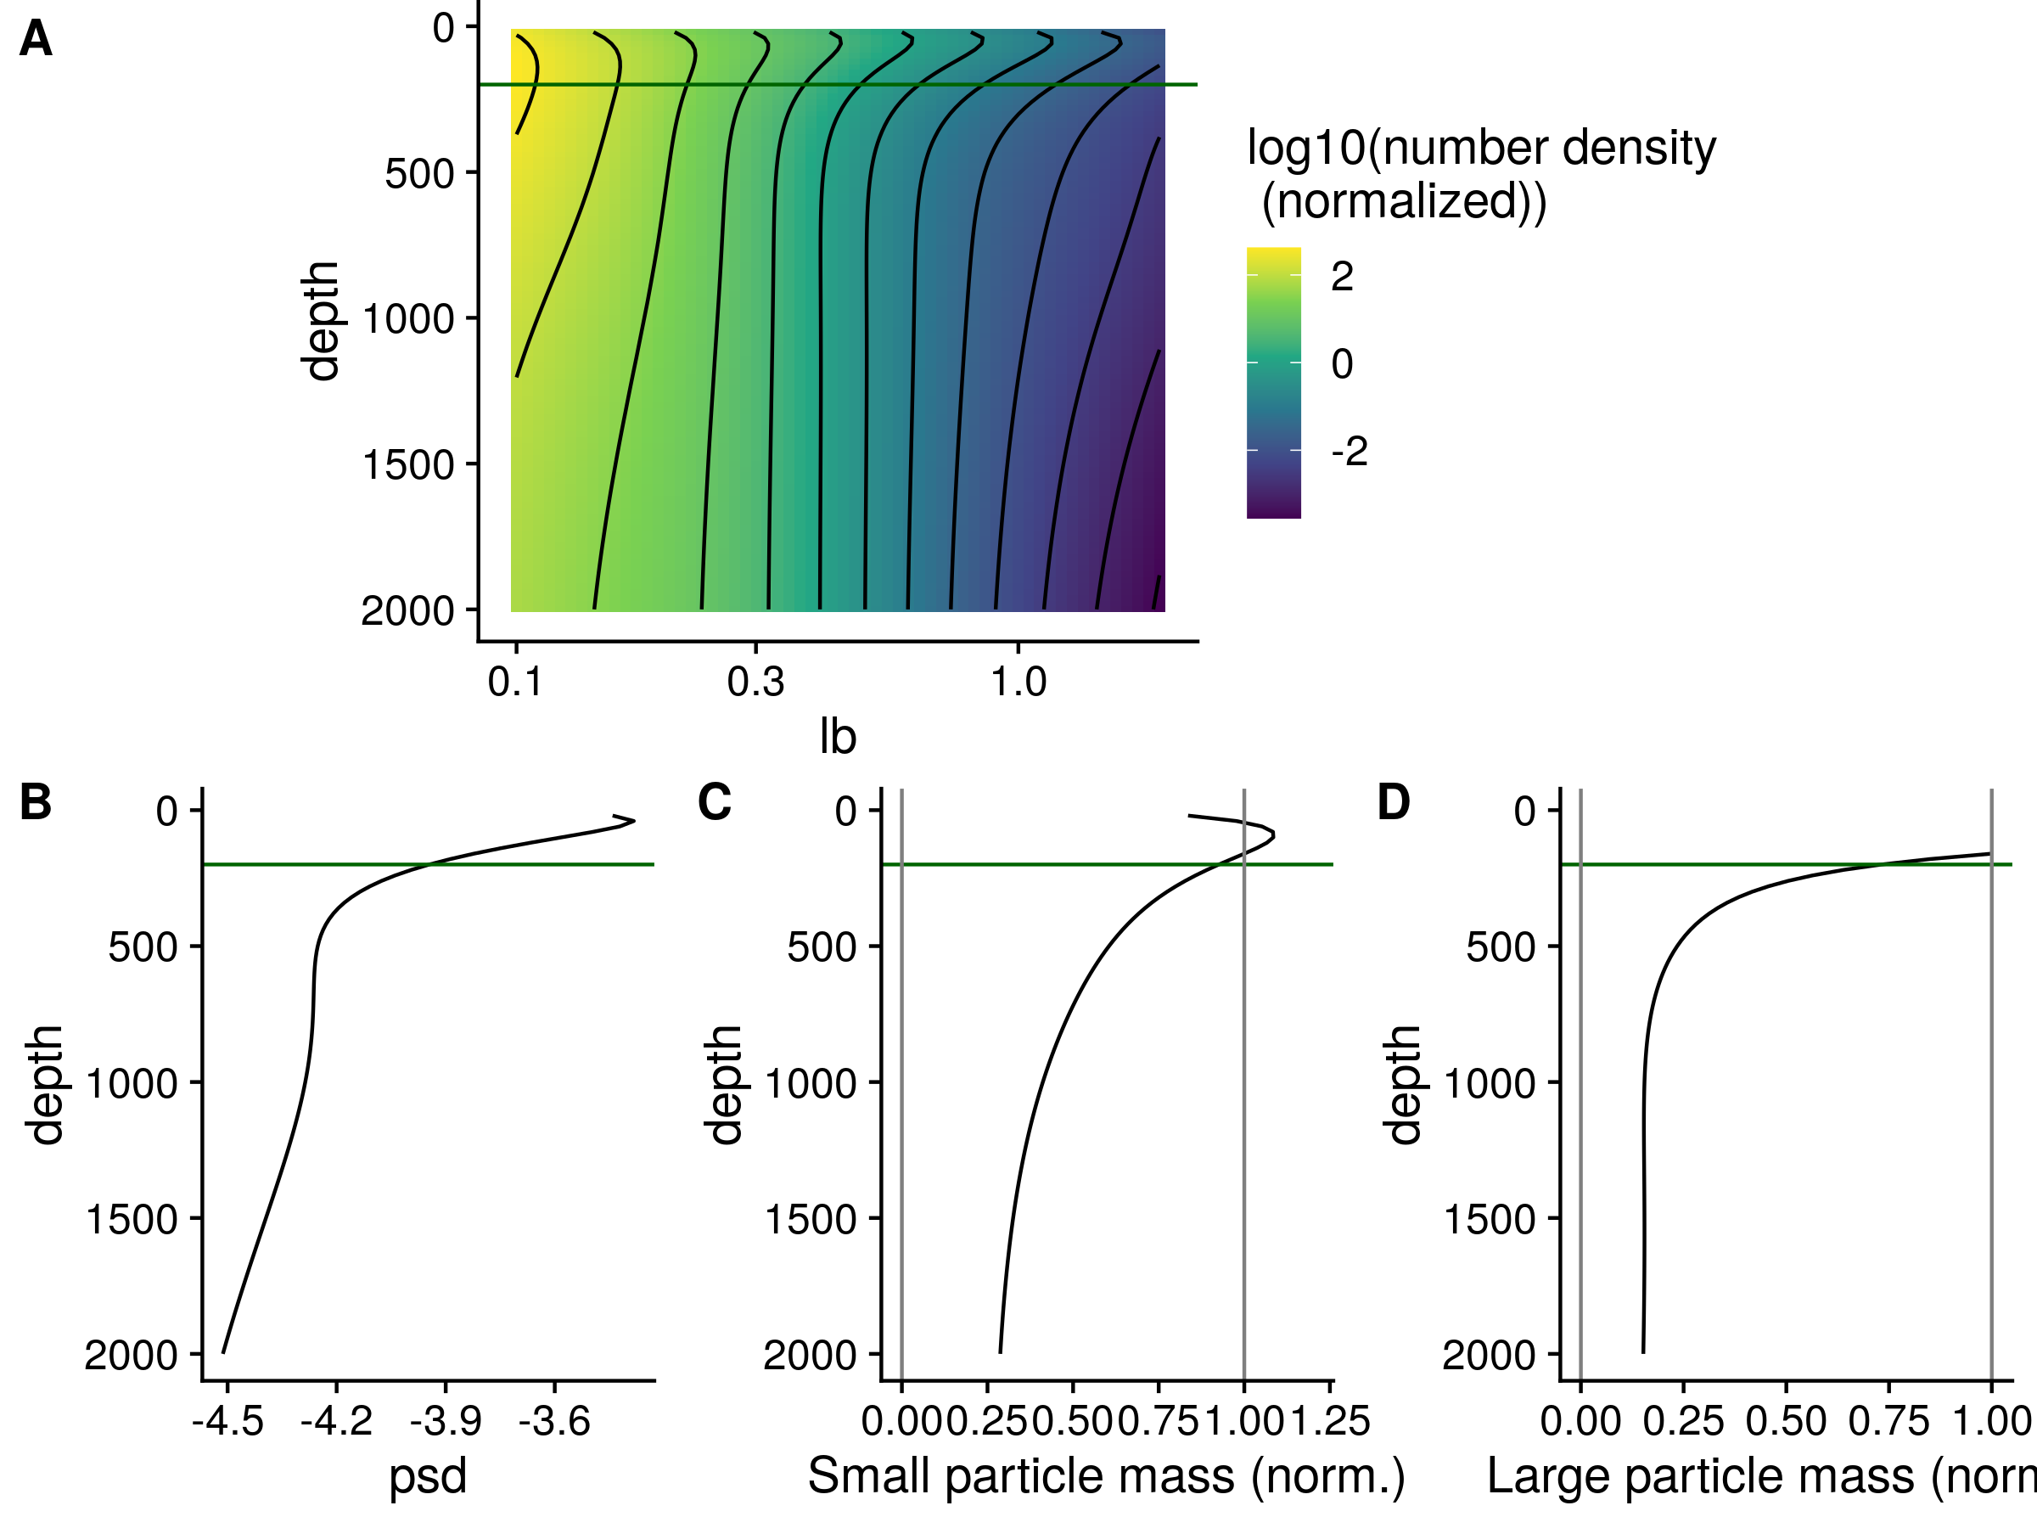 Figure S10. The same profiles as shown in Figure 5, but for the oxic site P16 Station 100. (A) GAM smoothed bin-size and volume particle numbers at each particle size class. (B) Particle size distributions. And estimated biomass of (C) Small and (D) Large particles. The horizontal green line at 200 m indicates the base of the DCM as estimated by World Ocean Atlas data for this site.

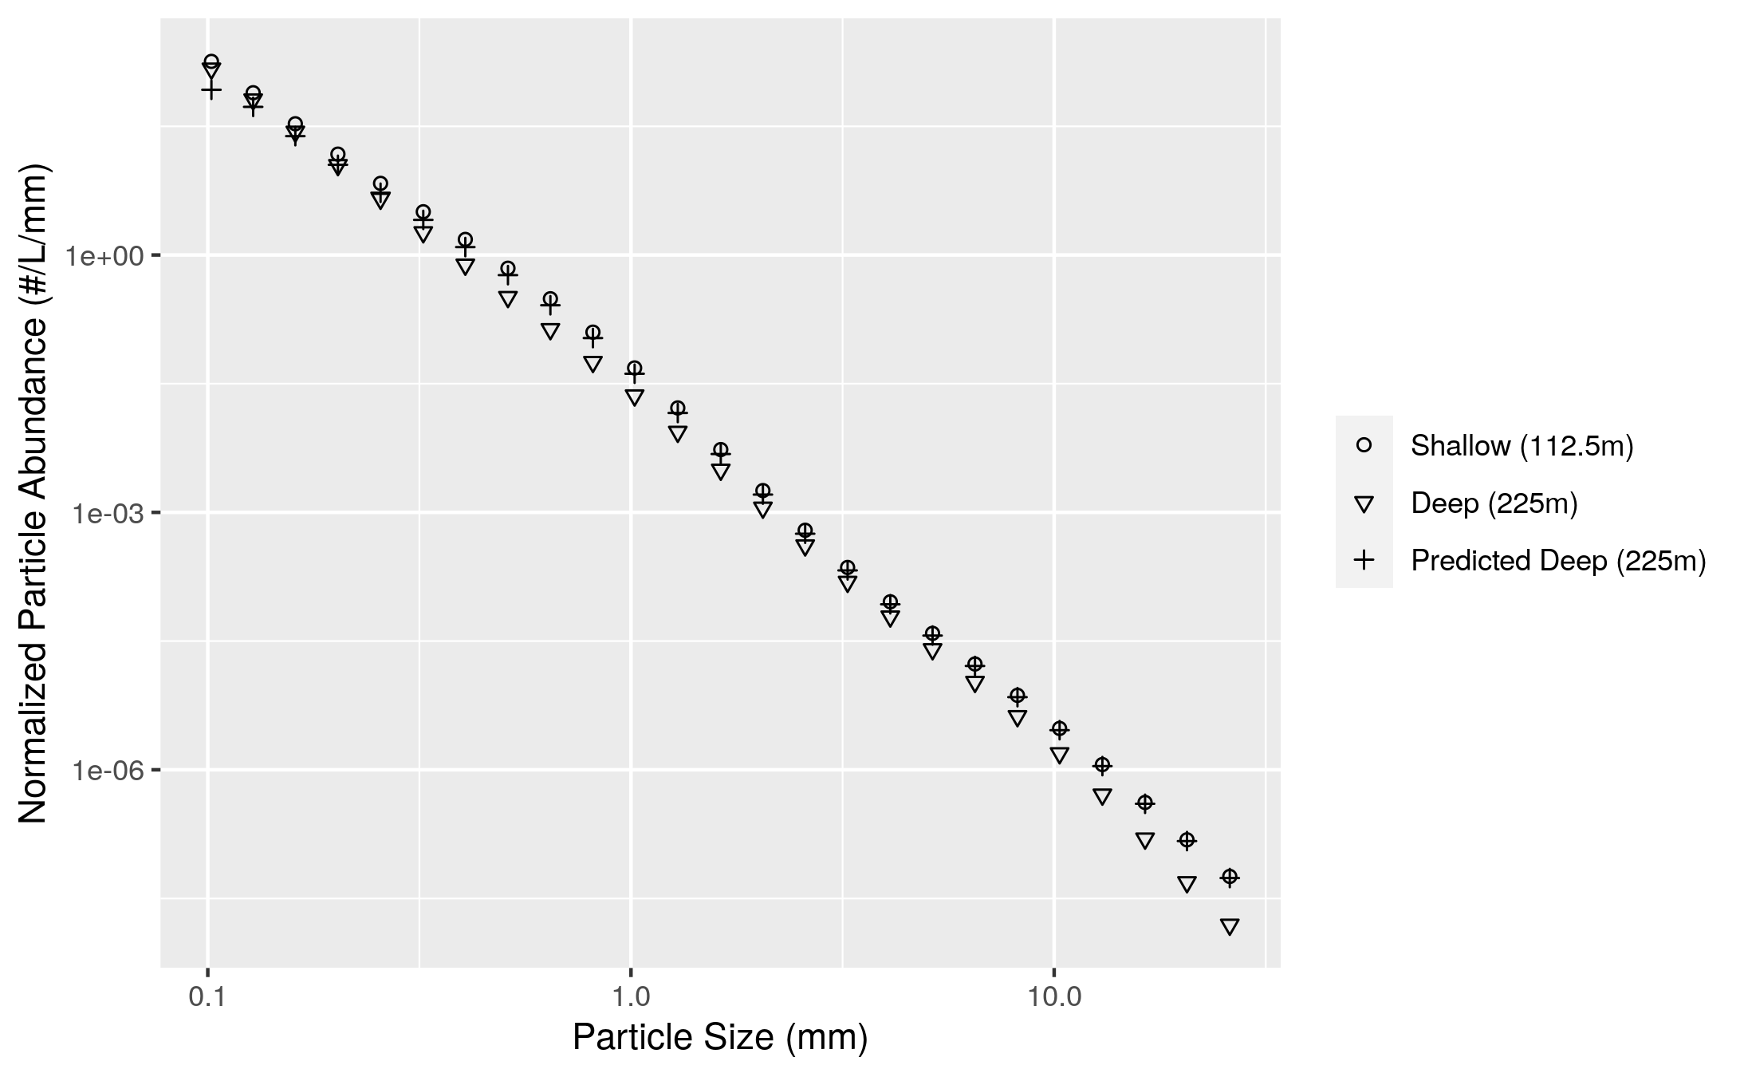

Figure S11. An example of differences between modeled and observed particle slope. The particle size distribution at a shallow and a deeper depth, from ETNP Station P2, are shown. The model generates a prediction of the deep depth profile from the shallow depth profile and the flux attenuation between the two profiles. The model predicts more attenuation of the smallest particles than is actually observed. In practice the model compares depths that are closer together than the two shown here. In particular, the depth bin above 225m in our analysis has a midpoint of 187.5m, but we choose in this example to compare the 225m particle size profile to the profile at 112.5 m. Two depths that are far apart are shown so that the flux attenuation is large enough to be seen by eye and to provide a conceptual example of the models’ function.

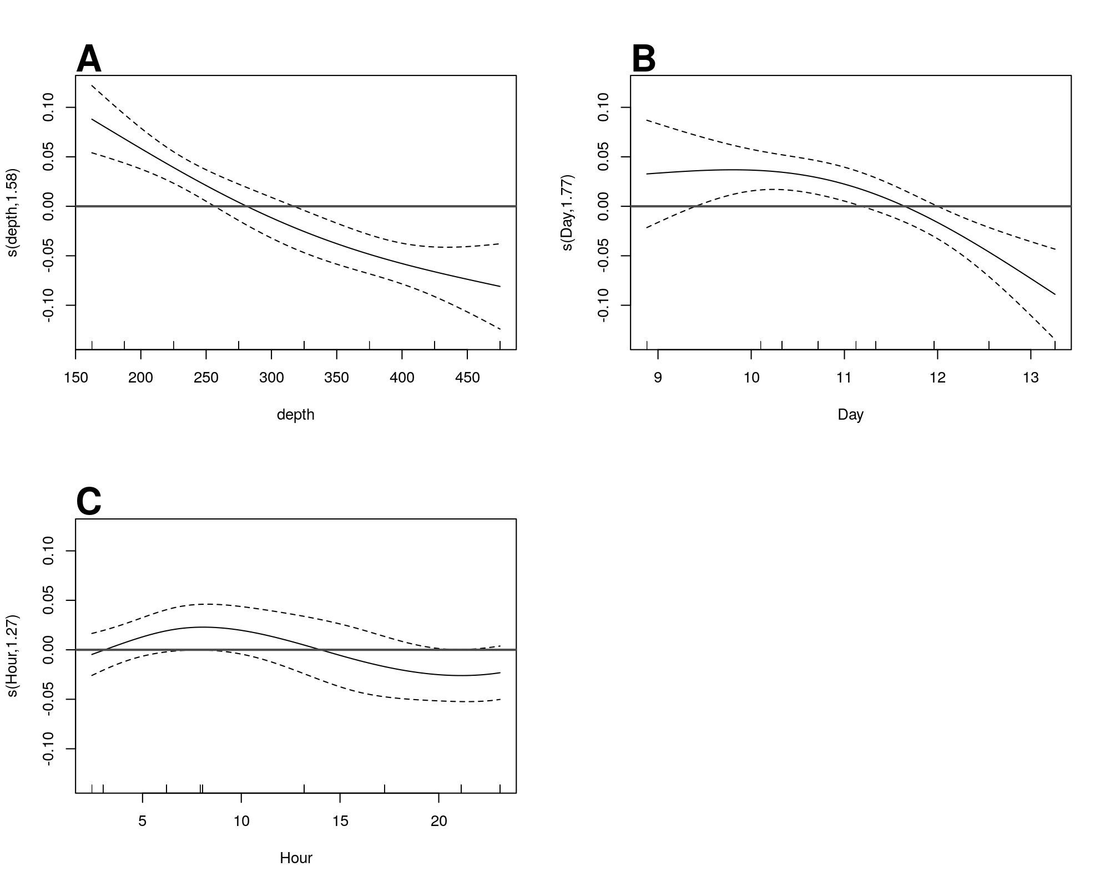

Figure S12. GAM predicted effects of A Depth, B Day of the month in January 2017, at ETNP Station P2. Y axis indicates the value of the component smooth functions effect on the difference between observed and modeled flux. Thus higher values correspond with greater flux of small particles than predicted by the model. Horizontal gray line indicates y = 0, corresponding to that parameter having zero effect, positive or on the outcome. Only Depth and Day have a statistically significant relationship to rate of change of flux (see Section 6.8).

Text S1. Full mathematical justification for the eularian version of the particle remineralization and sinking model (PRiSM) model. Ful document uploaded separately.