# Background

Each milliliter of seawater contains hundreds of thousands to millions of bacteria[1] that perform metabolic processes that drive and are shaped by regional ocean chemistry.[2,3] Of particular importance to this diversity are suspended and sinking particles, known as microaggregates (<500 um) and marine snow (>= 500um),[4] which are comprised of aggregates of dead phytoplankton, fecal pellets from zooplankton, lithogenic particles, and other components.[5,6] Describing the interaction between particles and microorganisms is important for four reasons: (1) an organism's **habitat** is a critical component of its ecology, (2) heterogeneous habitats promote microbial **diversity**, (3) particles **transport** microorganisms between different macroscale environments and (4) particle-bacteria interactions are likely to respond to environmental **change**.

**Habitat:** A fundamental aspect of any microorganism’s ecological niche is where it lives and when it can be found there.[7] Global microbial diversity surveys have explored these questions at macroscopic scales[8–10] and inform us about the drivers of biogeographic patterns. Microorganisms are very small[11] and so to understand microorganisms and their habitats we must think of habitats on a microscopic scale.[12] However, by ignoring particulate microenvironments, most spatiotemporal datasets do not truly resolve where microbial species live.

Particles provide microorganisms with energy, nutrients, and attachment surfaces.[13] Microbes, in turn, use extracellular enzymes to degrade and shrink particles,[4,14–16] and secrete exopolysaccharides that cause particle aggregation.[17] Some particles, especially large ones, harbor anoxic environments in which unique microorganisms, and key biogeochemical processes, such as anoxic denitrification, can occur even in otherwise non-oxygen limited water.[18–21]

Microorganisms face a tradeoff between metabolic flexibility and efficiency, with copiotrophs such as many roseobacteria[22,23] able to respond to localized concentrations of abundant nutrients, and oligotrophs such as SAR11 optimized for efficiency at the expense of adaptability.[24] Particle-attached bacteria may be more metabolically flexible than free-living ones,[25,26] perhaps because particles harbor different sets of abundant nutrient and energy sources, all of which are utilized by a similar community of organisms. Microbes also face a trade-off between the ability to grow fast when conditions permit, and slower growth but the ability to survive and grow on less abundant substrates.[27,28] While oligotrophic environments have been characterized as favoring more efficient organisms,[29] this tradeoff may favor faster growth on some particle classes. Lastly microbes face a disease and predation resistance vs growth tradeoff,[30,31] which may also vary across particle microenvironments.

**Diversity:** There are thousands of microbial species-level groups in each liter of water.[32,33] The reasons for this diversity have been an important theme in microbial ecology.[34,35] By postulating the “paradox of the plankton” Hutchinson[34] and others explained that with only a few apparent energy sources available to plankton, one would expect that competition would select for only a few organisms, while actually many are observed. Different particle types select for different microorganisms, thus increasing the total number of species in any one sample and driving differences between locations, depths, and times.

For instance, in a hypothetical ocean region with no particles, one might expect to still find abundant free-living organisms that consume dissolved organic matter (DOM), such as the many ecotypes SAR11,[29] various actinobacteria,[36] SAR86 [37] and others.[38] Adding particles would likely create a niche for bacteria that break down particles, such as those from the family *Flavobacteriaceae* and genus *Sacharophagus,* and bacteria that consume the DOM produced by these colonizing microorganisms, such as *Rhodobacteraceae.*[26] Adding large particles with anoxic microenvironments opens many new niches and thus promotes the growth of many bacterial taxa. Now available are niches for bacteria that break down particulate organic matter (POM) but use alternate electron acceptors. These bacteria include denitrifiers, such as the many phylogenetically diverse bacteria that contain the Nitrate reductase gene.[39] Secondarily, because the oxic and anoxic environments are adjacent on the scale of millimeters, denitrification biproducts like Nitrite can diffuse into the oxic environment and open niches for nitrite oxidizers such as Nitrospina,[39,40]and others. Indeed cryptic arsenic[41] and sulfur[42] cycles are both likely created by the presence of anoxic particles in oxic environments. Furthermore, particles select for different microbial traits than open water does and so niches are available for both predation susceptible and resistant bacteria, as well as metabolically flexible and inflexible organisms, even within in the same liter of seawater. I have only described mechanisms that promote bacterial diversity, but particles likely promote diversity of archaea, eukaryotes and viruses through similar mechanisms.[43–46]

**Transport:** In addition to enabling the growth of a diverse array of microorganisms, particles transport organisms from the surface of the ocean to the deep ocean.[47] Mestre et al.[47] observed that particle-attached microbial communities in the surface, particle-attached microbial communities in the deep, and free-living microbial communities in the deep ocean have similar community structures, especially compared against free-living microbial communities in the surface. One explanation for this pattern could be that microorganisms transported by particles from the surface accumulate at depth.[47] Photosynthetic cyanobacteria are often found in the deep ocean, where there is no light, suggesting that they may be transported by particles.[48,49] In estuarine environments, particles formed in regions of water mixing[50] or resuspension[51] may transport microorganisms laterally. Estuarine environments, including the Chesapeake Bay, have more lateral advection and less depth than open ocean environments,[52] and more particles.[53] The importance of transport and particles was demonstrated in the Columbia River estuary, where much of the microbial community was shown to be a mix of microorganisms from both free-living and particle associated communities transported from adjacent ocean and river environments.[38]

To quantify the relative roles of transport and growth in the deep ocean, it is necessary to quantify taxon specific microbial abundance on particles (in units of attached particles per volume of water or mass of particles), the flux of particles into the deep, and the growth of bacteria in situ. If these measurements are taken concurrently, transport of each taxonomic group into a deep layer of the water column could be compared to in-situ growth. Understanding the role of estuarine particles in transporting microbes similarly requires quantitative descriptions of which microbes attach to which sorts of particles, and in what quantities, and what microbial growth rates are on and off of particles.

**Change:** Due to anthropogenic climate change, oceans and coastal environments are becoming warmer (2015). Simultaneously, changes to ocean circulation and coastal eutrophication are causing low oxygen environments to expand in the open ocean[54] and coastal environments.[55] These changes have the potential to alter the distribution of microorganisms, and by extension, the biogeochemical processes these organisms carry out,[56,57] which in turn regulate locally important processes and global nutrient cycles. Alarmingly, in some environments, climate change appears to drive an increase in marine snow that host microbial pathogens.[58] Understanding how the distributions of organisms change from winter to summer, and how microbial communities are different in oxygenic and anoxygenic environments, provides important clues about how these communities and processes are likely to change.[59]

To describe microbial habitat distribution, explain microbial species diversity, characterize the role of particles in microbial transport, and predict the response of microbial communities to anthropogenic climate change, it is necessary to describe microorganisms not only across latitude, longitude, depth and time, but also across gradients of microhabitats. The distribution and processes on particles are subject to change as the ocean changes.[60] Thus, to truly understand microbial distributions, this study will consider the size, sinking speed, and particulate organic matter content of particles and how they relate to microbial community structure.

### Particle associated microbial biogeography

In the last two decades, numerous studies have explored the spatiotemporal distribution of microbial communities by performing ocean transects, sometimes global,[8–10] and through repeated time-series sampling.[59,61,62] While these studies have described microbial communities at large spatial scales, fewer have studied these communities’ microscale distribution. In general, most studies size fraction microbes with “attached” organisms getting caught on a filter with pores that are larger than most bacteria, and a second fraction that catches “free-living” organisms. The “attached” habitat is actually the sum of many different kinds of particles, each of which may harbor distinct microbial communities.

The quantitative analysis of particles in the Columbia River estuary, by Crump and Baross,[63] demonstrates the importance both of particle size and sinking speed in determining bacterial processes. The smallest particles, and the mostly slowly settling particles had the highest bacterial growth rate, despite having low carbon content.[63] While diversity was characterized in a related study,[38] abundance and diversity were not considered across particle types in that system. Indeed, only two studies, to my knowledge, have systematically described spatiotemporal patterns in diversity across particle types.

Mestre et al. explored microbial variability concurrently across five particle size fractions, time,[64] space and depth.[47] They showed that larger particles harbor greater species richness than smaller particles, and that particle size contributes to a greater difference in community structure than does time of year.[64] Moreover, examining particle size classes between depths showed that particle-attached and free-living bacterial communities in the deep ocean were similar to bacterial communities in the surface, suggesting a role of particles in transporting bacteria from the surface to the deep ocean.[47] However, this analysis was semi-quantitative, as the study did not quantify microbial total abundance on the particle fractions. Thus, a more quantitative approach would have been required to tell whether the particle attached bacteria have sufficient abundance to contribute to the free-living bacterial communities, as the authors suggest.

Such an approach was developed by Liu et al.[65] who quantified both relative and absolute abundances of free and particle attached microorganisms for a single size class of particles. The authors used amplicon sequencing to measure taxa specific relative abundances concurrently with qPCR of the 16S ribosomal RNA gene, to determine total bacterial abundance. Liu et al.[65] showed particle-attached bacteria make up an increasing portion of the microbial community with depth, ranging from only a few percent at the surface to nearly half of all bacteria at 6000m. By quantifying relative abundance with amplicon sequencing, the authors were able to identify which species make up this increasing proportion of microorganisms. Together these observations suggest that differences in particle characteristics cause differences in bacterial activity, abundance, and growth.

Despite the previous work, important questions remain unanswered, in part because each of these studies measure only some parameters. Much could be gained by measuring growth, abundance and diversity together across many particle types. To more fully describe the biogeography of microbial groups within water samples and across particle types, we propose to partition the microbial community by particle size and sinking speed, and to concurrently measure particulate organic matter with microbial abundance, growth, and diversity associated with each fraction. We will employ these measurements across space and time in eutrophic and oligotrophic environments, to explore how microbial partitioning across particle types varies across spatiotemporal scales. Thus, this study will generate the first dataset that quantitatively describes the microscale habitat distribution of marine organisms, and how that distribution varies at different spatial and temporal scales. It will furthermore provide a better picture of how particle associated communities promote marine biodiversity, how particles may transport microorganisms, and how these processes evolve in a changing ocean.

## Study Philosophy

The general philosophy of my ongoing and proposed work is to separate particles based on their physical characteristics and then to take quantitative measurements of their biological and physicochemical properties. Within this I aim to:

* Separate particles into enough size classes to treat size as a gradient, rather than just a few categories.
* Combine sinking speed fractionation with size fractionation, so as to explore variability along two components of particle variability.
* Perform complementary biological and physicochemical measurements from each particle class.
* Keep careful track of volumes processed, DNA extracted, and to “spike in” known concentrations of synthetic DNA sequences in order to have quantitative measurements.
* Measure particle abundance, mass, carbon content, and nitrogen content so that taxonomic abundances can be normalized to particle characteristics.
* For microbial analysis, combine deep shotgun sequencing with targeted amplicon sequencing so I have information about genes (shotgun sequencing) but also about community structure for **many** particle-class-time-locations (amplicon sequencing).
* Collect spatiotemporal data that are “nested” in their resolution -- that is, highly resolved datasets inside of less highly resolved, but more expansive, datasets -- in order to understand the scales at which microbial communities in different kinds of particle classes change across space and time.

# Questions and Hypotheses

This approach will allow us to ask:

What are the distributions of microorganisms across the different habitats that are present within a volume of water and how do these distributions vary across space, depth, and time?

By collecting the first spatiotemporal dataset that describes the range of microbial taxa across space, time, and microhabitat, we will be able to test hypotheses about microbial **habitat** (H1, H2), **diversity** (H1, H2), **transport** (H3) and **change** (H4), in the context of particles:

(H1) Microorganisms have niches that are bound by space, time, and microenvironmental type.

(H1A) Different size and sinking speed classes harbor distinct communities in every environment.

(H1B) For every size and sinking speed class, spatial proximity, temporal proximity, and environmental similarity all associate with microbial community structure similarity.

(H2) Different genes are expressed not only between free-living and particle associated microorganisms, but also between different particle size and sinking speed classes. In particular:

(H2A) Large particles, especially in intermediately oxic water, harbor genes for anoxic processes.

This follows from models and observations that suggest that particles create anoxic microzones.[18–21]

(H2B) Faster sinking particles likely favor microorganisms with fast, over efficient growth.

This is because faster sinking particles are, by definition, shorter lived environments than slower sinking ones.[66] Microorganisms have had less time to consume nutrients and energy sources on these particles making fast sinking particles richer environments, which may favor fast, rather than efficient, growth.[28]

(H2C) Larger particles favor microorganisms that are more resistant to infection and predation than smaller particles.

Particles behave as islands,[67] and organisms on larger islands have been shown to encounter more disease. This higher disease burden may select for more disease and predation resistant organisms.[31]

(H3): Microbial transport, by sinking particles, is sufficient to describe much of the free-living microbial community structure in the deep oligotrophic ocean.

(H4): Microbial communities across micro-and macro habitats change over time

(H4A): Spatial patterns of microbial diversity, across microhabitats, will vary seasonally in the Chesapeake Bay (CB) and at the Bermuda Atlantic Time-series Station (BATS).

(H4B): In a CB time-series, interannual, seasonal, and shorter scale variability will be evident.

My research group has pioneered a method to separate particles by size and sinking speed, to investigate how microbial properties vary between particle classes. We propose to combine samples already collected with additional sampling effort, and to process and combine these samples to understand how microorganisms distribute across space, time and micro-niche. In the following sections we will describe our method and its capabilities, then the preliminary data that we have collected using this method, and finally how we will process existing samples and expand our spatiotemporal dataset.

# Research Method and Preliminary Results

We have developed two experimental protocols. First a method to **size** **fractionate** particles in an environment and simultaneously measure microbial and particle characteristics. Microbial properties of interest include their abundance, community structure, genomic potential, and growth rates. Particle properties of interest include their mass, carbon content and nitrogen content. Second, a method to concurrently **size and sinking speed** **fractionate** particles and perform the aforementioned set of measurements. Both of these methods have been deployed in-situ.

## Experiment 1: Sorting particles by size

In this experiment (Figure 1), we collect ~ 10L of water in eutrophic waters, and ~120L of water in oligotrophic waters, by firing half or all bottles in a CTD-rosette at each depth. Water is then collected by opening the bottom of multiple Niskin bottles over a bucket in order to catch all particles. Carefully measured volumes of whole sea water are gravity filtered, in series, through nylon mesh of various pore sizes: 500 µm, 180 µm, 54 µm, 20 µm, 5 µm. We filter larger volumes of water through the coarser filters than the fine filters, because we have found that most biomass is concentrated in the smaller size fractions and because the finer mesh tends to clog sooner. In all cases we take note of the volume of water that passes through each mesh size.

Figure 1. Schematic for experiment one, in which particles are size fractionated, and bacterial and particle properties measured.

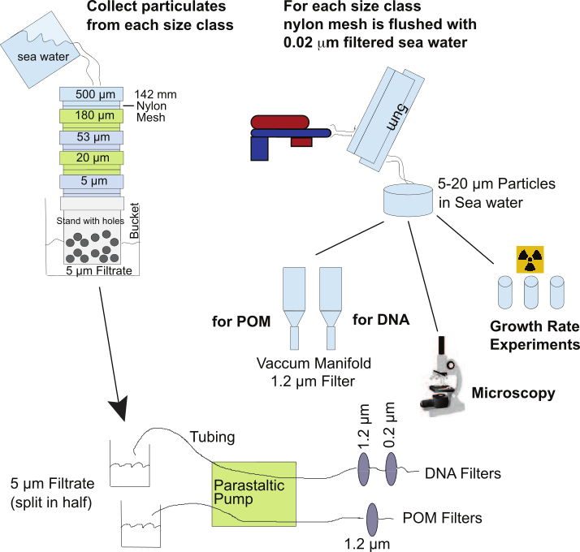

Each mesh is back-rinsed with 0.02 µm (30 kd) tangential flow filtered, virus free, sea water. The rinse water, which contains the particles, from each nylon mesh is subsampled for microscopy, growth rate measurements (tritiated thymidine and leucine incorporation), DNA analysis (1.2 µm polyethersulfone filter) and POM analysis (pre-combusted pre-weighted 1.2 µm glass fiber filter).

Water that passes through the 5 µm nylon mesh is further filtered through 1.2 and 0.2 µm polyethersulfone filters for DNA analysis, and a 1.2 µm glass fiber filter for POM analysis. Water that passes through the 1.2 µm POM filter is saved for growth and microscopy measurements of the free-living fraction.

These samples may then be analyzed for both metagenomic and amplicon sequencing, growth rate analysis, microbial abundance, and chemical analysis of POM.

## Experiment 2: Sorting particles by size and sinking speed

In this method we separate fast from slow sinking particles by using a CTD-rosette as a settling column. We collect 240L of water, as much water as the rosette holds, at one depth. The CTD is brought on deck and allowed to settle for one hour. Water from the top two thirds, which contains a higher proportion of slower sinking particles, is collected by siphon. Water in the lower third, which contains a higher proportion of faster sinking particles, is collected last by opening the lower cods on each Niskin bottle. We then size fractionate and process both the slow and fast sinking fractions as in experiment one. This approach is analogous to the separation applied by other groups with a marine snow catcher,[68] but can be deployed on any ship with a CTD-rosette, and so doesn’t require the purchase or transport of a heavy show catcher. In both experiments, we deploy Laser In-situ scattering (LISST) instruments, both in situ and to measure collected samples on deck, to estimate the size and abundances of particles in our 1.2-500um size range. This instrument is commonly used for this size range of particles in turbid environments,[69,70] and we have found can detect particles, across our size range, in the top 1000m of the open ocean.

Figure 2. Particle numbers, biomass, and DNA concentrations in the Chesapeake Bay. Symbol colors and shapes correspond to symbols in figures *b-d* **a**. Map of sampling locations. **b-c**, particle size properties. Both axes are on a log scale. The x axis shows the lower bound of each bin, so particles listed as “5” are between 5 and 20 um in diameter. Surface samples were collected within the top two meters of the water column, and bottom samples were collected 3 m above the sea floor. All y axis values are also log transformed **b.** Particles per liter, for several sizes of particles, measured by the LISST. All values are normalized to size-bin width. **c.** The relationship between particle size and mass. **d.** DNA concentration on particles, normalized to particle mass.

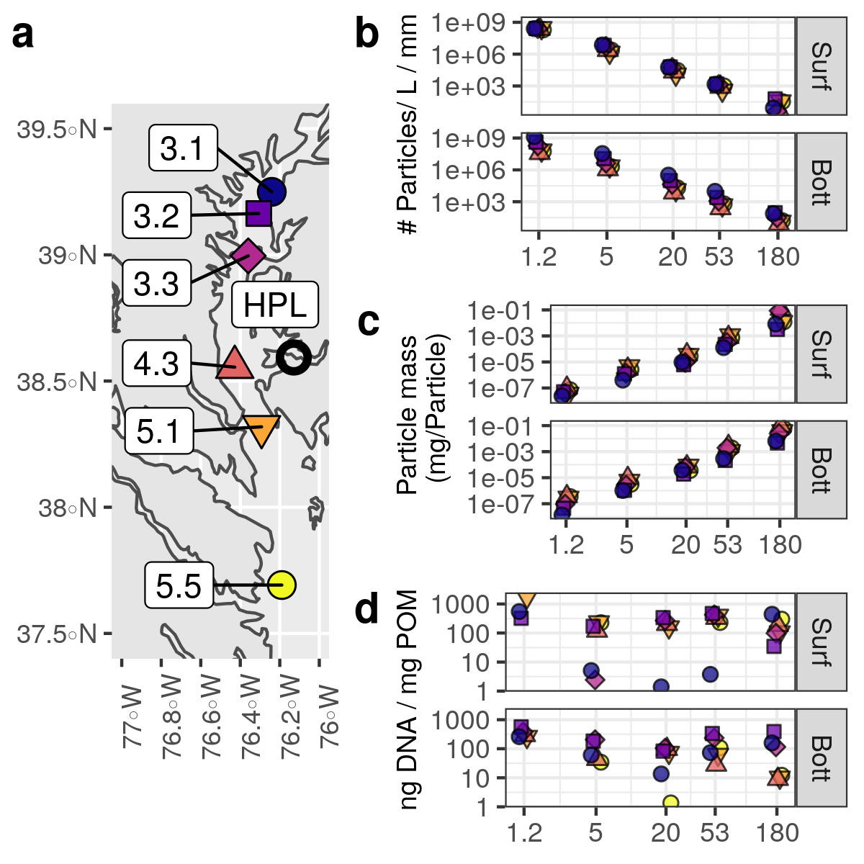

## Samples Collected:

Through startup funds and cruises of opportunity, we have collected, size fractionated, and archived samples from four distinct environments, following Experiment 1, minus the growth rate measurements. These include (1) the surface and bottom (and at one station, the midwater OMZ) of the Chesapeake Bay, along a transect from the mouth of the bay into its freshwater upper reaches, (2) the Bermuda Atlantic Time-series Station, from the surface through the bottom nephloid layer, (3) the Eastern Tropical North Pacific (ETNP) Oxygen minimum Zone with samples from the surface through the base of the OMZ, and (4) above the East Pacific Rise. In addition to size fractionated samples we also have two size and sinking speed fractionated samples from the ETNP and one from BATS.

We also collected a variety of negative controls including running 0.02 µm filtered water through the entire size fractionation and collection process to identify any background contamination. Our negative controls have shown little DNA contamination and will allow us to adjust for any background contamination in our amplicon libraries, if it exists.

## Preliminary data

Preliminary processing has provided us with data about the abundance of POM, particle size, number and DNA concentrations at each station in the Chesapeake Bay (Figures 2 and 3), as well as throughout the water column at BATS (Figure 4). The slope of the log-transformed size vs number relationship (Figures 2B, 4A) is known as the particle fractal dimension, and is an important consideration in particle modeling.[60,66,71,72] This slope, with a mean value of -3.3 ± 0.2 in CB, and -3.4 ± 0.3 at BATS, is not statistically significantly different between stations, depths and regions, and is typical of literature values.[60] The slope of the log-transformed size vs mass relationship (Figures 2C, 3B) is known as the fractal dimension[73,74] (2.5 ± 0.2 CB; 2.7 ± 0.4 BATS) and is also critical in modeling flux.[60,66] Particle size and mass data at BATS are all non-linear, with the largest particles unusually abundant, and light, relative to the expected power law, and so this data will be verified against Underwater Vision Profiler data also collected at this station. Particle DNA concentration (Figure 2D) appeared to be particularly low, on all size classes, at the northernmost CB station 3.1. This may reflect differences in particle age and origin, as this site contains an “estuarine turbidity maximum” where water mixing leads to the precipitation of new particles.[50] Particle abundance, and DNA concentration per particle at BATS (Figure 4C) is highest in the photic zone (200m), and may indicate either that particles are colonized by more living organisms or are themselves living organisms.

While amplicon analysis is in progress at most of these stations, we have performed the full analysis pipeline on two samples from the Choptank River, a tributary of the Chesapeake Bay (Figure 3). This analysis has shown that most bacteria are found on smaller particle size fractions (Figure 3A), not only because small particles are more abundant (Figure 2B), but also because they are either more densely packed on small particles, or because the 1.2-5 micron particles are actually living organisms (Figure 3B). Some bacteria, such as a *Cyanobium*, appear to have small particles as their primary habitat (Figure 3C), while others such as *Candidatus Amoebophilus* appear to have larger particles as their primary habitat (Figure 3C).[75]

Figure 3. Overall and taxon specific microbial abundances associated with different size classes at the HPL pier (Figure 1A). **A-B** Total combined 16S and 18S copy numbers per **A** liter of Chesapeake Bay water and **B** mg of POM. C-D, abundances of genus level groups of bacteria with different microscale habitat distributions. **C** Cyanombium PCC-6307 is a genus of cyanobacteria that is related to Syneccococus. **D** Candadadus Amoebophilus is a genus of the Bacteroidetes phylum many of whom have been shown to associate with marine snow.

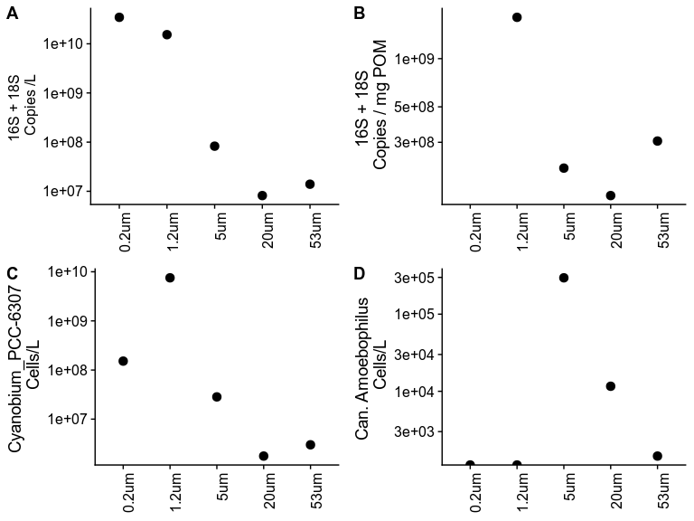

## Research Plan

We plan to work up our existing samples, and collect additional samples to expand the spatiotemporal distribution of our dataset. To investigate microbial community structure, and to define species ranges, we will perform amplicon sequencing on all samples, using the universal 515F-Y-926R primer set, which targets the V4 and V5 hypervariable regions of the 16s gene.[76] This primer has been previously validated against mock communities[76] and shown to replicate diversity from corresponding shotgun metagenome samples[77]. We will perform shotgun metagenomics on 10% of our samples. Both amplicon and shotgun sequencing will utilize spiked in controls[78,79] so that reads can be normalized to total, rather than relative abundances. We will also validate both approaches against mock communities to ensure reproducibility between runs and studies.[80] Our DNA concentrations are high enough that we can perform deep shotgun sequencing on our choice of these samples (> 160ng DNA per sample). Amplicon analysis will inform our decisions about which samples to shotgun sequence. We will select some stations with unique microbiota and some with similar microbiota in order to maximize the information provided by the shotgun sequence data.

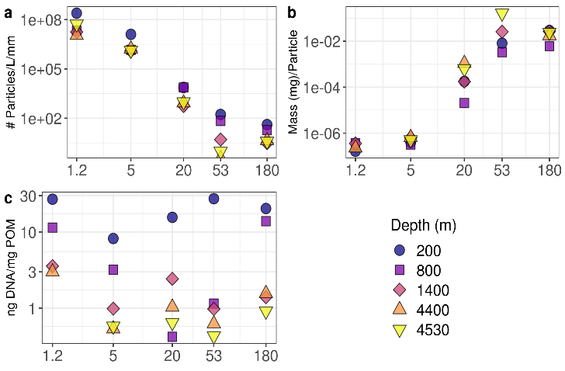

Figure 4: Particle numbers (A), biomass (B), and DNA concentrations (C) at BATS.

### Expanded Sampling

We will expand our spatiotemporal sampling by performing additional cruises, as well as a shore-based time-series (Figure 5). In all cases, we will minimize cost by taking advantage of ships of opportunity to sample the oligotrophic ocean, and by focusing on eutrophic regions that are close by.

Specifically, we will **repeat our Chesapeake Bay transect** twice, once in summer and once in winter. This will allow us to detect seasonal variability (i.e. are samples from summer transects more similar to each other than they are to samples from the winter transect) and to compare that to spatial variability. We have obtained permission to **revisit the Bermuda Atlantic Time-Series** **Station** (BATS), twice, by piggybacking on already scheduled cruises (see Rod Johnson, letter of support). We will revisit the station in the winter and summer, which will allow us to explore the relative effects of seasonality and depth. We will visit Station ALOHA, the site of the Hawaii Ocean Time-Series, by piggybacking on another scheduled cruise (see Michael Gonsior, letter of support). This, along with our previously collected samples from the East Pacific rise and BATS, will allow us to explore spatial distribution of particle associated bacteria in the oligotrophic ocean.

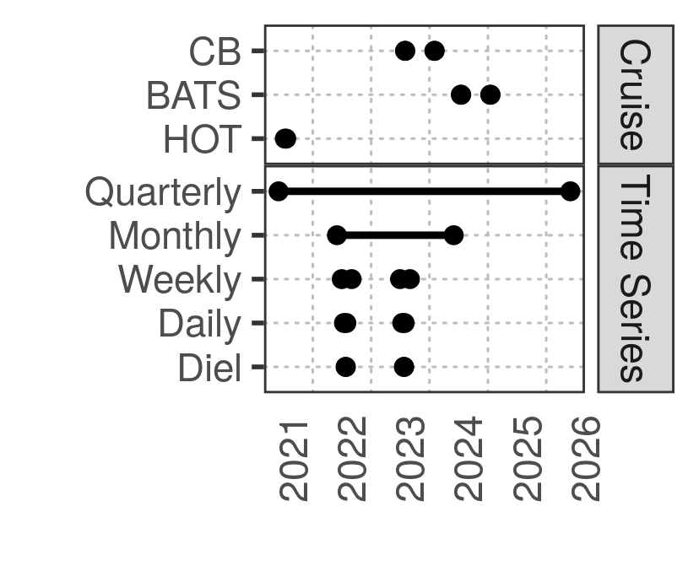

Figure 4. Project time-line of field sampling components, including cruises and time sampling from the Horn Point Laboratory Pier. All sampling dates are subject to being moved in response to COVID-19 related restrictions, though we plan the extended field sampling later in the project to minimize conflict with the pandemic. Because some samples have been collected but not yet processed, laboratory based processing, analysis and writing will take place on these samples throughout the project time-frame.

To further explore temporal variability, in addition to repeating BATS measurements and Chesapeake Bay transects as described above, we will run a **nested time-series from the HPL pier**. Samples will be collected, quarterly, during all five years of the project. In the second and third years of the project, we will sample monthly. During the summers of those two years, we will collect samples weekly for one month, daily for one week, and every six hours for two days. Nested analyses are an informative way to explore temporal variability across scales.[49,81–83]

### Analysis:

One product of this study will be a publicly available atlas of microorganisms that tells about both when, where, and in what state (free or attached to a certain range of particle types) organisms are found. Furthermore, I will determine, for different particle classes, how space, time and environmental parameters relate to patterns in microbial alpha and beta diversity. I anticipate using network analysis[84–86] to examine association patterns between microorganisms in different particle classes and to examine how these associations across space and time are different or similar in different size classes.

My team will use statistical approaches to test each hypothesis. We will investigate whether communities differ between each particle class more than in pairs of technical replicates taken at the same time, location and size class **(H1A)**. We will determine the scales of variability of microorganisms in each particle size class by examining autocorrelation patterns and by using mantel and permutational multivariate analysis of variance approaches to determine how spatiotemporal variability and measured environmental parameters relate to microbial similarity **(H1B)**. We will test whether genes, metabolic processes, and ecological trade-offs vary between particle size classes, and how these vary across space and time **(H2)**. In particular we will focus on genes for anoxic processes, especially nitrogen and sulfur reduction **(H2A)**, fast rather than efficient growth (especially in the form of high ribosomal gene copy numbers[87] and codon usage bias[88,89]) **(H2B)**, predation resistance (especially the presence of unusually small, large or filamented cells in the microscopy samples[90]) and viral resistance (especially CRISPR genes[91]) **(H2C)**. By combining literature values about the relationship between particle sinking speed and size[60 and references therein] with data, we will explore the relative magnitude of particle transport of bacteria to depth vs in-situ growth at depth **(H3)**. We will explore differences in our spatial transects across time **(H4A)** and in our nested time-series, focusing on temporal autocorrelation patterns, to determine the relevant scales of temporal variability **(H4B)**. In particular we will ask whether there is statistically detectable seasonal variability, and variability at other time scales following analysis methods deployed previously.[49,81–83]

## Additional considerations:

While this is my first CAREER proposal, many components of this proposal have been recycled from a peer reviewed, not funded, collaborative proposal. Many aspects of this proposal have been improved due to reviewer suggestions. I would like to address two reviewer points in particular.

One reviewer asked about whether the bacteria on particles resuspend evenly between samples and if this might affect our measurements. We argue that none of our measurements on these samples are affected by particle aggregation or differences in resuspension. Rather the properties that we measure, microbial growth, abundance, and POM characteristics, are independent of the resuspension process, as long as the subsamples contain similar amounts of material, and we have validated that there are no large clumps in our resuspensate. A caveat is that particle fragments smaller than 1.2 um, which might break off from larger particles during filtering, will not be detected, but we expect this fraction is minimal.

Another reviewer pointed out that it would be valuable to measure additional chemical parameters of our particles, such as biogenic ballast materials and metal concentrations. We agree that such measurements would be informative, but argue that they are beyond the scope of this proposal. We focus on particle mass, carbon and nitrogen because these are needed to normalize microbial abundance on particles. Additional measurements will require additional particle biomass, filters, and person-hours to collect. Metals in particular, can tell a lot about the biogeochemistry and history of particles,[92] and collaborations with chemists, including metal chemists, are a clear direction for future proposals.

# Education

My objective is to increase graduate student access to techniques in microbial ecology, scientific writing, and environmental data analysis, by teaching virtual and hybrid classes and by mentoring graduate students through experiential learning opportunities.

Graduate students, particularly those from historically underrepresented groups within science, often benefit from additional mentorship specifically with scientific writing and data analysis.[93–95] Open enrollment and virtual courses, if designed appropriately, provide a compelling method to help close these gaps.[96,97] It is particularly important that virtual classes are engaging to ensure student mastery.[98] Research shows that direct mentorship and experiential programs help retain first generation science students.[99–101]

By sharing engaging materials for hybrid and virtual graduate-level courses in Scientific Writing, Microbial Ecology, and Multivariate Analysis, Network Analysis, and Coding, I will increase access for students both in the University of Maryland system and across the country. I will further mentor students in analyzing their own research questions through the Horn Point R-Club; BioVCN, an online coding-focused teaching network; in my lab; and on research cruises.

To ensure that I am reaching all students in my classes, I will collect and analyze student demographic information upon entry and completion of my classes with the goal that first-generation (FG), underrepresented minority (URM), and English Language Learning (ELL) students both enter and complete my courses at a rate proportional to or exceeding the corresponding rate of entry and completion for FG, URM, and ELL students within their graduate cohorts, as recommended for increasing institutional accountability.[102] Student success in my classes is assessed in their synthesis of the topics studied with their own research interest on term papers and in presentations, as enumerated for each class below. Mentee success is measured by the number of papers and presentations produced with data my mentees acquired and/or that acknowledges R-Club or BioVCN.

My mentorship of graduate students through enrichment opportunities including as clubs and courses open to the public, as well as in the lab and on research cruises, will inform my teaching of classes offered for credit, and vice versa. I will release course content to the public as video lessons, blog posts of course materials for other instructors to use, and repositories of example code on GitHub; measure success through downloads, citations, and queries; and use existing BioVCN infestructure to promote these materials.

## Background

Coursework, research cruises, and optional enrichment opportunities such as clubs and online lectures, have the potential to enable graduate students to think more broadly about their field, and to learn skills that will help them in their dissertation and life as scientists and professionals. While much pedagogical research has gone into undergraduate and secondary school science education, the development of graduate level classes in oceanography have historically been more ad hoc.[103] Indeed, at University of Southern California where I was a PhD student, professors told us that they could not afford to invest too much time and attention in graduate courses because they did not get teaching credit for leading those classes. This can create challenges for students who enter graduate school lacking content knowledge, writing skills, and fluency with computational data analysis. In particular, many students in the environmental sciences generate or inherit large multivariate datasets, but have not had the opportunity to study computer-based modeling, computational statistics, or scientific writing in depth during their undergraduate course of study. Other students may find themselves in environments where they do not have a local expert in the technique or content area of interest. Graduate students from historically underrepresented groups, and international students, are statistically more likely to face challenges with scientific writing[104] and to have had limited access to computer techniques for modeling and data analysis at the high school and undergraduate level.[105]

Effective remote teaching often produces better outcomes than in person teaching,[106] and has significant potential to convey information to students when experts in the content area that students need are not locally available, which is particularly relevant for the highly specialized material offered at the graduate level.[107] University of Maryland Center for Environmental Science (UMCES) has been teaching classes that are at least partially remote since 1992. Most classes at UMCES use a hybrid face-to-face and remote structure because students and faculty are geographically spread across five laboratories and an additional twelve college campuses throughout the state of Maryland. Distributed learners engage with faculty who are themselves distributed using an interactive video network (IVN), through both the IVN and Zoom platforms. Thus, at UMCES, I have a unique opportunity to focus and develop novel opportunities for remote teaching of graduate students, including both students on campus at Horn Point Laboratory and students at other campuses under the University of Maryland's Marine and Estuarine Environmental Science (MEES) graduate program.

I teach Scientific Writing and Microbial Ecology for credit through UMCES, and am developing materials for a course on Multivariate Analysis in Environmental Science. The distributed teaching architecture at UMCES has highlighted both the benefits to students of remote courses in access to a specialist and the challenge of ensuring that remote students are engaged in the material. I have found that I can teach exactly the same material to students in a room and have a dynamic discussion, while in a class with even a portion of students outside of the room, almost all students are hesitant to raise questions or share observations. These benefits and challenges are of urgent interest in response to the 2019-2020 SARS-CoV-2 pandemic, as my peers and I adapt to the fully remote setting. Moreover, they inform my work with the Bioinformatics Virtual Coordination Network (BioVCN), a collaboration between several early career instructors spread across multiple universities, teaching bioinformatics to researchers who lack a local expert through open-enrollment online videos, remote workshops, and a Slack channel based discussion and teaching forum.

Students who haven’t done research projects before benefit from experiential learning.[100,108 and references therein] A key component of my teaching is mentoring students with their own projects through direct instruction on field projects, especially oceanographic cruises, as well as by discussing and troubleshooting their data analysis in informal settings. I will involve graduate students, from UMCES, undergraduate students, from the REU program, and high school students, from the local Cambridge South Dorchester High School (CSD) in the proposed fieldwork. In particular, cruises on the Chesapeake Bay and time-series sampling from the HPL pier provide opportunities to involve more students in cutting edge oceanographic field research. I outline my current efforts and future plans for each of my classes and experiential learning opportunities below.

## Scientific Writing

I co-teach Scientific Writing as a for-credit course through UMCES, with 4 local and 11 remote students enrolled in the Fall 2019 term. By the end of the term in Scientific Writing, students complete a scientific paper including full abstract and introduction, one paragraph from methods and discussion, and a bulleted list of results, using data from their ongoing research and referencing the current literature. They also present their research as a 15-minute oral presentation. Both the final paper and final presentation serve as summative assessments of student learning. Students are evaluated for their writing according to rubric categories including correctly structuring paper sections and providing appropriate information. Students are evaluated as well for the constructiveness of their editing and review of their peers’ work.

To increase engagement, I will concurrently expand the formative assessment elements of this class while implementing new opportunities for students to engage with each other in a supportive setting. I plan to add ungraded in-class writing exercises, with all students discussing each other's responses to practice exercises in small groups, by assigning them virtually into breakout sessions in the online teaching platform. Groups would then share insights with the class as a whole.

One writing exercise that has been shown to narrow achievement gaps faced by underrepresented minorities,[109] first-generation students,[110] and women,[111] is an ungraded value affirmation exercise which has been shown to combat stereotype threat. We will modify the exercise from Harackiewicz et al. [110,112] to create a three-page, mixed value selection and short writing assignment, which students will complete in 10-15 minutes at the start of week two and in the class before their oral presentation. The secondary intent of this ungraded assignment is to build confidence in expressing ideas in writing on a topic that students will not need to study, increasing student comfort with writing while emphasizing logical coherence over writing mechanics. Unlike other writing assignments, this particular exercise will not be peer reviewed.

Where students now provide written feedback on each other's work, I would like to prompt discussions between students about written feedback as well. This can be done in a think-pair-share framework,[113] in which students are given an anonymized writing sample and feedback from a previous course year, read and consider the sample individually for five minutes, then discuss the feedback according to the paper rubric in pairs. Instructors will then call on students to share their observations with the class. Increased formative assessments will allow students to monitor their engagement and mastery in real time during class, and highlight any paper sections or misconceptions that would benefit from additional review.

Instructors will identify students who would benefit from more individual support and encourage participation during class discussions as well as attendance in office hours. I will initially implement these developments out for some, but not all lessons, and then survey students, and compare the quality of work submitted between different lessons to assess which approaches are working. Course materials and observations about teaching methods will be shared from this and other UMCES classes at the annual MEES Graduate Program colloquium, which is attended by about 40 faculty. To ensure that the course is accountable to all students, demographic information including ethnicity, gender, first generation status, and whether students are English Language Learners will all be tracked and reported,[102] to my department and in my annual report to NSF.

## Microbial Ecology

In Microbial Ecology, a for-credit, hybrid course offered through UMCES, we explore core concepts such as biogeography, host-virus interactions and nutrient cycling. By the end of the term in Microbial Ecology, students apply the literature in microbial ecology to a deeper understanding of a chosen topic area by submitting a term paper summarizing the literature in that topic area and suggesting future scientific discussions. Per Bloom’s taxonomy,[114] synthesizing and evaluating a subject provides the highest level of student understanding, and so we focus on summative writing and presentation to encourage this synthesis. Students discuss the current literature and give a presentation to the class analyzing the methods and results of a scientific paper of the student’s choice, and then craft a term paper synthesizing the state of a chosen topic.

To increase engagement, I plan to spend more time on student-led paper discussions. I plan to transition from lecturing to producing video to implement a “flipped classroom” model.[115–117] We have had success deploying this model for some Microbial Ecology classes and would like to expand it. This flipped format will allow us to expand and test interactive elements and formatively assess student understanding. Students will post on an online discussion forum through Moodle every week with at least one question about the reading or flipped lessons. We will discuss these student posts as a class using the same frameworks for discussion that have proven effective in Scientific Writing, such as a mix of small groups and full class discussion as well as ungraded prompts, including a values affirmation prompt. As in Scientific Writing, pedagogical innovations are shared through the MEES colloquium and we will track demographic information and outcomes.

## R-Club

In the HPL R-Club, we discuss data, analysis and coding questions and problems that students are having in their coursework and research. R-Club was originally in-person, but as people from the other UMCES laboratories became interested, and especially with COVID-19, it has become first partially and now entirely remote. I find that here, because people have specific questions they want answered, R-Club consistently features lively discussion.

R-Club’s primary purpose is, and will continue to be, to address and discuss students’ ongoing problems with their own research. The efficacy of R-Club is assessed in student attendance, which is fully voluntary, and in engagement, with highly effective sessions focused on one to two student challenges presented to the club as a whole. Student attendance ranges from 3 to 45 per session, with highest participation during the REU program. While programming as a whole has been historically dominated by men,[118,119] R-Club has greater than 50% participation by women.

To increase the reach of R-Club, I will expand R-Club’s integration with the REU program. In its first year of engagement, R-Club offered two lessons for REU students at HPL. In the future, I plan to work with the REU program leaders (see Mike Allen, letter of support) to develop an R training module as an optional part of the students’ orientation so that they come in with some computational literacy. We have also arranged with teachers from the local Cambridge South Dorchester High school to mentor their student math team as they prepare for the MathWorks Math Modeling Challenge (see Jacquelyn Burchfield Letter of Collaboration).

## Bioinformatics Virtual Coordination Network (BioVCN)

BioVCN was originally a collaboration between several early career instructors spread across multiple universities with the original goal of teaching bioinformatics to researchers locked out of their laboratories during the COVID-19 pandemic. We plan to continue creating content even as we transition back to the lab. In addition to teaching students in real-time, BioVCN courses produce online video for each topic area, as well as interactive code that students can work with. I have been involved in particular in two “courses” within the broader BioVCN. One course teaches “R” programming and analysis and the other, “Network Science,” demonstrates networks to explore and evaluate patterns in multivariate datasets.[as in 85] I have found that these courses have been able to help students with ongoing projects, and have also helped me to generate teaching material that I plan to employ in other contexts.

BioVCN focuses on producing content. As of 10 July 2020, BioVCN as a whole has produced 79 videos, with a combined total of more than 7000 views. R and Network Science teams have released 15 and 7 videos respectively. Student progress is assessed formatively in BioVCN during the office hours/workshop sessions when students engage in class with topics that interest them by asking questions and voluntarily presenting code, data, figures and analysis. Students also help each other and reach out to instructors over a shared Slack channel. This allows students to get help on ongoing projects in real time. I have found this approach works well and plan to implement a similar forum in R-Club.

BioVCN is free and open to all interested participants, which removes barriers to entry of underrepresented students, and instructors are working to encourage participation in the program to students from underrepresented backgrounds. BioVCN has greater than 50 percent participation by women both as instructors and as students.

The content of BioVCN will inform my efforts to generate examples and material for my formal Multivariate Analysis course. Conversely, I will use BioVCN as a platform to share content created for the Multivariate Analysis course, as well as to address questions brought up in R-Club.

Summatively, I measure the success of my informal teaching as student publications and presentations whose analysis has benefited from participation. These acknowledge Cram, Cram’s co-leaders, R-Club or BioVCN classes. Of the ten student seminars given at Horn Point Laboratory last year, six met the above criteria. I measure success for BioVCN content with which I am involved though continued student participation, views of released course videos, and pulls of code examples from GitHub repositories.

## Multivariate Analysis in Environmental Science

I plan to develop a new course though the MEES program, Multivariate Analysis in Environmental Science (MAES), which will cover visualization, linear modeling, variable selection, time-series data and network analysis. By the end of the term students will have applied this range of techniques to either their own data or a publicly available dataset on weekly challenges. As a final project they will share the results of these analyses as an oral presentation, accompanied by reproducible code. I will adapt lessons developed in the Microbial Ecology, R-Club and BioVCN.

While HPL provides students with a strong statistical foundation, we do not currently prepare students to interact with datasets that have many variables. These datasets are becoming increasingly common, especially in microbial ecology, but also in other fields, from health sciences to economics.[120–122] MAES would focus on ways to approach these sorts of data in ways that are statistically appropriate.

To increase engagement, I plan to develop this course initially with a flipped format, with short ~30 minute per week video lessons, and class time devoted to working through interactive examples; ideally through pair programming, with one student coding and one “navigating.”[117] This will be implemented virtually by combining “breakout room” features with “screen sharing” features, in our remote teaching application, currently Zoom. As in Scientific Writing, class discussions will be informed by a Think Pair Share framework,[123] in this class modified to encourage pair programming.[124] This class will use a discussion forum through Moodle, with discussion norms informed by the discussion board in Microbial Ecology, but designed as a student-driven source of collaboration on weekly work. Students will post problems they encountered doing the work in the style of a Stack Overflow question, and their classmates will be encouraged to respond with any technique that worked for their own data.

As a final summative assessment, students will present the results of their analysis project to the class. Students’ analyses will be published as public code on GitHub or reserved for publication in a future paper as appropriate. The rubric will focus on the reproducibility of their code with learning targets including the clarity of comments and code, as well as on the soundness of their conclusions. As in the other two classes, innovations will be shared through the MEES colloquium. Materials will be shared through BioVCN which I expect will have similar reach to existing BioVCN materials. This class will also utilize the demographic information tracking and value affirmation exercise deployed in the other two formal courses.

## Experiential Learning

As part of this research, I will mentor one graduate student in my own laboratory group, one REU undergraduate student each summer, and four interns from the local high school as we collect and analyze the samples, ensuring that they master skills in microbial ecology through direct research experience. In particular, the regular time-series sampling from the HPL pier, combined with Chesapeake Bay sampling, provide a logistically reasonable mechanism to bring more students at every level into the field at minimal additional cost. I plan to bring 2-6 interested students from the REU program along on the Summer Chesapeake Bay cruise, and to bring 2-6 graduate student volunteers from other research groups, especially those that do not conduct fieldwork as a primary component of their research, to join my group on the winter Chesapeake Bay cruise. I will hire two high-school interns to work collaboratively[see 125] to support the fieldwork and analysis during the second and third project years, when the local Chesapeake Bay and high-resolution time-series sampling will occur.

# Integrating research and education

Research in microbial ecology, and more broadly within environmental science, increasingly requires its practitioners to analyze data that contains many parameters such as microbial taxa, genes, biotic variables, and environmental parameters. While many graduate programs, including MEES, offer some statistical training, basic statistics courses usually focus on univariate rather than multivariate analysis. Students must then find ways to analyze their research questions with little access to local experts, especially ones well versed in microbial ecology and data analysis. This lack exacerbates learning gaps and represents a particular barrier to students from demographic groups that are underrepresented within STEM fields.

The mixed remote and local teaching that I do, and which I will expand with support from this grant, emphasizes topics in microbial ecology, scientific writing, and data analysis, all of which are informed by my ongoing research. I am the right person to teach these topics because my ongoing research keeps my own microbial ecology knowledge, multivariate statistical skills, and writing technique current. I am active within professional networks to improve my own mastery and to develop my pedagogy, and I am committed to mentoring students individually with their research questions both through my formal classes and through informal opportunities.

The dataset generated in this research proposal, along with analysis that I and my students will carry out, will become public, and will be integrated into my teaching materials. My current teaching materials utilize data from previous projects, especially my dissertation research into microbial time-series analysis, and I expect the multivariate dataset generated here will provide a similar opportunity.

The experiential learning aspects will allow me to direct students in fieldwork, lab work, and data analysis as students at all levels engage directly with the scientific process.

# Intellectual Merit

This project is transformative in generating the most extensive spatiotemporal dataset its kind. It will advance understanding of how particles create microscale microbial habitats that promote microbial diversity, allow for transport between regions, and change over time. It presents a novel approach for generating a complementary set of measurements to simultaneously characterize the biology and chemistry of microbial habitats. It furthermore provides a framework for increasing graduate student access to expert instruction in topics of microbial ecology, scientific writing and data analysis through virtual courses and experiential learning.

My previous work collecting and analyzing time-series data of microbial communities[49,83,85,126] informs this proposal, and my research group has successfully taken preliminary measurements. I recognize that what I am proposing is a lot of work, with six size fractions collected per station-depth, and twelve in the case of sinking speed fractionation. Between samples already collected and archived and ones I have yet to collect, I am planning to process around 1200 samples over the five years of the study. We will work through these samples continuously over the course of this project. I anticipate two bottlenecks in particular, DNA extraction, because isolating enough DNA from these samples requires a time-consuming phenol-chloroform extraction, and SYBR green microscopy. For this reason, the proposed budget supports part time work of a technician to help the fully funded graduate student and myself to work through these samples.

Similarly, the dataset this project will generate will be multivariate and complex. My publication record and experience mentoring others in the processing of similarly complex datasets supports my ability to lead the analysis of this dataset as well as to develop materials for remote instruction within the field of multivariate data analysis particularly as applied to research questions in microbial ecology.

# Broader Impacts

Marine snow and the bacteria that inhabit them are an essential piece of the global carbon cycle and regulate climate.[127,128] While bacteria-particle interactions are generally treated implicitly in global climate models, understanding microbe-particle interactions will allow better understanding of earth system processes, and may allow for improved formulation of these models. Exploring how different particle types provide different habitats for different microorganisms and interact with microbial diversity, and transport microorganisms into the deep ocean will be essential for understanding these processes. Our robust spatiotemporal dataset will inform the community about how these processes are likely to change in warming oceans.

The educational and experiential components of this proposal further NSF’s Broader Impacts aims of fostering participation of women and underrepresented minorities in STEM, and improving STEM education and development of a diverse, globally competitive STEM workforce. Access to expert instruction and experiential research opportunities are essential for students at all levels, especially those from underrepresented backgrounds. This project will provide opportunities for graduate students, undergraduate students from the REU program, and high school students from the local Cambridge South Dorchester (CSD) High School, which is a Title I school in which more than half of students are from underrepresented groups,[129] to explore research questions in microbial ecology by collecting and analyzing data in the lab and on research cruises. A Horn Point REU student from the Summer 2019 cohort who presented her data at the Ocean Sciences Meeting has returned to Cram lab as a summer researcher to work up additional data comprising the Chesapeake Bay dataset, on which the student will be a co-author. This grant will also support the Horn Point R-Club in mentoring students from CSD.

Remote teaching provides an opportunity to provide access to a broad range of students and this project would provide me with the opportunity to expand my reach through the BioVCN program and HPL R-Club. In particular Cram and R-Club have planned with teachers and administrators from Cambridge South Dorchester (CSD) High School, our local public high school, to forge a connection between R-Club and the newly formed CSD Math Team as the team prepares for a data science challenge. I also aim to innovate in fostering student engagement in remote settings and will disseminate materials both within and beyond my institution through the MEES Colloquium and by sharing resources through BioVCN.

# Results from Prior NSF Support

Cram has had no prior NSF support.

# References

1. Maranger R, Bird D. Viral abundance in aquatic systems:a comparison between marine and fresh waters. Marine Ecology Progress Series 1995;121:217–26.

2. Falkowski PG, Barber RT, Smetacek V. Biogeochemical Controls and Feedbacks on Ocean Primary Production. Science 1998;281(5374):200–6.

3. Falkowski PG, Fenchel T, Delong EF. The Microbial Engines That Drive Earth’s Biogeochemical Cycles. Science 2008;320(5879):1034–9.

4. Simon M, Grossart H, Schweitzer B, Ploug H. Microbial ecology of organic aggregates in aquatic ecosystems. Aquat Microb Ecol 2002;28(2):175–211.

5. Alldredge AL, Silver MW. Characteristics, dynamics and significance of marine snow. Progress in Oceanography 1988;20(1):41–82.

6. Lamborg CH, Buesseler KO, Valdes J, Bertrand CH, Bidigare R, Manganini S, et al. The flux of bio- and lithogenic material associated with sinking particles in the mesopelagic “twilight zone” of the northwest and North Central Pacific Ocean. Deep Sea Research Part II: Topical Studies in Oceanography 2008;55(14–15):1540–63.

7. Myers AA, Giller P. Analytical Biogeography: An Integrated Approach to the Study of Animal and Plant Distributions. Springer Science & Business Media; 2013.

8. Rusch DB, Halpern AL, Sutton G, Heidelberg KB, Williamson S, Yooseph S, et al. The Sorcerer II Global Ocean Sampling Expedition: Northwest Atlantic through Eastern Tropical Pacific. Plos Biol 2007;5(3):e77.

9. Bork P, Bowler C, Vargas C de, Gorsky G, Karsenti E, Wincker P. Tara Oceans studies plankton at planetary scale. Science 2015;348(6237):873–873.

10. Duarte CM. Seafaring in the 21St Century: The Malaspina 2010 Circumnavigation Expedition. Limnology and Oceanography Bulletin 2015;24(1):11–4.

11. Leeuwenhoek A van. The Select Works of Anthony Van Leeuwenhoek: Containing His Microscopical Discoveries in Many of the Works of Nature. translator; 1800.

12. Azam F. Microbial Control of Oceanic Carbon Flux: The Plot Thickens. Science 1998;280(5364):694–6.

13. Paerl HW. Microbial attachment to particles in marine and freshwater ecosystems. Microb Ecol 1975;2(1):73–83.

14. Huston AL, Deming JW. Relationships between microbial extracellular enzymatic activity and suspended and sinking particulate organic matter: seasonal transformations in the North Water. Deep Sea Research Part II: Topical Studies in Oceanography 2002;49(22):5211–25.

15. Mislan KAS, Stock CA, Dunne JP, Sarmiento JL. Group behavior among model bacteria influences particulate carbon remineralization depths. Journal of Marine Research 2014;72(3):183–218.

16. Enke TN, Leventhal GE, Metzger M, Saavedra JT, Cordero OX. Microscale ecology regulates particulate organic matter turnover in model marine microbial communities. Nature Communications 2018;9(1):2743.

17. Bhaskar PV, Grossart H-P, Bhosle NB, Simon M. Production of macroaggregates from dissolved exopolymeric substances (EPS) of bacterial and diatom origin. FEMS Microbiol Ecol 2005;53(2):255–64.

18. Simon HM, Smith MW, Herfort L. Metagenomic insights into particles and their associated microbiota in a coastal margin ecosystem. Front Microbiol 2014;5:466.

19. Stief P, Kamp A, Thamdrup B, Glud RN. Anaerobic Nitrogen Turnover by Sinking Diatom Aggregates at Varying Ambient Oxygen Levels. Frontiers in Microbiology [Internet] 2016 [cited 2019 Jul 31];7. Available from: http://journal.frontiersin.org/Article/10.3389/fmicb.2016.00098/abstract

20. Stief P, Lundgaard ASB, Morales-Ramírez Á, Thamdrup B, Glud RN. Fixed-Nitrogen Loss Associated with Sinking Zooplankton Carcasses in a Coastal Oxygen Minimum Zone (Golfo Dulce, Costa Rica). Frontiers in Marine Science [Internet] 2017 [cited 2019 Jul 31];4. Available from: http://journal.frontiersin.org/article/10.3389/fmars.2017.00152/full

21. Bianchi D, Weber TS, Kiko R, Deutsch C. Global niche of marine anaerobic metabolisms expanded by particle microenvironments. Nature Geoscience 2018;11(4):263.

22. Petersen J, Frank O, Göker M, Pradella S. Extrachromosomal, extraordinary and essential—the plasmids of the Roseobacter clade. Appl Microbiol Biotechnol 2013;97(7):2805–15.

23. Tang K, Yang Y, Lin D, Li S, Zhou W, Han Y, et al. Genomic, physiologic, and proteomic insights into metabolic versatility in Roseobacter clade bacteria isolated from deep-sea water. Scientific Reports 2016;6(1):35528.

24. Giovannoni SJ, Tripp HJ, Givan S, Podar M, Vergin KL, Baptista D, et al. Genome Streamlining in a Cosmopolitan Oceanic Bacterium. Science 2005;309(5738):1242–5.

25. Bauer M, Kube M, Teeling H, Richter M, Lombardot T, Allers E, et al. Whole genome analysis of the marine Bacteroidetes‘Gramella forsetii’ reveals adaptations to degradation of polymeric organic matter. Environmental Microbiology 2006;8(12):2201–13.

26. Enke TN, Datta MS, Schwartzman J, Cermak N, Schmitz D, Barrere J, et al. Modular Assembly of Polysaccharide-Degrading Marine Microbial Communities. Current Biology 2019;29(9):1528-1535.e6.

27. Muscarella ME, Howey XM, Lennon JT. Trait-based approach to bacterial growth efficiency. Environmental Microbiology [Internet] [cited 2020 Jul 24];n/a(n/a). Available from: http://sfamjournals.onlinelibrary.wiley.com/doi/abs/10.1111/1462-2920.15120

28. Roller BR, Schmidt TM. The physiology and ecological implications of efficient growth. ISME J [Internet] 2015 [cited 2015 Jun 4];Available from: http://www.nature.com/ismej/journal/vaop/ncurrent/full/ismej2014235a.html

29. Vergin KL, Beszteri B, Monier A, Thrash JC, Temperton B, Treusch AH, et al. High-resolution SAR11 ecotype dynamics at the Bermuda Atlantic Time-series Study site by phylogenetic placement of pyrosequences. ISME J 2013;7(7):1322–32.

30. Thingstad TF. Elements of a Theory for the Mechanisms Controlling Abundance, Diversity, and Biogeochemical Role of Lytic Bacterial Viruses in Aquatic Systems. Limnology and Oceanography 2000;45(6):1320–8.

31. Winter C, Bouvier T, Weinbauer MG, Thingstad TF. Trade-Offs between Competition and Defense Specialists among Unicellular Planktonic Organisms: the “Killing the Winner” Hypothesis Revisited. Microbiol Mol Biol Rev 2010;74(1):42–57.

32. Aravindraja C, Viszwapriya D, Pandian SK. Ultradeep 16S rRNA Sequencing Analysis of Geographically Similar but Diverse Unexplored Marine Samples Reveal Varied Bacterial Community Composition. PLOS ONE 2013;8(10):e76724.

33. Raes EJ, Bodrossy L, Kamp J van de, Bissett A, Waite AM. Marine bacterial richness increases towards higher latitudes in the eastern Indian Ocean. Limnology and Oceanography Letters 2018;3(1):10–9.

34. Hutchinson GE. The Paradox of the Plankton. The American Naturalist 1961;95(882):137–45.

35. Roy S, Chattopadhyay J. Towards a resolution of ‘the paradox of the plankton’: A brief overview of the proposed mechanisms. Ecological Complexity 2007;4(1):26–33.

36. Bull AT, Stach JEM, Ward AC, Goodfellow M. Marine actinobacteria: perspectives, challenges, future directions. Antonie van Leeuwenhoek 2005;87(1):65–79.

37. Dupont CL, Rusch DB, Yooseph S, Lombardo M-J, Richter RA, Valas R, et al. Genomic insights to SAR86, an abundant and uncultivated marine bacterial lineage. ISME J 2012;6(6):1186–99.

38. Crump BC, Armbrust EV, Baross JA. Phylogenetic analysis of particle-attached and free-living bacterial communities in the Columbia river, its estuary, and the adjacent coastal ocean. Applied and Environmental Microbiology 1999;65(7):3192–204.

39. Fuchsman CA, Devol AH, Saunders JK, McKay C, Rocap G. Niche Partitioning of the N Cycling Microbial Community of an Offshore Oxygen Deficient Zone. Frontiers in Microbiology [Internet] 2017 [cited 2018 Dec 4];8. Available from: http://journal.frontiersin.org/article/10.3389/fmicb.2017.02384/full

40. Watson SW, Waterbury JB. Characteristics of two marine nitrite oxidizing bacteria, Nitrospina gracilis nov. gen. nov. sp. and Nitrococcus mobilis nov. gen. nov. sp. Archiv Mikrobiol 1971;77(3):203–30.

41. Saunders JK, Fuchsman CA, McKay C, Rocap G. Complete arsenic-based respiratory cycle in the marine microbial communities of pelagic oxygen-deficient zones. PNAS 2019;116(20):9925–30.

42. Canfield DE, Stewart FJ, Thamdrup B, Brabandere LD, Dalsgaard T, Delong EF, et al. A Cryptic Sulfur Cycle in Oxygen-Minimum–Zone Waters off the Chilean Coast. Science 2010;330(6009):1375–8.

43. Proctor LM, Fuhrman JA. Roles of viral infection in organic particle flux. Marine Ecology Progress Series 1991;69(1/2):133–42.

44. Woebken D, Fuchs BM, Kuypers MMM, Amann R. Potential Interactions of Particle-Associated Anammox Bacteria with Bacterial and Archaeal Partners in the Namibian Upwelling System. Appl Environ Microbiol 2007;73(14):4648–57.

45. Vojvoda J, Lamy D, Sintes E, Garcia JAL, Turk V, Herndl GJ. Seasonal variation in marine-snow-associated and ambient-water prokaryotic communities in the northern Adriatic Sea. Aquatic Microbial Ecology 2014;73(3):211–24.

46. Bochdansky AB, Clouse MA, Herndl GJ. Dragon kings of the deep sea: marine particles deviate markedly from the common number-size spectrum. Scientific Reports [Internet] 2016 [cited 2018 Dec 30];6(1). Available from: http://www.nature.com/articles/srep22633

47. Mestre M, Ruiz-González C, Logares R, Duarte CM, Gasol JM, Sala MM. Sinking particles promote vertical connectivity in the ocean microbiome. PNAS 2018;201802470.

48. Sohrin R, Isaji M, Obara Y, Agostini S, Suzuki Y, Hiroe Y, et al. Distribution of Synechococcus in the dark ocean. Aquat Microb Ecol 2011;64(1):1–14.

49. Cram JA, Chow C-ET, Sachdeva R, Needham DM, Parada AE, Steele JA, et al. Seasonal and interannual variability of the marine bacterioplankton community throughout the water column over ten years. The ISME Journal 2015;9:563–80.

50. Sanford LP, Suttles SE, Halka JP. Reconsidering the physics of the Chesapeake Bay estuarine turbidity maximum. Estuaries 2001;24(5):655–69.

51. Sanford LP, Dickhudt P, Rubano-Gomez L, Yates M, Suttles S, Friedrichs CT, et al. Variability of suspended particle concentrations, sizes and settling velocities in the Chesapeake Bay turbidity maximum. In: Droppo IG, Leppard GG, Liss SN, Milligan TG, editors. . Boca Raton, Florida: CRC Press, LLC; 2005. page 211–36.

52. Malone TC, editor. Ecosystems at the land-sea margin: drainage basin to coastal sea. Washington, D.C: American Geophysical Union; 1999.

53. Schubel JR. Size distributions of the suspended particles of the Chesapeake Bay turbidity maximum. Netherlands Journal of Sea Research 1969;4(3):283–309.

54. Stramma L, Johnson GC, Sprintall J, Mohrholz V. Expanding Oxygen-Minimum Zones in the Tropical Oceans. Science 2008;320(5876):655–8.

55. Joyce S. The dead zones: oxygen-starved coastal waters. Environmental Health Perspectives 2000;108(3):A120–5.

56. Karl DM, Bidigare RR, Letelier RM. Long-term changes in plankton community structure and productivity in the North Pacific Subtropical Gyre: The domain shift hypothesis. Deep Sea Research Part II: Topical Studies in Oceanography 2001;48(8–9):1449–70.

57. Wright JJ, Konwar KM, Hallam SJ. Microbial ecology of expanding oxygen minimum zones. Nat Rev Micro 2012;10(6):381–94.

58. Danovaro R, Fonda Umani S, Pusceddu A. Climate Change and the Potential Spreading of Marine Mucilage and Microbial Pathogens in the Mediterranean Sea. PLoS One [Internet] 2009 [cited 2020 Jul 25];4(9). Available from: https://www.ncbi.nlm.nih.gov/pmc/articles/PMC2739426/

59. Karl DM, Lukas R. The Hawaii Ocean Time-series (HOT) program: Background, rationale and field implementation. Deep Sea Research Part II: Topical Studies in Oceanography 1996;43(2–3):129–56.

60. Cram JA, Weber T, Leung SW, McDonnell AMP, Liang J-H, Deutsch C. The Role of Particle Size, Ballast, Temperature, and Oxygen in the Sinking Flux to the Deep Sea. Global Biogeochemical Cycles 2018;32(5):858–76.

61. Steinberg DK, Carlson CA, Bates NR, Johnson RJ, Michaels AF, Knap AH. Overview of the US JGOFS Bermuda Atlantic Time-series Study (BATS): a decade-scale look at ocean biology and biogeochemistry. Deep-Sea Research Part Ii-Topical Studies in Oceanography 2001;48(8–9):1405–47.

62. Fuhrman J, Steele J. Community structure of marine bacterioplankton: patterns, networks, and relationships to function. Aquat Microb Ecol 2008;53:69–81.

63. Crump BC, Baross JA. Characterization of the bacterially-active particle fraction in the Columbia River estuary. Marine ecology Progress series 2000;206:13–22.

64. Mestre M, Borrull E, Sala Mm, Gasol JM. Patterns of bacterial diversity in the marine planktonic particulate matter continuum. ISME J 2017;11(4):999–1010.

65. Liu R, Wang L, Liu Q, Wang Z, Li Z, Fang J, et al. Depth-Resolved Distribution of Particle-Attached and Free-Living Bacterial Communities in the Water Column of the New Britain Trench. Front Microbiol [Internet] 2018 [cited 2018 Apr 10];9. Available from: https://www.frontiersin.org/articles/10.3389/fmicb.2018.00625/full#B35

66. DeVries T, Liang J-H, Deutsch C. A mechanistic particle flux model applied to the oceanic phosphorus cycle. Biogeosciences Discuss 2014;11(3):3653–99.

67. Lyons M, Ward J, Gaff H, Hicks R, Drake J, Dobbs F. Theory of island biogeography on a microscopic scale: organic aggregates as islands for aquatic pathogens. Aquatic Microbial Ecology 2010;60(1):1–13.

68. Riley JS, Sanders R, Marsay C, Le Moigne FAC, Achterberg EP, Poulton AJ. The relative contribution of fast and slow sinking particles to ocean carbon export. Global Biogeochemical Cycles 2012;26(1):n/a-n/a.

69. Gartner JW, Cheng RT, Wang P-F, Richter K. Laboratory and field evaluations of the LISST-100 instrument for suspended particle size determinations. Marine Geology 2001;175(1):199–219.

70. Cartwright GM, Friedrichs CT, Sanford LP. In situ characterization of estuarine suspended sediment in the presence of muddy flocs and pellets [Internet]. In: The Proceedings of the Coastal Sediments 2011. Miami, Florida, USA: World Scientific Publishing Company; 2011 [cited 2019 Jan 26]. page 642–55.Available from: http://www.worldscientific.com/doi/abs/10.1142/9789814355537_0049

71. Guidi L, Jackson GA, Stemmann L, Miquel JC, Picheral M, Gorsky G. Relationship between particle size distribution and flux in the mesopelagic zone. Deep Sea Research Part I: Oceanographic Research Papers 2008;55(10):1364–74.

72. Jackson GA, Checkley DM. Particle size distributions in the upper 100 m water column and their implications for animal feeding in the plankton. Deep Sea Research Part I: Oceanographic Research Papers 2011;58(3):283–97.

73. Jackson GA. Using Fractal Scaling and Two-Dimensional Particle Size Spectra to Calculate Coagulation Rates for Heterogeneous Systems. Journal of Colloid and Interface Science 1998;202(1):20–9.

74. Kilps JR, Logan BE, Alldredge AL. Fractal dimensions of marine snow determined from image analysis of in situ photographs. Deep Sea Research Part I: Oceanographic Research Papers 1994;41(8):1159–69.

75. Dougherty E, Cram J. Determining the Abundance and Diversity of Bacteria on Marine Particles of Different Size Classes [Internet]. 2020 [cited 2020 Aug 5];Available from: https://agu.confex.com/agu/osm20/meetingapp.cgi/Search/0

76. Parada AE, Needham DM, Fuhrman JA. Every base matters: assessing small subunit rRNA primers for marine microbiomes with mock communities, time series and global field samples. Environmental Microbiology 2016;18(5):1403–14.

77. McNichol J, Berube P, Biller S, Chisholm SW, Fuhrman JA. Testing model predictions and revealing basin-scale biogeography with whole-community PCR amplicons from GEOTRACES [Internet]. AGU; 2020 [cited 2020 Jul 29]. Available from: https://agu.confex.com/agu/osm20/meetingapp.cgi/Paper/653514

78. Moran MA, Satinsky B, Gifford SM, Luo H, Rivers A, Chan L-K, et al. Sizing up metatranscriptomics. ISME J 2013;7(2):237–43.

79. Tourlousse DM, Yoshiike S, Ohashi A, Matsukura S, Noda N, Sekiguchi Y. Synthetic spike-in standards for high-throughput 16S rRNA gene amplicon sequencing. Nucleic Acids Res 2017;45(4):e23.

80. Yeh Y-C, Needham DM, Sieradzki ET, Fuhrman JA. Taxon Disappearance from Microbiome Analysis Reinforces the Value of Mock Communities as a Standard in Every Sequencing Run. mSystems [Internet] 2018 [cited 2020 Jul 29];3(3). Available from: https://msystems.asm.org/content/3/3/e00023-18

81. Chow C-ET. Microbe to microbe: Monthly microbial community dynamics and interactions at the San Pedro Ocean Time-series [Internet]. 2012 [cited 2014 May 27];Available from: http://search.proquest.com.libproxy.usc.edu/pqdtlocal1006272/docview/1143524759/abstract/4268C83DF69048D5PQ/1?accountid=14749

82. Hatosy SM, Martiny JBH, Sachdeva R, Steele J, Fuhrman JA, Martiny AC. Beta diversity of marine bacteria depends on temporal scale. Ecology 2013;94(9):1898–904.

83. Needham DM, Chow C-ET, Cram JA, Sachdeva R, Parada A, Fuhrman JA. Short-term observations of marine bacterial and viral communities: patterns, connections and resilience. ISME J 2013;7(7):1274–85.

84. Faust K, Raes J. Microbial interactions: from networks to models. Nature Reviews Microbiology 2012;10(8):538–50.

85. Cram JA, Xia LC, Needham DM, Sachdeva R, Sun F, Fuhrman JA. Cross-depth analysis of marine bacterial networks suggests downward propagation of temporal changes. ISME J 2015;9(12):2573–86.

86. Cram JA, Sun F, Fuhrman JA. Marine bacterial, archaeal and protistan association networks. In: Encyclopedia of Metagenomics. SpringerReference; 2014.

87. Roller BRK, Stoddard SF, Schmidt TM. Exploiting rRNA operon copy number to investigate bacterial reproductive strategies. Nature Microbiology 2016;1(11):1–7.

88. Long AM, Hou S, Ignacio-Espinoza JC, Fuhrman JA. Benchmarking metagenomic marine microbial growth prediction from codon usage bias and peak-to-trough ratios [Internet]. Microbiology; 2019 [cited 2020 Jul 16]. Available from: http://biorxiv.org/lookup/doi/10.1101/786939

89. Weissman JL, Hou S, Fuhrman JA. Estimating maximal microbial growth rates from cultures, metagenomes, and single cells via codon usage patterns [Internet]. Microbiology; 2020 [cited 2020 Aug 2]. Available from: http://biorxiv.org/lookup/doi/10.1101/2020.07.25.221176

90. Pernthaler J. Predation on prokaryotes in the water column and its ecological implications. Nature Reviews Microbiology 2005;3(7):537–46.

91. Barrangou R, Fremaux C, Deveau H, Richards M, Boyaval P, Moineau S, et al. CRISPR Provides Acquired Resistance against Viruses in Prokaryotes. Science 2007;315(5819):1709–12.

92. Jeandel C, Rutgers van der Loeff M, Lam PJ, Roy-Barman M, Sherrell RM, Kretschmer S, et al. What did we learn about ocean particle dynamics in the GEOSECS–JGOFS era? Progress in Oceanography 2015;133:6–16.

93. Belcher D. The apprenticeship approach to advanced academic literacy: Graduate students and their mentors. English for Specific Purposes 1994;13(1):23–34.

94. Brown MC, Davis GL, McClendon SA. Mentoring Graduate Students of Color: Myths, Models, and Modes. Peabody Journal of Education 1999;74(2,):105–18.

95. Montgomery BL, Dodson JE, Johnson SM. Guiding the Way: Mentoring Graduate Students and Junior Faculty for Sustainable Academic Careers. SAGE Open 2014;4(4):2158244014558043.

96. Jones SJ. Learning Equity between Online and On-Site Mathematics Courses. 2013;9(1):12.

97. Rose R. Access and Equity for All Learners in Blended and Online Education. Rose & Smith Associates; 2014.

98. Butz NT, Stupnisky RH. A mixed methods study of graduate students’ self-determined motivation in synchronous hybrid learning environments. The Internet and Higher Education 2016;28:85–95.

99. Gardner SK. Contrasting the Socialization Experiences of Doctoral Students in High- and Low-Completing Departments: A Qualitative Analysis of Disciplinary Contexts at One Institution. The Journal of Higher Education 2010;81(1):61–81.

100. Figueroa T, Hurtado S. Underrepresented Racial and/or Ethnic Minority (URM) Graduate Students in STEM Disciplines: A Critical Approach to Understanding Graduate School Experiences and Obstacles to Degree Progression. University of California, Los Angeles: Association for the Study of Higher Education; 2013.

101. Odedina FT, Behar-Horenstein LS, Fathi P, Kaninjing E, Nguyen J, Askins N, et al. Improving Representation of Underrepresented Minority (URM) Students in Oncology Biomedical Research Workforce: Outcome Evaluation from the ReTOOL Program. J Canc Educ [Internet] 2020 [cited 2020 Jul 31];Available from: https://doi.org/10.1007/s13187-020-01779-1

102. Estrada M, Burnett M, Campbell AG, Campbell PB, Denetclaw WF, Gutiérrez CG, et al. Improving Underrepresented Minority Student Persistence in STEM. CBE Life Sci Educ [Internet] 2016 [cited 2020 Jul 29];15(3). Available from: https://www.ncbi.nlm.nih.gov/pmc/articles/PMC5008901/

103. Pedlosky J. Graduate Education in Physical Oceanography. Oceanography 1992;5(2):117–20.

104. Reardon SF, Valentino RA, Shores KA. Patterns of Literacy among U.S. Students. The Future of Children 2012;22(2):17–37.

105. van Dijk JAGM. Digital divide research, achievements and shortcomings. Poetics 2006;34(4):221–35.

106. Means B, Toyama Y, Murphy R, Bakia M, Jones K. Evaluation of Evidence-Based Practices in Online Learning: A Meta-Analysis and Review of Online Learning Studies [Internet]. Centre for Learning Technology; 2009 [cited 2020 Jul 13]. Available from: https://repository.alt.ac.uk/629/

107. Lakhal S, Bateman D, Bédard J. Blended Synchronous Delivery Modes in Graduate Programs: A Literature Review and How it is Implemented in the Master Teacher Program. Collected Essays on Learning and Teaching 2017;10:47–60.

108. Tootle T, Hoffmann D, Allen A, Spracklen A, Groen C, Kelpsch D. Research and Teaching: Mini-Course-Based Undergraduate Research Experience: Impact on Student Understanding of STEM Research and Interest in STEM Programs. Journal of College Science Teaching [Internet] 2019 [cited 2020 Jul 31];048(06). Available from: https://www.nsta.org/store/product_detail.aspx?id=10.2505/4/jcst19_048_06_44

109. Jordt H, Eddy SL, Brazil R, Lau I, Mann C, Brownell SE, et al. Values Affirmation Intervention Reduces Achievement Gap between Underrepresented Minority and White Students in Introductory Biology Classes. CBE Life Sci Educ 2017;16(3).

110. Harackiewicz JM, Canning EA, Tibbetts Y, Giffen CJ, Blair SS, Rouse DI, et al. Closing the Social Class Achievement Gap for First-Generation Students in Undergraduate Biology. J Educ Psychol 2014;106(2):375–89.

111. Miyake A, Kost-Smith LE, Finkelstein ND, Pollock SJ, Cohen GL, Ito TA. Reducing the gender achievement gap in college science: a classroom study of values affirmation. Science 2010;330(6008):1234–7.

112. Harackiewicz JM, Canning EA, Tibbetts Y, Priniski SJ, Hyde JS. Closing Achievement Gaps with a Utility-Value Intervention: Disentangling Race and Social Class. J Pers Soc Psychol 2016;111(5):745–65.

113. Kaddoura M. Think Pair Share: A Teaching Learning Strategy to Enhance Students’ Critical Thinking. Educational Research Quarterly 2013;36(4):3–24.

114. Adams NE. Bloom’s taxonomy of cognitive learning objectives. J Med Libr Assoc 2015;103(3):152–3.

115. Bishop JL, University US, Verleger DMA, Univ E-RA, Beach D. The Flipped Classroom: A Survey of the Research. 2013;18.

116. Herreid CF, Schiller NA. Case Studies and the Flipped Classroom. Journal of College Science Teaching 2013;42(5):62–6.

117. Mok HN. Teaching tip: The flipped classroom. 2014;25:7.

118. Bonham KS, Stefan MI. Women are underrepresented in computational biology: An analysis of the scholarly literature in biology, computer science and computational biology. PLOS Computational Biology 2017;13(10):e1005134.

119. Eren AM. Gender Gap at an International Conference on Bioinformatics [Internet]. Meren Lab2017 [cited 2020 Jul 31];Available from: http://merenlab.org/2017/09/14/gender-gap/

120. Marx V. The big challenges of big data. Nature 2013;498(7453):255–60.

121. Murdoch TB, Detsky AS. The Inevitable Application of Big Data to Health Care. JAMA 2013;309(13):1351–2.

122. Einav L, Levin J. Economics in the age of big data. Science [Internet] 2014 [cited 2020 Aug 2];346(6210). Available from: http://science.sciencemag.org/content/346/6210/1243089

123. Kothiyal A, Majumdar R, Murthy S, Iyer S. Effect of think-pair-share in a large CS1 class: 83% sustained engagement [Internet]. In: Proceedings of the ninth annual international ACM conference on International computing education research. San Diego, San California, USA: Association for Computing Machinery; 2013 [cited 2020 Jul 10]. page 137–144.Available from: https://doi.org/10.1145/2493394.2493408

124. Nagappan N, Williams L, Ferzli M, Wiebe E, Yang K, Miller C, et al. Improving the CS1 experience with pair programming. SIGCSE Bull 2003;35(1):359–362.

125. Kosinski-Collins MS, Godsoe K, Epstein IR. The Brandeis Science Posse: Building a Cohort Model Program To Retain Underserved Students in the Sciences [Internet]. In: Nelson DJ, Cheng HN, editors. ACS Symposium Series. Washington, DC: American Chemical Society; 2017 [cited 2020 Aug 2]. page 45–58.Available from: https://pubs.acs.org/doi/abs/10.1021/bk-2017-1256.ch004

126. Chow C-ET, Sachdeva R, Cram JA, Steele JA, Needham DM, Patel A, et al. Temporal variability and coherence of euphotic zone bacterial communities over a decade in the Southern California Bight. ISME J 2013;7(12):2259–73.

127. Kwon EY, Primeau F, Sarmiento JL. The impact of remineralization depth on the air–sea carbon balance. Nature Geosci 2009;2(9):630–5.

128. Herndl GJ, Reinthaler T. Microbial control of the dark end of the biological pump. Nature Geosci 2013;6(9):718–24.

129. National Center for Education Statistics. School Detail for Cambridge-South Dorchester High School [Internet]. 2019 [cited 2020 Aug 4];Available from: https://nces.ed.gov/ccd/schoolsearch/school_detail.asp?Search=1&DistrictID=2400300&ID=240030000612