Car Chassis

The car will require a chassis which will bind all the components together, and provide a structure to place the microcontroller and motor drive board. Since the ability to drive in any direction was very important to our design we had decided to use Omni wheels these would allow the car to quickly and easily change direction without having retrace its path, behaviour we would experience if we went for a traditional motor vehicle chassis design. The next consideration was we would have to select a chassis which would have enough room to store 4 motors - one for each of the wheels, a motor drive board, microcontroller and the battery to power the device. After looking at online retailers, it was discovered that most Omni wheel compatible chassis would be by far the most expensive component of the build, or that they wouldn’t be able to comfortlay fit all the components. Additionally, most suitable candidates were very simple designs were components wouldn’t be able to be displayed in an aesthetically pleasing manor.

Due to these all these reasons we looked into alternative solutions, during an initial planning meeting with the group. It was mentioned that one of the group members had experience with 3D modelling, so the possibility of 3D designing and printing our own chassis was considered, after investigating the potential cost of materials and availability of suitable printers. It was decided that this would be the best option, since it allowed greater flexibility with our design, where we could design the chassis around the components and requirements rather than changing the requirements around the chassis. This also give us the ability to design a more aesthetically pleasing device.

Three initial sketches were created, these all featured Omni wheels attached to motors for movement and used an Arduino Uno for an idea of Microcontroller placement and rough size, and these can be seen below in figure ROSS_FIGURE_2.

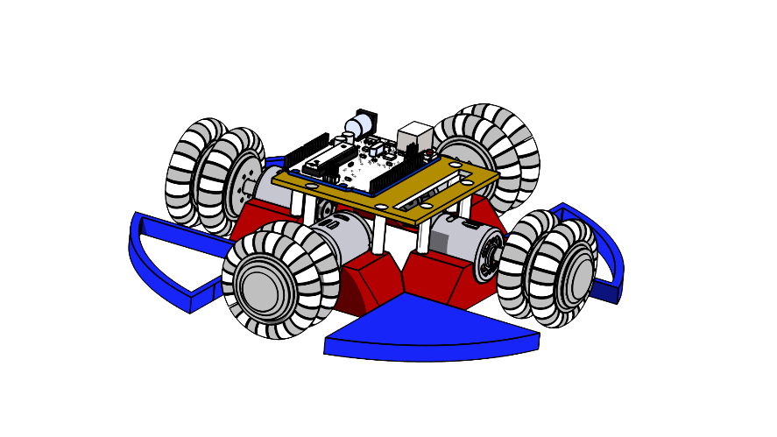

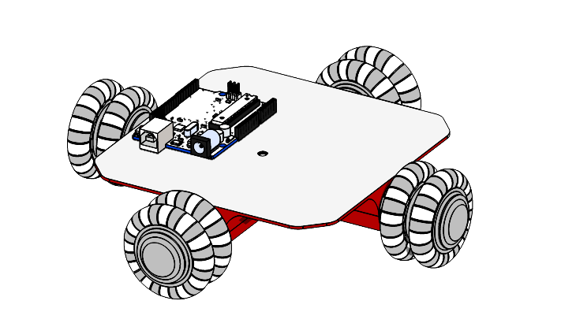

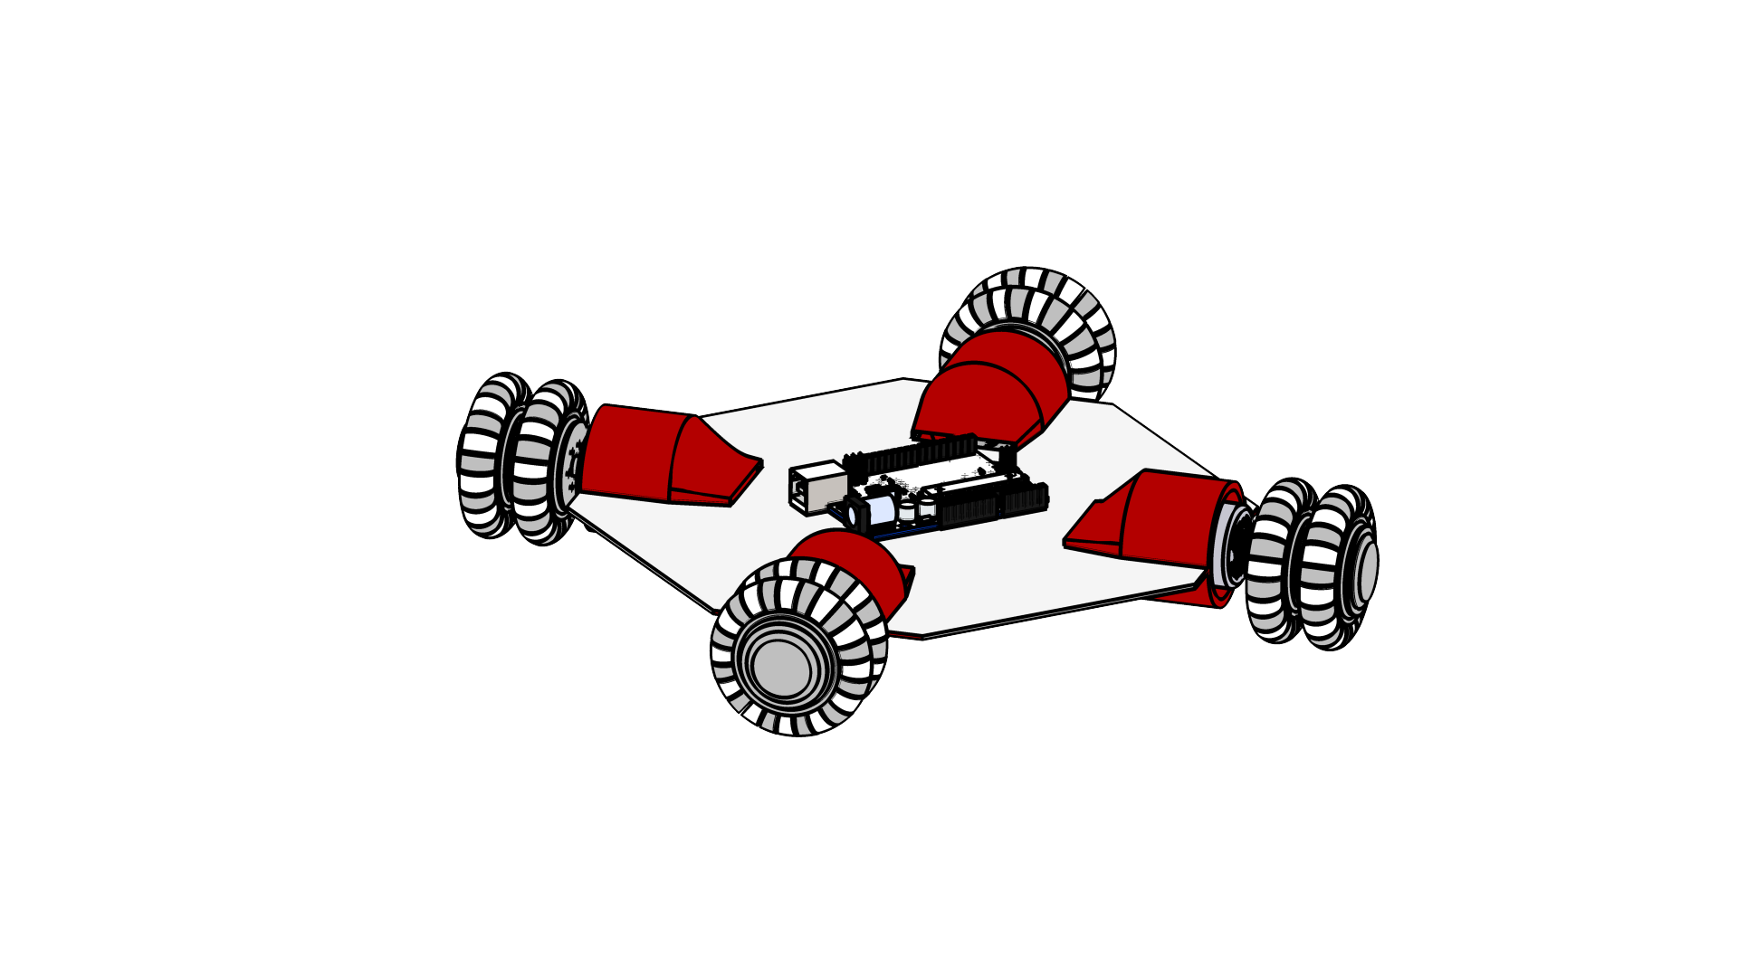

Figure ROSS_FIGURE_2: Initial Car Sketches [ROSS_REF_1,2]

Each design be originally based off a different placement of the wheels, then additional features were added around this. The design were also colour coded in order to help distinguish their features, the first design to be created was the circular frame shown in figure ROSS_FIGURE_3

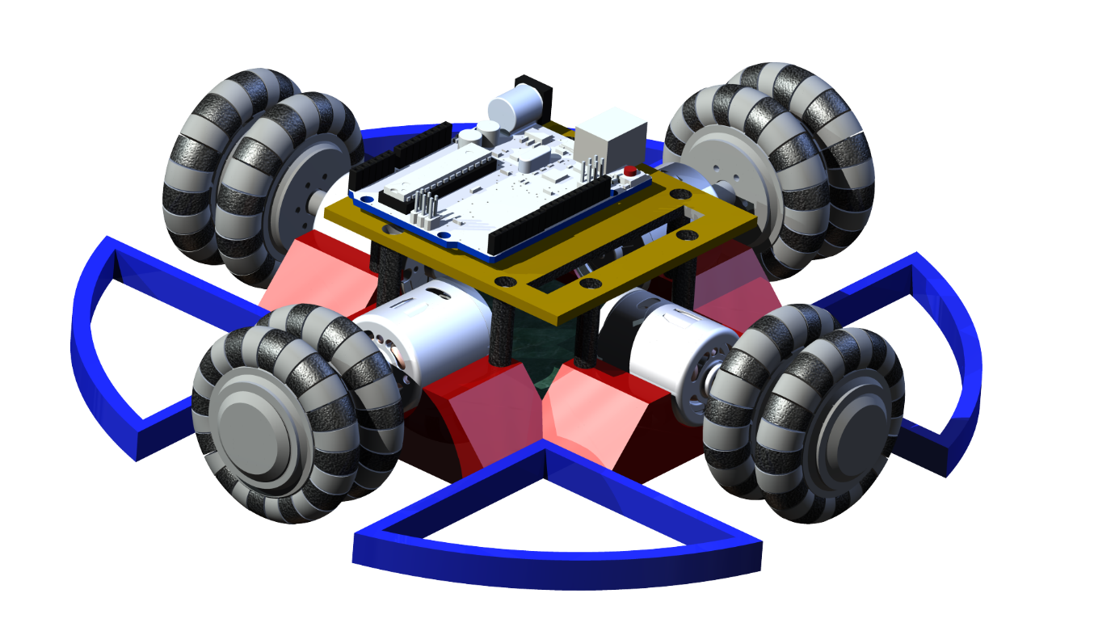Figure ROSS_FIGURE_3 : Circular Frame Design [ROSS_REF_1,2]

This design used the blue arcs positioned around the centre of the car in order to protect the wheels from any possible impact, they were also hollowed in order to give the structure some flexibility to better withstand any collision. The design also used the red structures to hold in motors in place, the green area positioned behind motors would be used to connect the drive board to the motors and to the microcontroller on the level above using the large rectangular hole to pass though wires. The top gold section would also be removable for easy assess to the connections.

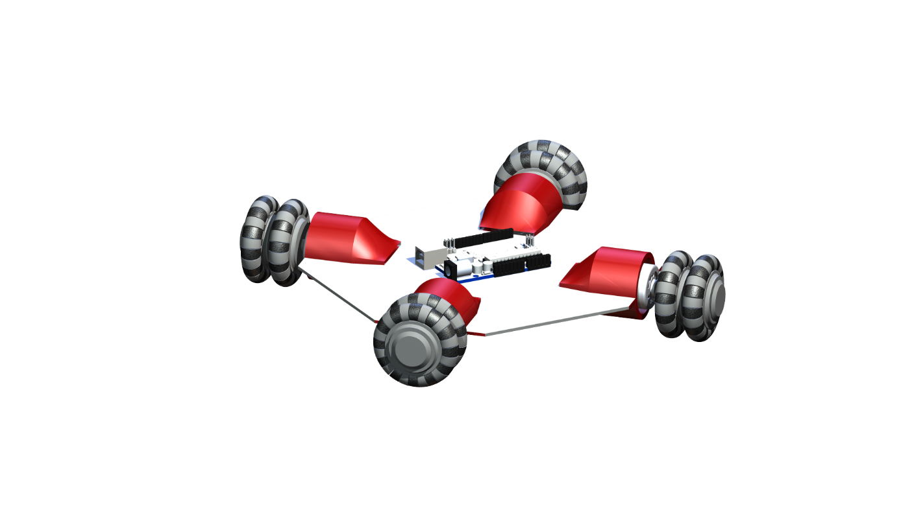

Figure ROSS_FIGURE_4 : Corner Wheel Design [ROSS_REF_1,2]

The next design to be created used the idea of securing the motors in a housing and extended it, by fully encapsulating the motors, as shown above in figure ROSS_FIGURE_4, by the red motor housings. This change in design mean the microcontroller could be positioned in the centre of the car without having to stack components. The connections to the motors would be wired though holes at the inside end of the enclosure, allowing them to be easily connected. The middle of the white top, contains holes to allow circuitry to be passed though to the underside of the car.

The final design used ideas from both previous designs; this is shown below in figure ROSS_FIGURE_5

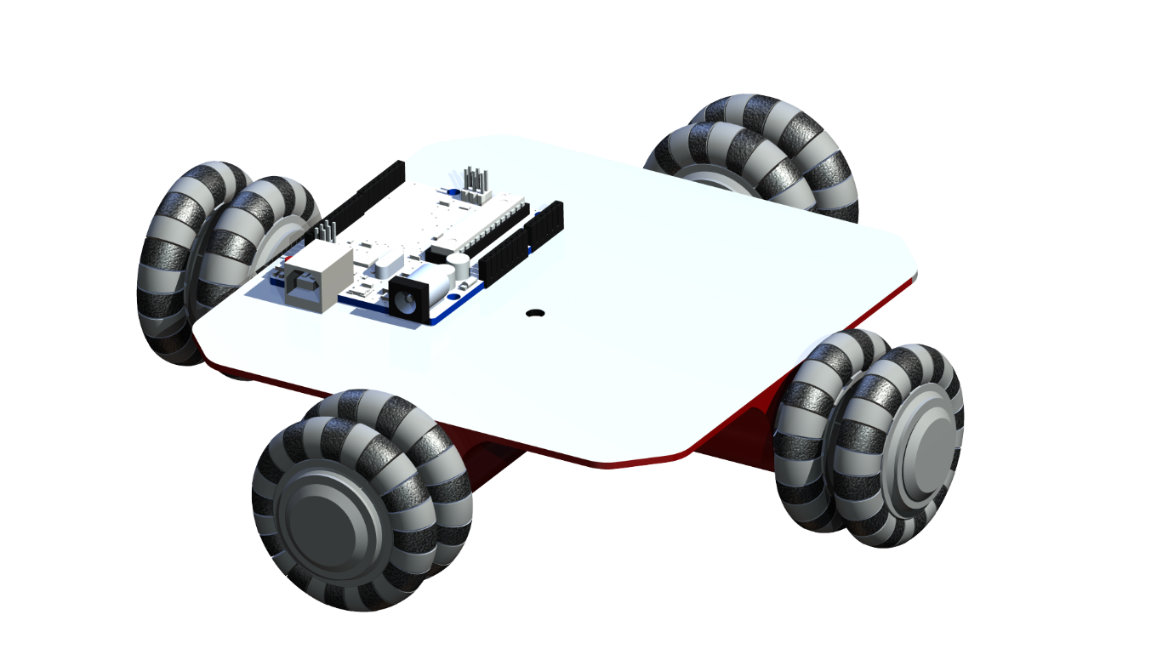

Figure ROSS_FIGURE_5: Square Frame Design [ROSS_REF_1,2]

The red housing the motors is once again used, however they are mounted on the under side of the car time. This allowed for a large area on the top of the car for all the components we require, as with the previous design holes in the top surface allow for circuity to connect to the motors underneath.

The next stage in the process of deciding on the best design involved integrating with other members of the time to get an idea of the components they would like to place on the car. One of the major components that we required for the pen holding and lifting mechanism. In order to see how this would look on each of the designs it was added to the design sketches. The updated sketches are below in figure ROSS_FIGURE_6

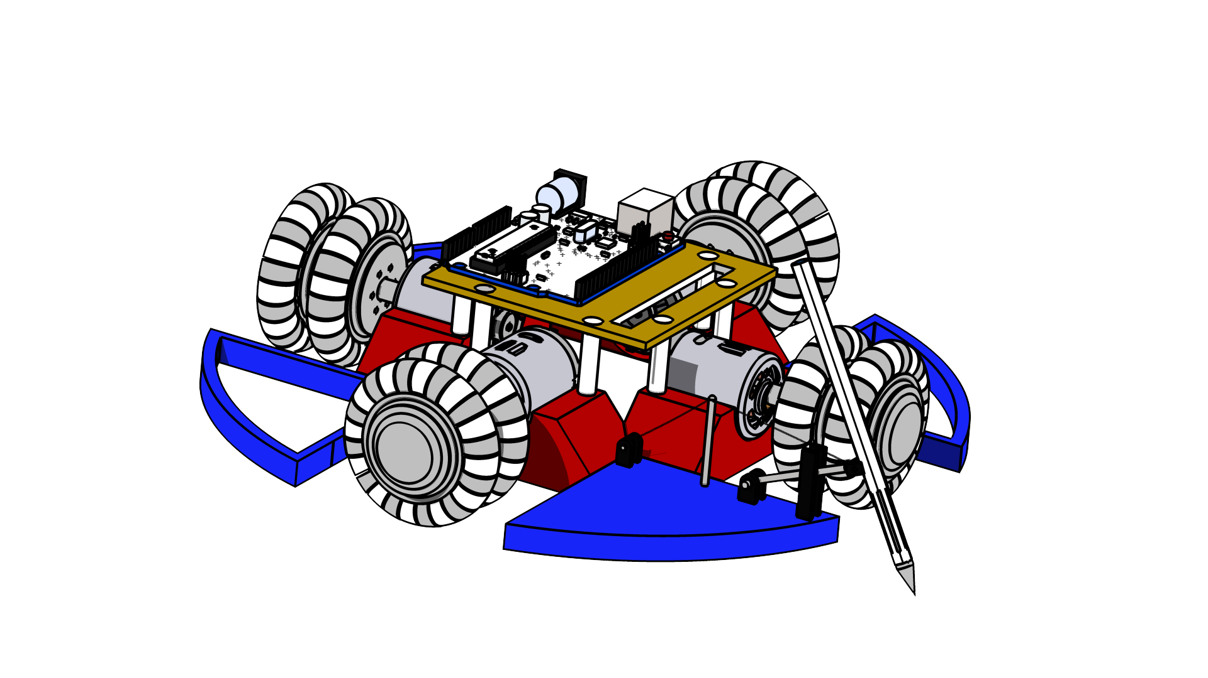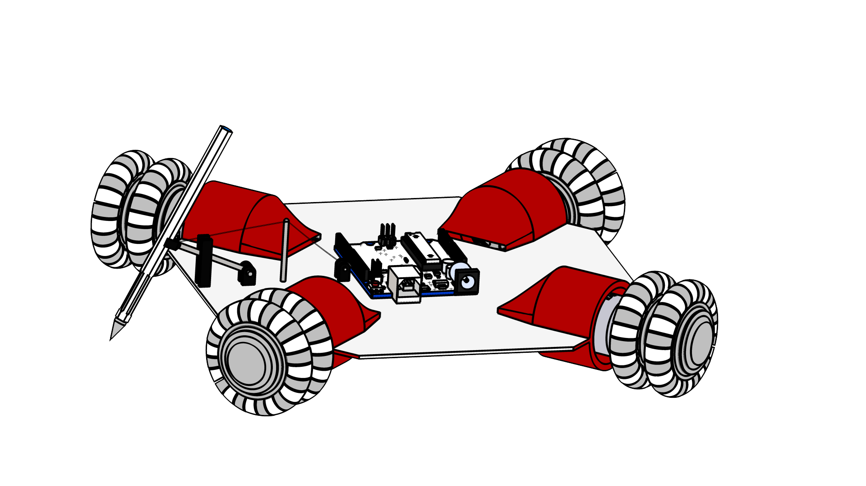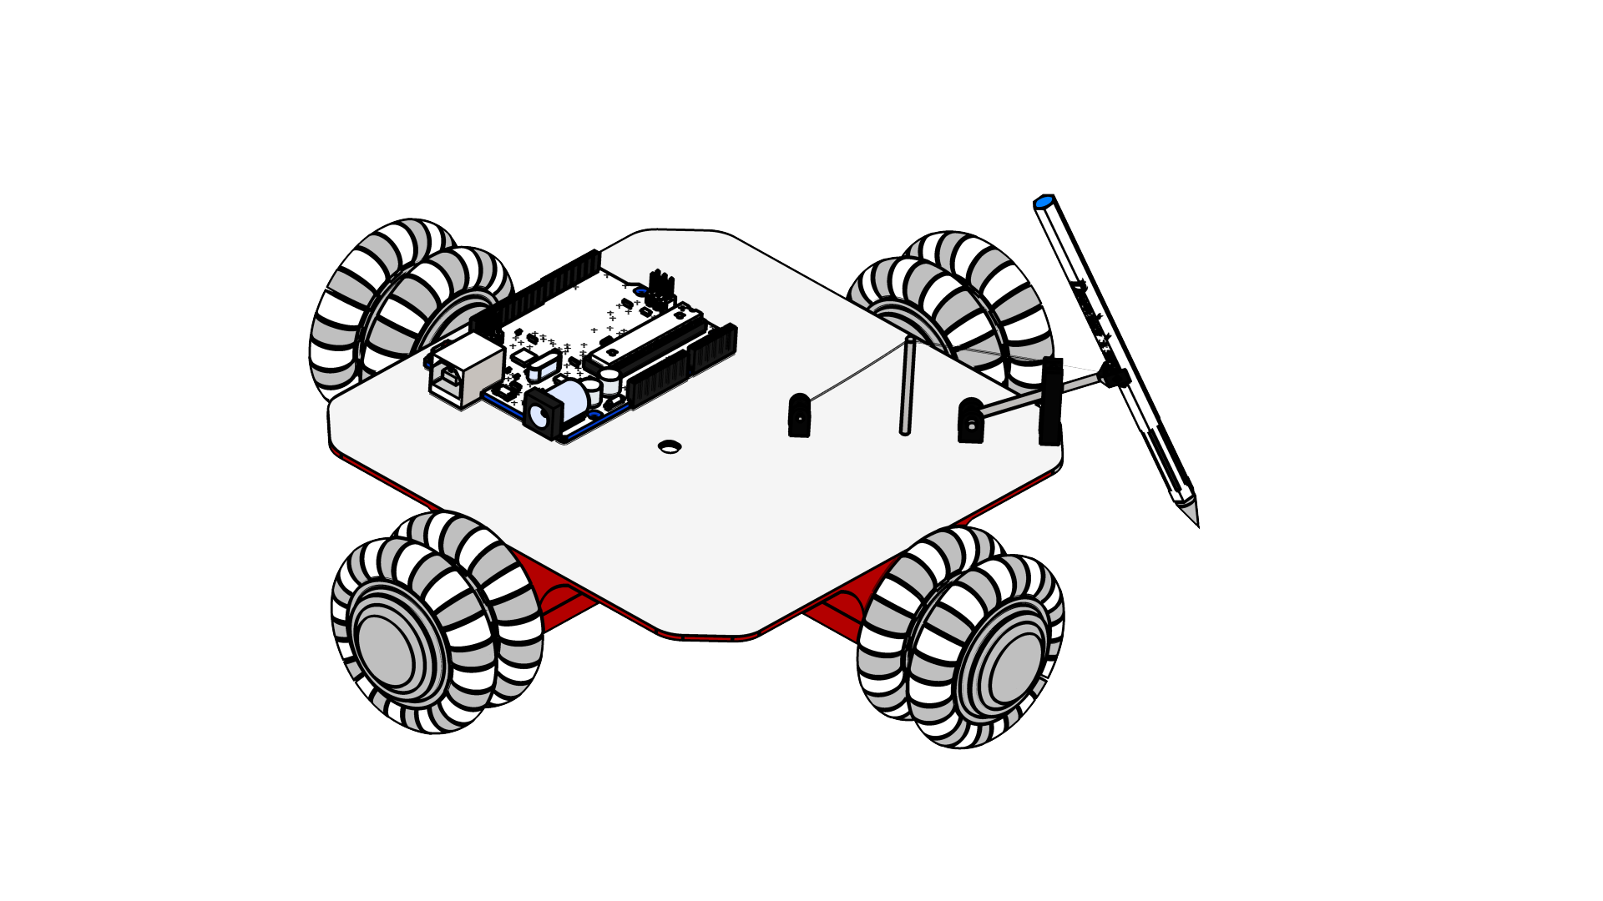

Figure ROSS_FIGURE_6: Sketches with Pen Mechanism [ROSS_REF_3]

While also considering the addition of a battery to power the idea, it was decided that the circular design would not have enough room to store all the required components, without changing the design. This can be shown clearly in the sketches, which show that even to fit the pen holder mechanism one of the blue wheel protectors had to be filled in, so support the mechanism. Since the battery required to power the car would be quite large, it could not fit on one of the wheel protectors. Due to these reasons this design was dropped from the running. This left the square and corner designs which are shown below with the addition of the pen mechanism below, in figures ROSS_FIGURE_7 and ROSS_FIGURE_8.

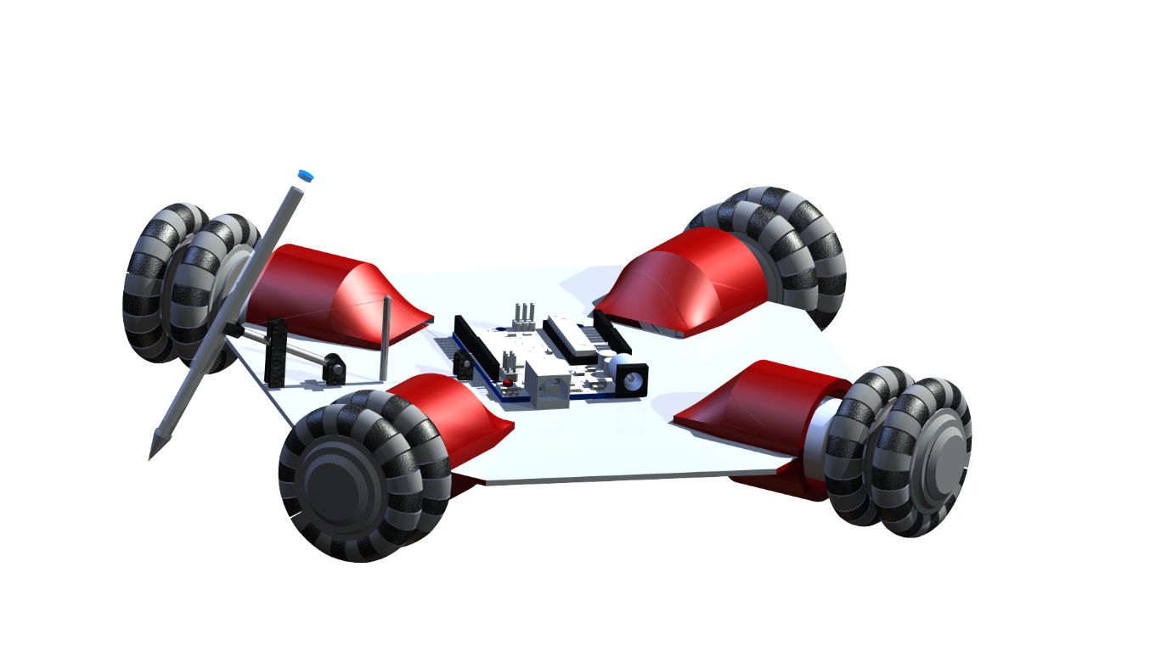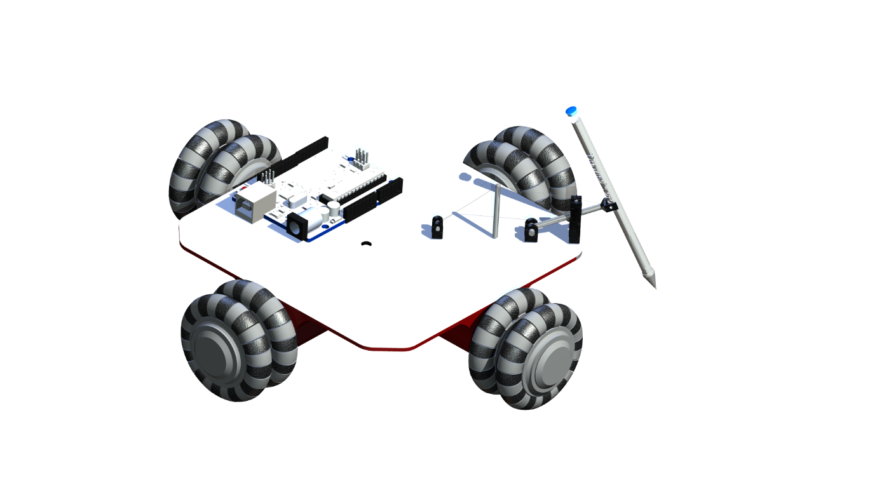

Figure ROSS_FIGURE_7: Corner Design with Pen Mechanism [ROSS_REF_3]

As can clearly be seen, both the Corner and Square designs can easily accommodate the pen mechanism. There is also enough room on both designs to store the required battery, just on the top in the square design and underneath in the Corner design. So since both these designs would be suitable the group discussed with design they preferred on aestheticaics, and the decision to go with the square design was made.

Designs made with using some open source models

[ROSS_REF_1] - https://grabcad.com/library/arduino-uno-4

[ROSS_REF_2] - https://grabcad.com/library/dc-motor-12v#

[ROSS_REF_3] - <https://grabcad.com/library/pen-78>

Figure ROSS_FIGURE_8: Square Design with Pen Mechanism [ROSS_REF_3]