The software design of the system will be broken into two main components, software for the android application and software for the microcontroller on the device itself. Since Bluetooth will be used to transmit the messages using a string format. These parts can be developed independently provided both sides adhere to the agreed standard serialisation format.

In order to assist and creation of this software, it was decided to create UML diagrams so that each member of the team would know how their section interacted with the overall system and what basic structure to follow. The initial design for the Android Application is shown below in figure ROSS_FIGURE_1, the chosen design uses interfaces and ‘Mock objects’ to allow the testing of separate components without the whole system having to be finished. This also allows for the system to be created concurrently. Since the application should be relatively simple with only one page and a dropdown. This can easily be created using the standard MainActivity class in Android which using built in libraries is able to create the required visual elements defined by XML and data defined in the class. The CalulateCoord class will also use existing android library functions to track the user’s finger movement to detect once they have finished inputting their drawing which will automatically start the transmission process.

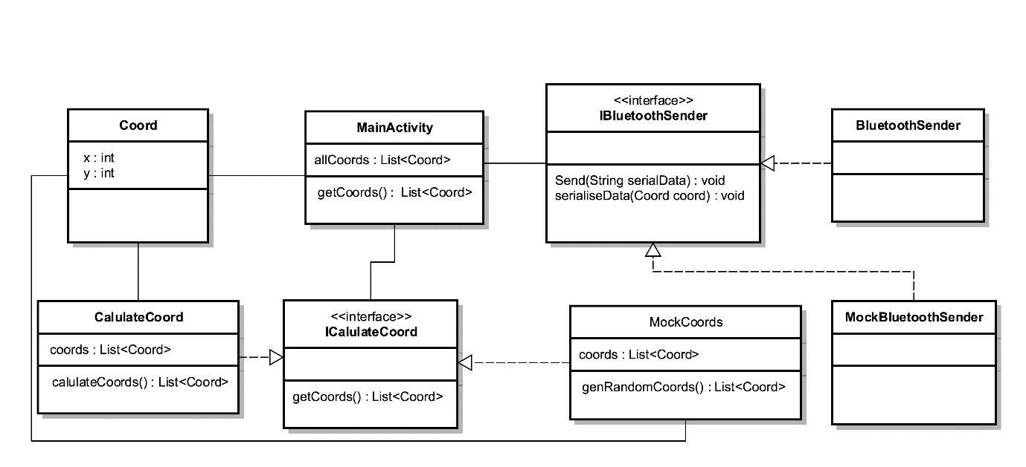

Figure ROSS_FIGURE_1 : Initial UML Diagram of Android Application

A similar idea was used for the car’s software system, however since this would be programmed in C, where the language doesn’t support interfaces, header files will be used in place. These will provide the same functionary of ensuring both the real and the mock implementations use consistent method signatures, this will allow for the ability to swap out the mock files in favour of the real ones, once the software has been transferred onto the microcontroller. Additionally while testing and developing the mock files can be used to call the methods required which will have a simple print statement to show the developer the code is working correctly. This is shown below in figure ROSS_FIGURE_2

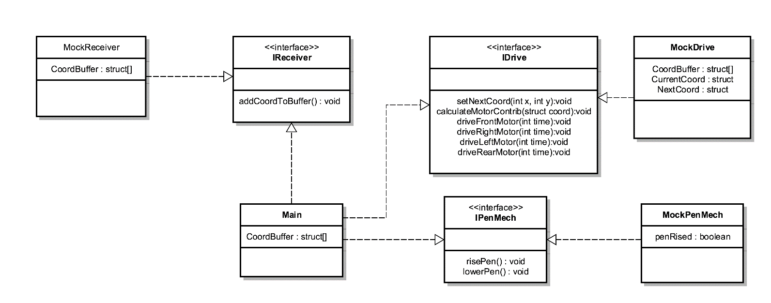

Figure ROSS_FUGURE_2 : initial Car Software Design