Table of Contents
Introduction 1
Tool Use 1
Example 1

CADStat: Statistical Tools for Causal Analysis

Correlation Analysis

Introduction
Correlation is the degree to which two sets of data are linearly associated. The standard method of computing a correlation is the Pearson's correlation coefficient. In addition to this method there are several other methods of computing correlation, including Kendall's Tau and Spearman's rank correlation coefficient. All of these measures of correlation can be used to test the correlation of variables in paired datasets.

Tool Use
Select Analysis Tools -> Correlation Analysis from the menus. A dialog box will open. Select the data set of interest from the pull-down menu, or browse for a tab-delimited text file. The Data Subsetting tab can be used to select a subset of the data file by choosing a variable from the pull down menu and then selecting the levels of that variable to include. You may control-click to add a single level, or shift-click to add a group of levels.
A list of variables will appear in the center of the dialog box. Select all variables of interest. You may control-click to add a single variable, or shift-click to add a group of variables. At least two variables must be chosen.
Select the type of correlation to compute, under Method.
You may choose to produce scatter plots for visual inspection of the pairwise variable relationships by selecting Create Scatterplot Matrix. You may choose to have confidence intervals calculated for the correlation between each pair of variables by selecting Compute Confidence Intervals. You can change the confidence level for the confidence intervals only after you have selected the option to calculate the confidence intervals.
The output is a correlation matrix, along with scatterplots and confidence intervals if requested.

Example
First launch the correlation analysis dialog by selecting Analysis Tools -> Correlation Analysis (see below).

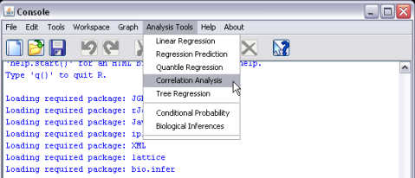
Once this option is selected, a dialog window will appear. Select mergedData as your active dataset (refer to help pages on Loading and merging data to find out how to load CADStat example data).
Hold the <CTRL> key down and select at least two variables. Also select the correlation method, and whether you would like confidence intervals calculated or scatter plots generated. Only one method of correlation computation can be selected at a time.

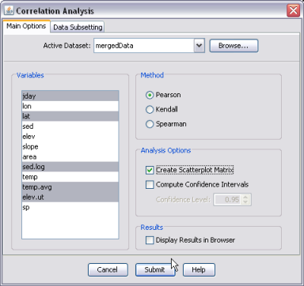
The correlation coefficient matrix and confidence intervals are printed to the CADStat console, and the scatterplot matrix appears in the plot window.
