Table of Contents
Introduction 1
Input files 1
Output file 1

CADStat: Statistical Tools for Causal Analysis

Predicting environmental conditions from biological observations

Introduction
This module estimates environmental conditions from observations of benthic macroinvertebrates for a set of sites, by combining observations of each particular taxon with a taxon-environment relationship. This calculation has three steps. First, observations of benthic macroinvertebrates are matched with standard taxonomic names, with a full taxonomic hierarchy. Second, operational taxonomic units (OTUs) are defined for the data set, so that each individual taxon is counted at a consistent taxonomic level. Third, observations are matched with existing taxon-environment relationships and an estimate of environmental conditions computed.
The module is initiated by choosing Analysis Tools -> Predicting env. conditions from biological observations from the menus. A dialog box should appear as follows:

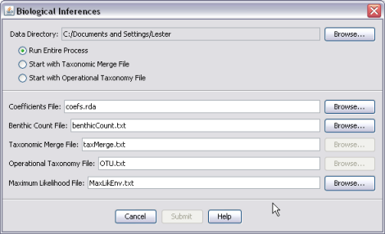

The Data Directory can be specified to indicate the default location that you wish to search for input files and write output files. Unless the browse buttons for individual files are used to specify other directories, all input and output comes from this directory.
Note: Changing the data directory does not change the working directory for R, only for the default locations of the input/output files for this module.
There are three options for starting points for running this module. By default, the entire process should be run. However, since the first two steps of the process may require some feedback, these steps can be skipped in subsequent runs to reduce user effort.
- Run Entire Process – This option is the default setting. It begins with the benthic macroinvertebrate count file and runs all steps required for: merging taxonomy with a standard taxonomic hierarchy from the Integrated Taxonomic Information System (ITIS), generating OTUs corresponding to the coefficient file, and computing maximum likelihood estimates of environmental conditions. Output files include an merged taxonomic file, an OTU file, and a maximum likelihood file.
- Start with Merge Taxonomic Merge File – This option assumes that the tool has been run previously to merge taxonomy of the benthic macroinvertebrate count file with a standard taxonomic hierarchy. The benthic macroinvertebrate file is not necessary for input, as the merged taxonomic file is read as input for the starting point. Output files include an OTU file and a maximum likelihood file. This option is recommended only for experienced users.
- Start with Operational Taxonomy File – This option assumes that the tool has been run previously to merge taxonomy of the benthic macroinvertebrate count file with a standard taxonomic hierarchy and to generate OTUs. The benthic macroinvertebrate file and the taxonomic merge file are not necessary for input, as the OTU file is read as input for the starting point. Only one output file is generated – the maximum likelihood file. This option is recommended only for experienced users.

Input files
Coefficients file: This file is an R data file (e.g., .rda or .rdata) that contains the taxon-environment relationships. At the present time only one coefficient file is available: coef.west.wt.rda, which provides relationships for stream temperature and percent substrate sand/fines for macroinvertebrates of western U.S. streams. Select this file from the default directory that appears when the Browse button is selected.
Benthic Count File: This file contains the observations of benthic macroinvertebrate. The file should be supplied as tab-delimited text. Three columns in the following order are required: (1) Sample identifier, (2) taxon name, and (3) taxon abundance.
Example:
SITE.ID TAXANAME ABUNDANCE
A01 SWELTSA SP. 1
A01 HYDROPSYCHIDAE 5
. . .
. . .
A02 BAETIS SP. 50

Taxonomic Merge File: If Run Entire Process is chosen, this file is the result of the merge between local macroinvertebrate observations and a standard taxonomic hierarchy. If Start with Merge Taxonomic Merge File is chosen, this file is the starting input file. The format of the file is tab-delimited text.
Operational Taxonomy File: If “Start with Operational Taxonomy File” is chosen, it is the starting input file. See above.

Output file
Maximum likelihood File: This file is the saved output of this module. It is a tab-delimited text file, with at least three columns: 1) Site name; 2) Maximum likelihood estimate of environmental conditions; 3) An indicator of whether or not multiple maximum likelihood estimates were found – “TRUE” here indicates that global convergence was not attained. The number of columns may increase, depending on how many environmental parameters are estimated simultaneously.

