Table of Contents
Introduction 1
Tool Use 1
Example: EPT and Percent Fines in the Substrate 1

CADStat: Statistical Tools for Causal Analysis

Conditional Probability

Introduction
Conditional probability is the probability of some event, given the occurrence of some other event. In causal analysis, we are often interested in quantifying the level of a stressor (e.g., nutrient concentration) at which the probability of a biological response (e.g., IBI less than a criterion value) is relatively high. Conditional probability analysis can be used to identifying such thresholds.

Tool Use
Select Analysis Tools -> Conditional Probability from the menus. A dialog box will open. Select the data set of interest from the pull-down menu, or browse for a tab-delimited text file. The Data Subsetting tab can be used to select a subset of the data file by choosing a variable from the pull down menu and then selecting the levels of that variable to include. You can hold down the <CTRL> key to select several levels.
Select Stressor and Response variables from the pull-down menu. If each sample in your data set represents a different proportion of your population (e.g., data collected using a stratified random sampling design), you can Specify a weighting variable that provides the relative weight for each sample.
Assign a Response Cutoff Value. This value defines the threshold for defining your response of interest. For example, if your response is an IBI, the Response Cutoff Value would be the criterion value for your IBI below which the site is assess as biologically impaired. Selection of the Cutoff Value Direction depends on whether you expect the value of your response to increase or decrease with stress. For IBI, which decreases with stress, Cutoff Value Direction would be Less Than.
Probability Direction defines the direction in which you would like to assess the stressor level. For a stressor whose severity increases with increasing values (e.g., percent fines), you should select Greater Than or Equal. Other stressors (e.g., pH) increase in severity as their value decreases, in which case you would select Less Than or Equal.
Selecting Bootstrap confidence intervals directs the tool to repeatedly resample the data set to estimate confidence intervals on the estimate relationship.
You may change the axes labels and plot title by typing them in the Plot Labels dialog.
The output is a graph of the fitted probability (that the dependent variable is less than the conditional value) versus the independent variable.

Example: EPT and Percent Fines in the Substrate
For this example, first load the CADStat example data entitled eptpctfin.txt (see Loading and merging data help page for how to navigate to and load CADStat example data). Then, launch the conditional probability tool by selecting Analysis Tools -> Conditional Probability.

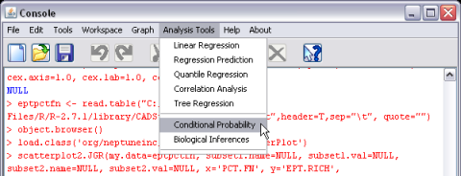
In the next dialog box, you can select different options for computing a conditional probability plot.

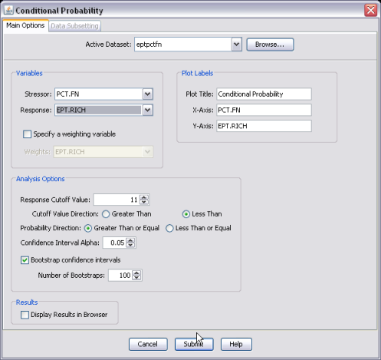
The response variable in the case is the total richness of EPT (Ephemeroptera + Plecoptera + Trichoptera) taxa (EPT.RICH). The explanatory variable in this data set is PCT.FN, a measure of the percentage of fine particles in the stream substrate.
The calculation of a conditional probability for a given value of PCT.FN is a two-step process: first, samples are selected exceeding the given value of PCT.FN, and second, the fraction of the selected samples for which the response variable falls below a specified threshold (e.g., EPT.RICH < 11) is computed. This process is repeated for the entire range of observed PCT.FN values. The result is an empirical curve for probability of impact for streams exceeding PCT.FN. In the dialog box, after selecting response and explanatory variables, the Response Cutoff Value of the response variable can be specified.
The selection of the Response Cutoff Value defines the occurrence of a biological impact in terms of EPT.RICH. In the example presented here, a sample with an EPT.RICH < 11 is used to define an impact. PCT.FN is selected as the explanatory (independent) variable since it is of interest to see how the probability of impact changes for different values of percent fines in the substrate. Labels for the axes and title of the plot can be changed in this box as well. Once the values of interest are selected, the submit button should be selected to generate a plot.
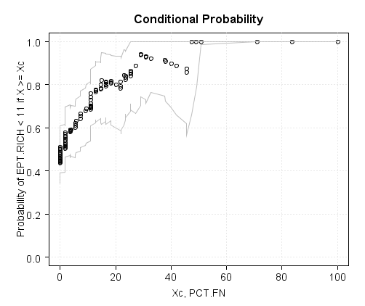
The probability of a biological impact (as defined by EPT.RICH < 11) increases as PCT.FN increases. When PCT.FN = 0, the probability of a biological impact is about 0.45, but this probability increases markedly as PCT.FN increases. When PCT.FN > 50, no sites have EPT.RICH that exceeds 11. The bootstrap confidence limits around the relationship are broad, suggesting that there is a substantial degree of uncertainty in the estimated relationship.

