myreport

06-18-21

Table of Contents

1 Overall 1

2 Theta 1

3 IWRES vs IVAR 2

4 DV vs IVAR 3

# Overall

Table Overall

| ofv | nobs | nind | nparm | -2LL | AIC | BIC |
| --- | --- | --- | --- | --- | --- | --- |
| -1403.905 | 476 | 74 | 11 | 2,807.8100 | 2,829.8100 | 2,855.1547 |
| Source: scriptxyz.R | | | | | | |

# Theta

Table Theta

| name | label | value | se | rse | fixed |
| --- | --- | --- | --- | --- | --- |
| THETA1 | TVCL | 26.2900 | 0.8915 | 0.0339 | FALSE |
| THETA2 | TVV | 1.3480 | 0.0438 | 0.0325 | FALSE |
| THETA3 | TVKA | 4.2040 | 0.8091 | 0.1925 | FALSE |
| THETA4 | LAG | 0.2080 | 0.0157 | 0.0755 | FALSE |
| THETA5 | Prop. Err | 0.2046 | 0.0224 | 0.1097 | FALSE |
| THETA6 | Add. Err | 0.0106 | 0.0037 | 0.3466 | FALSE |
| THETA7 | CRCL on CL | 0.0072 | 0.0017 | 0.2366 | FALSE |
| Source: scriptxyz.R | | | | | |

# IWRES vs IVAR

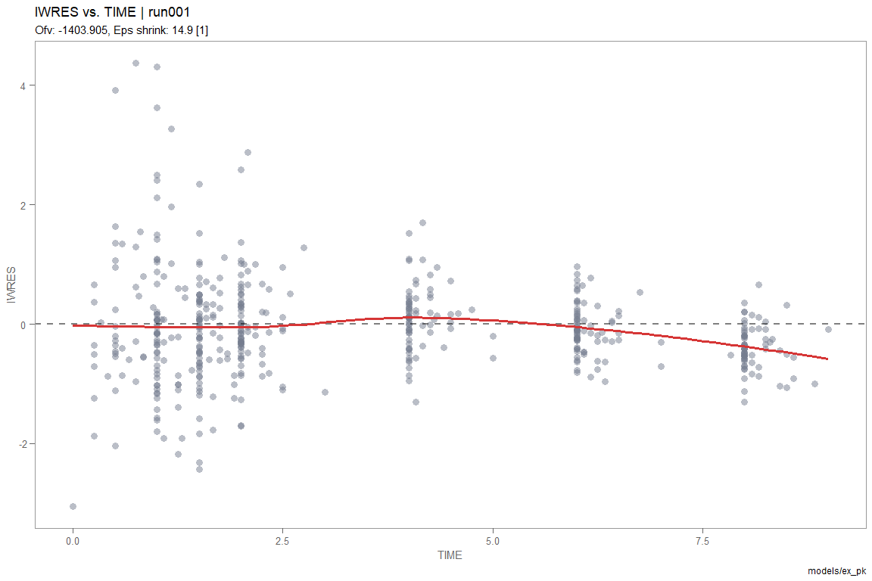

Plot Caption

# DV vs IVAR

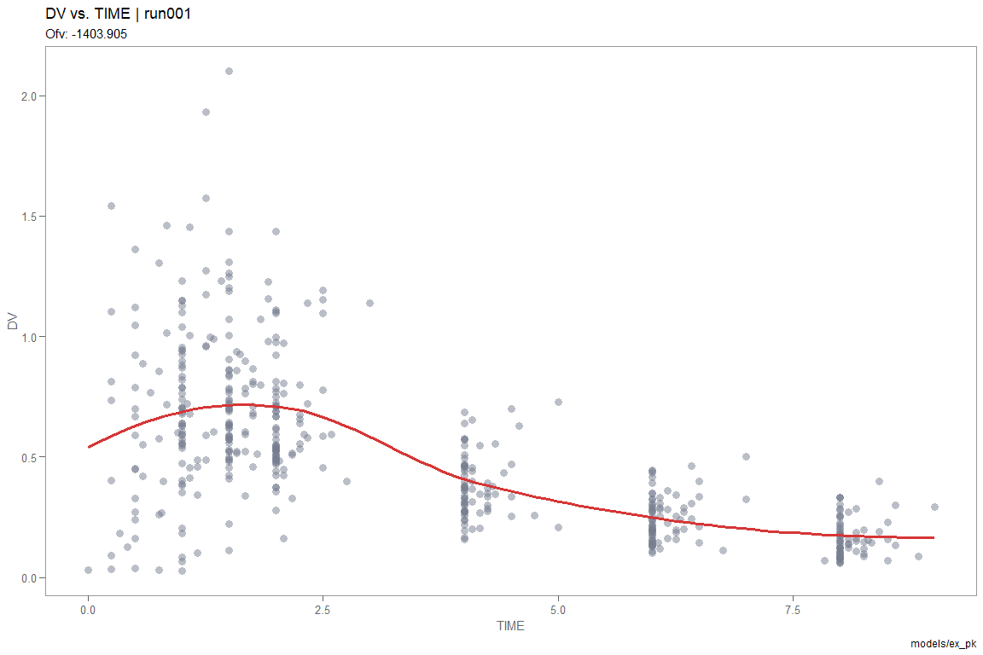

Plot Caption