%PROJECT% - %PACKAGE%

%TASK%

%AUTHOR%

%DATE%

Table of Contents

# ===================== HELPER CODE ==========================  
{  
 library(D4TAlink.light)  
 try(require(D4TAlink))  
 setTaskSponsor("%SPONSOR%")  
 setTaskStructure(pathsDefault)  
 try(setTaskRoot("%ROOT%"))  
  
 # load the task  
 task <- loadTask(project="%PROJECT%", package="%PACKAGE%", taskname="%TASK%")  
   
 # render the task  
 renderTaskRmd(task)   
   
 # archive the task to the home directory  
 archiveTask(task,zf<-paste0("~/",task$task,".zip"),overwrite=FALSE)  
   
 # settings for new repository  
 oro <- getTaskRoot()   
 setTaskRoot("/PATH/TO/NEW/REPOSITORY")  
 ost <- getTaskStructure()   
 setTaskStructure(pathsDefault)  
  
 # copy the task to a new repository  
 newtask <- restoreTask(zf)  
 print(list.files(getTaskPaths(newtask)$data,  
 full.names=FALSE,recursive=TRUE))  
   
 #restore old settings  
 setTaskRoot(oro)   
 setTaskStructure(ost)  
}  
# ============================================================

# p  
# Please enter password in TK window (Alt+Tab)

# Error in setTaskRoot("%ROOT%") : root directory does not exist

# Error in get(x = "rootpath", pos = .pkgEnv): object 'rootpath' not found

# Error in eval(expr, envir, enclos): object 'task' not found

# Scope

In this section the scope / rationale of the task should be explained.

# Input

The section list the information and data sources.

* List of patients (see email by JD dated 2022-05-01 17:12).
* List of assays (see task 20220102_loadAssays).

# Methods and Results

The results-section contains more details regarding the results of task X.

## Table

**Table** **:** caption 1

| l | L |
| --- | --- |
| a | A |
| b | B |
| c | C |
| d | D |
| e | E |
| f | F |

## Plot

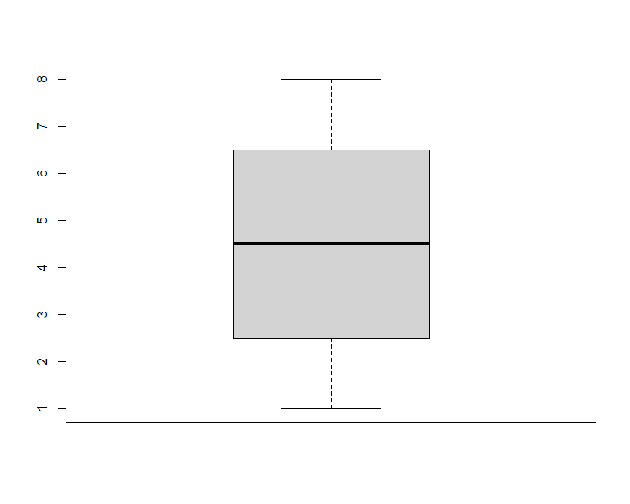

**Figure** **:** A boxplot

# Output

The section contains detailed information on output (incl. location).

* List of assays.

# References

1. R Core Team (2022). R: A language and environment for statistical computing. R Foundation for Statistical Computing, Vienna, Austria. URL <https://www.R-project.org/>.

# Appendices

## Session information

R version 4.2.1 (2022-06-23 ucrt) Platform: x86_64-w64-mingw32/x64 (64-bit) Running under: Windows 10 x64 (build 19043)

Matrix products: default

locale: [1] LC_COLLATE=English_Ireland.utf8 LC_CTYPE=English_Ireland.utf8  
[3] LC_MONETARY=English_Ireland.utf8 LC_NUMERIC=C  
[5] LC_TIME=English_Ireland.utf8

attached base packages: [1] stats4 stats graphics grDevices utils datasets methods  
[8] base

other attached packages: [1] xml2_1.3.3 svglite_2.1.0 getPass_0.2-2  
[4] D4TAlink_0.8 Biobase_2.56.0 BiocGenerics_0.42.0  
[7] httr_1.4.4 devtools_2.4.5 usethis_2.1.6  
[10] gdata_2.18.0.1 sn_2.1.0 pROC_1.18.0  
[13] coin_1.4-2 survival_3.4-0 namespace_0.9.1  
[16] rjson_0.2.21 RUnit_0.4.32 D4TAlink.light_2.1.10 [19] openssl_2.0.4 rmarkdown_2.17 jsonlite_1.8.2  
[22] officer_0.4.4 officedown_0.2.4

loaded via a namespace (and not attached): [1] pkgload_1.3.0 splines_4.2.1 gtools_3.9.3  
[4] shiny_1.7.2 askpass_1.1 yaml_2.3.5  
[7] remotes_2.4.2 sessioninfo_1.2.2 gdtools_0.2.4  
[10] numDeriv_2016.8-1.1 lattice_0.20-45 glue_1.6.2  
[13] uuid_1.1-0 digest_0.6.29 promises_1.2.0.1  
[16] sandwich_3.0-2 htmltools_0.5.3 httpuv_1.6.6  
[19] Matrix_1.5-1 plyr_1.8.7 purrr_0.3.5  
[22] xtable_1.8-4 mvtnorm_1.1-3 processx_3.7.0  
[25] later_1.3.0 ellipsis_0.3.2 TH.data_1.1-1  
[28] cachem_1.0.6 cli_3.4.1 mnormt_2.1.1  
[31] magrittr_2.0.3 crayon_1.5.2 mime_0.12  
[34] memoise_2.0.1 evaluate_0.17 ps_1.7.1  
[37] fs_1.5.2 MASS_7.3-58.1 pkgbuild_1.3.1  
[40] profvis_0.3.7 tools_4.2.1 prettyunits_1.1.1  
[43] lifecycle_1.0.3 matrixStats_0.62.0 multcomp_1.4-20  
[46] stringr_1.4.1 zip_2.2.1 callr_3.7.2  
[49] compiler_4.2.1 systemfonts_1.0.4 rlang_1.0.6  
[52] grid_4.2.1 rstudioapi_0.14 htmlwidgets_1.5.4  
[55] miniUI_0.1.1.1 tcltk_4.2.1 codetools_0.2-18  
[58] curl_4.3.3 R6_2.5.1 rvg_0.2.5  
[61] zoo_1.8-11 knitr_1.40 fastmap_1.1.0  
[64] libcoin_1.0-9 modeltools_0.2-23 stringi_1.7.8  
[67] parallel_4.2.1 Rcpp_1.0.9 urlchecker_1.0.1  
[70] xfun_0.33

## List of figures

## List of tables