Converting ModelMap output to ArcMap

In ArcCatalog, Open toolbox 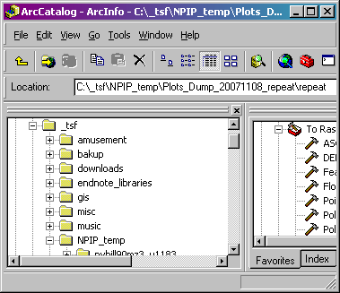:

(1) Convert ASCII output file to an ArcInfo raster Grid.
From Arc Toolbox navigate to Conversion Tools … To Raster … and open ASCII to Raster.

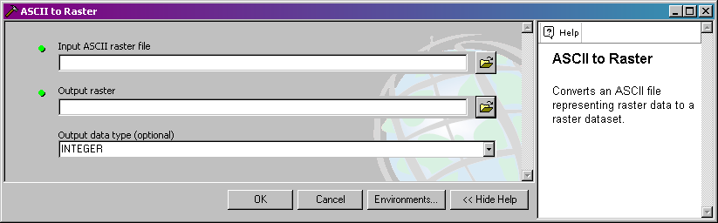

Parameters:
Input ASCII raster file – Browse to output ASCII file.
Output raster – Browse to directory for output raster and change name of default if desired.
Note: the name must be 13 characters or less.
Output data type (optional) – Integer or Float

(2) Define projection of ArcInfo raster Grid.
From Arc Toolbox navigate to Projections and Transformations … Raster … and open Define Projection.

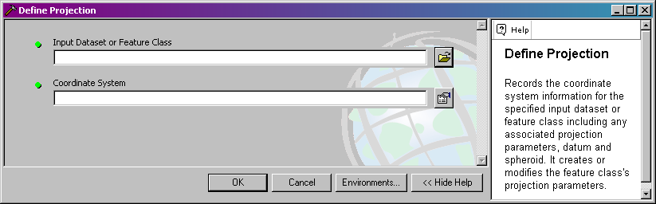

Parameters:
Input Dataset or Feature Class – Browse to output Grid raster.
Coordinate System – Click on icon and in pop-up window, click on Import…
Browse to an input predictor raster with projection information already defined.
Click OK.

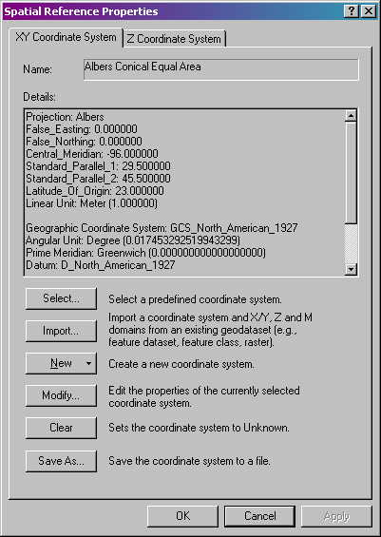

(3) Open ArcMap and Add Layer.

