> critic(t=time3,Y=sit,dinf=0,dsup=90,durinf=2,dursup=80,nperm=5000,grtype="filledcontour")
Critical correlogram
------------------------

Name of the series : year
length of the basic series : 365

Lower beginning 0
Upper beginning 90
Minimal span 2
Maximal span 80
Matrix dimension : 91 79

Maximum correlation : 0.9808761
Beginning of the period: 35
Span of the period: 45
Ordinary confidenceInterval: 0.8717195 0.9972838
p-value : 9.614559e-05

Number of random permutations: 5000
Estimated p-value (random permutations): 0.0076

Bootstrap with wy2
red : pseudovalues
S)

Simulation. Données time3, Y obtenu par
> Y=2+0.01*S+rnorm(7,0,0.1);plot(S,Y)
> z=critic(t=time3,Y=Y,dinf=0,dsup=90,durinf=2,dursup=80,nperm=0,nboot=1000,grType="contour",ps.print=F)
Critical correlogram
====================

J.S.Pierre - 2015

Data type: Without replicates

Name of the series : year
length of the basic series : 365

Lower beginning 0
Upper beginning 90
Minimal span 2
Maximal span 80
Matrix dimension : 91 79

Maximum correlation : 0.9882426
Beginning of the period: 40
Span of the period: 44
Ordinary confidenceInterval: 0.9194228 0.9983354
p-value : 2.860795e-05

Number of random permutations: 0
Estimated p-value (random permutations): NA

Bootstrap estimation
====================

pseudovalues
============

Bootstrap estimator for best correlation : 0.9919657
Bootstrap estimator for beginning of the period: 36.53273
Bootstrap estimator for length of the period: 39.07049
standard erro on rhomax : 0.01897882

Standard error for best correlation : 0.01897882
Confidence interval for best correlation (alpha = 0.05 ):
Lower : 0.9547679
Upper : 1.029164

Covariance and correlation matrix of the two dimensions of the period :
======================================================================

Number of calculable pseudovalues : 1000
begin dur
begin 312.8137 -130.1213
dur -130.1213 438.3579
Correlation beginning-duration:
begin dur
begin 1.0000000 -0.3513913
dur -0.3513913 1.0000000
There were 11 warnings (use warnings() to see them)

> z=critic(t=time3,Y=Y,dinf=0,dsup=90,durinf=2,dursup=80,nperm=0,nboot=1000,grType="contour",ps.print=F)
Critical correlogram
====================

J.S.Pierre - 2015

Data type: Without replicates

Name of the series : year
length of the basic series : 365

Lower beginning 0
Upper beginning 90
Minimal span 2
Maximal span 80
Matrix dimension : 91 79

Maximum correlation : 0.9993872
Beginning of the period: 41
Span of the period: 41
Ordinary confidenceInterval: 0.9956578 0.9999137
p-value : 1.784842e-08

Number of random permutations: 0
Estimated p-value (random permutations): NA

Bootstrap estimation
====================

pseudovalues
============

Bootstrap estimator for best correlation : 0.9995778
Bootstrap estimator for beginning of the period: 37.73092
Bootstrap estimator for length of the period: 40.001
standard erro on rhomax : 0.0007060686

Standard error for best correlation : 0.0007060686
Confidence interval for best correlation (alpha = 0.05 ):
Lower : 0.9981939
Upper : 1.000962

Covariance and correlation matrix of the two dimensions of the period :
======================================================================

Number of calculable pseudovalues : 1000
begin dur
begin 93.61798 -84.05601
dur -84.05601 152.88744
Correlation beginning-duration:
begin dur
begin 1.0000000 -0.7025921
dur -0.7025921 1.0000000
Warning messages:
1: In cor(YB, Sboot[i - dinf + 1, j - durinf + 1, ]) :
l'écart type est nulle
2: In cor(YB, Sboot[i - dinf + 1, j - durinf + 1, ]) :
l'écart type est nulle
3: In cor(YB, Sboot[i - dinf + 1, j - durinf + 1, ]) :
l'écart type est nulle
4: In cor(YB, Sboot[i - dinf + 1, j - durinf + 1, ]) :
l'écart type est nulle
5: In cor(YB, Sboot[i - dinf + 1, j - durinf + 1, ]) :
l'écart type est nulle
6: In cor(YB, Sboot[i - dinf + 1, j - durinf + 1, ]) :
l'écart type est nulle
7: In cor(YB, Sboot[i - dinf + 1, j - durinf + 1, ]) :
l'écart type est nulle
>
Bruit nul :
===========

> Y=2+0.01*S;plot(S,Y,pch=20);abline(lm(Y~S))
> z=critic(t=time3,Y=Y,dinf=0,dsup=90,durinf=2,dursup=80,nperm=0,nboot=1000,grType="contour",ps.print=F)
Critical correlogram
====================

J.S.Pierre - 2015

Data type: Without replicates

Name of the series : year
length of the basic series : 365

Lower beginning 0
Upper beginning 90
Minimal span 2
Maximal span 80
Matrix dimension : 91 79

Maximum correlation : 1
Beginning of the period: 41
Span of the period: 41
Ordinary confidenceInterval: 1 1
p-value : 0

Number of random permutations: 0
Estimated p-value (random permutations): NA

Bootstrap estimation
====================

pseudovalues
============

Bootstrap estimator for best correlation : 1
Bootstrap estimator for beginning of the period: 40
Bootstrap estimator for length of the period: 40
standard erro on rhomax : 5.979045e-17

Standard error for best correlation : 5.979045e-17
Confidence interval for best correlation (alpha = 0.05 ):
Lower : 1
Upper : 1

Covariance and correlation matrix of the two dimensions of the period :
======================================================================

Number of calculable pseudovalues : 1000
begin dur
begin 0 0
dur 0 0
Correlation beginning-duration:
begin dur
begin 1 NaN
dur NaN 1
There were 13 warnings (use warnings() to see them)
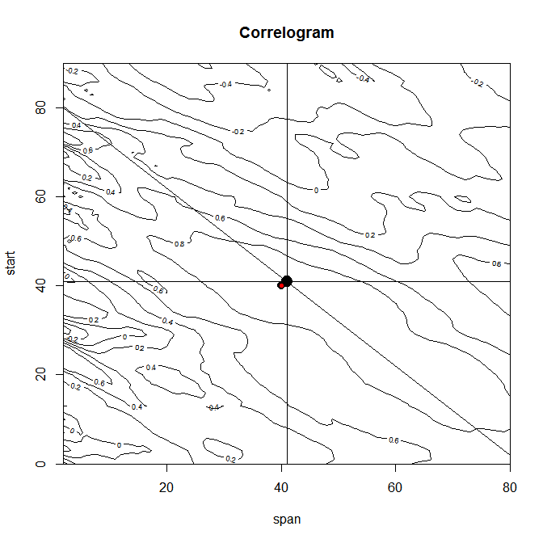
L'estimateur bootstrap coïncide bien (à peu près) avec l'estimateur brut, les pseudovalues sont toutes concentrées, ok, mais la forme du corrélogramme n'est pas celle prévue. Ben oui, en dehors de la période critique, le coefficient de corrélation est aléatoire !

