# This is a very basic template of Word document with few bookmarks where we want to insert FlexTables

Some information about bookmarks in MS Word (for MS Word 2013)

## Making bookmarks visible

To make the bookmarks visible go to Options > Advanced > there to “Show document content” section and check the checkbox “Show bookmarks” there

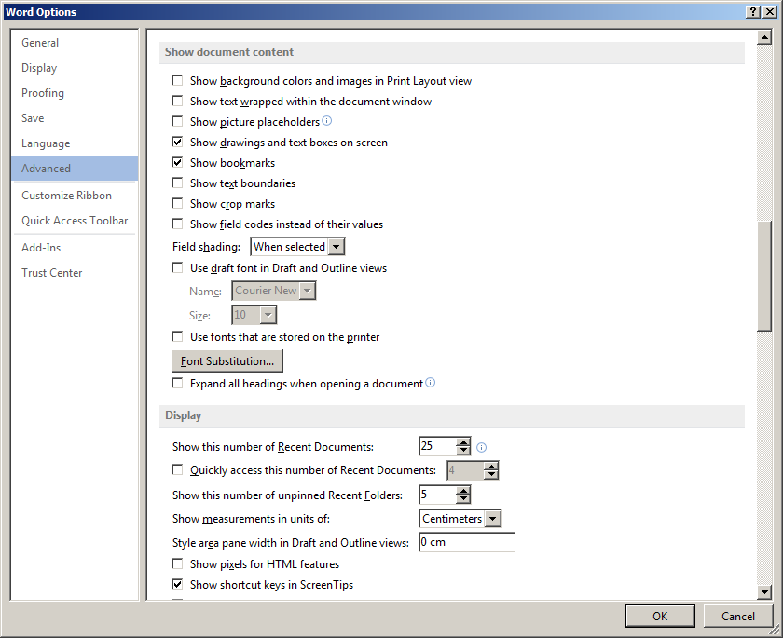

## Inserting a new bookmark

Go to INSERT panel > Bookmark

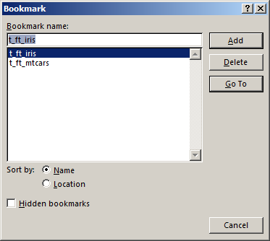

Below are two bookmarks, first is named t_ft_mtcars, second t_ft_iris.

| **mpg** | **cyl** | **disp** | **hp** | **drat** | **wt** | **qsec** | **vs** | **am** | **gear** | **carb** |
| --- | --- | --- | --- | --- | --- | --- | --- | --- | --- | --- |
| 21.0 | 6 | 160.0 | 110 | 3.90 | 2.620 | 16.46 | 0 | 1 | 4 | 4 |
| 21.0 | 6 | 160.0 | 110 | 3.90 | 2.875 | 17.02 | 0 | 1 | 4 | 4 |
| 22.8 | 4 | 108.0 | 93 | 3.85 | 2.320 | 18.61 | 1 | 1 | 4 | 1 |
| 21.4 | 6 | 258.0 | 110 | 3.08 | 3.215 | 19.44 | 1 | 0 | 3 | 1 |
| 18.7 | 8 | 360.0 | 175 | 3.15 | 3.440 | 17.02 | 0 | 0 | 3 | 2 |
| 18.1 | 6 | 225.0 | 105 | 2.76 | 3.460 | 20.22 | 1 | 0 | 3 | 1 |
| 14.3 | 8 | 360.0 | 245 | 3.21 | 3.570 | 15.84 | 0 | 0 | 3 | 4 |
| 24.4 | 4 | 146.7 | 62 | 3.69 | 3.190 | 20.00 | 1 | 0 | 4 | 2 |
| 22.8 | 4 | 140.8 | 95 | 3.92 | 3.150 | 22.90 | 1 | 0 | 4 | 2 |
| 19.2 | 6 | 167.6 | 123 | 3.92 | 3.440 | 18.30 | 1 | 0 | 4 | 4 |
| 17.8 | 6 | 167.6 | 123 | 3.92 | 3.440 | 18.90 | 1 | 0 | 4 | 4 |
| 16.4 | 8 | 275.8 | 180 | 3.07 | 4.070 | 17.40 | 0 | 0 | 3 | 3 |
| 17.3 | 8 | 275.8 | 180 | 3.07 | 3.730 | 17.60 | 0 | 0 | 3 | 3 |
| 15.2 | 8 | 275.8 | 180 | 3.07 | 3.780 | 18.00 | 0 | 0 | 3 | 3 |
| 10.4 | 8 | 472.0 | 205 | 2.93 | 5.250 | 17.98 | 0 | 0 | 3 | 4 |
| 10.4 | 8 | 460.0 | 215 | 3.00 | 5.424 | 17.82 | 0 | 0 | 3 | 4 |
| 14.7 | 8 | 440.0 | 230 | 3.23 | 5.345 | 17.42 | 0 | 0 | 3 | 4 |
| 32.4 | 4 | 78.7 | 66 | 4.08 | 2.200 | 19.47 | 1 | 1 | 4 | 1 |
| 30.4 | 4 | 75.7 | 52 | 4.93 | 1.615 | 18.52 | 1 | 1 | 4 | 2 |
| 33.9 | 4 | 71.1 | 65 | 4.22 | 1.835 | 19.90 | 1 | 1 | 4 | 1 |
| 21.5 | 4 | 120.1 | 97 | 3.70 | 2.465 | 20.01 | 1 | 0 | 3 | 1 |
| 15.5 | 8 | 318.0 | 150 | 2.76 | 3.520 | 16.87 | 0 | 0 | 3 | 2 |
| 15.2 | 8 | 304.0 | 150 | 3.15 | 3.435 | 17.30 | 0 | 0 | 3 | 2 |
| 13.3 | 8 | 350.0 | 245 | 3.73 | 3.840 | 15.41 | 0 | 0 | 3 | 4 |
| 19.2 | 8 | 400.0 | 175 | 3.08 | 3.845 | 17.05 | 0 | 0 | 3 | 2 |
| 27.3 | 4 | 79.0 | 66 | 4.08 | 1.935 | 18.90 | 1 | 1 | 4 | 1 |
| 26.0 | 4 | 120.3 | 91 | 4.43 | 2.140 | 16.70 | 0 | 1 | 5 | 2 |
| 30.4 | 4 | 95.1 | 113 | 3.77 | 1.513 | 16.90 | 1 | 1 | 5 | 2 |
| 15.8 | 8 | 351.0 | 264 | 4.22 | 3.170 | 14.50 | 0 | 1 | 5 | 4 |
| 19.7 | 6 | 145.0 | 175 | 3.62 | 2.770 | 15.50 | 0 | 1 | 5 | 6 |
| 15.0 | 8 | 301.0 | 335 | 3.54 | 3.570 | 14.60 | 0 | 1 | 5 | 8 |
| 21.4 | 4 | 121.0 | 109 | 4.11 | 2.780 | 18.60 | 1 | 1 | 4 | 2 |

| **Sepal.Length** | **Sepal.Width** | **Petal.Length** | **Petal.Width** | **Species** |
| --- | --- | --- | --- | --- |
| 5.1 | 3.5 | 1.4 | 0.2 | setosa |
| 4.9 | 3.0 | 1.4 | 0.2 | setosa |
| 4.7 | 3.2 | 1.3 | 0.2 | setosa |
| 4.6 | 3.1 | 1.5 | 0.2 | setosa |
| 5.0 | 3.6 | 1.4 | 0.2 | setosa |
| 5.4 | 3.9 | 1.7 | 0.4 | setosa |
| 4.6 | 3.4 | 1.4 | 0.3 | setosa |
| 5.0 | 3.4 | 1.5 | 0.2 | setosa |
| 4.4 | 2.9 | 1.4 | 0.2 | setosa |
| 4.9 | 3.1 | 1.5 | 0.1 | setosa |
| 5.4 | 3.7 | 1.5 | 0.2 | setosa |
| 4.8 | 3.4 | 1.6 | 0.2 | setosa |
| 4.8 | 3.0 | 1.4 | 0.1 | setosa |
| 4.3 | 3.0 | 1.1 | 0.1 | setosa |
| 5.8 | 4.0 | 1.2 | 0.2 | setosa |
| 5.7 | 4.4 | 1.5 | 0.4 | setosa |
| 5.4 | 3.9 | 1.3 | 0.4 | setosa |
| 5.1 | 3.5 | 1.4 | 0.3 | setosa |
| 5.7 | 3.8 | 1.7 | 0.3 | setosa |
| 5.1 | 3.8 | 1.5 | 0.3 | setosa |
| 5.4 | 3.4 | 1.7 | 0.2 | setosa |
| 5.1 | 3.7 | 1.5 | 0.4 | setosa |
| 4.6 | 3.6 | 1.0 | 0.2 | setosa |
| 5.1 | 3.3 | 1.7 | 0.5 | setosa |
| 4.8 | 3.4 | 1.9 | 0.2 | setosa |
| 5.0 | 3.0 | 1.6 | 0.2 | setosa |
| 5.0 | 3.4 | 1.6 | 0.4 | setosa |
| 5.2 | 3.5 | 1.5 | 0.2 | setosa |
| 5.2 | 3.4 | 1.4 | 0.2 | setosa |
| 4.7 | 3.2 | 1.6 | 0.2 | setosa |
| 4.8 | 3.1 | 1.6 | 0.2 | setosa |
| 5.4 | 3.4 | 1.5 | 0.4 | setosa |
| 5.2 | 4.1 | 1.5 | 0.1 | setosa |
| 5.5 | 4.2 | 1.4 | 0.2 | setosa |
| 4.9 | 3.1 | 1.5 | 0.2 | setosa |
| 5.0 | 3.2 | 1.2 | 0.2 | setosa |
| 5.5 | 3.5 | 1.3 | 0.2 | setosa |
| 4.9 | 3.6 | 1.4 | 0.1 | setosa |
| 4.4 | 3.0 | 1.3 | 0.2 | setosa |
| 5.1 | 3.4 | 1.5 | 0.2 | setosa |
| 5.0 | 3.5 | 1.3 | 0.3 | setosa |
| 4.5 | 2.3 | 1.3 | 0.3 | setosa |
| 4.4 | 3.2 | 1.3 | 0.2 | setosa |
| 5.0 | 3.5 | 1.6 | 0.6 | setosa |
| 5.1 | 3.8 | 1.9 | 0.4 | setosa |
| 4.8 | 3.0 | 1.4 | 0.3 | setosa |
| 5.1 | 3.8 | 1.6 | 0.2 | setosa |
| 4.6 | 3.2 | 1.4 | 0.2 | setosa |
| 5.3 | 3.7 | 1.5 | 0.2 | setosa |
| 5.0 | 3.3 | 1.4 | 0.2 | setosa |
| 7.0 | 3.2 | 4.7 | 1.4 | versicolor |
| 6.4 | 3.2 | 4.5 | 1.5 | versicolor |
| 6.9 | 3.1 | 4.9 | 1.5 | versicolor |
| 5.5 | 2.3 | 4.0 | 1.3 | versicolor |
| 6.5 | 2.8 | 4.6 | 1.5 | versicolor |
| 5.7 | 2.8 | 4.5 | 1.3 | versicolor |
| 6.3 | 3.3 | 4.7 | 1.6 | versicolor |
| 4.9 | 2.4 | 3.3 | 1.0 | versicolor |
| 6.6 | 2.9 | 4.6 | 1.3 | versicolor |
| 5.2 | 2.7 | 3.9 | 1.4 | versicolor |
| 5.0 | 2.0 | 3.5 | 1.0 | versicolor |
| 5.9 | 3.0 | 4.2 | 1.5 | versicolor |
| 6.0 | 2.2 | 4.0 | 1.0 | versicolor |
| 6.1 | 2.9 | 4.7 | 1.4 | versicolor |
| 5.6 | 2.9 | 3.6 | 1.3 | versicolor |
| 6.7 | 3.1 | 4.4 | 1.4 | versicolor |
| 5.6 | 3.0 | 4.5 | 1.5 | versicolor |
| 5.8 | 2.7 | 4.1 | 1.0 | versicolor |
| 6.2 | 2.2 | 4.5 | 1.5 | versicolor |
| 5.6 | 2.5 | 3.9 | 1.1 | versicolor |
| 5.9 | 3.2 | 4.8 | 1.8 | versicolor |
| 6.1 | 2.8 | 4.0 | 1.3 | versicolor |
| 6.3 | 2.5 | 4.9 | 1.5 | versicolor |
| 6.1 | 2.8 | 4.7 | 1.2 | versicolor |
| 6.4 | 2.9 | 4.3 | 1.3 | versicolor |
| 6.6 | 3.0 | 4.4 | 1.4 | versicolor |
| 6.8 | 2.8 | 4.8 | 1.4 | versicolor |
| 6.7 | 3.0 | 5.0 | 1.7 | versicolor |
| 6.0 | 2.9 | 4.5 | 1.5 | versicolor |
| 5.7 | 2.6 | 3.5 | 1.0 | versicolor |
| 5.5 | 2.4 | 3.8 | 1.1 | versicolor |
| 5.5 | 2.4 | 3.7 | 1.0 | versicolor |
| 5.8 | 2.7 | 3.9 | 1.2 | versicolor |
| 6.0 | 2.7 | 5.1 | 1.6 | versicolor |
| 5.4 | 3.0 | 4.5 | 1.5 | versicolor |
| 6.0 | 3.4 | 4.5 | 1.6 | versicolor |
| 6.7 | 3.1 | 4.7 | 1.5 | versicolor |
| 6.3 | 2.3 | 4.4 | 1.3 | versicolor |
| 5.6 | 3.0 | 4.1 | 1.3 | versicolor |
| 5.5 | 2.5 | 4.0 | 1.3 | versicolor |
| 5.5 | 2.6 | 4.4 | 1.2 | versicolor |
| 6.1 | 3.0 | 4.6 | 1.4 | versicolor |
| 5.8 | 2.6 | 4.0 | 1.2 | versicolor |
| 5.0 | 2.3 | 3.3 | 1.0 | versicolor |
| 5.6 | 2.7 | 4.2 | 1.3 | versicolor |
| 5.7 | 3.0 | 4.2 | 1.2 | versicolor |
| 5.7 | 2.9 | 4.2 | 1.3 | versicolor |
| 6.2 | 2.9 | 4.3 | 1.3 | versicolor |
| 5.1 | 2.5 | 3.0 | 1.1 | versicolor |
| 5.7 | 2.8 | 4.1 | 1.3 | versicolor |
| 6.3 | 3.3 | 6.0 | 2.5 | virginica |
| 5.8 | 2.7 | 5.1 | 1.9 | virginica |
| 7.1 | 3.0 | 5.9 | 2.1 | virginica |
| 6.3 | 2.9 | 5.6 | 1.8 | virginica |
| 6.5 | 3.0 | 5.8 | 2.2 | virginica |
| 7.6 | 3.0 | 6.6 | 2.1 | virginica |
| 4.9 | 2.5 | 4.5 | 1.7 | virginica |
| 7.3 | 2.9 | 6.3 | 1.8 | virginica |
| 6.7 | 2.5 | 5.8 | 1.8 | virginica |
| 7.2 | 3.6 | 6.1 | 2.5 | virginica |
| 6.5 | 3.2 | 5.1 | 2.0 | virginica |
| 6.4 | 2.7 | 5.3 | 1.9 | virginica |
| 6.8 | 3.0 | 5.5 | 2.1 | virginica |
| 5.7 | 2.5 | 5.0 | 2.0 | virginica |
| 5.8 | 2.8 | 5.1 | 2.4 | virginica |
| 6.4 | 3.2 | 5.3 | 2.3 | virginica |
| 6.5 | 3.0 | 5.5 | 1.8 | virginica |
| 7.7 | 3.8 | 6.7 | 2.2 | virginica |
| 7.7 | 2.6 | 6.9 | 2.3 | virginica |
| 6.0 | 2.2 | 5.0 | 1.5 | virginica |
| 6.9 | 3.2 | 5.7 | 2.3 | virginica |
| 5.6 | 2.8 | 4.9 | 2.0 | virginica |
| 7.7 | 2.8 | 6.7 | 2.0 | virginica |
| 6.3 | 2.7 | 4.9 | 1.8 | virginica |
| 6.7 | 3.3 | 5.7 | 2.1 | virginica |
| 7.2 | 3.2 | 6.0 | 1.8 | virginica |
| 6.2 | 2.8 | 4.8 | 1.8 | virginica |
| 6.1 | 3.0 | 4.9 | 1.8 | virginica |
| 6.4 | 2.8 | 5.6 | 2.1 | virginica |
| 7.2 | 3.0 | 5.8 | 1.6 | virginica |
| 7.4 | 2.8 | 6.1 | 1.9 | virginica |
| 7.9 | 3.8 | 6.4 | 2.0 | virginica |
| 6.4 | 2.8 | 5.6 | 2.2 | virginica |
| 6.3 | 2.8 | 5.1 | 1.5 | virginica |
| 6.1 | 2.6 | 5.6 | 1.4 | virginica |
| 7.7 | 3.0 | 6.1 | 2.3 | virginica |
| 6.3 | 3.4 | 5.6 | 2.4 | virginica |
| 6.4 | 3.1 | 5.5 | 1.8 | virginica |
| 6.0 | 3.0 | 4.8 | 1.8 | virginica |
| 6.9 | 3.1 | 5.4 | 2.1 | virginica |
| 6.7 | 3.1 | 5.6 | 2.4 | virginica |
| 6.9 | 3.1 | 5.1 | 2.3 | virginica |
| 5.8 | 2.7 | 5.1 | 1.9 | virginica |
| 6.8 | 3.2 | 5.9 | 2.3 | virginica |
| 6.7 | 3.3 | 5.7 | 2.5 | virginica |
| 6.7 | 3.0 | 5.2 | 2.3 | virginica |
| 6.3 | 2.5 | 5.0 | 1.9 | virginica |
| 6.5 | 3.0 | 5.2 | 2.0 | virginica |
| 6.2 | 3.4 | 5.4 | 2.3 | virginica |
| 5.9 | 3.0 | 5.1 | 1.8 | virginica |