**DEMOGRAPHICS DATA TABLE**

**LESSON 1**

|  |  |  |  |  |  |  |  |  |
| --- | --- | --- | --- | --- | --- | --- | --- | --- |
| **Lesson 1: Step 1** | | | | | | | | |
| Country | Birthrate | Death Rate | Population Growth 2005 | Population Growth 2050 | Relative place in Transition | Social Factors 1 | Social Factors 2 | Social Factors 3 | |
| USA | 2.06 | 0.51% | 0.92% | -0.06% | Post- Industrial | Female Independence | Stable Birth Rate | Good technology | |
| China | 1.62 | 0.3% | 0.6% | -0.58% | Post- Industrial | Government intervention | Technology | Urbanization | |
| Egypt | 2.83 | 0.41% | 2.0% | 1.32% | Mature Industrial | Not yet industrialized | More children needed | Slightly higher life expectancy | |
| India | 2.35 | 0.34% | 1.56% | 0.76% | Post Industrial | Economic growth | Poverty | Becoming more industrialized | |
| Italy | 1.28 | 0.72% | 0.35% | -1.33% | Late Post industrial | Stable birth rate | People marry later | Better health care | |
| Mexico | 2.43 | 0.25% | 1.41% | 0.96% | Mature Industrial | Better health care | Emigration | Economic growth | |
| Nigeria | 4.78 | 0.26% | 2.46% | 3.58% | End of Mechanization of Agriculture | Disease | People marry early | People have many children | |

|  |  |  |
| --- | --- | --- |
| **Lesson 1: Step 2** | | |
| Country | Shape of Pyramid: Prediction | Shape of Pyramid: Simulation |
| USA | Stable base, stable middle,  narrow at very top | Stable base, stable middle,  narrow at very top |
| China | Narrow base, large top | Narrow base, large top |
| Egypt | Large base, narrow top | Large base, narrow top |
| India | Larger base, narrower top | Larger base, narrower top |
| Italy | Stable base, stable middle, larger top | Stable base, stable middle, larger top |
| Mexico | Large base, narrower top | Large base, narrower top |
| Nigeria | Large base, narrow top | Large base, narrow top |

|  |
| --- |
| **Responses to Questions** |
| **Lesson 1- Step 1**   1. Living conditions for countries that are further along the demographic transition are most likely better and more sanitary than countries that are earlier in the transition. The better the living conditions the more likely for a more stable death rate than countries earlier in the transition, and with a more stable death rate less people will have children because people are surviving longer, thus the birthrate will be lower than that of earlier countries of the transition. 2. Three social factors that contribute to lower birth rates in counties father along would be lower mortality rates, more female opportunities, and contraception. These factors could be encouraged to emerge in the early transition countries if the countries further in the transition introduce these factors and gradually work them into the society of the countries that are earlier in the transition. 3. Countries that are further along in the demographic transition are considered first world countries. The countries earlier in the transition are considered third world countries. And countries that are middle in the transition are considered second world countries. |
| **Lesson 1- Step 2**   1. The more developed countries correspond with pyramid shapes the are more rounded at the top and have an even spread of age groups, while lesser developed countries correspond with a pyramid shape that is more pointed toward the top with a very wide bottom and very decreasing number as the age groups increase. 2. If there are not more people that are in the “prime of life” than the people who are dependent then there will be a population decreased because there will not be enough people to take care of the dependant people. Better technology and more advances in the countries allow for there to be a lower requirement for the “prime life” people, however. The pyramids that correspond with lesser developed countries that are more triangle, mean that there are not as many in the “prime life” stage to take care of the dependants. Therefore the young and the old suffer and have a higher death rate. |

|  |
| --- |
| **Notes** |
|  |

**DEMOGRAPHICS DATA TABLE**

**LESSON 2**

|  |  |  |  |  |  |
| --- | --- | --- | --- | --- | --- |
| **Lesson 2: Step 1** | | | | | |
| Nigeria | Default | Prediction | + 5 years | +15 years | -5 years |
| Birth rate | 4.78 | Goes Down | 4.76 | 4.72 | 4.79 |
| Death rate | 0.36% | Stay the Same | 0.42% | 0.52% | 0.3% |
| Population growth | 3.58% | Goes Down | 3.02% | 2.32% | 4.38% |

Sketch of Nigeria using USA birth and death rates:

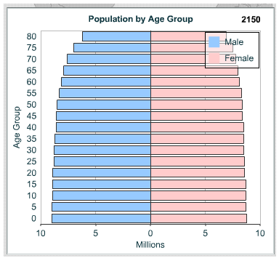

|  |  |  |  |  |
| --- | --- | --- | --- | --- |
| **Lesson 2: Step 2** | | | | |
| Italy | Prediction | + 5 years | +15 years | -5 years |
| Birth rate | 1.28 | Goes Up | 1.28 | 1.28 |
| Death rate | 2.14% | Stays the Same | 2.05% | 1.92% |
| Population growth | -1.33% | Goes Up | -1.28% | -0.82% |

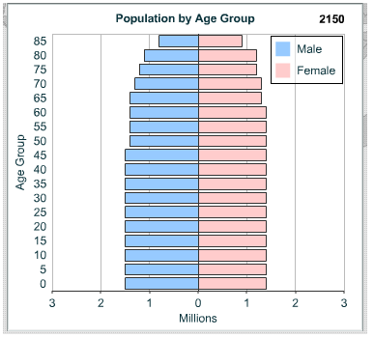

|  |
| --- |
| **Responses to Questions:** |
| **Lesson 2- Step 1**   1. The shape becomes more even and rounded. All age groups are now, for the most part, evenly represented, instead of dominating areas in age group. 2. The average childbearing age group increases. This decreases the birth rate and evens out the number of people in each age group of the population. First world countries tend to have older childbearing women because there is contraception available, therefore younger women do not get pregnant as often as they do in third world countries. |
| **Lesson 2- Step 2**   1. I predicted that the birth rate in Italy would drop with an increase in age. When I ran the simulation the results proved my prediction to be correct. As the age of the mother increased the birth rate decreased. The pyramids for Nigeria and Italy were different yet somewhat similar in shape, however their difference was that the number of people in each age group was greater for every age group in Nigeria than it was for Italy. 2. Itlay has much lower numbers in each age group than Nigeria. I think that the fact that people are having children at older ages makes a very stable birthrate, while Nigeria is following the trend of having some children at lower ages, thus the population increased because it takes longer for those who give birth to die, thus allowing more generations to be alive at once in a family. 3. A baby boom would increase the number of children and this increase would result in an increase in the number of women able to give birth later on in life. Thus whenever the women give birth there will be more children and the trend will continue resulting in and increase in population. |

|  |
| --- |
| **Notes:** |
|  |