gosset: An R package for analysis and synthesis of ranking data in agricultural experimentation

## Kauê de Sousa1,2[*], David Brown3,4, Jonathan Steinke2,5, Jacob van Etten2

1 Department of Agricultural Sciences, Inland Norway University of Applied Sciences, 2318 Hamar, Norway  
2 Digital Inclusion, Bioversity International, Parc Scientifique Agropolis II, 34397, Montpellier Cedex 5, France  
3 Laboratory of Geo-Information Science and Remote Sensing, Wageningen University & Research, Droevendaalsesteeg 3, 6708 PB, Wageningen, The Netherlands  
4 Digital Inclusion, Bioversity International, 30501, Turrialba, Costa Rica  
5 Humboldt University Berlin, Berlin, Germany  
[*] Correspondence should be addressed to: [k.desousa@cgiar.org](mailto:k.desousa@cgiar.org)

# Abstract

Appropriate data management and analysis are necessary to produce practical information from agricultural experimentation data. There is also an ongoing trend advocating for programmatic tools that supports reproducible workflows in scientific research. We developed the R package gosset, providing functionality to support analysis workflows with rank-based models. The gosset package facilitates data preparation, modelling and results presentation stages. We demonstrate the functionality of the package with a case of a decentralized on-farm trial of common bean (*Phaseolus vulgaris* L.) varieties in Nicaragua.

**Keywords**: Bradley-Terry, data science, Plackett-Luce, on-farm trials, tricot approach

# Code metadata

*Code metadata*

| **Code metadata description** | **Please fill in this column** |
| --- | --- |
| Current code version | 0.4 |
| Code repository | <https://github.com/AgrDataSci/gosset> |
| Legal code license | MIT |
| Code versioning system used | git |
| Software code languages, tools, and services used | R |
| Compilation requirements, operating environments & dependencies | R |
| Link to developer documentation | <https://agrdatasci.github.io/gosset/> |
| Support email for questions | [desousa.kaue@gmail.com](mailto:desousa.kaue@gmail.com) |

# Motivation and significance

Participatory experimentation approaches have been increasingly applied in agricultural research [1]. While collecting data in ranking format is uncommon in general agricultural research settings, it is often collected in participatory experiments [2]. Recently developed approaches for on-farm experimentation, such as the tricot approach are based on the collection of data in ranking format [3]. On the other hand, newly proposed approaches for synthesis of crop variety evaluation data largely depend on the analysis of ranking data [4].

The analysis of ranking data requires the use of appropriate statistical models such as Plackett-Luce [5,6] or Bradley-Terry [7]. Functionality for fitting Bradley-Terry and Plackett-Luce models are available in R with the packages BradleyTerry2 [8] and PlackettLuce [9] respectively. However, extended functionality was required for the entire data science workflow, which usually includes: (1) Data preparation and cleaning, (2) modelling and validation, and (3) results presentation. For (1) gosset provides functions for converting and preparing data into ranking or pairwise format required by the packages PlackettLuce and BradleyTerry2 respectively. For (2), gosset provides functions for model selection and validation using cross-validation. In the case of (3), enhanced functionality for plotting model results is provided by the gosset package.

# Software description

The R package gosset provides functionality supporting the analysis workflows in agricultural experimentation, especially with rank-based approaches. The package is available in The Comprehensive R Archive Network (CRAN) and can be installed by executing install.packages("gosset"). The package is named in honor to William Sealy Gosset, known by the pen name ‘Student’, a pioneer of modern statistics in small sample experimental design and analysis [10].

## Software Architecture

The R package gosset is structured following the guidelines described in the manual for creating R add-on packages [11]. This structure basically consist of files DESCRTIPTION, LICENSE, NAMESPACE and NEWS, and directories data, dev, docs, inst, man, R, and vignettes. The package functions were developed following the S3 methods style [11] and are contained in the R sub-directory.

## Software Functionalities

### Data management and preparation

* rank_binomial transforms a ranking object into a binary comparisons, as required by package BradleyTerry2 [8].
* rank_numeric converts numeric values into rankings. The parameter ascending = indicates if the rankings should be made considering the numeric values in ascending order. The default is asceding = FALSE. This function is useful when the data were collected as numerical observations, for instance, in a experiment measuring crop yield.
* rank_tricot transforms data in tricot format into PlackettLuce rankings.

### Modelling

* AIC computes the Akaike Information Criterion [12] for a Bradley-Terry model [8] or a Plackett-Luce model [9].
* btpermute deviance-based forward variable selection [13] procedure for Bradley-Terry models.
* crossvalidation performs k-fold cross-validation, where k could be specified by the user.The default is 10-fold. Folds can be provided as a vector for a custom cross-validation, such as blocked cross-validation.
* forward executes forward variable selection with cross-validation.
* kendallTau computes the Kendall-tau rank correlation coefficient between two rankings [14].
* kendallW computes Kendall’s W (coefficient of concordance) among observed rankings and those predicted by the Plackett-Luce model [15].
* pseudoR2 computes goodness-of-fit metrics, such as McFadden’s pseudo-R2 [16].

### Visualization and results presentation

* compare is a visualization approach to compare measures from two different methods [17].
* plot provides an alternative S3 method to plot.pltree() method implemented by the PlackettLuce package.
* regret computes the regret coefficients, the loss under the worst possible outcome. A common heuristic in risk assessment strategy [18].
* reliability computes the probability of a set of items to outperform a reference item. A common heuristic in plant breeding [19].
* worth_bar creates a bar plot of the estimated *worth* for each evaluated item.
* worth_map creates a heatmap plot of the estimated log-worth for all items considering each of the evaluated traits.

# Illustrative example

To demonstrate the functionality of the gosset package, we use the nicabean dataset, which was generated with decentralized on-farm trials of common bean (*Phaseolus vulgaris* L.) varieties in Nicaragua over five seasons (between 2015 and 2016). Following the tricot approach [3], farmers were asked to test in their farms three varieties of common bean. The varieties were randomly assigned as incomplete blocks of size three (out of 10 varieties). The farmers assessed which of the three varieties had the best and worst performance in eight traits (vigor, architecture, resistance to pests, resistance to diseases, tolerance to drought, yield, marketability, and taste). The farmers also provided their overall appreciation about the varieties, i.e., which variety had the best and the worst performance based on the overall performance considering all the traits. To analyze the data, we use the Plackett-Luce model implemented in the R package *PlackettLuce* [9].

The nicabean is a list with two data frames. The first, trial, contains the trial data with farmers’ evaluations, ranked from 1 to 3, with 1 being the higher ranked variety and 3 the lowest ranked variety for the given trait and incomplete block. The rankings in this dataset were previously transformed from tricot rankings (where participants indicate best and worst) to ordinal rankings using the function rank_tricot(). The second data frame, covar, contains the covariates associated to the on-farm trial plots and farmers. This example will require the packages PlackettLuce [9], climatrends [20], chirps [21] and ggplot2 [22].

library("gosset")  
library("PlackettLuce")  
library("climatrends")  
library("chirps")  
library("ggplot2")  
  
data("nicabean", package = "gosset")  
  
dat <- nicabean$trial  
  
covar <- nicabean$covar  
  
traits <- unique(dat$trait)

To start the analysis of the data, we transform the ordinal rankings into Plackett-Luce rankings (a sparse matrix) using the function rank_numeric(). We run iteratively over the traits adding the rankings to a list called R. Since the varieties are ranked in an ascending order, with 1 being the higher ranked and 3 the lower ranked, we use the argument asceding = TRUE to indicate which order should be used.

R <- vector(mode = "list", length = length(traits))  
  
for (i in seq_along(traits)) {  
  
 dat_i <- subset(dat, dat$trait == traits[i])  
  
 R[[i]] <- rank_numeric(data = dat_i,  
 items = "item",  
 input = "rank",  
 id = "id",  
 ascending = TRUE)  
}

Then, using the function kendallTau() we can assess the Kendall tau ($τ$) coefficient [14]. This approach can be used, for example, to assess the drivers of farmers choices or to prioritize traits to be tested in a next stage of tricot trials (e.g. a lite version of tricot with no more than 4 traits to assess). We use the overall appreciation as the reference trait, and compare the Kendall tau with the other 8 traits.

baseline <- which(grepl("OverallAppreciation", traits))  
  
kendall <- lapply(R[-baseline], function(X){  
 kendallTau(x = X, y = R[[baseline]])  
})  
  
kendall <- do.call("rbind", kendall)  
  
kendall$trait <- traits[-baseline]

The kendall correlation shows that farmers prioritized the traits yield ( $τ$ = 0.749), taste ( $τ$ = 0.653) and marketability ( $τ$ = 0.639) when assessing overall appreciation.

Kendall tau correlation between ‘overall performance’ and the other traits assessed in the Nicaragua bean on-farm trials.

| trait | kendallTau |
| --- | --- |
| Vigor | 0.439 |
| Architecture | 0.393 |
| ResistanceToPests | 0.463 |
| ResistanceToDiseases | 0.449 |
| ToleranceToDrought | 0.411 |
| Yield | 0.749 |
| Marketability | 0.639 |
| Taste | 0.653 |

Then, for each trait, we fit a Plackett-Luce model using the function PlackettLuce() from the package of the same name. This will allow us to continue the analysis of the trial data using the other functions in the package gosset.

mod <- lapply(R, PlackettLuce)

The worth_map() function can be used to visually assess and compare item performance based on different characteristics. The values represented in a worth_map are log-worth estimates. From the breeder or product developer perspective the function worth_map() offers a visualization tool to help in identifying item performance based on different characteristics and select crossing materials.

worth_map(mod[-baseline],  
 labels = traits[-baseline],  
 ref = "Amadeus 77") +  
 labs(x = "Variety",  
 y = "Trait")

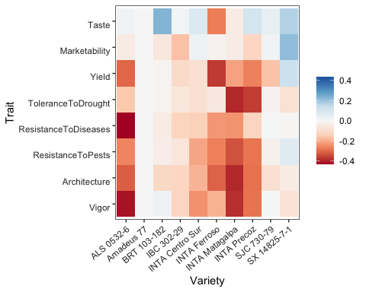

Trait performance (log-worth) of bean varieties in Niragua. Variety ‘Amadeus’ is set as reference (log-worth = 0). Blue values indicate a superior performance of varieties for a given trait, compared to the reference. Red values indicate a variety with weak performance for the given trait, compared to the reference.

To consider the effect of climate factors on yield, we use agro-climatic covariates to fit a Plackett-Luce tree. For simplicity, we use the total rainfall (Rtotal) derived from CHIRPS data [23], obtained in R using the R package chirps [21]. Additional covariates can be used in a Plackett-Luce tree, for example using temperature data from R package ag5Tools [24] or nasapower [25].

We request the CHIRPS data using the package chirps. Data should be returned as a matrix. This process can take some minutes to be implemented.

dates <- c(min(covar[, "planting_date"]),  
 max(covar[, "planting_date"]) + 70)  
  
chirps <- get_chirps(covar[, c("longitude","latitude")],   
 dates = as.character(dates),  
 as.matrix = TRUE,  
 server = "ClimateSERV")

We compute the rainfall indices from planting date to the first 45 days of plant growth using the function rainfall() from package climatrends [20].

newnames <- dimnames(chirps)[[2]]  
newnames <- gsub("chirps-v2.0.", "", newnames)  
newnames <- gsub("[.]", "-", newnames)  
  
dimnames(chirps)[[2]] <- newnames  
  
rain <- rainfall(chirps, day.one = covar$planting_date, span = 45)

To be linked to covariates, the rankings should be coerced to a ‘grouped_rankings’ object. For this we use the function group() from PlackettLuce. We retain the ranking corresponding to yield.

yield <- which(grepl("Yield", traits))  
  
G <- group(R[[yield]], index = 1:length(R[[yield]]))

Now we can fit the Plackett-Luce tree with climate covariates.

pldG <- cbind(G, rain)  
  
tree <- pltree(G ~ Rtotal, data = pldG, alpha = 0.1)

The following is an example of the plot made with the function plot() in the gosset package. The functions node_labels(), node_rules() and top_items() can be used to identify the splitting variables in the tree, the rules used to split the tree and the best items in each node, respectively.

plot(tree, ref = "Amadeus 77", ci.level = 0.9)  
  
node_labels(tree)  
  
node_rules(tree)  
  
top_items(tree, top = 3)

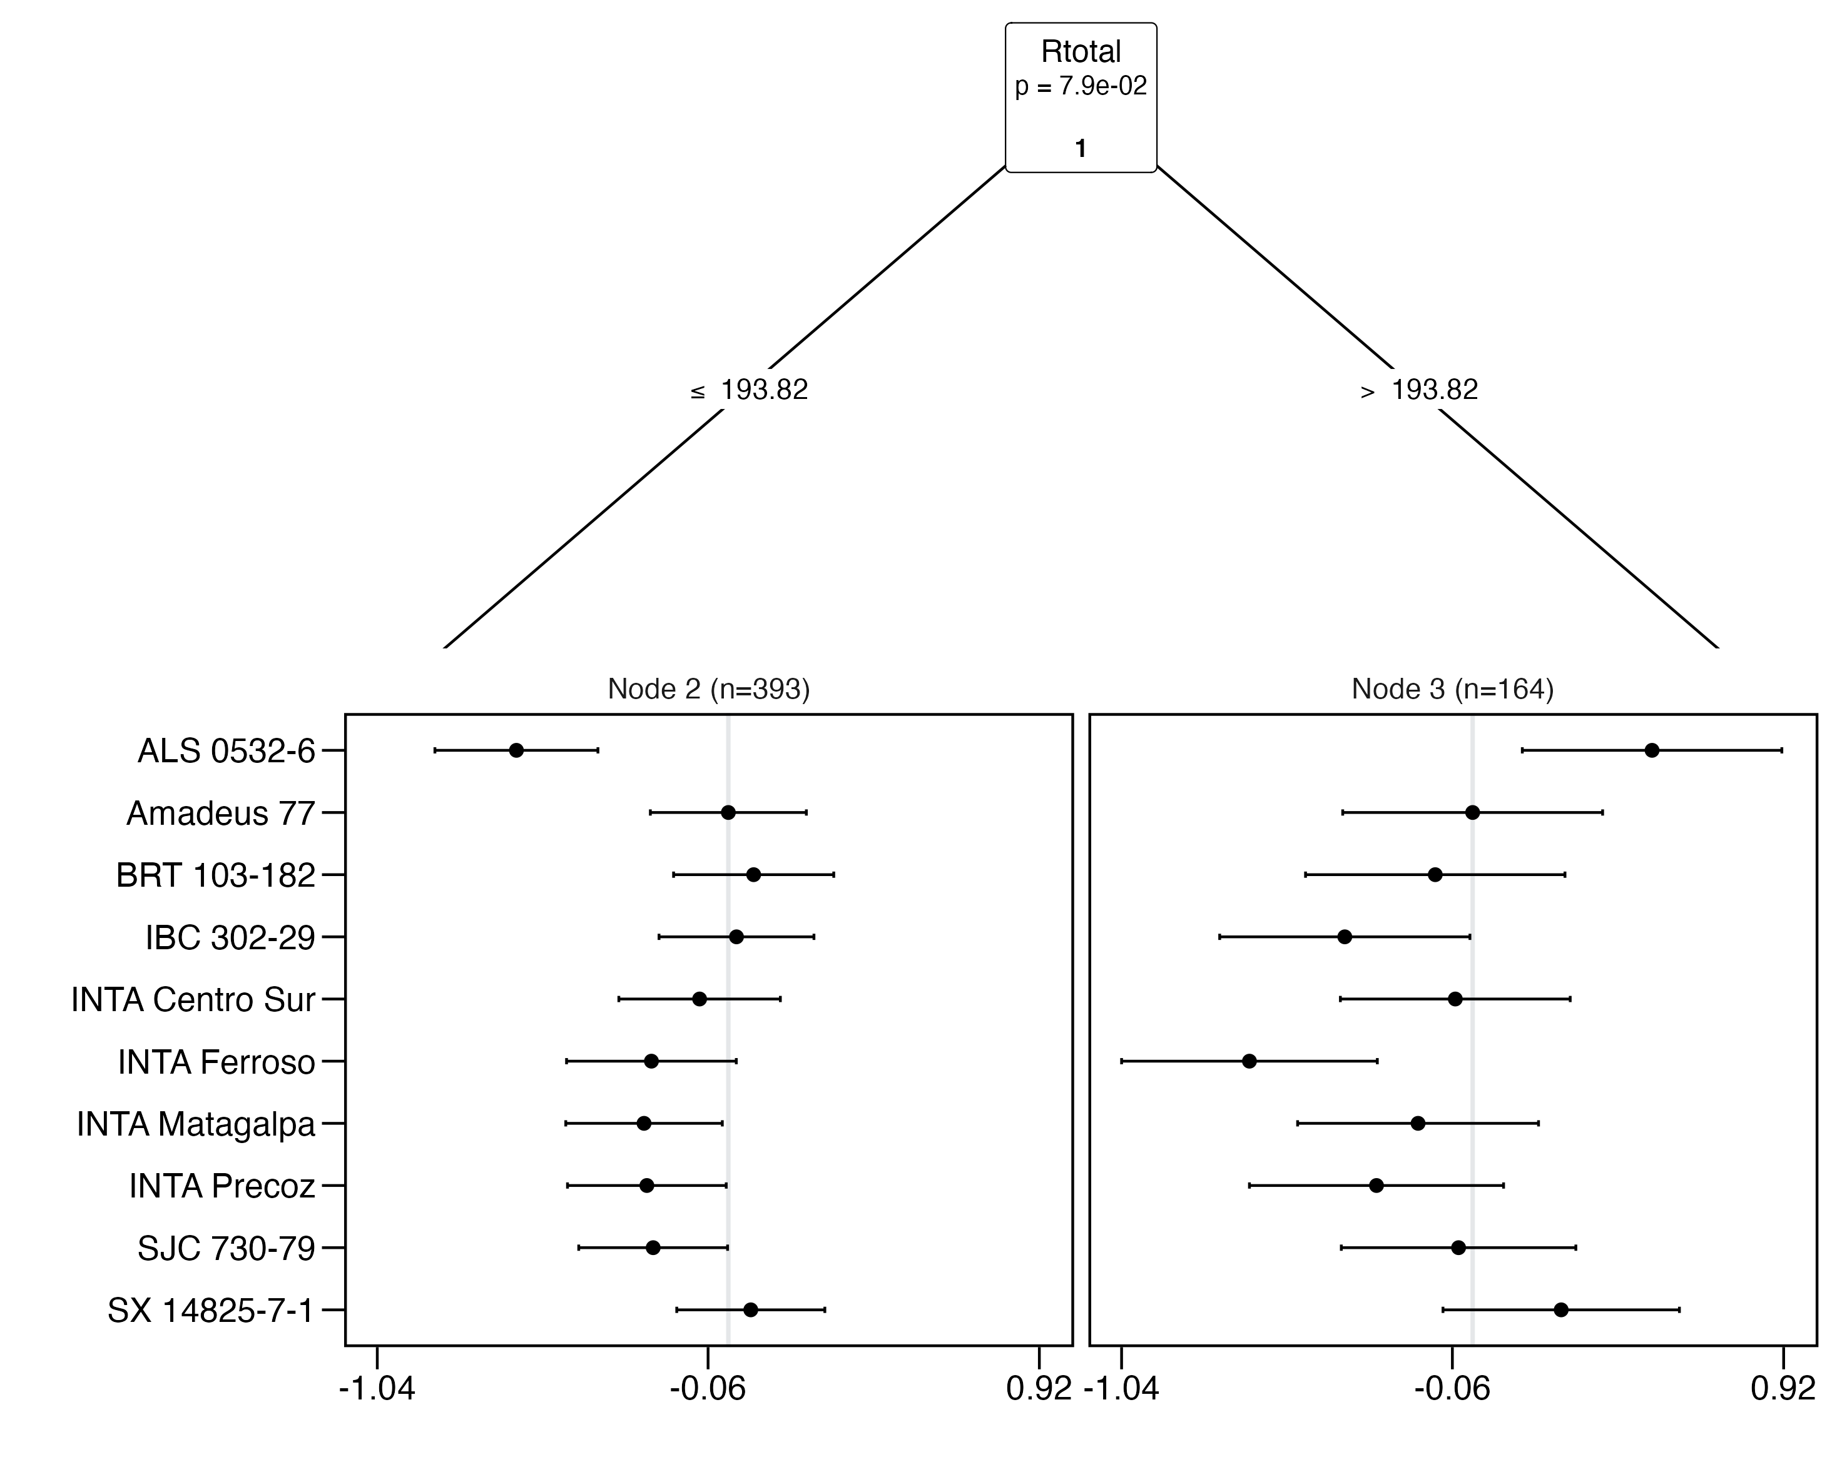

Effect of total rainfall (Rtotal) on yield of common beans in on-farm trials. Agroclimate variables are obtained from planting date to the first 45 days of plant growth. Axis X presents log-worth, the probability of outperforming the other varieties in the set.

We can use the function reliability() to compute the reliability of the evaluated common bean varieties in each of the resulting nodes of the Plackett-Luce tree (Table 3). This helps in identifying the varieties with higher probability to outperform a variety check (Amadeus 77). For simplicity, we present only the varieties with reliability $≥$ 0.5.

reliability(tree, ref = "Amadeus 77")

Reliability of common bean varieties based on yield performance under different rainfall conditions from planting date to the first 45 days of plant growth. Variety Amadeus 77 is set as reference.

| node | item | reliability | reliabilitySE | worth |
| --- | --- | --- | --- | --- |
| 2 | Amadeus 77 | 0.500 | 0.035 | 0.114 |
| 2 | BRT 103-182 | 0.519 | 0.036 | 0.123 |
| 2 | IBC 302-29 | 0.506 | 0.035 | 0.117 |
| 2 | SX 14825-7-1 | 0.517 | 0.033 | 0.122 |
| 3 | ALS 0532-6 | 0.630 | 0.056 | 0.177 |
| 3 | Amadeus 77 | 0.500 | 0.058 | 0.104 |
| 3 | SX 14825-7-1 | 0.565 | 0.053 | 0.135 |

The result shows that three varieties can marginally outperform Amadeus 77 under drier growing conditions (Rtotal $≤$ 193.82 mm) whereas two varieties have a superior yield performance when under higher rainfall conditions (Rtotal $>$ 193.82 mm) compared to the reference. This approach helps in identifying superior varieties for different target population environments. For example, the variety ALS 0532-6 shows weak performance in the whole yield ranking, however for the sub-group of higher rainfall, the variety outperforms all the others. Combining rankings with socio-economic covariates could also support the identification of superior materials for different market segments.

A better approach to assess the performance of varieties can be using the ’Overall Appreciation”, since we expect this trait to capture the performance of the variety not only for yield, but for all the other traits prioritized by farmers (Table 2). To support this hypotheses, we use the function compare() which applies the approach proposed by Bland and Altman (1986) [17] to assess the agreement between two different measures. We compare overall vs yield. If both measures completely agree, all the varieties should be centered to 0 in the axis Y.

Overall <- PlackettLuce(R[[baseline]])  
Yield <- PlackettLuce(R[[yield]])  
  
compare(Overall, Yield) +  
 labs(x = "Average log(worth)",  
 y = "Difference (Overall Appreciation - Yield)")

The chart shows no complete agreement between overall appreciation and yield. For example, variety SX 14825-7-1 shows superior performance for overall appreciation when compared with yield. Looking at the log-worth in the heat map of Figure 1, we can argue that the superior performance of the given variety is also related to taste, marketability and diseases resistance. This performance, however, was not captured when assessing only yield.

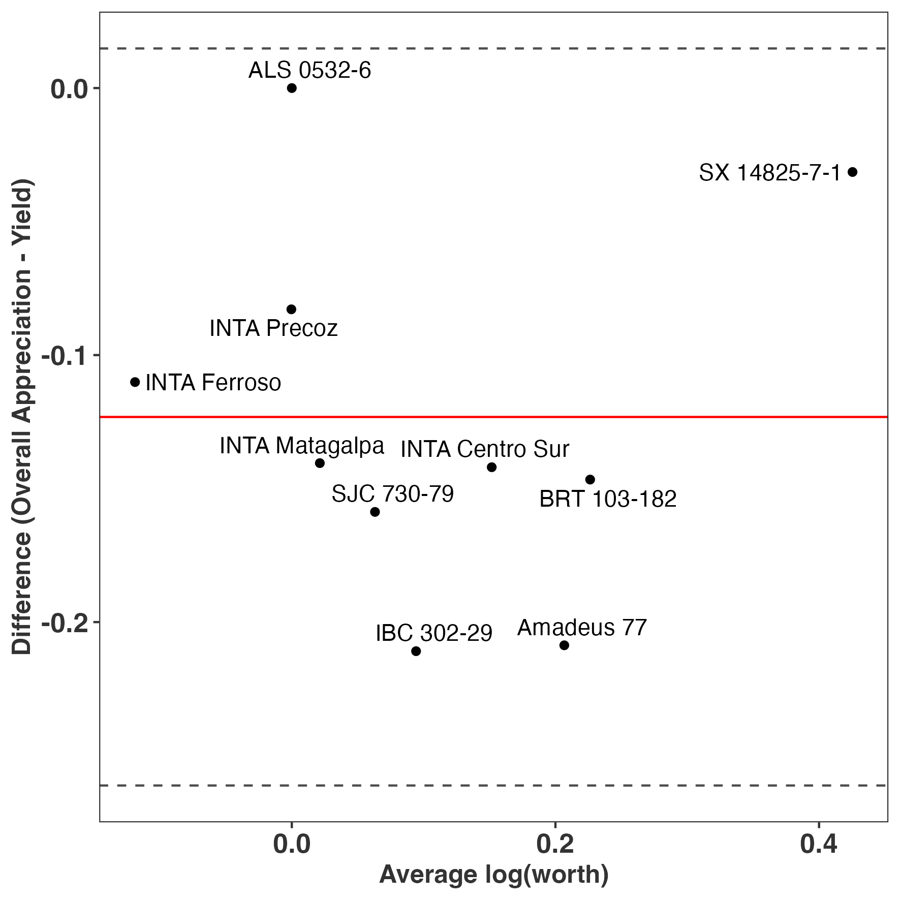

Agreement between overall appreciation and yield for crop variety performance in on-farm trials.

Here we presented a simple workflow to assess crop variety performance and trait prioritization in decentralized on-farm trials with the tricot approach. A more complex workflow will also utilize other functions available in gosset, for example, a forward selection combined with crossvalidation() to improve model robustness, or model selection with btpermute() to consider all possible permutations in Bradley-Terry models, or a risk analysis using regret() to support the selection of varieties, or using rank_numeric() to combine legacy data and deal with heterogeneous data from different trials. All of these were previously implemented and validated elsewhere [26–30].

# Impact

Reproducible and efficient workflows are fundamental in scientific research (Lowndes et al. 2017) [31]. The gosset package provides functionality that was not previously available from other R packages and which enabled scientific studies based on the analysis of ranking data. This functionality enables making the entire workflow to be reproducible and more efficient. The utility of the gosset package has been demonstrated by enabling studies based on the analysis of decentralized on-farm trial data and/or heterogeneous data from different sources. For instance, van Etten et al. (2019) [26], Moyo et al. (2021) [27] and de Sousa et al. (2021) [28] applied the Plackett-Luce model in combination with recursive partitioning [9,32]. In these studies, the gosset package supported data preparation, model validation and results presentation tasks.

# Conclusions

We described the functionality of the R package gosset to support the synthesis and analysis of ranking data. The package provide functions not available in existing R packages for analyzing ranking data. We provided an illustrative example covering the main functionality across the stages involved in the analysis workflow.

# Conflict of Interest

The authors declare no conflict of interests.

# Acknowledgements

We acknowledge Olga Spellman (Science Writing Service of the Alliance of Bioversity International and CIAT) for English editing of this manuscript. The nicabean data was generated through the Cooperative Agreement AID-OAA-F-14-00035, which was made possible by the generous support of the American people through the US Agency for International Development (USAID). The package was developed as part of the CGIAR Research Programs on Climate Change, Agriculture and Food Security (CCAFS) and the CGIAR Research Program on Roots, Tubers and Bananas (RTB), which were carried out with support from the CGIAR Trust Fund and through bilateral funding agreements (details are at <https://www.cgiar.org/funders>). New analytical approaches were developed during the projects Accelerated Varietal Improvement and Seed Systems in Africa (AVISA) and 10000FARMS supported by the Bill and Melinda Gates Foundation. The views expressed in this document cannot be taken to reflect the official opinions of these organizations.

# References

1. De Roo, N.; Andersson, J.A.; Krupnik, T.J. On-Farm Trials for Development Impact? The Organisation of Research and the Scaling of Agricultural Technologies. *Experimental Agriculture* **2019**, *55*, 163–184.

2. Coe, R. Analyzing ranking and rating data from participatory on-farm trials. In *Quantitative Analysis of Data from Participatory Methods in Plant Breeding*; Bellon, M.R., J. Reeves, Eds.; CIMMYT: Mexico City, Mexico, 2002; pp. 44–65.

3. van Etten, J.; Beza, E.; Calderer, L.; Van Duijvendijk, K.; Fadda, C.; Fantahun, B.; Kidane, Y.G.; Van De Gevel, J.; Gupta, A.; Mengistu, D.K.; et al. First Experiences with a Novel Farmer Citizen Science Approach: Crowdsourcing Participatory Variety Selection Through on-Farm Triadic Comparisons of Technologies (Tricot). *Experimental Agriculture* **2016**, *55*, 275–296, doi:[10.1017/S0014479716000739](https://doi.org/10.1017/S0014479716000739).

4. Brown, D.; Van den Bergh, I.; de Bruin, S.; Machida, L.; van Etten, J. Data Synthesis for Crop Variety Evaluation. A Review. *Agronomy for sustainable development* **2020**, *40*, 1–20.

5. Luce, R.D. *Individual Choice Behavior*; Courier Corporation, 1959; p. 153;

6. Plackett, R.L. The Analysis of Permutations. *Journal of the Royal Statistical Society. Series C (Applied Statistics)* **1975**, *24*, 193–202, doi:[10.2307/2346567](https://doi.org/10.2307/2346567).

7. Bradley, R.A.; Terry, M.E. Rank analysis of incomplete block designs: I. The method of paired comparisons. *Biometrika* **1952**, *39*, 324–345.

8. Turner, H.; Firth, D. [Bradley-Terry Models in R: The BradleyTerry2 Package](https://www.jstatsoft.org/v48/i09/). *Journal of Statistical Software* **2012**, *48*, 1–21.

9. Turner, H.L.; van Etten, J.; Firth, D.; Kosmidis, I. Modelling rankings in R: the PlackettLuce package. *Computational Statistics* **2020**, doi:[10.1007/s00180-020-00959-3](https://doi.org/10.1007/s00180-020-00959-3).

10. Ziliak, S.T. How Large Are Your G-Values? Try Gosset’s Guinnessometrics When a Little “p” Is Not Enough. *The American Statistician* **2019**, *73*, 281–290, doi:[10.1080/00031305.2018.1514325](https://doi.org/10.1080/00031305.2018.1514325).

11. R Core Team [Writing r Extensions](https://cran.r-project.org/doc/manuals/r-release/R-exts.html) 2022.

12. Akaike, H. A New Look at the Statistical Model Identification. *IEEE transactions on automatic control* **1974**, *19*, 716–723.

13. Lysen, S. Permuted Inclusion Criterion: A Variable Selection Technique. *Publicly accessible Penn Dissertations* **2009**, 28.

14. Kendall, M.G. A new measure of rank correlation. *Biometrika* **1938**, *30*, 81–93, doi:[10.1093/biomet/30.1-2.81](https://doi.org/10.1093/biomet/30.1-2.81).

15. Kendall, M.G.; Smith, B.B. [The Problem of m Rankings](http://www.jstor.org/stable/2235668). *The Annals of Mathematical Statistics* **1939**, *10*, 275–287.

16. McFadden, D. et al. Conditional Logit Analysis of Qualitative Choice Behavior. **1973**.

17. Bland, J.M.; Altman, DouglasG. Statistical Methods for Assessing Agreement Between Two Methods of Clinical Measurement. *The Lancet* **1986**, *327*, 307–310, doi:[10.1016/s0140-6736(86)90837-8](https://doi.org/10.1016/s0140-6736(86)90837-8).

18. Loomes, G.; Sugden, R. Regret Theory: An Alternative Theory of Rational Choice Under Uncertainty. *The Economic Journal* **1982**, *92*, 805–824, doi:[10.2307/2232669](https://doi.org/10.2307/2232669).

19. Eskridge, K.M.; Mumm, R.F. Choosing Plant Cultivars Based on the Probability of Outperforming a Check. *Theoretical and Applied Genetics* **1992**, *84*, 494–500, doi:[10.1007/BF00229512](https://doi.org/10.1007/BF00229512).

20. de Sousa, K.; van Etten, J.; Solberg, S.Ø. [*climatrends: Climate Variability Indices for Ecological Modelling*](https://CRAN.R-project.org/package=climatrends); 2020;

21. de Sousa, K.; Sparks, A.H.; Ashmall, W.; van Etten, J.; Solberg, S.Ø. chirps: API Client for the CHIRPS Precipitation Data in R. *The Journal of Open Source Software* **2020**, *5*, 2419, doi:[10.21105/joss.02419](https://doi.org/10.21105/joss.02419).

22. Wickham, H. [*ggplot2: Elegant Graphics for Data Analysis*](https://ggplot2.tidyverse.org); Springer-Verlag New York, 2016; ISBN 978-3-319-24277-4.

23. Funk, C.; Peterson, P.; Landsfeld, M.; Pedreros, D.; Verdin, J.; Shukla, S.; Husak, G.; Rowland, J.; Harrison, L.; Hoell, A.; et al. The climate hazards infrared precipitation with stations—a new environmental record for monitoring extremes. *Scientific Data* **2015**, *2*, 150066, doi:[10.1038/sdata.2015.66](https://doi.org/10.1038/sdata.2015.66).

24. Brown, D.; de Sousa, K. [*ag5Tools: Toolbox for Downloading and Extracting Copernicus AgERA5 Data*](https://agrdatasci.github.io/ag5Tools/); 2022;

25. Sparks, A.H. Nasapower: A NASA POWER Global Meteorology, Surface Solar Energy and Climatology Data Client for r. *The Journal of Open Source Software* **2018**, *3*, 1035, doi:[10.21105/joss.01035](https://doi.org/10.21105/joss.01035).

26. van Etten, J.; de Sousa, K.; Aguilar, A.; Barrios, M.; Coto, A.; Dell’Acqua, M.; Fadda, C.; Gebrehawaryat, Y.; van de Gevel, J.; Gupta, A.; et al. Crop variety management for climate adaptation supported by citizen science. *Proceedings of the National Academy of Sciences* **2019**, *116*, 4194–4199, doi:[10.1073/pnas.1813720116](https://doi.org/10.1073/pnas.1813720116).

27. Moyo, M.; Ssali, R.; Namanda, S.; Nakitto, M.; Dery, E.K.; Akansake, D.; Adjebeng-Danquah, J.; van Etten, J.; de Sousa, K.; Lindqvist-Kreuze, H.; et al. Consumer Preference Testing of Boiled Sweetpotato Using Crowdsourced Citizen Science in Ghana and Uganda. *Frontiers in Sustainable Food Systems* **2021**, *5*, 6, doi:[10.3389/fsufs.2021.620363](https://doi.org/10.3389/fsufs.2021.620363).

28. de Sousa, K.; van Etten, J.; Poland, J.; Fadda, C.; Jannink, J.-L.; Kidane, Y.G.; Lakew, B.F.; Mengistu, D.K.; Pè, M.E.; Solberg, S.Ø.; et al. Data-Driven Decentralized Breeding Increases Prediction Accuracy in a Challenging Crop Production Environment. *Communications biology* **2021**, *4*, 1–9.

29. Steinke, J.; Achieng, J.O.; Hammond, J.; Kebede, S.S.; Mengistu, D.K.; Mgimiloko, M.G.; Mohammed, J.N.; Musyoka, J.; Sieber, S.; van de Gevel, J.; et al. Household-specific targeting of agricultural advice via mobile phones: Feasibility of a minimum data approach for smallholder context. *Computers and Electronics in Agriculture* **2019**, *162*, 991–1000, doi:[10.1016/j.compag.2019.05.026](https://doi.org/10.1016/j.compag.2019.05.026).

30. Brown, D.; Carpentier, S.; de Bruin, S.; de Sousa, K.; Machida, L.; van Etten, J. [Combining legacy data from heterogeneous crop trials to identify genotype by environment interactions using model-based recursive partitioning](https://hdl.handle.net/10568/117614). In Proceedings of the ASA/CSSA/SSSA international annual meeting; Salt Lake City, USA, 2021.

31. Lowndes, J.S.S.; Best, B.D.; Scarborough, C.; Afflerbach, J.C.; Frazier, M.R.; O’Hara, C.C.; Jiang, N.; Halpern, B.S. Our Path to Better Science in Less Time Using Open Data Science Tools. *Nature Ecology & Evolution* **2017**, *1*, doi:[10.1038/s41559-017-0160](https://doi.org/10.1038/s41559-017-0160).

32. Zeileis, A.; Hothorn, T.; Hornik, K. Model-Based Recursive Partitioning. *Journal of Computational and Graphical Statistics* **2008**, *17*, 492–514, doi:[10.1198/106186008X319331](https://doi.org/10.1198/106186008X319331).