An example of augmenting a Latin Hypercube.

First create a random hypercube using A <- randomLHS(5,2). An example is plotted below. Notice that the “Latin property” of the hypercube requires that each of the 5 equal probability intervals be filled (i.e. each row and each column is filled with one point). Also notice that the exact location of the design point is randomly sampled from within that cell.

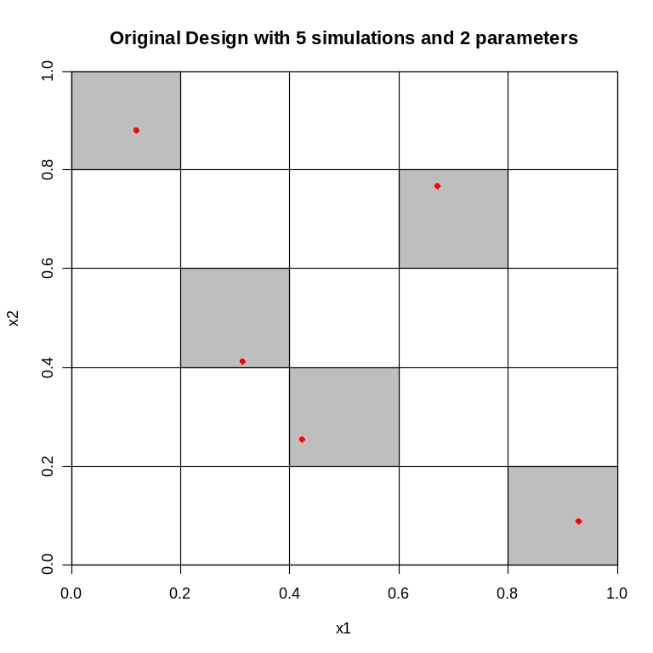
Next, in order to augment the design with 5 more points (augmentLHS(A, 5)), re-divide the original design into 5+5=10 intervals keeping the original design points exactly in the same position. Then randomly fill the empty row-column sets. (Shown below).

From the documentation for augmentLHS:
First, create a new matrix to hold the candidate points after the design has
been re-partitioned into \eqn{(n+m)^{2}}{(n+m)^2} cells, where n is number of
points in the original \code{lhs} matrix. Then randomly sweep through each
column (1\ldots\code{k}) in the repartitioned design to find the missing cells.
For each column (variable), randomly search for an empty row, generate a
random value that fits in that row, record the value in the new matrix.
The new matrix can contain more filled cells than \code{m} unles \eqn{m = 2n},
in which case the new matrix will contain exactly \code{m} filled cells.
Finally, keep only the first m rows of the new matrix. It is guaranteed to
have \code{m} full rows in the new matrix. The deleted rows are partially full.
The additional candidate points are selected randomly due to the random search
for empty cells.
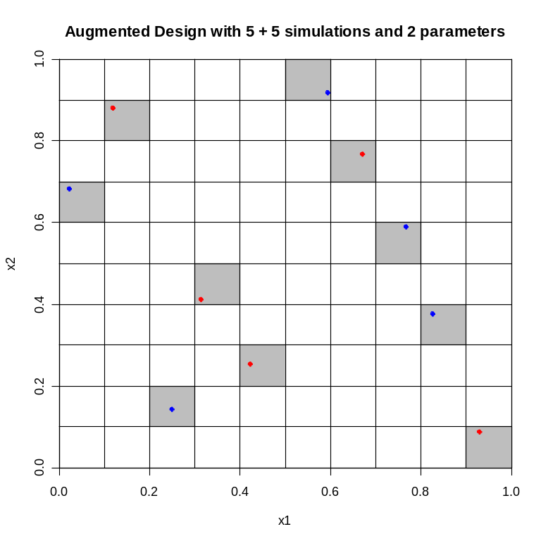

Now, the augmenting points do not necessarily form a Latin Hypercube themselves, only the joint properties of the total original design and augmenting points are guaranteed to form a Latin Hypercube.

Also notice that because the original points are randomly placed within the cells, depending on how you bin the marginal distributions, a histogram (of X1 for example) will not necessarily be exactly uniform.

Here is an example of augmenting a 7 simulation design with one point.
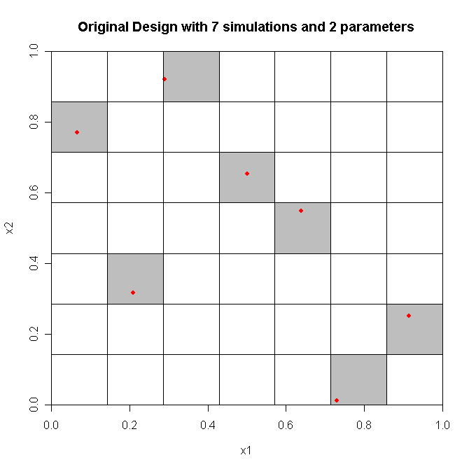
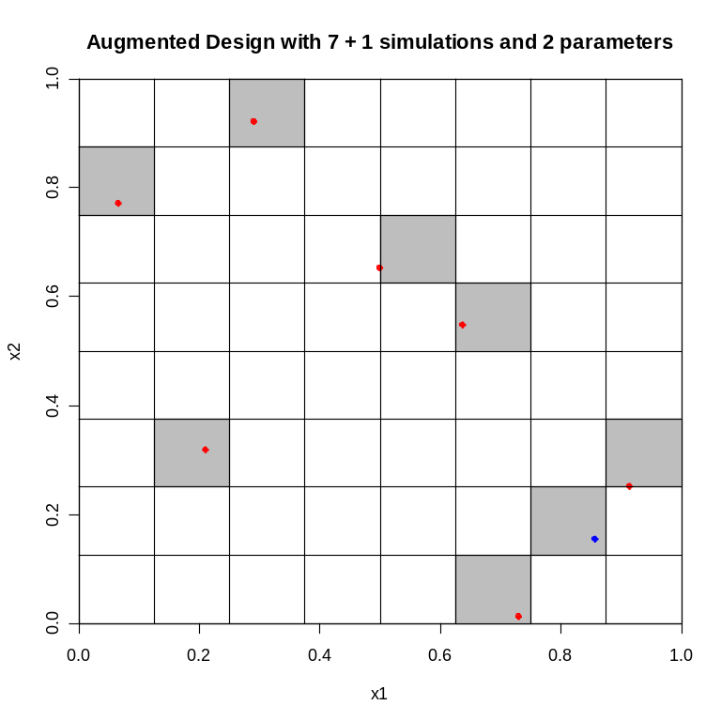

The code used to generate these examples is below:

require(lhs)

graph2DaugmentLHS <- function(sims, extras, plotHist)
{
A <- randomLHS(sims, 2)
B <- augmentLHS(A, extras)

windows()
plot.default(A[,1], A[,2], type="n", ylim=c(0,1),
xlim=c(0,1), xlab="x1", ylab="x2", xaxs="i", yaxs="i",
main=paste("Original Design with", sims, "simulations and 2 parameters"))
for(i in 1:length(A[,1]))
{
rect(floor(A[i,1]*sims)/sims, floor(A[i,2]*sims)/sims,
ceiling(A[i,1]*sims)/sims, ceiling(A[i,2]*sims)/sims, col="grey")
}
points(A[,1], A[,2], pch=19, col="red")
abline(v=(0:sims)/sims, h=(0:sims)/sims)

windows()
plot.default(A[,1], A[,2], type="n", ylim=c(0,1),
xlim=c(0,1), xlab="x1", ylab="x2", xaxs="i", yaxs="i",
main=paste("Augmented Design with", sims, "+", extras, "simulations and 2 parameters"))
N <- sims + extras
for(i in 1:length(B[,1]))
{
rect(floor(B[i,1]*N)/N, floor(B[i,2]*N)/N,
ceiling(B[i,1]*N)/N, ceiling(B[i,2]*N)/N, col="grey")
}
points(A[,1], A[,2], pch=19, col="red")
points(B[((sims+1):(sims+extras)),1], B[((sims+1):(sims+extras)),2],
pch=19, col="blue")
abline(v=(0:N)/N, h=(0:N)/N)

if(plotHist)
{
windows()
par(mfrow=c(2,2))
hist(A[,1], breaks=sims, xlab="x1",
main=paste("Original design in", sims, "bins"))
hist(A[,1], nclass=floor(sims/3), xlab="x1",
main=paste("Original design in", sims, "/ 3 bins"))
hist(B[,1], breaks=N, xlab="x1",
main=paste("Augmented design in", N, "bins"))
hist(B[,1], breaks=floor(N/3), xlab="x1",
main=paste("Augmented design in", N, "/ 3 bins"))
}
}

set.seed(10)
graph2DaugmentLHS(5,5,FALSE)
graph2DaugmentLHS(7,1,FALSE)
graph2DaugmentLHS(50,50,TRUE)

