Document Formatting with OdfWeave

Max Kuhn

05/31/07

Table of Contents
1 Defining Styles 1
2 Examples of Changing Styles for Tables, Paragraphs, Bullets and Pages 7
3 Creating Images 20
4 Generating This Document 30

This document was written to help users understand different options for formatting documents using odfWeave. It provides some reference for specific syntax as well as examples of different document components.

Defining Styles

Within your document, you can change styles of various elements, such as tables, figures or text. For example, a series of plots can have different dimensions. Also, you may want to have cells of a table differentially highlighted via an algorithm. The two main functions to do this, getStyles and setStyles, are discussed later in this section.

However, all the styles that will be used within the document must be defined prior to running odfWeave. Various styles for document elements, such as paragraphs or tables, can be defined. There can be multiple formats for document components and every style does not need to be used within the document.

This section describes the various style elements and the possible format-related options. Section 2 shows techniques for changing formatting, as well as several examples.

Style Definitions

The current set of style definitions can be obtained via the getStyleDefs function. This returns a list of lists. Each sublist contains the specifications for some element of style. The sublists can contain different values but will always have value of a variable called type that defines which style element the list pertains to. For example, the following code chunk gets the existing styles and enumerates the style names and types.

> currentDefs <- getStyleDefs()
> allStyles <- data.frame(type = unlist(lapply(currentDefs, function(x) x$type)))
> allStyles <- allStyles[order(allStyles$type), , drop = FALSE]
> allStyles
type
Rbullet Bullet List
wideBullet Bullet List
basicFigFrame Figure Frame
frameWithBorders Figure Frame
paddingEx Figure Frame
anchor2 Figure Frame
anchor1 Figure Frame
wrapping Figure Frame
RlandscapePage Page
ArialCenteredBold Paragraph
ArialNormal Paragraph
ArialCentered Paragraph
ArialHighlight Paragraph
ttBlue Paragraph
ttRed Paragraph
ArialCenteredItalics Paragraph
RTable1 Table
RTable2 Table
noBorder Table Cell
lowerBorder Table Cell
lowerBorderGray Table Cell
highlight Table Cell
Chunk 1: A list of the currently defined styles

The types listed above reflects all of the styles that can currently be accessed using odfWeave. The remainder of this section will describe specific options for different pats of the document.
Paragraph Styles
The paragraph style can affect several areas, including basic paragraphs and text that appears in table cells. Looking at the definition for the style ArialNormal, this style corresponds to basic text. The following code chunk shows the specific definition of this style.

> styleDetails <- function(x) {
+ out <- as.data.frame(unlist(getStyleDefs()[x]))
+ rownames(out) <- unlist(lapply(strsplit(rownames(out), "\\."),
+ function(x) x[2]))
+ colnames(out) <- "Element Value"
+ out
+ }
> styleDetails("ArialNormal")
Element Value
type Paragraph
parentStyleName
textAlign left
fontName Arial
fontSize 12pt
fontType normal
fontColor #000000
Chunk 2: The specifications for the ArialNormal style

The specifications for a paragraph style are:

- type: for this style to correspond to paragraph formatting, this should be the text string “paragraph”.

- ParentStyleName: this is an optional character string for a master style that is to be modifed.

- textAlign: this corresponds to how the text is justified and can be one of the following text values: “start”, “end”, “left”, “right”, or “center”.

- fontName: a text string that specifies which font will be used, such as “Arial”, “Courier” etc.

- fontSize: a text string for the size of the font. This can be declared in terms of absolute point size (e.g. “12pt”).

- fontType: this corresponds to a string that can be used to specify how the text looks. Values for this string include: “bold,” “italic”, “underline”, “shadow”, “superscrpt” and “subscript”. Multiple specifications can be made in the same string. For example, to use text that is both bolded and italicized, this string would be “bold italic” (order does not matter). Currently, odfWeave has hard-coded the definition of some of these properties (e.g. superscript text is 58% of normal text and cannot be changed).

- fontColor: this is another character string to specify colors in hex format. The function colorConverter in the grDevices package can be helpful for specifying this value. To move between color names (as retrieved by color() or other functions) and hex representations, the next code chunk provides a function to do so.

col2hex <- function(col)
{
require(colorspace)
rgbVals <- col2rgb(col)/255
rgbObj <- RGB(rgbVals[1,], rgbVals[2,], rgbVals[3,])
hex(rgbObj)
}
Chunk 3: A convenience function to go between color names (e.g. “darkgreen”) and hexadecimal representations
Table Styles

The style Rtable1 is an example specification for a table:

> styleDetails("RTable1")
Element Value
type Table
marginLeft 0.05in
marginRight 0.05in
marginTop 0.05in
marginBottom 0.05in
align margins
Chunk 4: The specifications for the “RTable1” style

The options are:

- type: for this style to correspond to paragraph formatting, this should be the text string “table”.

- marginLeft, marginRight, marginTop and marginBottom: these are specifications of the margins around the table. This is the primary mechanism for resizing the dimensions of the table.

- align: a description of how the table should be centered, with possible values “left”, “center”, “right” and “margins”. The last option fixes the table in between the left and right margins (this is the default in odfWeave)

Table Cell Styles

The code chunk below shows an example style for a table cell where there is a line beneath the cell:

> styleDetails("lowerBorder")
Element Value
type Table Cell
backgroundColor #FFFFFF
padding 0.0382in
verticalAlign auto
leftBorder none
rightBorder none
topBorder none
bottomBorder 0.0007in solid #000000
Chunk 5: The specifications for the “lowerBorder” table cell style

The table cell specifications are:

- type: the text string “Table Cell”.

- backgroundColor: the color used to fill the background of the entire cell in hex format

- padding: a string specifying the amount of padding in the table cell, such as “0.1in”

- verticalAlign: a string for the alignment of the contents of the cell. “bottom”, “middle”, “top” or “auto”. The ODF Specification (V1.1) describes “auto” as: “Automatically, which sets the vertical alignment to suit the text rotation. Text that is rotated 0 or 90 degrees is aligned to the baseline, while text that is rotated 270 degrees is aligned to the center of the line.”

- leftBorder, rightBorder, topBorder and bottomBorder: these strings relate to the type of border. The three parts of the string specifies the width, line style and color of the border. The width is specified in absolute measurements and the color is in hex format. The line style of border can be either: “none”, “solid”, “dotted”, “dashed”, or “dot-dashed”.

Bullet Styles

Bullets have a limited amount of styles for customization, including:

- bulletChar: specification of the character to be used as the bullet. Currently, only symbols from the StarSymbol font can be used as bullets, which can be specified as a three character binary code, such as the string "\342\227\217" which may render in the output of the next code chunk as a solid dot. Other examples are given in the table below:

- \342\200\242 | - \356\200\214 | - \342\236\224
- \342\236\242 | - \342\234\227 | - \342\234\224

- paraStyle: a character string for an existing paragraph style to use for the contents of the list

- spaceBefore: the amount of space to the left of the list

- minLabelWidth: the amount of space between the bullet and the text

The default bullet values are listed below.

> styleDetails("Rbullet")
Element Value
type Bullet List
paraStyle ArialNormal
bulletChar ●
spaceBefore 0.25in
minLabelWidth 0.25in
Chunk 6: The specifications for the “Rbullet” style

Page Styles

As seen later, odfWeave allows the user to adjust the size and justification of pages. The chunk below shows the details for the “RlandscapePage” page style

> styleDetails("RlandscapePage")
Element Value
type Page
printOrientation landscape
numFormat 1
pageWidth 11in
pageHeight 8.5in
marginLeft 1.25in
marginRight 1.25in
marginTop 1in
marginBottom 1in
Chunk 7: The specifications for the “RlandscapePage” style

The components of these styles are the following:

- numFormat: an identifier as to how the page numbers should be displayed. Examples are: “1”, “i”, “I”, “a”, or “A”.

- printOrientation: either “portrait” or “landscape”. Note that this specification can be used in conjunction with the pageWidth and pageHeight specifications. If the width and height are set to 11 and 8.5 inches with a “landscape” orientation, this would produce a traditional portrait-type page.

- pageWidth and pageHeight: the physical size of the page

- marginLeft, marginRight, marginTop and marginBottom: the size of the margins for the four areas.

Note that, unlike other document elements, new pages created by odfWeave do not automatically use the currently defined page style. Examples of how to use page styles are given later.
Registering Style Definitions

At any given time, the current styles that can be used by odfWeave are saved as global variables. Simply getting the styles and modifying them does not impact the document until they are re-saved into the global environment. The function setStyleDefs does this.

After adding or modifying style definitions, they are “registered” for use with odfWeave by using setStyleDefs:

currentDefs <- getStyleDefs()

# make a new style based on an existing paragraph style
currentDefs$ArialCenteredUnderlined <- currentDefs$ArialCenteredBold
currentDefs$ArialCenteredBold$fontType <- "underline"

# make it available
setStyleDefs(currentDefs)
Chunk 8: “Registering” a new font type for use

This would allow underlined text to be used. This creates the style definitions that can be used but, as shown in the next section, the function setStyles() is needed to use the style.

Examples of Changing Styles for Tables, Paragraphs, Bullets and Pages

Once you have all of the styles updated, you can use them in the document. To see what the default styles are for different document elements, getStyles can be used. By default, it returns a list of the currently active styles. The code chunk below shows the current styles at this point in the document (but formatted into a matrix):

> activeStyles <- t(data.frame(getStyles()))
> colnames(activeStyles) <- "Name"
> activeStyles
Name
paragraph "ArialNormal"
input "ttRed"
output "ttBlue"
table "RTable1"
cell "noBorder"
header "lowerBorder"
cellText "ArialCentered"
headerText "ArialCenteredBold"
bullet "Rbullet"
figureFrame "basicFigFrame"
page "RlandscapePage"
Chunk 9: The current style assignments

The various elements of this list are discussed below.

The easiest way to change the formatting in the document is to get the styles, change them and reset them. For example:

currentStyles <- getStyles()

# make a new style based on an existing paragraph style
currentStyles$paragraph <- "ArialCenteredUnderlined"

# make it available
setStyles(currentStyles)
Chunk 10: A simple example of changing a style within a document.

would change the default paragraph style from “ArialNormal” to “ArialCenteredUnderlined”.

Document Elements
Paragraphs

The “paragraph” style affects text created via the odfCat function. For example:

odfCat("The average of the first four integers is", mean(1:4))

Chunk 11: An example of odfCat with the default formatting
produces

The average of the first four integers is 2.5

but

currentStyles <- getStyles()
currentStyles$paragraph <- "ArialCentered"
setStyles(currentStyles)
odfCat("The average of the first four integers is", mean(1:4))
currentStyles <- getStyles()
currentStyles$paragraph <- "ArialNormal"
setStyles(currentStyles)

Chunk 12: An example of odfCat with the text centered

produces

The average of the first four integers is 2.5

Formatting text generated via Sexpr tags is somewhat different. Essentially, the results in in-line Sweave tags use the existing formatting. For example, if I use an Sexpr tag to show the square-root of 2, I get 1.414. I can bold the tag in the odfWeave template and get different formatting: 1.414.

R Input and Output
The styles for “input” and “output” can be used to define how the output of code chunks is formatted. The default styles, ttRed and ttBlue, are fixed-width teletype fonts that were chosen to mirror the results of the Windows GUI for R.

Code chunks can be placed inside of tables and frames. For example, the results of the proceeding code chunks were placed within a frame with the following specifications:

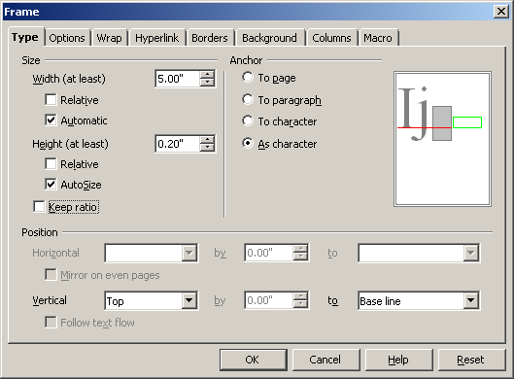

The frame was set to auto-size itself so that the frame width expands with the output. The captions were added by right-clicking on the frame to access the caption dialog.

Tables

The three styles that can be used to change table formatting are “table”, “cell”, “header”, “cell text” and “header text”. The table style controls the overall dimensions of the table. The “header” and “cell” styles control the formatting of cells (in the header row or the interior of the table, respectively).

For example, let's create a small example data frame from the US data (see ?state):

> set.seed(416)
> tableData <- state.x77[c(7, 20, 38, 46), c(7, 1, 8)]
> tableData
Frost Population Area
Connecticut 139 3100 4862
Maryland 101 4122 9891
Pennsylvania 126 11860 44966
Virginia 85 4981 39780

Chunk 13: An example data frame for table formatting
A basic table can be produced using odfTable:

odfTable(tableData)

Chunk 14: A basic table with the default formatting

which produces this table:

 | Frost | Population | Area
Connecticut | 139 | 3100 | 4862
Maryland | 101 | 4122 | 9891
Pennsylvania | 126 | 11860 | 44966
Virginia | 85 | 4981 | 39780

To change the size of the table, the margins around the table can be resized. For example, the style RTable2 uses large(r) margins to make the table smaller:

> styleDetails("RTable1")
Element Value
type Table
marginLeft 0.05in
marginRight 0.05in
marginTop 0.05in
marginBottom 0.05in
align margins
> styleDetails("RTable2")
Element Value
type Table
marginLeft 1.00in
marginRight 1.00in
marginTop 0.05in
marginBottom 2in
align margins

The same table as above can be created with the “RTable2” style:

 | Frost | Population | Area
Connecticut | 139 | 3100 | 4862
Maryland | 101 | 4122 | 9891
Pennsylvania | 126 | 11860 | 44966
Virginia | 85 | 4981 | 39780

The column widths are equally distributed across the total table width.

As an illustration, we can change the background color of the header row by referencing the style “lowerBorderGray”, which was defined prior to generating this document with a background color equal to "#E8E8E8" (light gray). The table can be regenerated with the desired effect.

currentStyles <- getStyles()
currentStyles$header <- "lowerBorderGray"
setStyles(currentStyles)
odfTable(tableData)

Chunk 15: A modification to create a light gray background in the header row

This generates the following table:

 | Frost | Population | Area
Connecticut | 139 | 3100 | 4862
Maryland | 101 | 4122 | 9891
Pennsylvania | 126 | 11860 | 44966
Virginia | 85 | 4981 | 39780

Similarly, we can change the text in the interior of the table by referencing a pre-defined style that uses a slightly smaller font size and italicized characters.

currentStyles <- getStyles()
currentStyles$cellText <- "ArialCenteredItalics"
setStyles(currentStyles)
odfTable(tableData)

Chunk 16: A modification to the text of the table interior

 | Frost | Population | Area
Connecticut | 139 | 3100 | 4862
Maryland | 101 | 4122 | 9891
Pennsylvania | 126 | 11860 | 44966
Virginia | 85 | 4981 | 39780

More complex changes can be made to tables using the tableStyles function. Suppose that we want to draw attention to the state with the largest area by coloring the background and text for those rows blue. First, we would run tableStyles on our data set to generate a template of the current style names for the table elements. This information can be passed to the styles argument of the odfTable function. There are two cases for doing this:

- If the call to odfTable has useRowNames = TRUE, the header columns should be passed to tableStyles using the header argument (see the next example code chunk)

- If the row names will not be used, the no extra values need to be passed to the header argument.

The next Code Chunk shows an example of creating the default style definitions without using the row names.

> headerNames <- colnames(tableData)
> headerNames <- c("", headerNames)
> tableStyles <- tableStyles(tableData, header = headerNames)
> tableStyles
$table
[1] "RTable1"

$text
[,1] [,2] [,3] [,4]
[1,] "ArialCentered" "ArialCentered" "ArialCentered" "ArialCentered"
[2,] "ArialCentered" "ArialCentered" "ArialCentered" "ArialCentered"
[3,] "ArialCentered" "ArialCentered" "ArialCentered" "ArialCentered"
[4,] "ArialCentered" "ArialCentered" "ArialCentered" "ArialCentered"

$cell
[,1] [,2] [,3] [,4]
[1,] "noBorder" "noBorder" "noBorder" "noBorder"
[2,] "noBorder" "noBorder" "noBorder" "noBorder"
[3,] "noBorder" "noBorder" "noBorder" "noBorder"
[4,] "noBorder" "noBorder" "noBorder" "noBorder"

$header
[,1] [,2] [,3]
[1,] "ArialCenteredBold" "ArialCenteredBold" "ArialCenteredBold"
[,4]
[1,] "ArialCenteredBold"

$headerCell
[,1] [,2] [,3] [,4]
[1,] "lowerBorder" "lowerBorder" "lowerBorder" "lowerBorder"

Chunk 17: Determining the specific formats for a table

Now, we have a set of objects that define the specific styles for the table cells and the headers. These can be manipulated as needed:

> bigState <- which.max(tableData[, "Area"])
> tableStyles$text[bigState, ] <- "ArialHighlight"
> tableStyles$cell[bigState, ] <- "highlight"
> tableStyles$text
[,1] [,2] [,3] [,4]
[1,] "ArialCentered" "ArialCentered" "ArialCentered" "ArialCentered"
[2,] "ArialCentered" "ArialCentered" "ArialCentered" "ArialCentered"
[3,] "ArialHighlight" "ArialHighlight" "ArialHighlight" "ArialHighlight"
[4,] "ArialCentered" "ArialCentered" "ArialCentered" "ArialCentered"

Chunk 18: Changing table formats for the state with the largest area

Once we have modified the formatting as needed, we can create the table using odfTable and the styles argument

odfTable(tableData, styles = tableStyles)

Chunk 19: Creating a table with differential formatting

This produces a table with one of the rows highlighted:

 | Frost | Population | Area
Connecticut | 139 | 3100 | 4862
Maryland | 101 | 4122 | 9891
Pennsylvania | 126 | 11860 | 44966
Virginia | 85 | 4981 | 39780

Captions can be produced for tables using the odfTableCaption function. This function should be called immediately after the creation of a table. Typically, the only argument to this function is the text to be used in the caption. As an example, we can re-create the last table and add a caption:

odfTable(tableData, styles = tableStyles)
odfTableCaption("a table using differential formatting")

Chunk 20: Creating a table with differential formatting

produces:

 | Frost | Population | Area
Connecticut | 139 | 3100 | 4862
Maryland | 101 | 4122 | 9891
Pennsylvania | 126 | 11860 | 44966
Virginia | 85 | 4981 | 39780
Table 1: a table using differential formatting

There are additional arguments to this function to format the number style and how the caption formula is updated.
Bullets

The default type of bulleted list is produced by the next code chunk

odfItemize(c("a", "bulleted", "list"))

Chunk 21: Basic bulleted list

with the output:

- a
- bulleted
- list

The same list can be shown when there is less space between the margin and the list (via spaceBefore ="0.1in"), more space between the bullet and the text (minLabelWidth = "0.5in"), a different font for the text (ttBlue) and a different bullet symbol:

- a
- bulleted
- list

The data that are used in the list are processed by the format function prior to being put into bullets. Arguments to format can be passed via the three dots in the call to odfItemize, such as digits (to control the printed precision).

Pages

The function odfPageBreak can be used to insert a page break via code:

odfPageBreak()

Chunk 22: Inserting a page break

Executing this chunk produces:

The new page has the same style as the previous page. As previously mentioned, the page style is different then most other styles in that, when a new page is created, it uses the same style as the prior page. To go to a new page that has a different format (e.g. landscape), odfSetPageStyle can be used. This function has one argument: the name of the new page style. This style can be defined in two different ways:

- using the odfWeave page style. For example,

> styleDetails(getStyles()$page)
Element Value
type Page
printOrientation landscape
numFormat 1
pageWidth 11in
pageHeight 8.5in
marginLeft 1.25in
marginRight 1.25in
marginTop 1in
marginBottom 1in

is an example of a page style.

- Also, any existing style in the document can be used. Under the Format menu, the exiting page styles can be found by picking “Styles and Formatting”. Clicking on the fourth icon to the right lists the specifications for custom styles that are already defined (if any).

For example, there is an existing style in this document named “Envelope” that is short and fat:

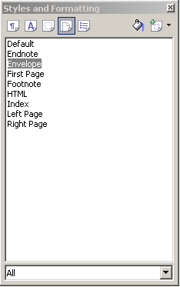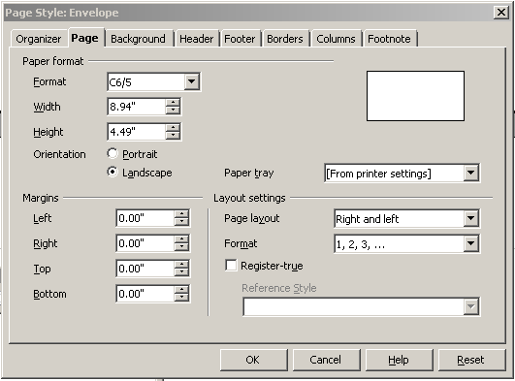

We could switch to this style using

odfSetPageStyle(“Envelope”)

To demonstrate the first method, the next code chunk switches to landscape mode.

odfSetPageStyle(“RlandscapePage”)

Chunk 23: Switching to landscape

To get back, we just reference another style, such as “Default”:

> odfSetPageStyle("Default")

and here we are.

Creating Images

For technical reasons, styles for images are handled differently in odfWeave. Instead of using setStyles and getStyles, the functions setImageDefs and getImageDefs are used to retrieve and specify image properties.

For example, the next code chunk shows the various image generation options as currently specified.

> unlist(getImageDefs())
type device plotHeight plotWidth dispHeight dispWidth
"png" "png" "480" "480" "4" "4"

Chunk 24: Basic image properties

The options are:

- type: the type of plot, such as “png”, “gif” etc. This governs the image file extension as well as error trapping. PDF and SVG images are not currently supported by the ODF specification.

- device: the device that should be called to created the image. This usually defaults to the same value as type, but the user can optionally specify the function. For example, PNG images can be created by several functions, such as png and bitmap, and this argument allows for flexibility regarding the capabilities of the operating system and the configuration of R.

- plotHeight and plotWidth: the size of the image (in the units of the function producing the image). For example, if the png function is used, the units should be in pixels, but the bitmap function uses inches.

- dispHeight and dispWidth: the size of the displayed image in inches.

Additionally, one other option that is not shown unless specified is:

- args: optional arguments that are to be passed to the image generating functions. For example, to use postscript images, it is recommended that the options horizontal = FALSE, onefile = FALSE, and paper = "special” be set. To do this, args should be a list with three elements named “horizontal”, “onefile” and “paper” and the list values appropriately set.

As with other styles, the get function can be used to retrieve the current options and the set function can be used to change them.

The next code chunk shows a function to create an example plot from the S-Plus trellis documentation (reproduced in the Lattice help pages)
> makePlot <- function() {
+ ozo.m <- loess((ozone^(1/3)) ~ wind * temperature * radiation,
+ parametric = c("radiation", "wind"), span = 1, degree = 2)
+ w.marginal <- seq(min(wind), max(wind), length = 50)
+ t.marginal <- seq(min(temperature), max(temperature), length = 50)
+ r.marginal <- seq(min(radiation), max(radiation), length = 4)
+ wtr.marginal <- list(wind = w.marginal, temperature = t.marginal,
+ radiation = r.marginal)
+ grid <- expand.grid(wtr.marginal)
+ grid[, "fit"] <- c(predict(ozo.m, grid))
+ exPlot <- contourplot(fit ~ wind * temperature | radiation,
+ data = grid, cuts = 10, region = TRUE, xlab = "Wind Speed (mph)",
+ ylab = "Temperature (F)", main = "Cube Root Ozone (cube root ppb)")
+ print(exPlot)
+ }

Chunk 25: A function to produce an example image. As a reminder, Lattice graphics must be explicitly printed to be seen.

The following figure shows the resulting plot under the default image specifications:

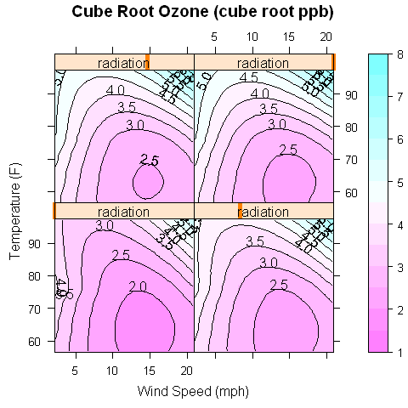

When this plot was created, a png image file was generated and saved in the Picture directory of this odt file.

Image Size

To render the image on a smaller scale, we can produce the same image but choose to display it with smaller dimensions, as illustrated in the next code chunk:

currentPlotDef <- getImageDefs()
currentPlotDef$dispHeight <- 3
currentPlotDef$dispWidth <- 3
setImageDefs(currentPlotDef)

Chunk 26: Changing the dimensions of the rendered image

which produces:

This same procedure can be used to adjust the relative dimensions of plots. If the next plot is a long time series, we may want the image to be wide and short. The function adjustImageSize is a convenience function that automates this process.

The bitmap devices, such as png or bitmap, have resolution parameters. One way to make these image look more appealing is to increase the resolution. As an alternative, we can scale-up the image file size by some factor and display the image in smaller dimensions:

> adjustImageSize(4, 4, scale = 1.75)
> makePlot()
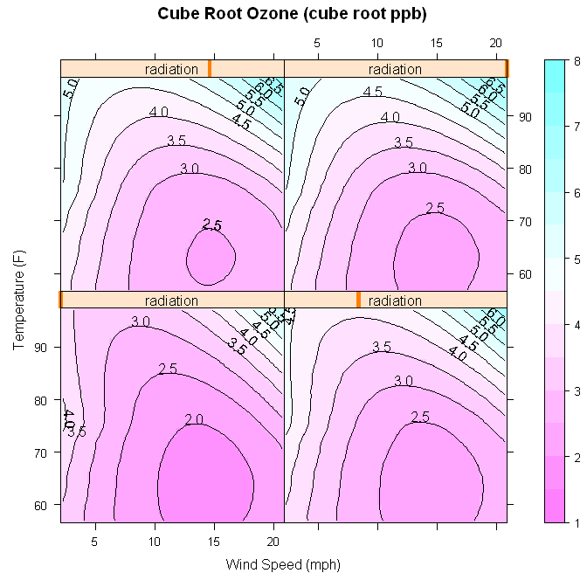

Image Captions and Frames

Unlike captions for tables, the ODF specification includes figure captions are included in frames surrounding the image. Up to now, there have been no frames around the images since we have not specified any captions.

To create captions, the odfFigureCaption function is used:

adjustImageSize(3, 3, scale = 1.75)
makePlot()
odfFigureCaption("Caption and frame created by using odfFigureCaption('caption text')")

Chunk 27: Adding a caption to a figure.

creates

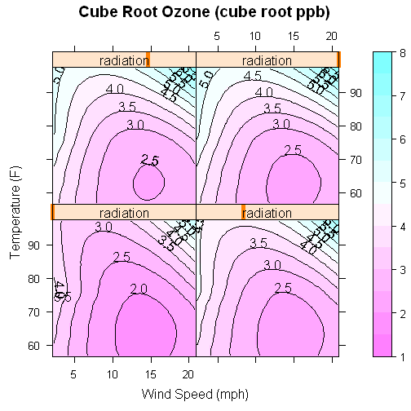 Illustration 1 : Caption and frame created by using odfFigureCaption('caption text')
There are a few options for figures with captions/frames. For example, here is the same plot with black borders on the frame:

> currentStyles <- getStyles()
> currentStyles$figureFrame <- "frameWithBorders"
> setStyles(currentStyles)
> styleDetails("frameWithBorders")
Element Value
type Figure Frame
verticalPosition from-top
verticalRelates paragraph
horizontalPosition center
horizontalRelates paragraph
frameAnchor paragraph
imageAnchor paragraph
wrap none
backgroundColor transparent
padding 0.02in
leftBorder 0.01in solid #000000
rightBorder 0.01in solid #000000
topBorder 0.01in solid #000000
bottomBorder 0.01in solid #000000

Illustration 2 : Adding black borders

ODF can incorporate padding between the frame and the image/caption. The "Figure Frame" style has a single padding element that can be used to control the amount of padding on all four sides. Since padding cannot be used in frames without borders, the default frame style has a white border and a small amount of padding so that the figure and caption are not flush against the frame. The next two code chunks show how to specify the padding for the previous figure.

> currentStyles <- getStyles()
> currentStyles$figureFrame <- "paddingEx"
> setStyles(currentStyles)
> styleDetails("paddingEx")
Element Value
type Figure Frame
verticalPosition from-top
verticalRelates paragraph
horizontalPosition center
horizontalRelates paragraph
frameAnchor paragraph
imageAnchor paragraph
wrap none
backgroundColor transparent
padding 0.5in
leftBorder 0.01in solid #000000
rightBorder 0.01in solid #000000
topBorder 0.01in solid #000000
bottomBorder 0.01in solid #000000

Illustration 3 : Black borders with a (specified) padding of 0.5 inches

Note that the resulting frame is not perfectly rectangular, despite the specification of a square image and uniform padding of a half inch. This is due to the frame adapting to the height of the caption, which adds the height of two text lines.

Another feature of ODF is the ability to anchor the figure to parts of the document. When an framed image is inserted, the anchor specifies how is should be integrated into the document, since frames can float. The Figure Frame style controls the frame's anchor using the frameAnchor element. The main values for this parameter are:

- paragraph: keep the frame in the current paragraph (the default value) This has be used up to this point in the document

- char: the frame is anchored to the next character

- as-char: the frame is not really anchored and behaves like a character.

The two code chunks below show the effect of the “as-char” anchor. The frame is no longer center justified and text can be typed to the right of the frame.

> currentStyles <- getStyles()
> currentStyles$figureFrame <- "anchor1"
> setStyles(currentStyles)
> styleDetails("anchor1")
Element Value
type Figure Frame
verticalPosition from-top
verticalRelates paragraph
horizontalPosition center
horizontalRelates paragraph
frameAnchor as-char
imageAnchor paragraph
wrap none
backgroundColor transparent
padding 0.02in
leftBorder 0.0008in solid #ffffff
rightBorder 0.0008in solid #ffffff
topBorder 0.0008in solid #ffffff
bottomBorder 0.0008in solid #ffffff

Illustration 4 : Using an frame anchor of 'as-char' instead of 'paragraph'

The Figure Frame style also has an anchor for images within the frame, although this may be less useful. This anchor has the same possible values as above, but the effects are relatively minor since there is not a lot of room within the frame to move around. Note that in the previous framed images, the image has been vertically centered within the frame. This is the results of using a value of “paragraph” for the imageAnchor element of the Figure Frame style. The two code chunks below show what happens when the image anchor is changed to “as-char”.

> currentStyles <- getStyles()
> currentStyles$figureFrame <- "anchor2"
> setStyles(currentStyles)

Illustration 5 : Using an image anchor of 'as-char' instead of 'paragraph'

The image is slightly of center (to the left) in the frame.

When the frame anchor is not “as-char”, other parts of the document, such as text, might be wrapped around the frame. The Figure Frame style element anchor can be used to control this. Some possible values are:

- none: don't wrap anything (the odfWeave default).

- left: wrap content to the left (similarly, right can also be chosen)

- parallel: content may go around both sides

- dynamic: “Text may wrap around both sides of the drawing shape, provided that there is sufficient space left.” (OASIS specification). This is called “optimal” in the OpenOffice GUI for frames.

As an example, the following two chunks show what occurs when “right” wrapping is used:

> currentStyles <- getStyles()
> currentStyles$figureFrame <- "wrapping"
> setStyles(currentStyles)

Illustration 6 : The effect of setting the wrap parameter to 'right'
The paragraph immediately after the frame gets wrapped around the frame. Since we specified a value of 'right', the text is on the right side.

Generating This Document

This file was run using the code below.

basicStyles <- getStyleDefs()
basicStyles$lowerBorder$backgroundColor <- "#FFFFFF"
basicStyles$lowerBorderGray <- basicStyles$lowerBorder
basicStyles$lowerBorderGray$backgroundColor <- "#E8E8E8"
basicStyles$ArialCenteredItalics <- basicStyles$ArialCenteredBold
basicStyles$ArialCenteredItalics$fontSize <- "10 pt"
basicStyles$ArialCenteredItalics$fontType <- "italic"
basicStyles$ArialHighlight$fontColor <- "#000080"
basicStyles$ArialHighlight$fontType <- ""
basicStyles$highlight <- basicStyles$noBorder
basicStyles$highlight$backgroundColor <- "#D4EBF3"
basicStyles$RTable2 <- basicStyles$RTable1
basicStyles$RTable2$marginLeft <- "1.00in"
basicStyles$RTable2$marginRight <- "1.00in"
basicStyles$RTable2$marginTop <- "0.05in"
basicStyles$RTable2$marginBottom <- "2in"
basicStyles$frameWithBorders <- basicStyles$basicFigFrame
basicStyles$frameWithBorders$bottomBorder <- "0.01in solid #000000"
basicStyles$frameWithBorders$topBorder <- "0.01in solid #000000"
basicStyles$frameWithBorders$leftBorder <- "0.01in solid #000000"
basicStyles$frameWithBorders$rightBorder <- "0.01in solid #000000"
basicStyles$paddingEx <- basicStyles$frameWithBorders
basicStyles$paddingEx$padding <- "0.5in"
basicStyles$anchor2 <- basicStyles$basicFigFrame
basicStyles$anchor2$imageAnchor <- "as-char"
basicStyles$anchor1 <- basicStyles$basicFigFrame
basicStyles$anchor1$frameAnchor <- "as-char"
basicStyles$wrapping <- basicStyles$basicFigFrame
basicStyles$wrapping$wrap <- "right"
basicStyles$wideBullet <- basicStyles$Rbullet
basicStyles$wideBullet$spaceBefore <- "0.1in"
basicStyles$wideBullet$minLabelWidth <- "0.5in"
basicStyles$wideBullet$paraStyle <- "ttBlue"
basicStyles$wideBullet$bulletChar="\342\234\224"
setStyleDefs(basicStyles)
plotInfo <- getImageDefs()
plotInfo$dispHeight <- 4
plotInfo$dispWidth <- 4
setImageDefs(plotInfo)
options(width = 80)
odfWeave("formatting.odt", "formattingOut.odt")

Chunk 28: Commands to generate this document

One exception is the process for specifying images. Changing image properties is discussed in Section 3
Some with find this process similar to specifying Lattice graphics. OdfWeave uses a process very similar to running trellis.par.set on Trellis themes.
This method is somewhat prone to error. For example, if you partially format the in-line tag, it may prevent the tag from being executed or could cause and error. Essentially, OpenOffice encapsulates the R code inside of XML formatting statements. If the R code is not completely within the formatting, the XML does not get removed. For example, \Sexpr{round(sqrt(2), 3)} does not get evaluated.
This function is a modified version of one sent by Sarah Goslee

