Figure 1.0
MTCARS Miles per Cylinder Plot
Cylinders: 4

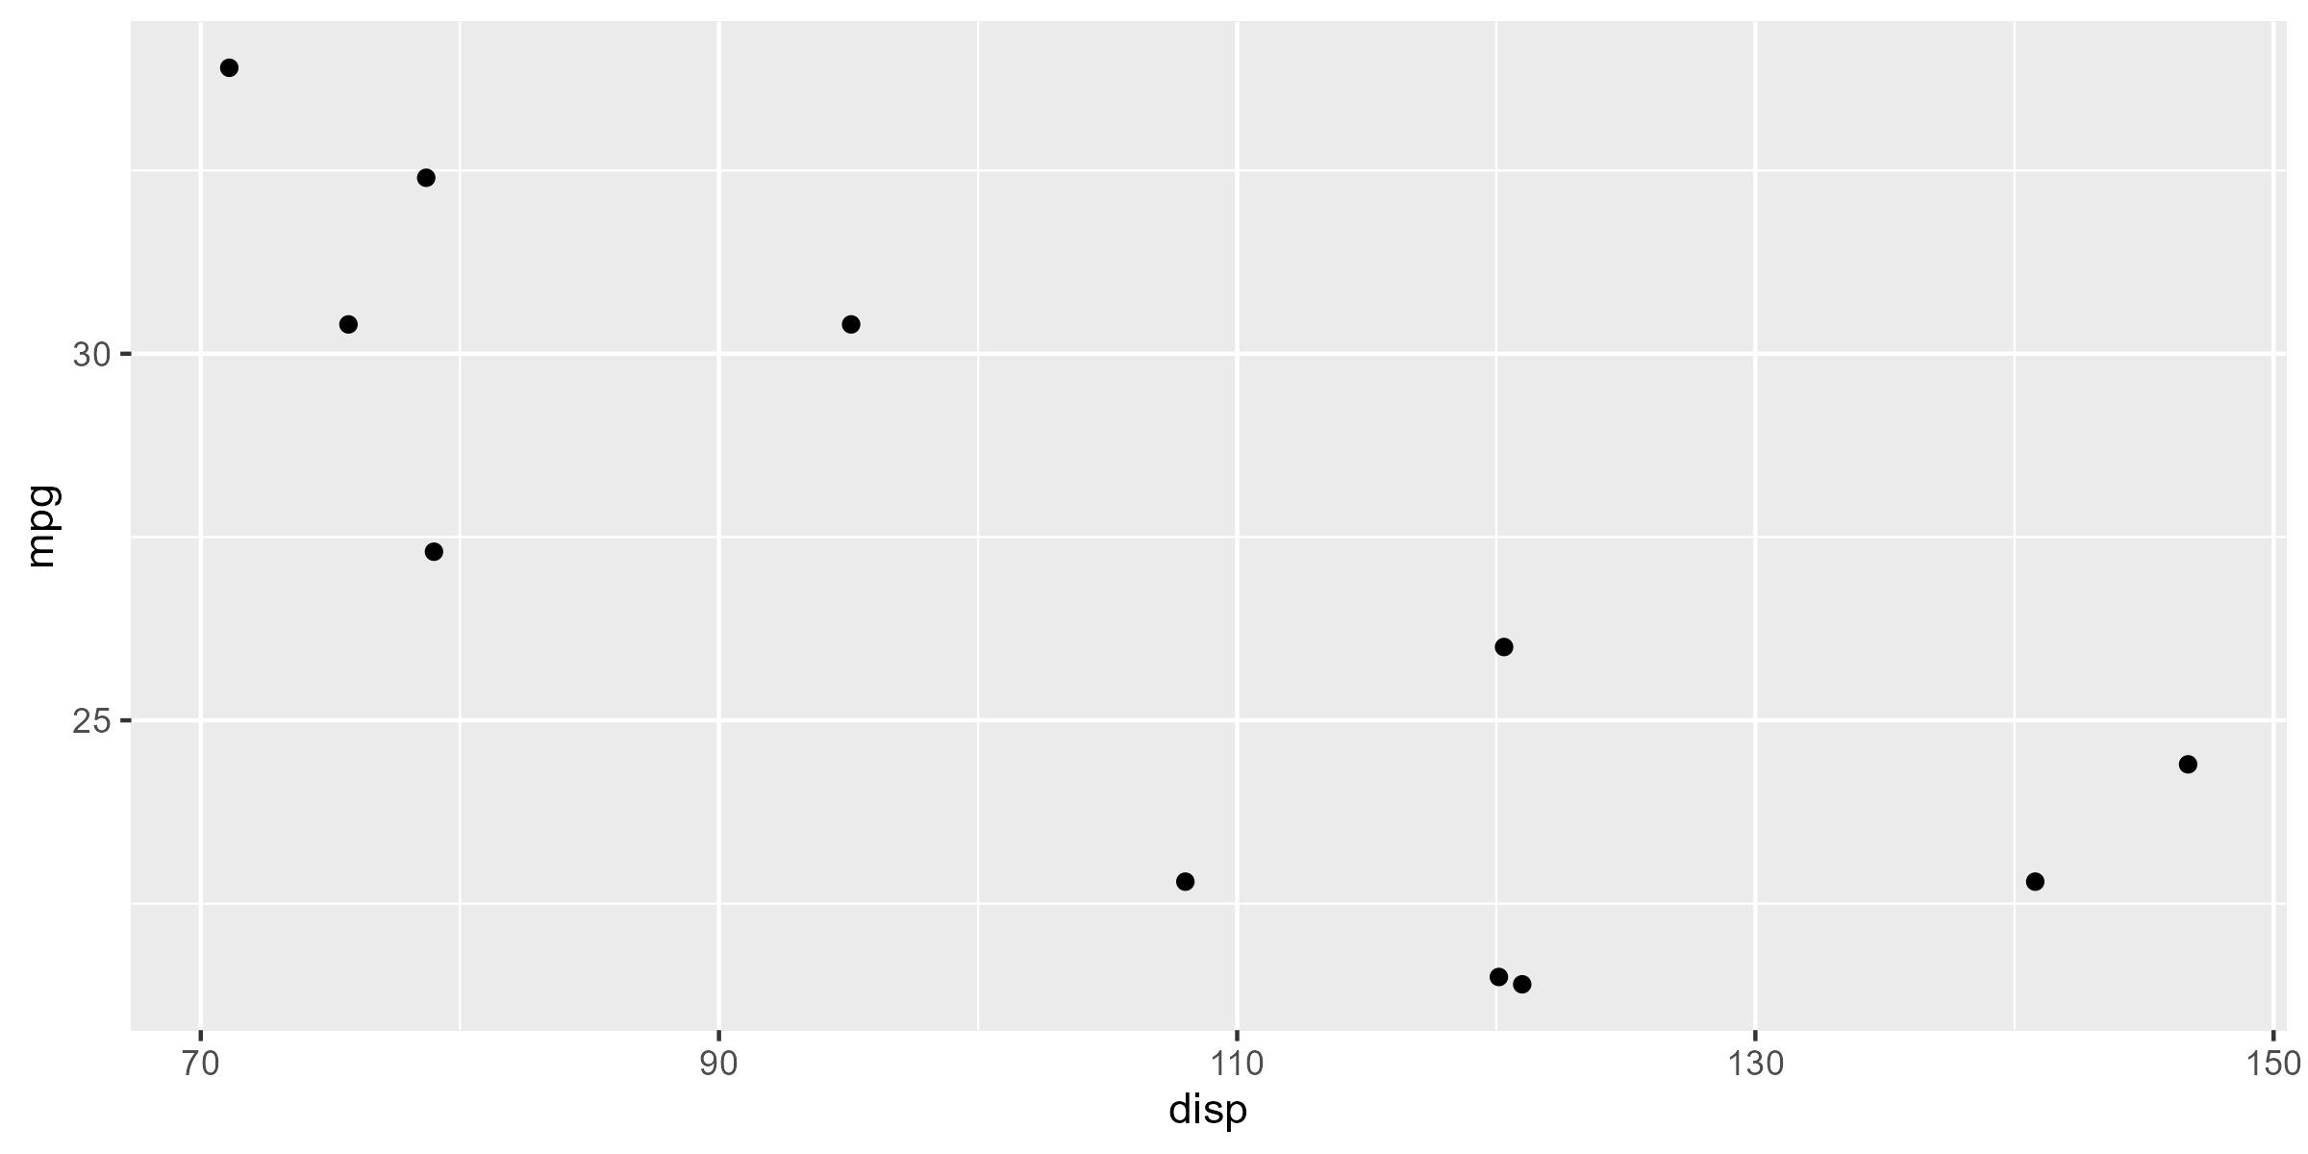

* Motor Trend, 1974

Figure 1.0
MTCARS Miles per Cylinder Plot
Cylinders: 6

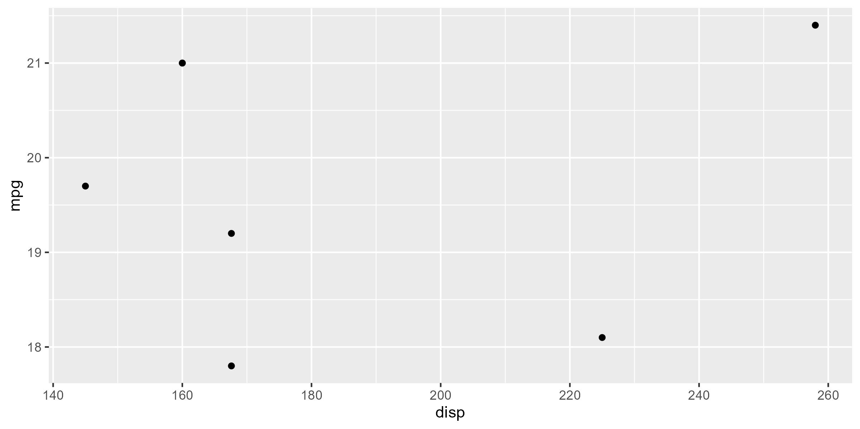

* Motor Trend, 1974

Figure 1.0
MTCARS Miles per Cylinder Plot
Cylinders: 8

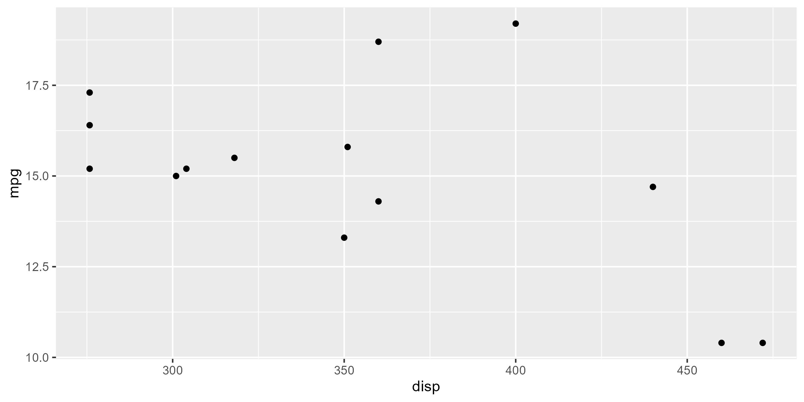

* Motor Trend, 1974

