Client Study: XYZ
Figure 1.0
MTCARS Miles per Cylinder Plot
Cylinders: 4
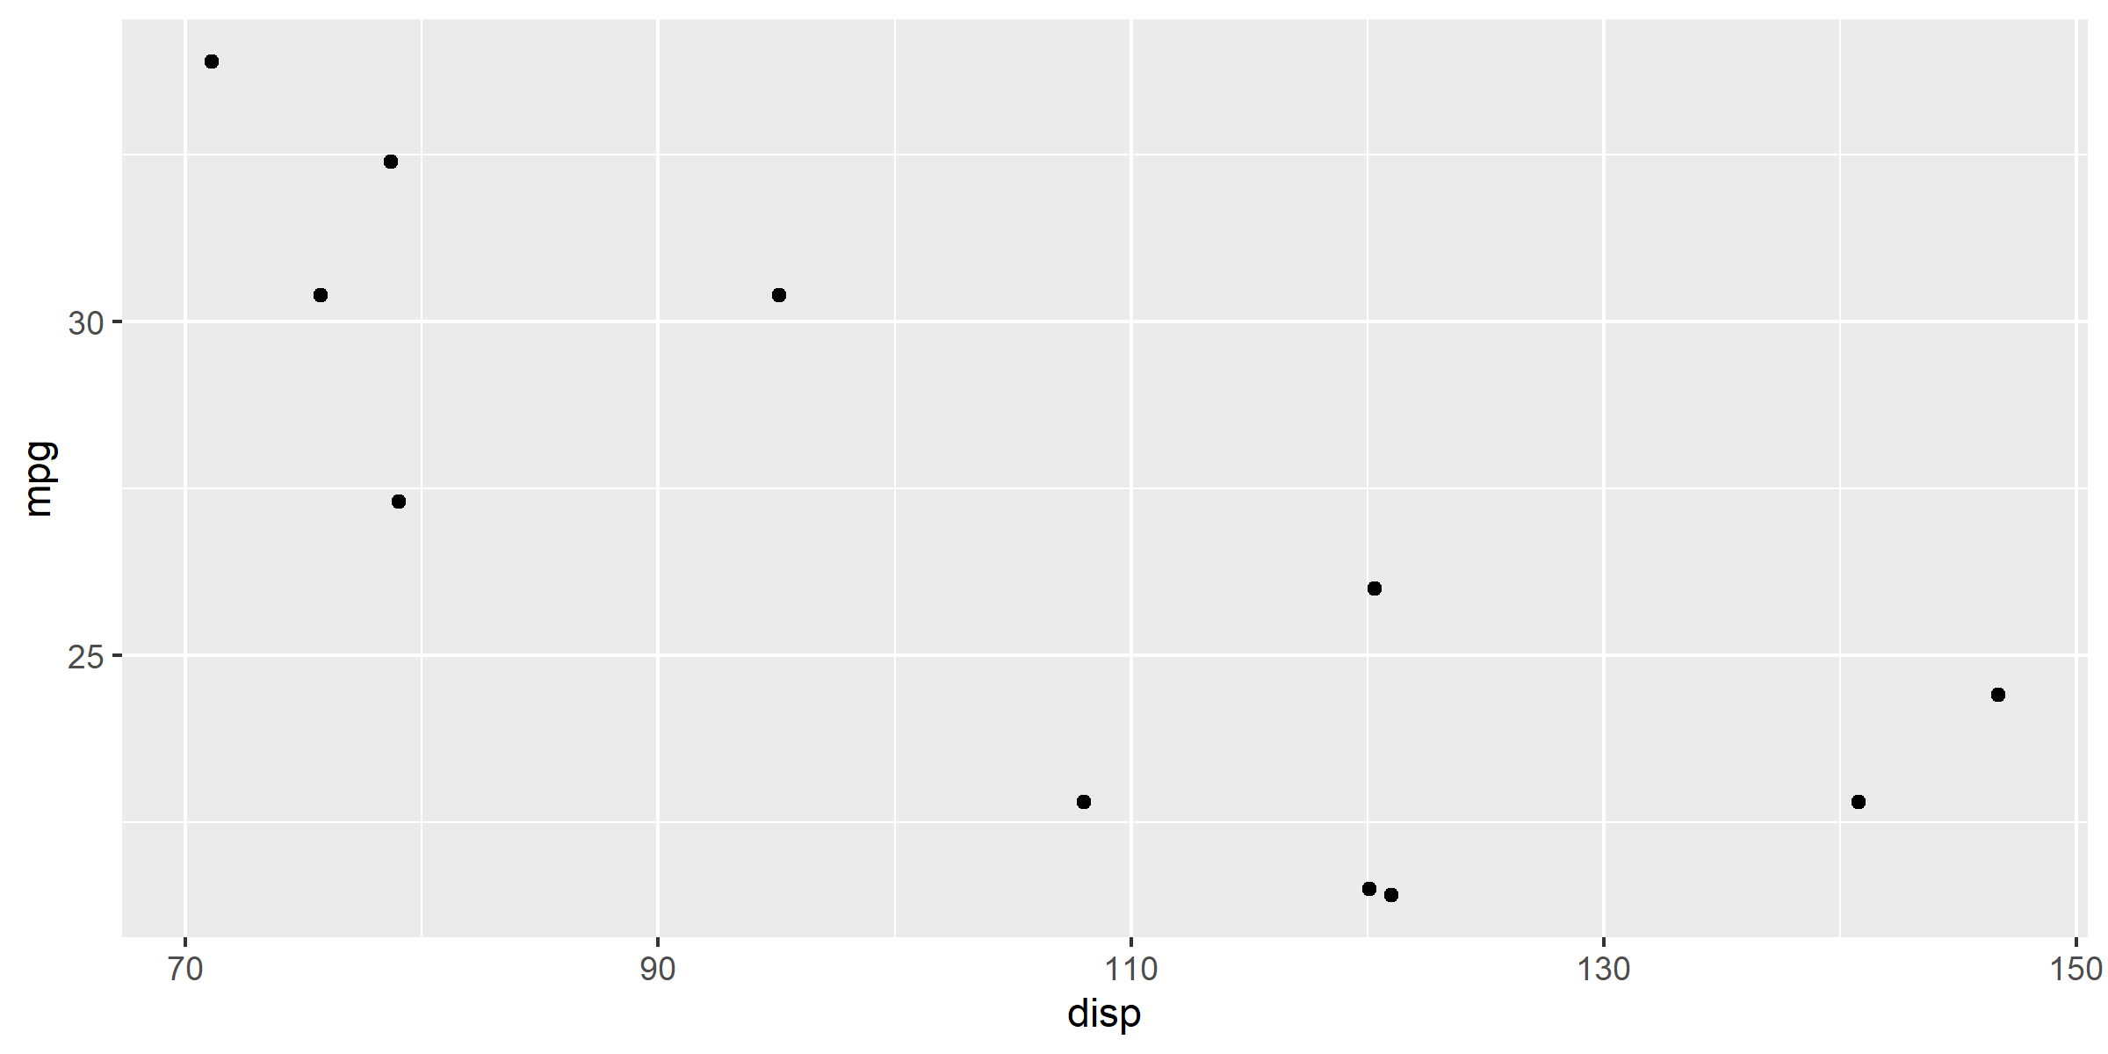
* Motor Trend, 1974
Time Confidential Page 1 of 3
Client Study: XYZ
Figure 1.0
MTCARS Miles per Cylinder Plot
Cylinders: 6
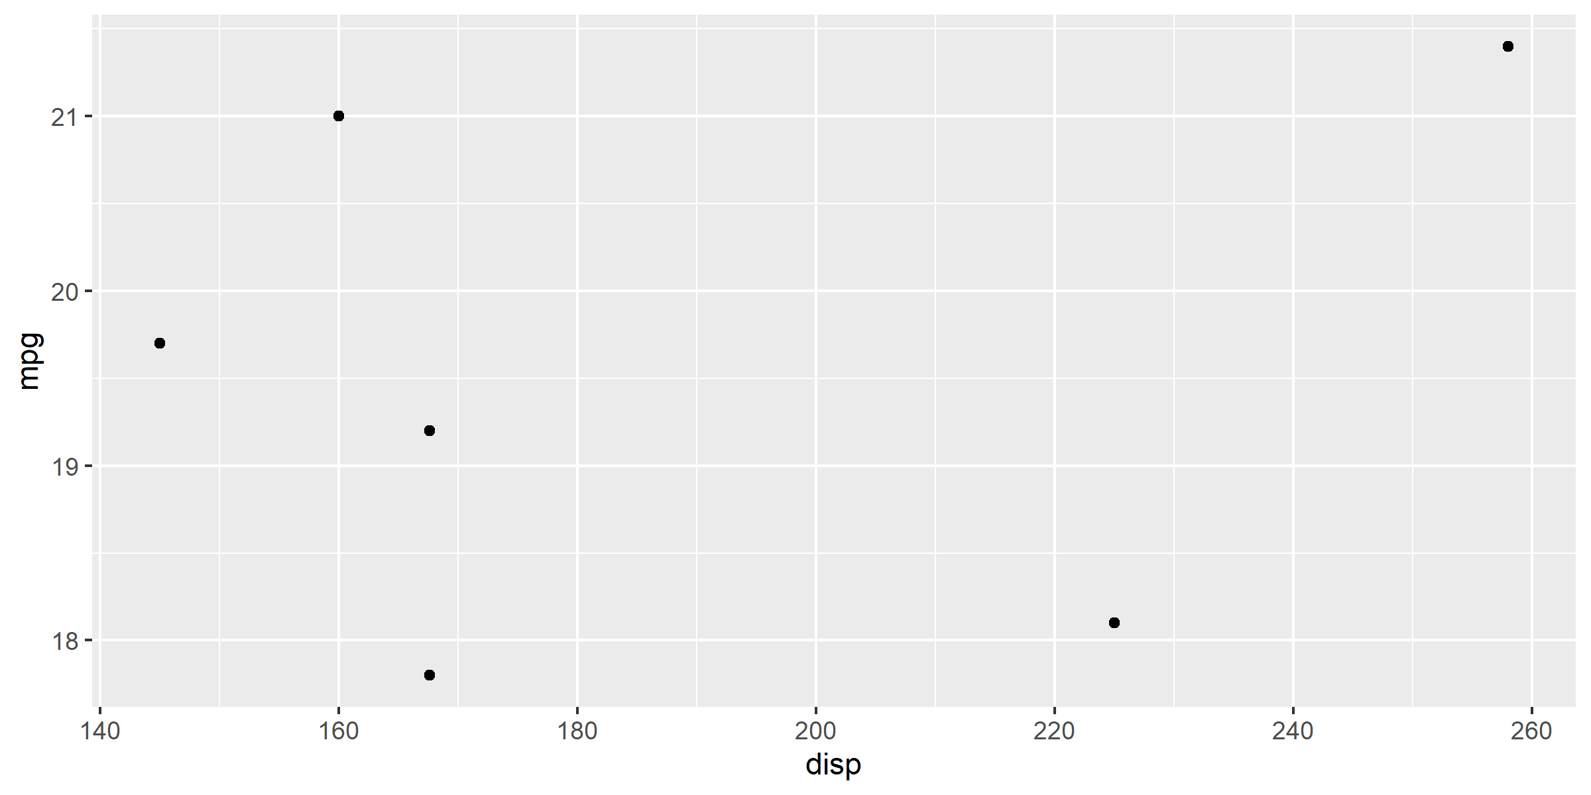
* Motor Trend, 1974
Time Confidential Page 2 of 3
Client Study: XYZ
Figure 1.0
MTCARS Miles per Cylinder Plot
Cylinders: 8
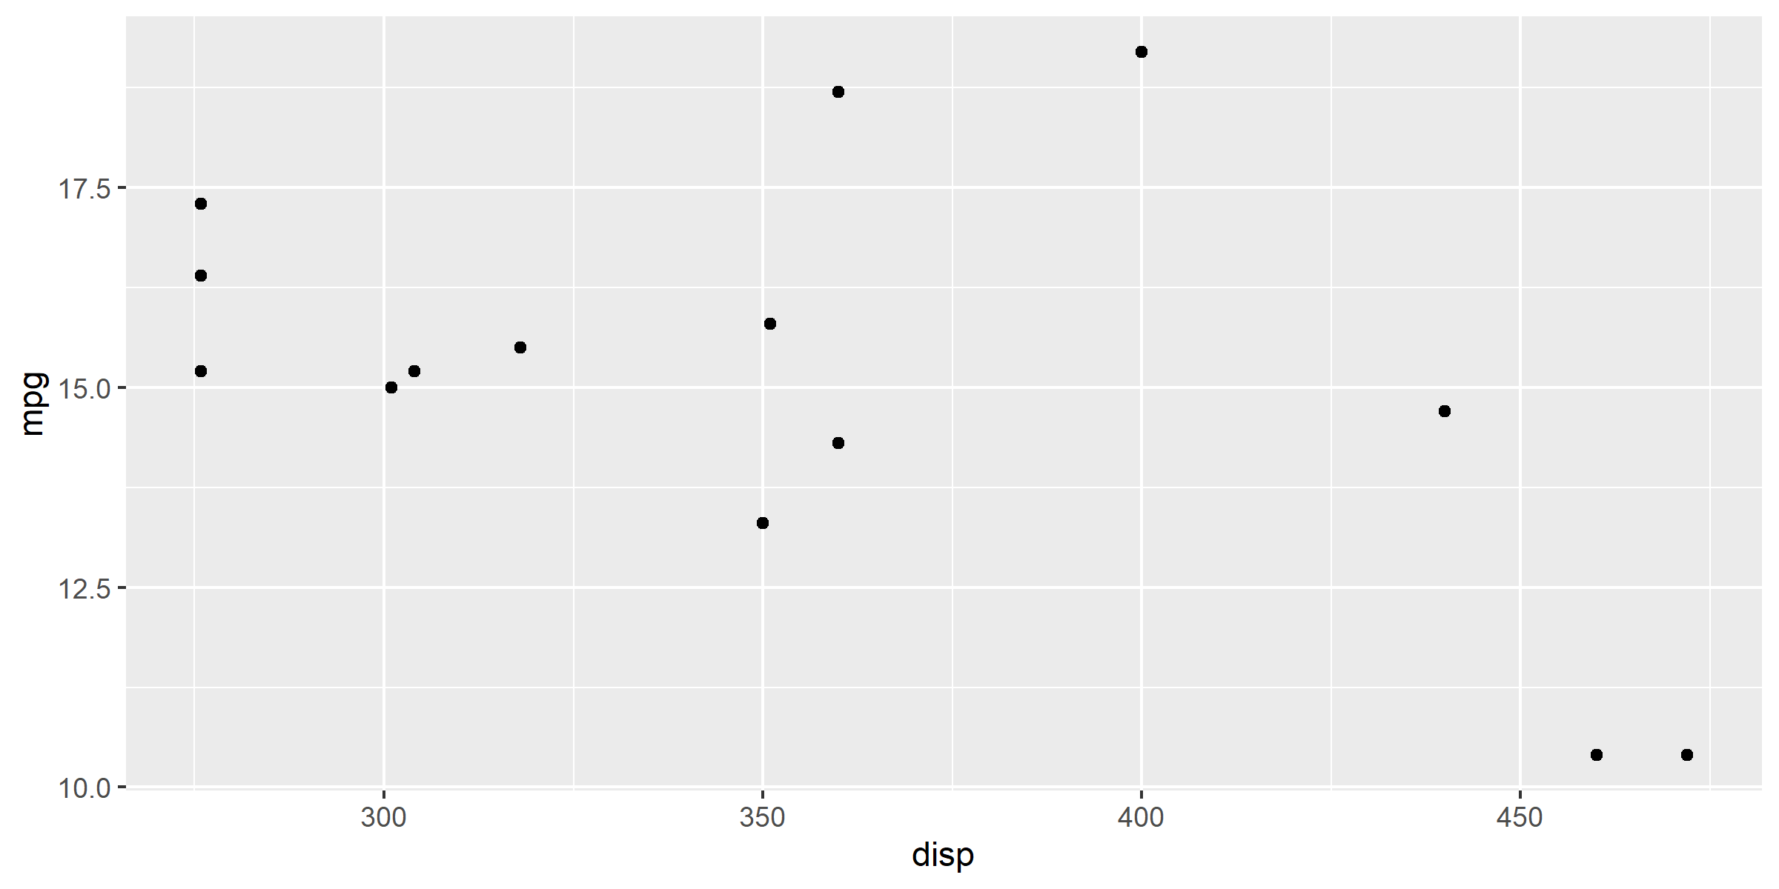
* Motor Trend, 1974
Time Confidential Page 3 of 3

