Figure 1.0 Client
MTCARS Plot Page
More
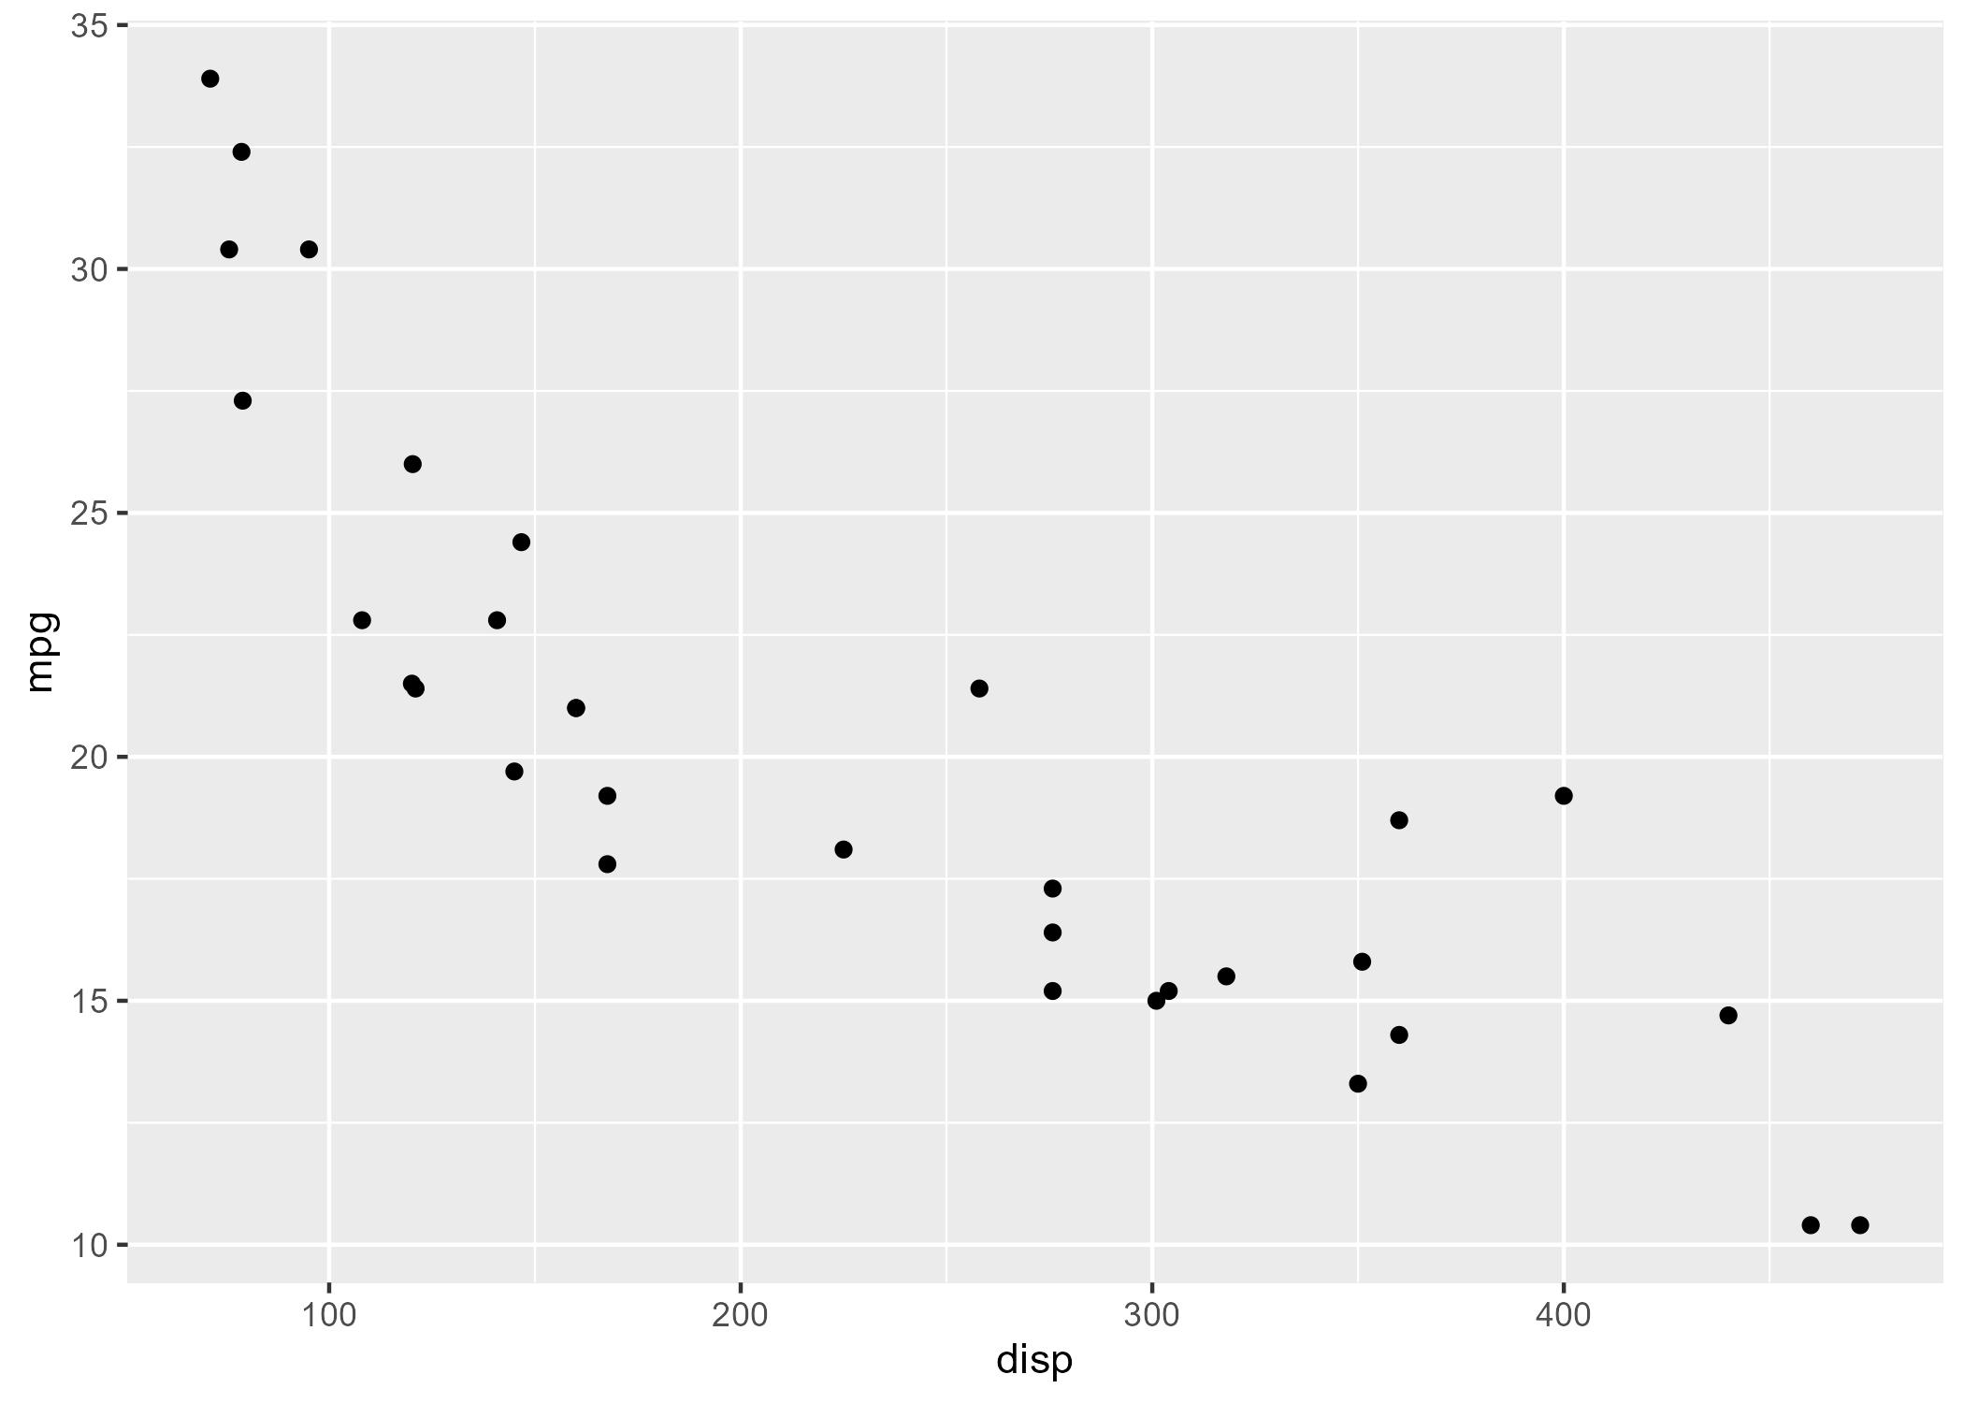
* Motor Trend, 1974

