%PROJECT% - %PACKAGE%
%TASK%
%AUTHOR%
%DATE%
Table of Contents

# ===================== HELPER CODE ==========================
{
library(D4TAlink.light)
try(require(D4TAlink))
setTaskSponsor("%SPONSOR%")
setTaskStructure(pathsDefault)
try(setTaskRoot("%ROOT%"))
# load the task
task <- loadTask(project="%PROJECT%", package="%PACKAGE%", taskname="%TASK%")
# render the task
renderTaskRmd(task)
# archive the task to the home directory
archiveTask(task,zf<-paste0("~/",task$task,".zip"),overwrite=FALSE)
# settings for new repository
oro <- getTaskRoot()
setTaskRoot("/PATH/TO/NEW/REPOSITORY")
ost <- getTaskStructure()
setTaskStructure(pathsDefault)
# copy the task to a new repository
newtask <- restoreTask(zf)
print(list.files(getTaskPaths(newtask)$data,
full.names=FALSE,recursive=TRUE))
#restore old settings
setTaskRoot(oro)
setTaskStructure(ost)
}
# ============================================================
# p
# Please enter password in TK window (Alt+Tab)
# Error in setTaskRoot("%ROOT%") : root directory does not exist
# Error in get(x = "rootpath", pos = .pkgEnv): object 'rootpath' not found
# Error in eval(expr, envir, enclos): object 'task' not found

Scope
In this section the scope / rationale of the task should be explained.

Input
The section list the information and data sources.
- List of patients (see email by JD dated 2022-05-01 17:12).
- List of assays (see task 20220102_loadAssays).

Methods and Results
The results-section contains more details regarding the results of task X.

Table
Table : caption 1
l | L
a | A
b | B
c | C
d | D
e | E
f | F

Plot
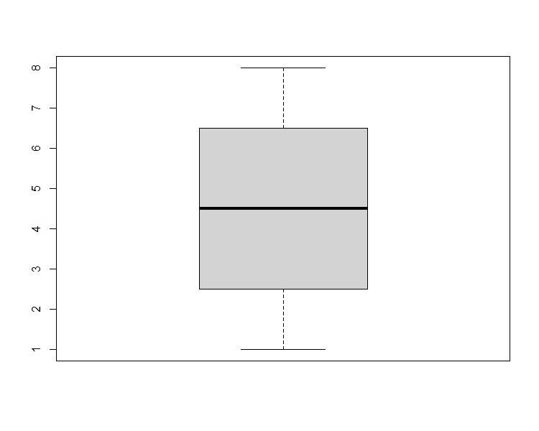
Figure : A boxplot

Output
The section contains detailed information on output (incl. location).
- List of assays.

References
- R Core Team (2022). R: A language and environment for statistical computing. R Foundation for Statistical Computing, Vienna, Austria. URL https://www.R-project.org/.

Appendices

Session information
R version 4.2.1 (2022-06-23 ucrt) Platform: x86_64-w64-mingw32/x64 (64-bit) Running under: Windows 10 x64 (build 19043)
Matrix products: default
locale: [1] LC_COLLATE=English_Ireland.utf8 LC_CTYPE=English_Ireland.utf8
[3] LC_MONETARY=English_Ireland.utf8 LC_NUMERIC=C
[5] LC_TIME=English_Ireland.utf8
attached base packages: [1] stats4 stats graphics grDevices utils datasets methods
[8] base
other attached packages: [1] xml2_1.3.3 svglite_2.1.0 getPass_0.2-2
[4] D4TAlink_0.8 Biobase_2.56.0 BiocGenerics_0.42.0
[7] httr_1.4.4 devtools_2.4.5 usethis_2.1.6
[10] gdata_2.18.0.1 sn_2.1.0 pROC_1.18.0
[13] coin_1.4-2 survival_3.4-0 namespace_0.9.1
[16] rjson_0.2.21 RUnit_0.4.32 D4TAlink.light_2.1.10 [19] openssl_2.0.4 rmarkdown_2.17 jsonlite_1.8.2
[22] officer_0.4.4 officedown_0.2.4
loaded via a namespace (and not attached): [1] pkgload_1.3.0 splines_4.2.1 gtools_3.9.3
[4] shiny_1.7.2 askpass_1.1 yaml_2.3.5
[7] remotes_2.4.2 sessioninfo_1.2.2 gdtools_0.2.4
[10] numDeriv_2016.8-1.1 lattice_0.20-45 glue_1.6.2
[13] uuid_1.1-0 digest_0.6.29 promises_1.2.0.1
[16] sandwich_3.0-2 htmltools_0.5.3 httpuv_1.6.6
[19] Matrix_1.5-1 plyr_1.8.7 purrr_0.3.5
[22] xtable_1.8-4 mvtnorm_1.1-3 processx_3.7.0
[25] later_1.3.0 ellipsis_0.3.2 TH.data_1.1-1
[28] cachem_1.0.6 cli_3.4.1 mnormt_2.1.1
[31] magrittr_2.0.3 crayon_1.5.2 mime_0.12
[34] memoise_2.0.1 evaluate_0.17 ps_1.7.1
[37] fs_1.5.2 MASS_7.3-58.1 pkgbuild_1.3.1
[40] profvis_0.3.7 tools_4.2.1 prettyunits_1.1.1
[43] lifecycle_1.0.3 matrixStats_0.62.0 multcomp_1.4-20
[46] stringr_1.4.1 zip_2.2.1 callr_3.7.2
[49] compiler_4.2.1 systemfonts_1.0.4 rlang_1.0.6
[52] grid_4.2.1 rstudioapi_0.14 htmlwidgets_1.5.4
[55] miniUI_0.1.1.1 tcltk_4.2.1 codetools_0.2-18
[58] curl_4.3.3 R6_2.5.1 rvg_0.2.5
[61] zoo_1.8-11 knitr_1.40 fastmap_1.1.0
[64] libcoin_1.0-9 modeltools_0.2-23 stringi_1.7.8
[67] parallel_4.2.1 Rcpp_1.0.9 urlchecker_1.0.1
[70] xfun_0.33

List of figures

List of tables

