Template Shell
Analyst at TNTP
August 25, 2016

Page Break

Executive Summary

This report is really empty. Please give me some better text here.

Page Break

Key Findings

- Key finding 1
- Key finding 2
- Key finding 3

Page Break

Recommendations

- Recommendation 1
- Recommendation 2
- Recommendation 3

Page Break

Section Heading
Text...

Subheading
More explanatory text...
Table 1. Distribution of cars by cylinder count
Cylinders | Count | Percent
4 | 11 | 0.34
6 | 7 | 0.22
8 | 14 | 0.44

Here's a crosstab showing distribution of engine cylinder by number of carburetors:
Table 2. Crosstab of cars by cylinder count
Carburetors | 4 cylinders | 6 cylinders | 8 cylinders
1 | 71.4% (5) | 28.6% (2) | 0.0% (0)
2 | 60.0% (6) | 0.0% (0) | 40.0% (4)
3 | 0.0% (0) | 0.0% (0) | 100.0% (3)
4 | 0.0% (0) | 40.0% (4) | 60.0% (6)
6 | 0.0% (0) | 100.0% (1) | 0.0% (0)
8 | 0.0% (0) | 0.0% (0) | 100.0% (1)

Page Break
Here's that same data, visualized:
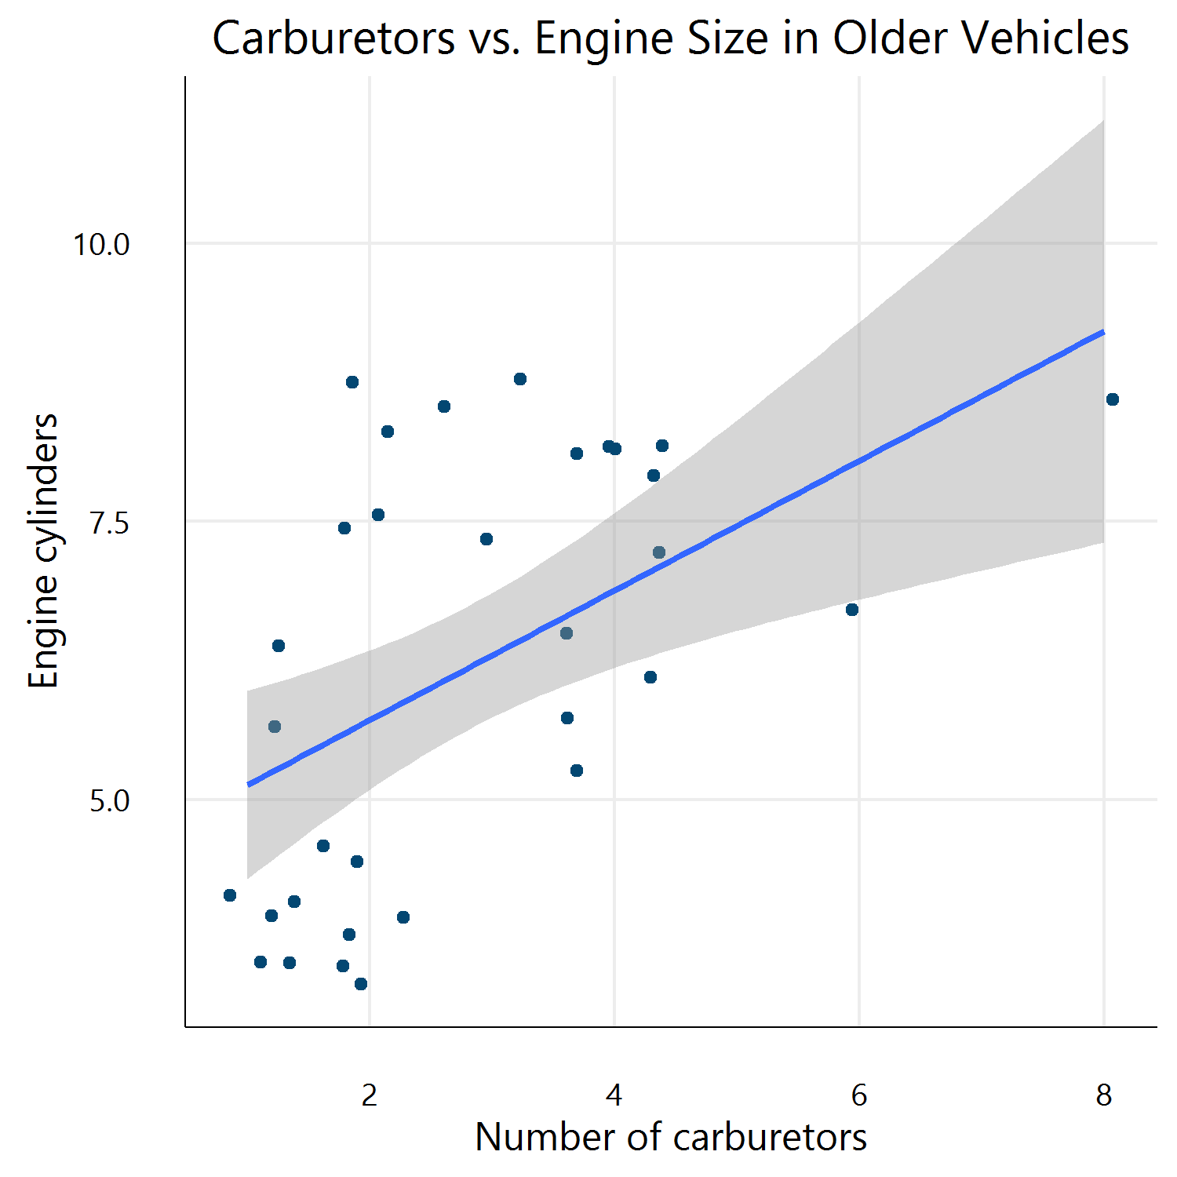
Figure 1. Carburetors vs. Engine Size in Older Vehicles

