DClust(symbolicDA)

Dynamical clustering based on distance matrix

The aim of the DClust is to partition objects set C into a (fixed) number k of homogenous groups on the basis of the distance matrix. It is an optimization clustering method in which the optimized criterion based on the sum of squares of the distances between objects belonging to the same cluster (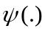). The DClust algorithm is as follows (see Diday, Noirhomme-Fraiture [2008], pp. 192):
Step 1. Data set. Symbolic data table containing 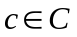objects described by z symbolic variables.
Step 2. Initialization. The initial vector of prototypes 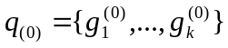 contains random concepts or elements of C.
Step 3. Allocation. An object 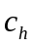 is assigned to the class 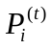 if and only if 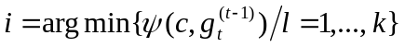, k – number of clusters (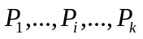 of the partition P).
Step 4. Representation. For 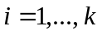 the prototype 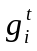 representing class 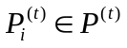 is the symbolic object of the concept where the index is equal to 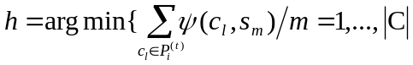 then the prototype is equal to the symbolic object 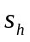 of the concept .
Step 5. Stopping rule. If 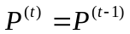 then stop, else go to allocation step.

References
Bock, H.H., Diday, E. (Eds.) (2000), \emph{Analysis of symbolic data. Explanatory methods for extracting statistical information from complex data}, Springer-Verlag, Berlin.
Diday, E., Noirhomme-Fraiture, M. (Eds.) (2008), \emph{Symbolic Data Analysis with SODAS Software}, John Wiley & Sons, Chichester, pp. 191-204.
Diday, E. (1971), \emph{La methode des Nuees dynamiques}, Revue de Statistique Appliquee, Vol. 19-2, pp. 19-34.
Celeux, G., Diday, E., Govaert, G., Lechevallier, Y., Ralambondrainy, H. (1988), \emph{Classifcation Automatique des Donnees}, Environnement Statistique et Informatique - Dunod, Gauthier-Villards, Paris.

