HINoV.SDA(symbolicDA)

Modification of HINoV method for symbolic data

The modification of original algorithm of Carmone, Kara \& Maxwell's Heuristic Identification of Noisy Variables (HINoV) for symbolic data set is presented as fallows:
Step 1. Symbolic data table containing n objects described by m symbolic variables.
Step 2. The set of symbolic objects is divided into u clusters via optimization clustering method (pam, SClust, DClust) or hierarchical clustering method (single, complete, average, mcquitty, median, centroid, Ward) separately for each j-th variable (see e.g. Bock, Diday [2000]; Diday, Noirhomme-Fraiture [2008]).
Step 3. Adjusted Rand (or Rand) indices (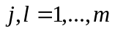) for partitions formed from all distinct pairs of the m variables (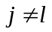) are calculated. Due to symmetric property of adjusted Rand (or Rand) index only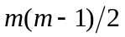values are calculated.
Step 4. Adjusted Rand (or Rand) matrix (parim) is constructed. Sum rows (or columns) for each j-th variable 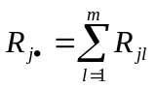 (topri):
parim topri
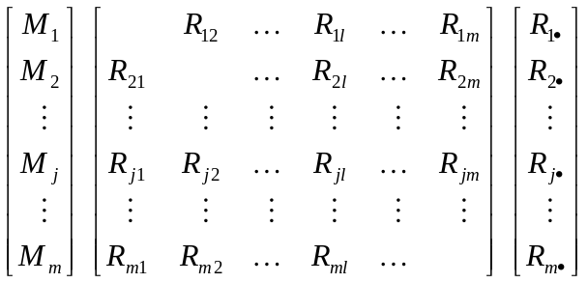

Step 5. Rank topri values 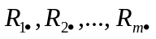in decreasing order (stopri) and plot a scree diagram. The values of topri indicate the contribution of each variable to the cluster structure. In the scree diagram sharp changes in topri values can be identified. The variables with relatively low-valued topri are defined as noisy variables and can be eliminated from further analysis.

References
Bock, H.H., Diday, E. (Eds.) (2000), \emph{Analysis of Symbolic Data. Explanatory Methods for Extracting Statistical Information from Complex Data}, Springer-Verlag, Berlin.
Diday, E., Noirhomme-Fraiture, M. (Eds.) (2008), \emph{Symbolic Data Analysis with SODAS Software}, John Wiley & Sons, Chichester.
Carmone, F.J., Kara, A., Maxwell, S. (1999), \emph{HINoV: a New Method to Improve Market Segment Definition by Identifying Noisy Variables}, "Journal of Marketing Research", November, vol. 36, pp. 501-509.
Rand, W.M. (1971), \emph{Objective Criteria for the Evaluation of Clustering Methods}, "Journal of the American Statistical Association", no. 336, pp. 846-850.
Walesiak, M., Dudek, A. (2008), \emph{Identification of Noisy Variables for Nonmetric and Symbolic Data in Cluster Analysis},In: C. Preisach, H. Burkhardt, L. Schmidt-Thieme, R. Decker (Eds.), Data Analysis, Machine Learning and Applications, Studies in Classification, Data Analysis, and Knowledge Organization, Springer-Verlag, Berlin-Heilderberg, pp. 85-92.

