index.G1d(symbolicDA)

Caliński-Harabasz pseudo F-Statistic based on distance matrix

Calinski-Harabasz pseudo F-statistic takes the form of:
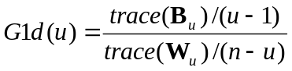
where: 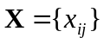 – symbolic data table, 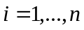 (n – number of objects), 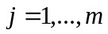 (m – number of variables),
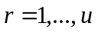 – cluster number, u – number of clusters (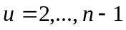),
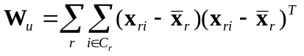– within-group dispersion matrix for data set divided into u clusters,
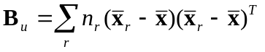– between-group dispersion matrix for data set divided into u clusters,
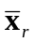 – medoid of cluster r,
– medoid of symbolic data table,
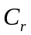 – the indices of objects in cluster r,
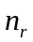 – number of objects in cluster r.
The value of u, which maximizes 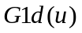, is regarded as specifying the number of clusters.

References
Calinski, R.B., Harabasz, J. (1974), \emph{A Dendrite Method for Cluster Analysis}, Communications in Statistics", Vol. 3, pp. 1-27.
Everitt, B.S., Landau, E., Leese, M. (2001), \emph{Cluster Analysis}, Arnold, London, p. 103.
Gordon, A.D. (1999), \emph{Classification}, Chapman & Hall/CRC, London, p. 62.
Milligan, G.W., Cooper, M.C. (1985), \emph{An Examination of Procedures of Determining the Number of Clusters in a Data Set}, "Psychometrika", Vol. 50, No. 2, pp. 159-179.
Diday, E., Noirhomme-Fraiture, M. (Eds.) (2008), \emph{Symbolic Data Analysis with SODAS Software}, John Wiley & Sons, Chichester, pp. 236-262.
Dudek, A. (2007), \emph{Cluster Quality Indexes for Symbolic Classification. An Examination}, In: H.H.-J. Lenz, R. Decker (Eds.), Advances in Data Analysis, Springer-Verlag, Berlin, pp. 31-38.

