Student Marketplace
  - Assignment 1 Design Note
Annan Khan | CMS 506644 | BESE15-B
CS344 Web Engineering | Idea 16 | 30 October 2026

User and workflow
Student Marketplace helps students find goods, offer services and request items on campus. Users browse or search, filter by type, category and price, then open or save a listing. The demo owner can create, edit and delete posts. New and edited posts stay pending. The app contains nine fictional records, including six active listings, and resets on refresh.

Design choices
The layout follows a newspaper: a blackletter masthead, compact headlines, white backgrounds and occasional wider listings. Wanted posts have a separate classifieds column. Green solid rules identify goods, blue double rules identify services, and rust dashed borders identify wanted posts. Each type also has a text label.
Desktop navigation sits on the left and can collapse to give listings more space. Tablet and mobile use a compact horizontal menu; small screens stack the listings. Labeled fields, semantic headings, a skip link and visible keyboard focus support accessibility.

WDLC stages
Requirements: identify the student workflow and the constraints of idea 16. Design: sketch the browse and posting screens and choose responsive layouts. Implementation: build the HTML structure, CSS and JavaScript interactions. Testing: check valid, invalid and empty cases, then inspect desktop, tablet and mobile views. Maintenance: preserve this version in Git and extend the same records in later assignments.

What runs in the browser
JavaScript filters the listing array, handles forms and updates the DOM. Records, saved items and recent views stay in memory. Forms use native browser constraints and JavaScript checks; user text is escaped before display. The HTTP server only serves static files. There is no database, real login or payment service in Assignment 1.

Run and source
Live app: https://student-marketplace-cs344.vercel.app
For local use, run the command below from the repository root with Python 3, then open http://127.0.0.1:5519. Setup steps, screenshots and the nine automated tests are in the README.
py -m http.server 5519 --bind 127.0.0.1 --directory assignment-1
https://github.com/crankysmh47/student-marketplace-cs344
Fonts: Unifraktur Cook and Roboto Slab from google/fonts. Licenses and asset attribution are included in the repository.

Wireframes
These wireframes show the main layout. Actual application screenshots are included in the repository README.
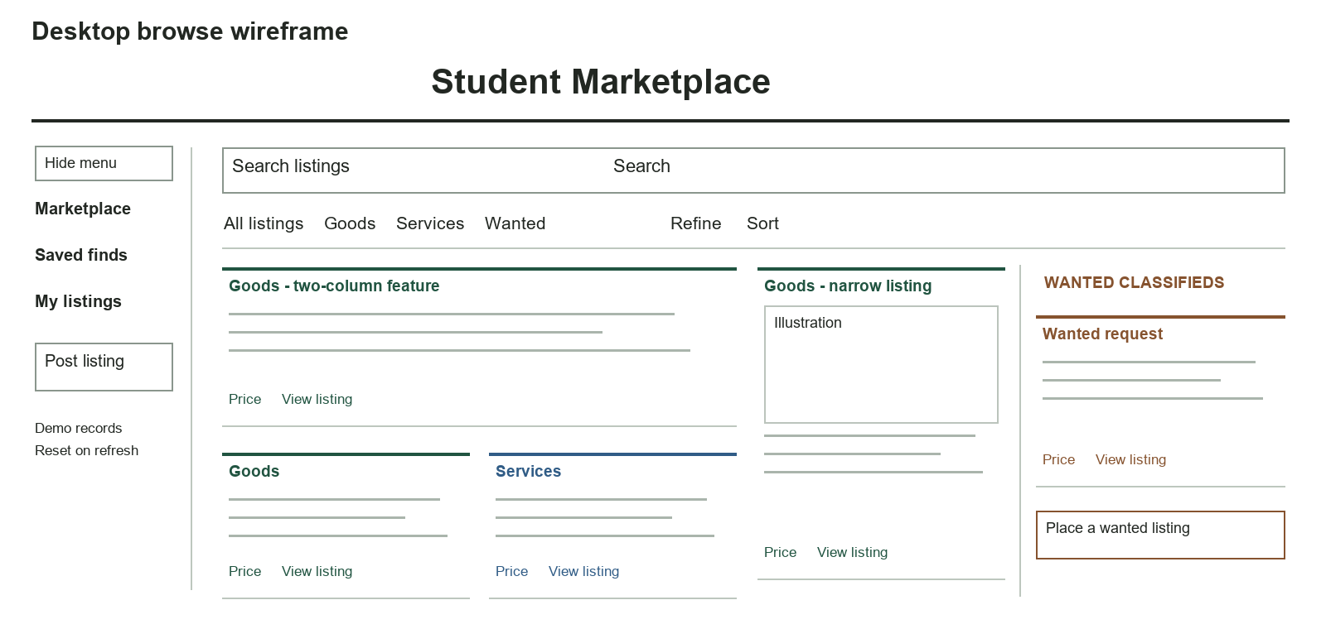
Figure 1 Desktop browse with left navigation and a separate Wanted column
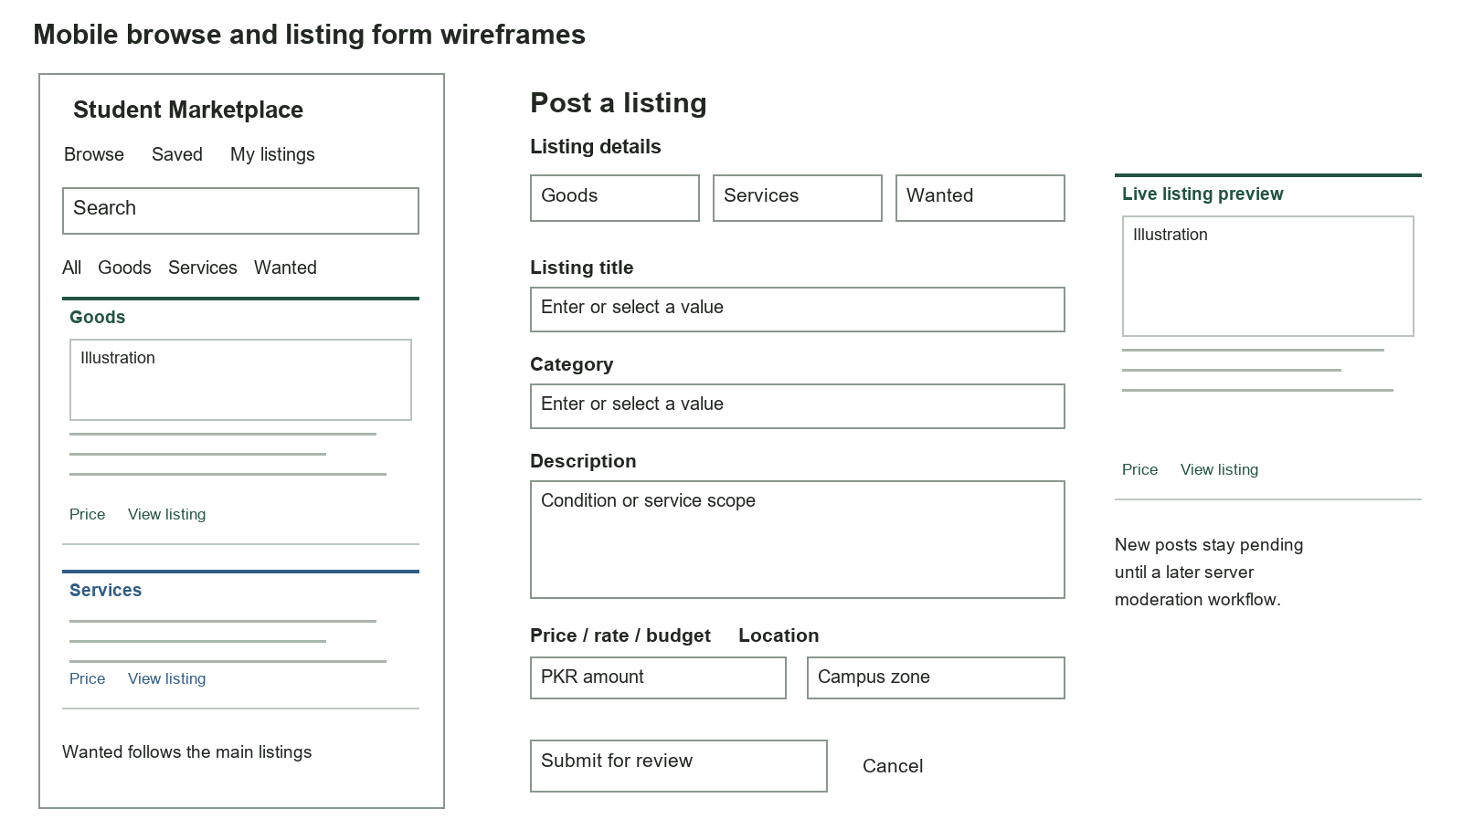
Figure 2 Mobile browse and the listing form with a live preview

