# Process Mining to aid in the Claims Litigation Predictive Modeling Process

## Author: Corey Arnouts

# Introduction

In Michigan Personal Injury Protection has been a very unique coverage in that Auto Insurers have paid all of the costs for any injuries that occurred during an auto accident. Not only does this make Michigan unique but also in till recently unlimited coverage for PIP was mandatory. Because of these regulations an environment of overcharging auto insurers for these injuries was developed by many medical providers. For example a MRI for a non auto related injury may cost $1,000 while the same MRI for an auto related injury may cost as much as $10,000 or more. Insurance companies only recourse is to deny payments that they deem unnecessary, this inevitably ends up in some sort of Legal Battle. This is what I am attempting to predict through this initiative. I want to determine what claims will end becoming problematic and go in to Litigation.

There is a field known as Process Mining which uses event logs from Information Systems to look at how Processes play out from a data perspective. Using this event log data organizations can discover how their processes are actually playing out and can work to further improve and optimize these processes. Predictive Modeling is also a field in recent years that has gained a lot of attention. Predictive Modeling uses data from the past to predict what will happen in the future it pairs data with statistical models in order to do this.

Predictive Modeling has a rich history in the Auto Insurance space, using loss forecasting to predict vehicle damages has been a part of the industry for a long time. To a large degree Predictive Modeling in the Insurance space is based off static modeling elements such as the loss history of an Insured, the age of an Insured, type of vehicle, size of home, and Insurance Score which is a metric developed off of credit reporting elements in order to predict future losses.

## Problem Statement

My proposal is to create a Predictive Model that predict with a high degree of accuracy whether or not a claim will end up in Litigation. I am making the prediction on the information that is available on the claim within 60 days of the claim being reported or before the claim the litigation whatever length of time is shorter. I am building the training set off of claims that occurred in 2016, 2017, and 2018 and have a Personal Injury Protection exposure on them. I will then test the predictive model on the first 6 months of 2019, the reason that the testing data is from 2019 not 2020 is because PIP Claims play out over a long period of time so in order to truly know whether or not a claim will end up in Litigation, the claim needs a at least year to go through it’s lifecycle. In order to accomplish this goal I plan on using predictive features like Claim Loss Location, Medical Providers that are parties on the claim, along with features about the client themselves. engineer predictive features that are not only based off of a single point in time but rather are also based on the interactions we have with the client in the past, this will lead to a more dynamic and informative view of our customers.

# Objectives

To prove that whether or not an Auto Insurance Claim ends up in Litigation is predictable using data elements gathered during the Claims Lifecycle, and that Process Mining can be used on Complex Event Logs to help engineer both Predictive features and target variables to be used in Predictive Modeling Initiatives, that will ultimately increase the profitability of the company.

# Methodology

### Extract the Data

The first step will be to find all of the needed data from across the organization, this data may be found in different systems and will give different perspectives on how different Business Processes and Client Interactions are playing out. This data will include data that is generated from our employees, our agents, our clients, and our systems. All of the data sources used will need to contain timestamps that so they can be assembled in a chronological order that can then be mined for patterns. Even non Process Related features like the location of the Loss will need timestamps so that we understand the point in time that they occur.

### Transform the Data

I will need to put the data in a format in which it can be combined some of the key aspects of Process Mining data are:

##### Case ID: Represents the Party that is going through the process (Person, Policy, Claim, etc..)

##### Activity: The event that has taken place

##### Activity Instance ID: Unique Identifier for the Activity

##### Resource: Person or system responsible for executing the event

##### Start Datetime: start of the event

##### End Datetime: End of the event

All of these data components are necessary to construct a process mining log. Logs of various systems will be combined into one Master Event Log. Once this master event log is constructed data from the target variable will be paired with this event data.

### Analysis

Once the event log data is paired with the target variable the transitions between the events that take place will be encoded with the percent of those cases where the target variable is 1. So for example in the diagram below 11% of claims that travel from the contact insured activity to the first notice of loss activity end up in litigation. All of these transition probabilities are combined and a mean is taken of all of them to determine a Process based Proclivity metric, this methodology was used in the case study below and will be used for the Customer Attrition/Churn case study as well.

After the process mining has generated this feature, the feature will be paired with other relevant information such as policy, claim, account, and geographical attributes among others to improve the improve the potential predictive power of the dataset.

Once all of the Features have been assembled the data will be imported in R, in order to try out a number of predictive algorithms. Various Generalized Linear Models and tree based models such as Random Forest, and XGBoost will be tried on the dataset in order to predict the target variable. Cross Validation on the hyperparameters and the different modeling techniques will be applied to find the most overall predictive model.

# Literature Review

**[1]** Polato, M., Sperduti, A., Burattin, A., de Leoni, M.: **Time and activity sequence prediction of business process instances**. arXiv preprint arXiv:1602.07566 (2016)

<https://arxiv.org/pdf/1602.07566.pdf>

This paper is probably the most similar of any of the above papers as it is using Transition Probabilities within the event log to predict specific process outcomes which is exactly what I am trying to do. It discusses how there can be difficulties predicting process outcomes when the process is currently running, but this is really the only useful types of models to build. It also discusses certain possibilities like seasonal drift that can occur in process based Predictive Models. To do predictions the models that they build not only use previous traces that look exactly like the process instance being predicted on. They also use Jaccard Similarity and Damerau Levenshtein distance as a way to identify similar Process Instances. This is a really creative way of identifying processes that are similar but are not exactly the same. The different process traces and transitions are engineered into features using one hot encoding. This paper does predictions on the remaining amount of time in the Process Instance and also the future path of the Process Instance. They call the prediction method a Similarity-based Transition system.

**[2] Widad Es Soufi, Esma Yahia, Lionel Roucoules. On the use of Process Mining and Machine Learning to support decision making in systems design.** 13th IFIP International Conference on Product Lifecycle Management (PLM), Jul 2016, Columbia, United States. pp.56-66, ff10.1007/978-3-319-54660-5_6ff. ffhal-01403073f<https://hal.archives-ouvertes.fr/hal-01403073/document>

This article looks at using both Process Mining and machine learning to optimize the use of resources to achieve a specified Business goal this is what I am trying to do with my project, I want to use process mining and Machine Learning to understand how to better handle PIP Claims so that we incur less costs and bills from Medical Providers.

**[3] Process Mining in Insurance: Measuring and Managing Activity Costs** <https://www.casact.org/community/affiliates/maf/0919/1.pdf>

This is a interesting article because it talks about using Process Mining in insurance to figure out the amount of time that is being spent on various processes within in an Insurance Company a lot of the data elements that they are leveraging are very similar to the ones that I will be using.

**[4] M. de Leoni, et al., A general process mining framework for correlating, predicting and clustering dynamic behavior based on event logs, Information Systems (2015),** <http://dx.doi.org/10.1016/j.is.2015.07.003i>

This paper looks at a generic approach to use Process Mining to perform correlation analysis with different target variables and discover underlying patterns. It discusses predicting variables from different perspectives: the control flow perspective, which is predicting the next activity in the process. The data-flow perspective which is predicting a variable about the specific case, this is the one I am especially interested in. The time perspective predicting how much time the specific case will take. The resource perspective, predicting the resource needed to execute the case. This paper really shows how process mining can help predict different aspects of a process, but I would like to extend this to predicting certain characteristics of the actors that are involved in the process, e.g. the customer.

**[5] A Network-Based Approach to Modeling and Predicting Product Coconsideration Relations**

This paper proposes how to use Network Based metrics to improve predictive models. This specific paper discusses how network metrics are used to predict what products that clients will want to buy. It will be helpful to apply a similar methodology when I am evaluating why certain clients are choosing certain medical providers to provide them with service.

**[6] Carlos Andre Reis Pinheiro, Oi, Rio de Janeiro, Brazil. Highlighting Unusual Behavior in Insurance Based on Social Network Analysis**

[**http://support.sas.com/resources/papers/proceedings11/130-2011.pdf**](http://support.sas.com/resources/papers/proceedings11/130-2011.pdf)

This paper discusses how to find unusual connections within the social networks that surround Insurance Claims. I am hoping to implement this in my own predictive model in order to identify which claims could be potentially fraudulent in the future. This paper also uses Principal Component Analysis on all of the Network Metrics to reduce the dimensionality of the dataset. I will also use this kind of methodology to do community detection to see which fraudulent Medical Providers are often working together.

**[7] M. Pospíšil, V. Mates, and T. Hruška, “Process Mining in Manufacturing Company,” in The Fifth International Conference on Information, Process, and Knowledge Management, Nice, France, IARIA, 2013, pp. 143-148, ISBN 978-1-61208-254-7**

This paper identifies ways in which Process Mining can help determine which cases should be escalated to different resources based on the attributes of the Process Instance. This will help construct a methodology for how certain claims should be escalated to more skilled adjusters if the Claim needs to be based off of it’s attributes, both the attributes of the Claim itself and the Claim Process Instance.

**[8] Predicting Insurance Fraud with Machine Learning (SMOTE)**

<https://medium.com/analytics-vidhya/predicting-insurance-fraud-with-machine-learning-smote-da94adf8fb62>

This article takes a look at different techniques to identify future claims, these are some of the variables/features that I will use alongside some of the network analysis and process mining variables. The variables discussed in this article will be some of the same variables that I will plan on using in my analysis on PIP Litigation/Fraud. Some of these variables include client attributes, claim attributes, vehicle attributes, attributes about the injuries that happened during the incident. The article also talks about using SMOTE which is an oversampling technique. This is something that may also employ if I find that I do not have enough positive cases to predict.

# **[9] Artificial Intelligence and Process Mining**

<https://medium.com/datadriveninvestor/artificial-intelligence-in-process-mining-d8a61c0adfd1>

This article really gets to the heart of what I am trying to do with this project, it talks about putting a layer of AI/ML on top of Process Mining to further optimize Business Processes and the outcomes that they are trying to achieve. The Process Mining will generate understanding and new variables that can then be analyzed and help predict the specified target variable. The Process Mining can also inform what the best strategy is to handle the various scenarios that arise within the Claim Process.

**[10]** [**“Process mining on the loan application process of a Dutch Financial Institute. BPI Challenge 2017”**](https://www.win.tue.nl/bpi/lib/exe/fetch.php?media=2017:bpi2017_winner_professional.pdf)Liese Blevi, Lucie Delporte, Julie Robbrecht KPMG Technology Advisory, Bourgetlaan 40, 1130 Brussels, Belgium

This paper is really looking the application of Process Mining to aid in the understanding and improvement of the loan application process within a Dutch Financial Institution a lot of the methodology and measurements that they do can be applied to my analysis of PIP Claims. The better we understand the process the better we can understand how to alter the process to achieve an specified business outcome.

**[11]** [“Predictive Business Process Monitoring with LSTM Neural Networks”](https://arxiv.org/abs/1612.02130) **by**[**Niek Tax**](https://scholar.google.com.au/citations?user=XkRvCC4AAAAJ&hl=en&oi=ao)**,**[**Ilya Verenich**](https://scholar.google.com.au/citations?user=xRa_fyMAAAAJ&hl=en&oi=ao)**,**[**Marcello La Rosa**](http://www.marcellolarosa.com/)**and**[**Marlon Dumas**](http://kodu.ut.ee/~dumas/)

In this paper they are concerned with Predicting what will happen with running cases of a certain Process Instance. They are trying to predict Process Outcomes based off of what has already occurred int the Process Instance this is very similar to what I am trying to do. I want to predict the result of whether or not litigation will occur based on the previous activity on the Claim. The focus on this paper is to use a Neural Net and try to make this predictions as generalizable as possible so that they perform well on new event logs and new process instances.

# Analysis and Results

# Data Gathering

For my data gathering I used data from of number of different Enterprise Systems and applications at Farm Bureau Insurance of Michigan. We use Guidewire as our primary administration system and this comes with multiple components. The household based Metrics that I developed and further discuss in the section belows are pulled from our CRM (Customer Relationship Management) system called FBCares. The Advantage of using features from a CRM is the fact that it contains a mix of both legacy system data and data from updated systems. So it is a good place to get a holistic view of a customer and the household they belong to. The FBCares CRM system also allows us to view across all lines of business at the same time.

## Challenges with Data Gathering and Aggregation

There are some difficulties however when combining data across multiple systems, for example often policy numbers are listed different across different systems and data for the same claim can be a mix of legacy and new data. To remedy this I have to a number of different manipulation techniques to get the data to match. I created a user defined function in SQL that takes just the numeric characters from a string, this has proven to be useful, but there are other manipulations that have to be done as well. Sometimes a policy number in a certain system may have a prefix in front of it but will not have prefix in another system.

## Extract Transform and Loading Data

During the Data Gathering phases I had to move a lot of data from disparate sources onto the same server so that the data could be merged, blended, and enriched. In Order to Move Data from Multiple sources I utilized a open source Data Science Platform known as Knime. Knime allows me to execute and an entire workflow of the data science process at once. I spent quite a bit of time in the past connecting Knime to our SQL Servers at Farm Bureau but it has proved to be very beneficial. I can combine SQL Scripts, R Scripts, and Python Scrips all in one cohesive workflow and Knime also has a lot of Data Science Functionality of their own that is accessible.

**Fig4 –** Picture of the full data science workflow built in knime that orchestrates all of the ETL processes and also

Executes the R script for the predictive model

# Feature Engineering

Feature Engineering is perhaps the most critical aspect of the Machine Learning process and it is where the creativity of person performing the analysis is required.

## Using Event Log data to Predict Litigation on Claims

In Personal Auto Insurance there exists what is known as Personal Injury Protection Claims (PIP) that occur when an insured is injured in a car accident and because of this they need some sort of medical care. Depending on their healthcare plan we may have to act as either the Primary or Excess insurer on this healthcare coverage. Michigan up in till recently was a no fault state and had unlimited limits on PIP Insurance, this has caused an environment of litigation to occur between insurance companies and medical providers essentially because medical providers want to charge as much as possible on injuries that occurred during automobile accidents because they know the Auto Insurer will cover whatever they charge. Because of this PIP Claims are heavily litigated in Michigan and a high percentage of our PIP claims have some kind of litigation occurring on them somewhere in the neighborhood of 10%, litigated claims are increasingly expensive because we then have to pay legal costs and may still be stuck with the full cost of the medical bill, because of this insurers would like to avoid PIP Litigation whenever possible. To do this they would like to identify which PIP Claims have a high likelihood at litigation so they can take actions to prevent litigation.

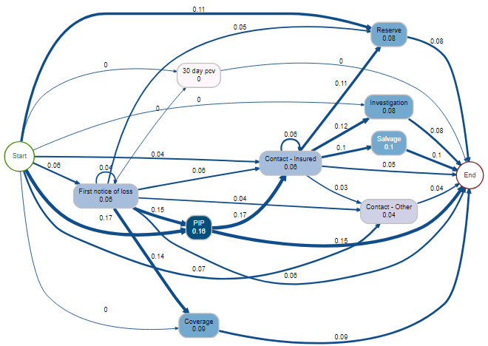

**Fig1 –** This diagram is showing the relationships between the different paths that a claim can take and the mean encoding of those different paths, below the different activity types are described.

**PIP - These are notes that have to do with PIP Coverage specifically**

**Coverage - This are notes that have to do with whether or not we are covering a specified exposure**

**Contact Other – Someone other than the Insured contacts the office**

**Investigation – The Claim is under investigation by the Special Investigations Team**

**Contact Insured – The insured contacts the home office**

**First Notice of Loss – The Claim is formally recorded and fully set up in the Information System**

### Process Oriented Metrics (Target Mean Encoding Discrete Event Transitions)

A common practice in Machine Learning is to encode categorical variables with the mean of whatever we are trying to predict, in my case I am trying to predict whether or not a Certain Claim will end up in Litigation, during the Claims Process there is a lot of different steps that take place and in our admin system most of this are indicated

### Process Data

In the Claims Department there is an information system ClaimsCenter that is responsible for handling every aspect of the Claim from the claim being reported to the claim being closed. This information system stores data about the Claim itself, how it was reported, the actions taken on it, the transactions involved with the claim, etc…. Within this system there are Events that are logged on the Claim depending on what happens to the claim, some of these activities are displayed above.

**All of these activities occur during the onset of the Claim (within the first couple months) these activities are only a small subset of all of the possible events that occur on the claim during this time. I paired the Process Event Log Data of historical Claims with a Boolean target variable (0,1) representing whether or not that Claim eventually went to Litigation and looked at the percent of Claims that had a certain sequences of activities and went to Litigation. That is what is represented in the Graphic above. The number within the Activity bubbles represent the number of times that activity occurred on PIP Claims, and the number on the transitions between activities represents the percent of Claims that took that path that also eventually went into Litigation. For example a Claim that has the Investigation activity occur before the First Notice of Loss Activity occurs has a 25% likelihood of going to Litigation much higher than the base rate of 10%.**

**Coming up with the Process Based Metric (Simplified diagram)**

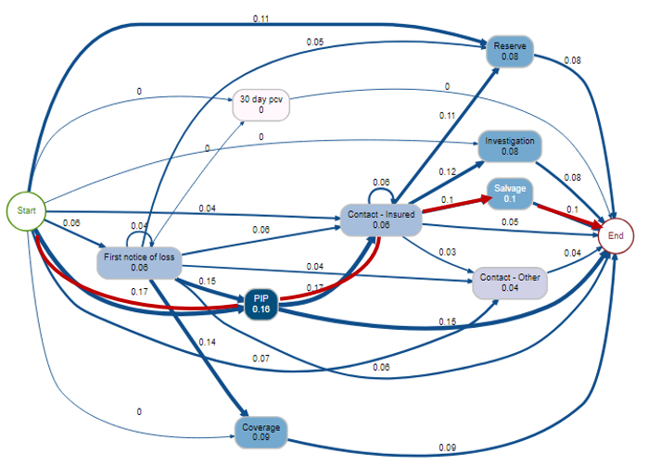

**Fig2 –** The same diagram as figure 1 except a specific path is highlight. **The Path above would be represented by the following equation:(.17+.17+.1+.1)/4 = .135, for Claims that followed this specific path their Process based Litigation Encoding would be .135. This roughly equates to saying “based on this Claim’s path only it has a 13.5% chance of going into Litigation”**

## **Engineering Process Based Features**

**Essentially I am using the Activities that occurred on the Beginning of the Claim to understand the likelihood that the Claim will eventually end up in Litigation. I did this on all the Activities Event Log data that occurred on the Claim during the first two months of the Claims Lifespan or before the Claim ever went to Litigation whatever period was shorter. I then came up with an aggregate Metric called Process Based Litigation Proclivity that was the average of all of the Transition Likelihoods. This variable was one of the features that I used in the Litigation Predictive Model. I created a training set of data that was based off of 2017 – 2019 and my test set was based off of first half of 2019 data. The Activity Transition Litigation Likelihoods were mapped to the test set, in order to come up with the aggregate Process Based Litigation Proclivity Metric of these Claims.**

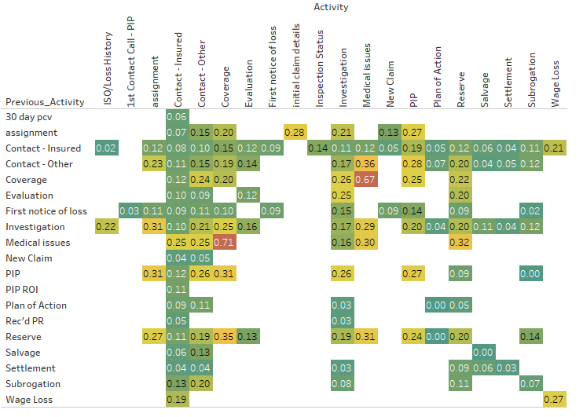

**Fig3 –** Diagram the various Litigation proclivities for the various activity transitions, the activity on the left axis is the previous activity and the activity on the x axis is the activity that the claim is transitioning to

The above matrix shows a majority of the transition matrix that is used to determine the Process Based Litigation Proclivity as you can see there are certain patterns that reveal themselves to be, for example having a coverage note and then a medical Issues is indicative of a Claim that will go to Litigation as 67% of Claims that have taken this path have gone to Litigation in the past. While other path Paths are much more innocuous such as moving from New Claim to Contact-Insured this is a pretty common and straight forward path, a Claim happens and then we have some sort of Contact with the Insured to talk about what happened.

### Household Metrics

Household Metrics are metrics that are based off of all the business that we have with a specific customer so if they are associated with 10 policies on our book then data from all ten policies will be included. It is somewhat similar to a Customer Lifetime Value metrics that are used in marketing. The Metrics focus on how profitable the Household has been during the time that they have been a client. Households consist of a number of different people who are then connected to a number of policies some of these people may be on the same policy but others may be on different policies but at one time they were on the same policy. Households rules are not necessarily strictly defined at Farm Bureau, but represents connections between people one another and the policies they have or have had in the past. Looking at metrics on this level further let us understand clients on a more holistic basis and client profitability in one line of business has been shown to predict profitability in other lines of business as well.

# 

HHStandardizedRelativeLossCount **=** This metric is derived by looking at all of the policies that the specific household is apart of, and the amount of time that those said policies have been open. This metric is meant to compare how many losses this household has had vs how many losses we would expect them to have based on the amount of time they have been a customer of ours. Then we calculate essentially a Z-Score for the specific policy based off the number of Claims a policy has had vs the number the claims we expected the policy to have. So let’s say on average an auto policy has .1 claims per year with a standard deviation .9. Over a 10 year period we see that a specific policy has 3 Auto Claims so to calculate the Z score of this policy we do the following:

z = (x-μ)/σ), Z= (3 –1)/9, therefore the “Policy Standardized Relative Loss Count” would be 2/9 or .22 which would mean that this policy has a relatively high loss proclivity. Anything over zero is perceived as an above average Loss Proclivity.

We then take Standardized score for every policy that the Household has across all lines of business and then aggregate these using an arithmetic average. So if a Household has a Home, Auto, and Farm Policy then we would take the average of the Standardized Loss Counts across all of these policies. This final average metric is the HHStandardizedRelativeLossCount which essentially represents the loss proclivity of an entire household from a frequency perspective.

The reason that the standardization is important is because when you are aggregating across multiple lines of business it is important to understand that different lines have different loss proclivities and different loss distributions so in order to truly calculate a fair metric we have to aggregate Z-Scores as opposed to just dividing by the average. The Z-score always us to account for some lines of business having more variation in their loss frequency distributions.

HHStandardizedRelativePremium **=** Same methodology as above except this features attempts to understand the amount of premium that we are collecting from a client relative to what one would expect based solely on the policies that they have.

HHStandardizedRelativeLossAmount **=** Same methodology as above, but this feature is looking at the loss amount of the Claims, so it is comparting the expected amount of losses for each policy to the actual amount of losses for each policy taking the Z-score based off of this and then aggregating the metric across all lines of Business

HHStandardizedRelativeLossRatio **=** Loss Ratio is a common term that is used in Insurance, it is often used as an Accounting Figure for an entire company or Line of Business it is essientially:

(Losses/Premium Collected), so how much you had to pay for the exposures that you cover vs the amount of premium that you collected to cover those exposures, it is a good indicator of how your company is doing. For this Household Metric I did a similar thing and calculated the Loss Ratios for each Policy and Line of Business and then compared this loss ratios for the expected loss ratio based on the policy type and then aggregated these measures up to a Household Level.

#### So are these Household Features Predictive?

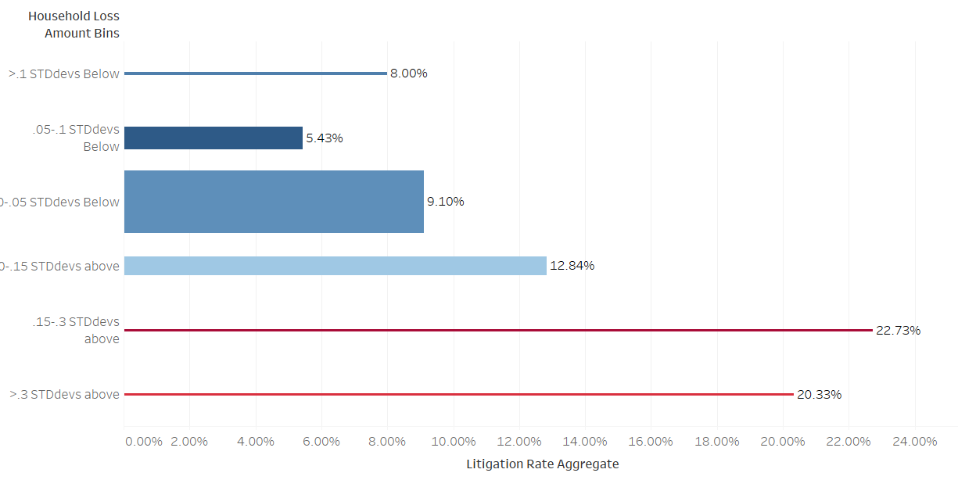

As you can see from the graphic above the Household Relative Loss Amount Feature is a good way to predict litigation proclivity of a certain Claim. Higher Household Relative Loss Amount correlate well with Litigation Proclivities as you see from the graph above. Any Claim that belongs to a household with a RelativeLossAmount more than .3 standard deviations above the average has almost double the likelihood of having PIP Claim Litigated. This just shows how historical data on households can do a really job predicting clients that may be problematic in the future.

### Brief Explanation of Data Leakage

Data Leakage is when the features contain some sort of encoding of the target variable. You only want to be using information that would be available at the time of the prediction. I am doing forms on target variable encoding in some of the features that I will be discussing in the next few sections. Any form of target encoding will lead to some degree of data leakage in the training set. I have been sure though that there is no data leakage occurring in the test set. The test set is built off of claims with reported dates occurring in the first 6 months of 2019. All of the target mean encoding that is occurring is built off of claims that occurred before the start of 2019.

### Claims Contact and HealthCare Provider Metrics

In the current Personal Injury Protection (PIP) Insurance environment there are Medical Providers that try to take advantage of the fact that Insurance Companies have to pay the full bill for medical treatments related to car accidents and in till recently this coverage was unlimited for everyone. In order to capture information around which providers we are most likely to end up going to court with, I created metrics that measure the proclivity of a Medical Providers propensity for litigation. In order to do this I connected all Lawsuits to their relevant Claims and any related litigation. I then came up with a metric that compared the number of Claims that a Provider is on to the number of Lawsuits that said Provider is involved with. Number of Lawsuits provider is involved with divided by the number of claims the provider is on is equal to the Provider Lawsuit proclivity. I then aggregated all of the Provider Lawsuit Proclivities on each claim for Providers that were on the claim within the first 60 days of the Claim. So the average of the Provider Lawsuit Proclivity for the entire claim then became the “Provider Lawsuit Average” feature that you see in the modeling data. This metric is derived off of Claims between the start of 2016 and the end of 2018, so it is built off of roughly three years of data. The training data set for this modeling initiative was also built of 2016 – 2018 and the testing set was built off of the first half of 2019. So doing this Provider Lawsuit Average variable meant that there was going to be some data leakage into the training dataset because the Lawsuits that we are trying to predict are also encoded somewhere in the Provider Lawsuit Average variable. This could potentially lead to some overfitting of the data. The testing dataset will not have data leakage problems because all of the claims in the testing set happened after 2019 and the variable is built off of claims that occurred before that.

#### Provider Lawsuit Average Metric diagram

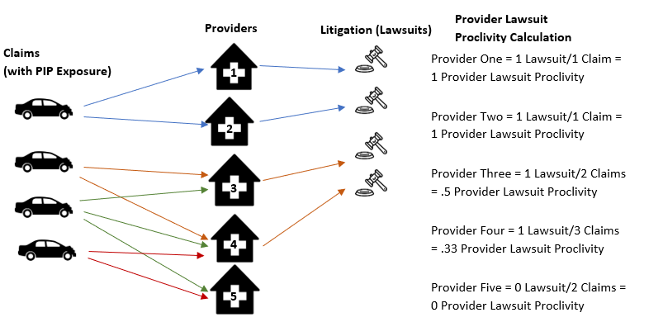

This diagram above shows the relation between auto claims Providers and Litigation and how the Provider Lawsuit Proclivity Calculation is calculated on the Provider Level. If we are assigning a Provider Lawsuit Average metric for a Claim that say had Providers 1,3, and 5. Then the Provider Lawsuit Average for that Claim would be (1+.33+.5) = .61.

## Predictive Power of Provider Lawsuit Proclivity Average

On the chart below the left hand axis represents groupings of the Provider Lawsuit Proclivity Average and as you can see while the lower grouping of the metric definitely have a majority of the claims the higher groupings of the metric have much higher lawsuit Proclivities. The data below is built off of the testing data so there is absolutely no data leakage in the data below.

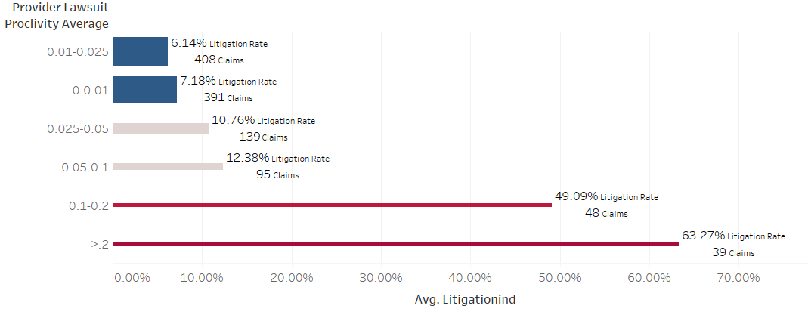

### Medical Review Data

Looking at whether or not the Claim had Medical Bills that were sent for Bill Review within the first 60 days of the Claim can give us some helpful insight into whether or not the Claim will end up in Litigation because most of the Litigation is around the charges on said Medical Bills

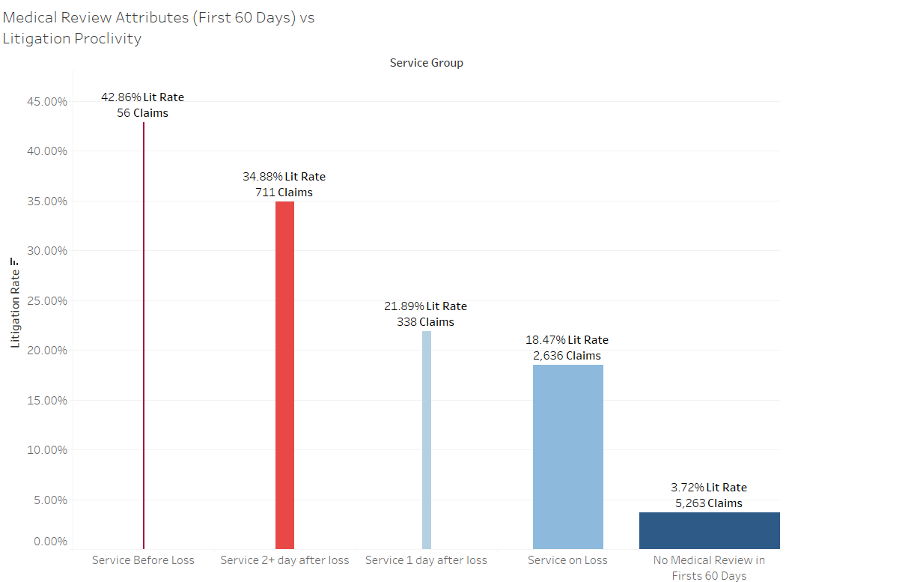

The color in the chart represents the percent of Claims that go into Litigation for each Service Group, the different Service groups are differentiated by looking at when the insured got there first treatment relative to the loss date. As you can see there is even a subset of Claims that had a Medical service before the loss date, the only explanations for this are either bad data or fraudulent behavior because it is impossible to get treatment for an injury you haven’t had yet. The next most litigated category are claims that had there first service date 2 or more days after the loss happened. This may also be suspicious because if you get injured in a car accident you would

# Geospatial Analysis

The figure above shows Personal Injury Protection Litigation Percentage based off of the Loss Location of the Claims. This graph displays the data on the Zip/Postal Code level. Here we are looking at Zip Codes that have at least 10 PIP Claims that have occurred in them and the color is representing the percentage of those claims that were litigated. As you can see the Southeast has a high percentage of Claims that end up in Litigation and this is definitely something that the model is picking up. You can see in the figure below that a lot of the problem is also centered in the Sterling Heights/Warren Michigan area there seems to be some sort of behavior that is going one in this area that is leading to more of these Claims end up in Litigation. This pattern is picked up by the various predictive models and can be utilized to predict whether or not future Claims will end up in Litigation. The Predictive Models are fed Latitude and Longitude features that they correlate and pattern match with the Litigation Target variable.

## Geospatial Analysis continued

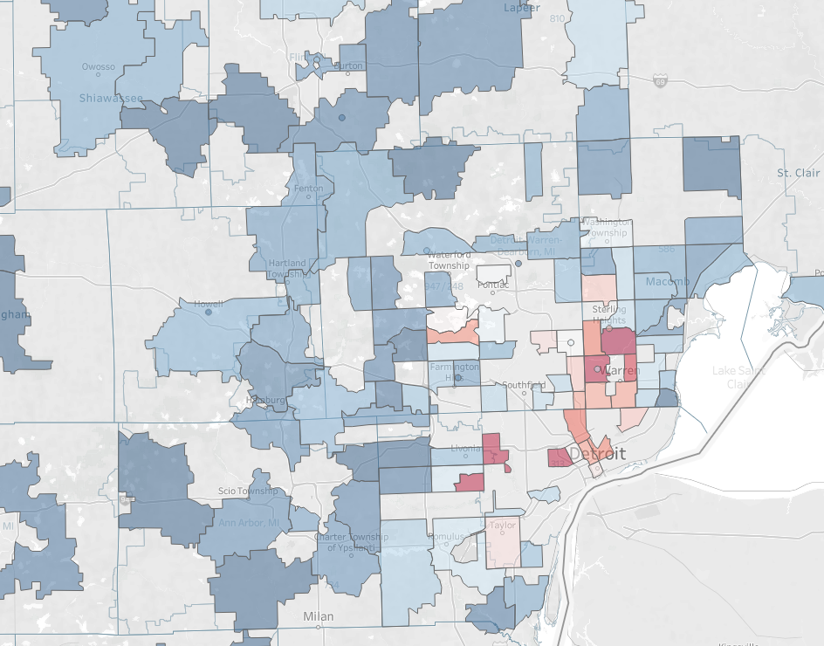

Demarcation of the Sample Decision Tree

## 

The lines on the graph above so the boundaries that are set up by the decision tree on the left. The decision tree on the left is able to differentiate litigation proclivity based on the latitude and longitude data that it was fed. This tree is similar to one that are used to construct the tree based models that are discussed below.

## Building the Predictive Model

Once I have done all of the data aggregation gathering and prep I pull all of the various data sources into my R Script and aggregate the data together. The feature engineering for the predictive model I have talked about in the sections above.

### Imputing Missing Data using MICE

### Trying out Various Predictive Models

**Corey’s Random Forest:** This is a function that I built myself, that allows the user to build a Random Forest using rpart decision trees in R

**Logistic Regression Model:** The logistic regression model is used to build a baseline that the other models can be compared to. Logistic regression is good for building a model that correlates basic relationships between your feature space and your binary target variable. It is a type of Generalized Linear Model. The shortcomings of the logistic regression model are that it does not take into account interaction relationships between variables in the feature space. It only combines them in a multiplicative manner.

**Ranger Random Forest:** The Ranger random forest function is used to compare my random forest function to one from another package in R.

**Gradient Boosting Machine (caret):** The Gradient Boosting Machine model slightly outperformed both my and the ranger random forest functions. The gradient Boosting machine has a boosting or error reduction component to it. It fits a tree based model based off a subset of the attributes and then measures the error function after this initial model and recursively fits sequential models off of that error function each time fitting new models based off the error of the previous models. It slowly learns how to better reduce the error using all of the variables at its disposal. The only real downsides to the gradient boosting machine are that it can potentially overfit relationships between variables which I was worried about, however I think I

# Evaluating the Model Results

## Metrics that Make Sense for this Initiative

Even though this is a classification problem I ran the models as though they were predicting a regression problem this way they will return a probability that the Claim will go to Litigation. Because it is a relatively unbalanced dataset (11% are positives).

## Constructing the Training and Test Set

## **Evaluation**

**Using just the Process Based Litigation Proclivities metrics and the geographic location of the Claim the predictive model was able to return a promising results. The chart below shows the results of this model for example the top 5% of highest scoring claims according to this predictive model represented 32% of the Claims that went to Litigation. And the top 50% of highest scoring claims represented 94% of the Claims that went to Litigation.**

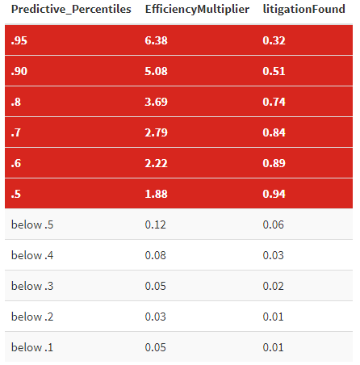

**The table on the left gives us an idea of the different model performances at the different score intervals the higher scoring a claim is the more likely that the claim will end up in litigation according to the model. We can see that the top 5% of highest scoring claims account for 32% of the litigation in the test set. This means that trying to find litigation by looking at claims in this range is 6.32 times more efficient that random sampling of the entire test set.**

**The benefit of being able to identify Claims that are likely to go to Litigation before they actually do is that those Claims can be reassigned to Adjusters that are more equipped to deal with tricky Claims and potentially prevent this Claims from ever going to Litigation or at least limit the amount that we pay out on this Clams. This model allows the insurance company to put the right Claims in the hands of experts. Once implementation time comes I think it may make sense to have multiple models running at once, there may be a model that scores Claims right when they are reported and another model that scores them after the first month, two months, etc… These details still need to be ironed out.**

## Evaluation

The evaluation of the predictive model will be done on the test or hold-out set of data, the process based Proclivity Metrics will be applied to the hold out data according to the process patterns that exist with the Hold out data, but this will not cause any target variable leakage because the Process Information that the hold out data will encoded with will only be based off the metrics that were devised using the training data. The different metrics used to compare the predictive models will be ROC, AUC curves and also a gains chart, to see how the well the model is predicting Claims that will end up in Litigation.

# **Next Steps:**

## Using Process Mining to Determine the Best Routing for Potentially Litigated Claims

Once I identify which Claims are likely to be Litigated in the Future I would like to determine the optimal path for these Claims to take to avoid as much adverse development on the Claims as possible. This may include certain things like choosing what bills to pay, or what attorneys to hire, or what adjusters should own these potentially harmful Claims. There are also other actions that can be taken on certain Claims things such as Independent Medical Examinations that will inform us whether or not an insured’s injuries are legitimate or if they are being exaggerated.