Learning Algorithm

Deep Q Network (DQN) with Experience Replay.

Hyper-parameters
Epsilon Start = 1.0
Epsilon End = .01
Epsilon Decay Rate = .995
Gamma (Discount Factor) = .99
Learning Rate = .00004
# of States = 37
# of Actions = 4

Model Architecture for Neural Network
Three layer Neural Network

1st Layer takes as input the number of STATES, 64 units as output
2nd Layer – 64 units as input, 64 units as output
3rd Layer – 64 units as input, output is the number of ACTIONS

Rectified Linear Units connect the Layers together.

Plot of Rewards per Episode (Goal: Average Score of 13 over 100 episodes)

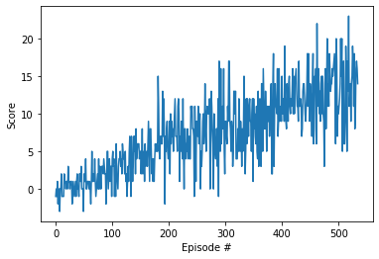

Number of Episodes needed to solve environment

Episode 100 Average Score: 0.90
Episode 200 Average Score: 4.52
Episode 300 Average Score: 7.39
Episode 400 Average Score: 8.98
Episode 500 Average Score: 12.59
Episode 535 Average Score: 13.02
Environment solved in 435 episodes! Average Score: 13.02

