Table of Contents
Learning Algorithm 1
Deep Deterministic Policy Gradient (DDPG) 1
Code Walk-through 2
Model Architecture for Neural Network 2
Hyper-parameters 2
Experimentation 3
Results 4
Ideas for Future Work 5
References 6

Learning Algorithm

Deep Deterministic Policy Gradient (DDPG)

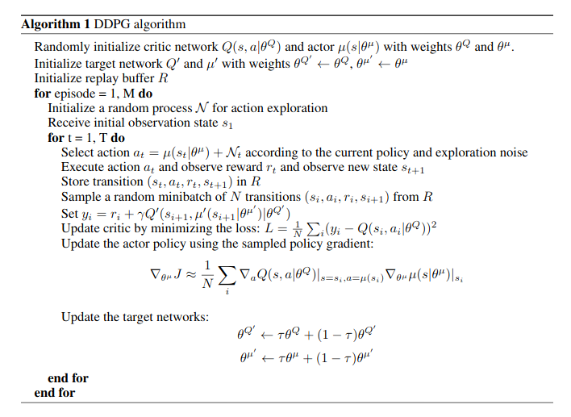

Code Walk-through

File: Continuous_Control.ipynb

1. Instantiate ddpg_agent
2. Initialize Variables
3. Outer Loop (1000 Episodes)
a. Reset the Reacher Environment
b. Retrieve the Initial State from the Environment
c. Reset the Learning Agent
d. Inner Loop (1 Full Episode)
i. Get Action for Given State from Agent
ii. Send the Action to the Environment
iii. Get the New State
iv. Get the Reward
v. Check if Episode is Done
vi. Transition to the next state
vii. Accumulate rewards for the Episode
viii. Exit Loop when Done
e. Store each Episode’s Score for the last 100 Episodes
f. Store each Episode’s Score for Plotting

Model Architecture for Neural Network
Actor Model:

Three layer Neural Network

1st Layer takes as input the number of STATES, 128 units as output
2nd Layer – 128 units as input, 128 units as output
3rd Layer – 128 units as input, output is the number of ACTIONS

Rectified Linear Units connect the Layers together with a Batch Normalization for the first layer.

Critic Model:

Three layer Neural Network

1st Layer takes as input the number of STATES, 128 units as output
2nd Layer – 128 units + number of ACTIONS as input, 128 units as output
3rd Layer – 128 units as input, output is 1

Rectified Linear Units connect the Layers together with a Batch Normalization for the first layer.

Hyper-parameters
Hyper Parameter | Value | Description
BUFFER_SIZE | 1 x 10⁶ | replay buffer size
BATCH_SIZE | 1024 | Mini batch size
GAMMA | 0.8 | discount factor
TAU | 1 x 10⁻³ | for soft update of target parameters
LR_ACTOR | 2 x 10⁻⁴ | learning rate of the actor
LR_CRITIC | 2 x 10⁻⁴ | learning rate of the critic
WEIGHT_DECAY | 0 | L2 weight decay
THETA | 0.15
SIGMA | 0.1

Experimentation

Batch Size. Experimented with different batch sizes [64, 128, 256, 512, 1024]. Settled on 1024, as the algorithm learned much quicker (less episodes). Approximately 1/3 the number of Episodes at 1024.
Gamma. Experimented with different GAMMA settings. Slowly decreasing from .99, to .9, .8, then .1. Decreasing to .8 allowed the Agent to learn in less episodes, decreasing to .1 didn’t have a positive impact.
L2 Weight Decay. Started with an L2 weigh decay of 1 x 10⁻² and then settled on 0 for performance reasons.
TAU. Tested .01 and .001. When testing at .01, the agent appeared to have poor stability in learning.
Network Size. Started the network at 400, 300 first and second layers but decreased to 128, 128. Utilizing a smaller network while still maintaining good learning was the goal as a smaller network will reduce the chances of over-fitting to the training data.

Results
(Goal: Average Score of 30 over 100 episodes)

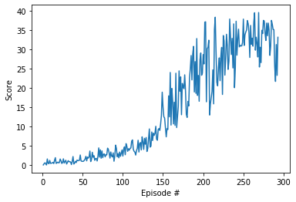

Episode 100 Average Score: 1.65
Episode 200 Average Score: 12.66
Episode 293 Average Score: 30.05
Environment solved in 293 episodes! Average Score: 30.05

Ideas for Future Work

Attempt the multi-agent version of the Reacher problem.

References

@misc{lillicrap2015continuous,
title={Continuous control with deep reinforcement learning},
author={Timothy P. Lillicrap and Jonathan J. Hunt and Alexander Pritzel and Nicolas Heess and Tom Erez and Yuval Tassa and David Silver and Daan Wierstra},
year={2015},
eprint={1509.02971},
archivePrefix={arXiv},
primaryClass={cs.LG}
}

