Nuvoton deney kartı projesi tanıtım dosyası

**AYTEN KILIÇ**

**11/B 44**

**19 Nisan 2023**

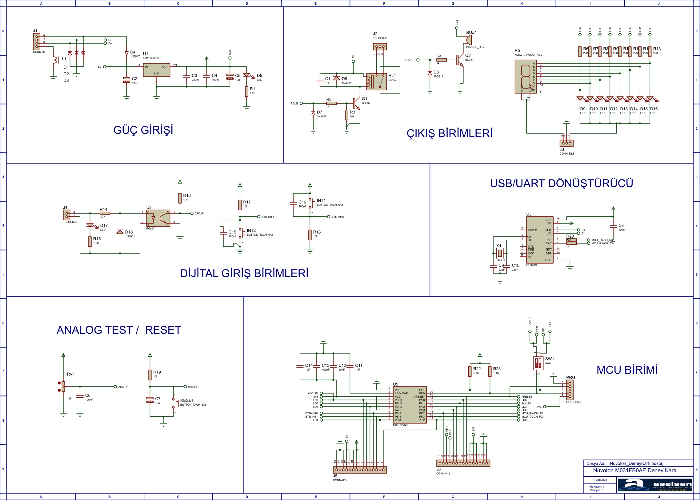

**DEVRENİN ISIS ŞEMASI**

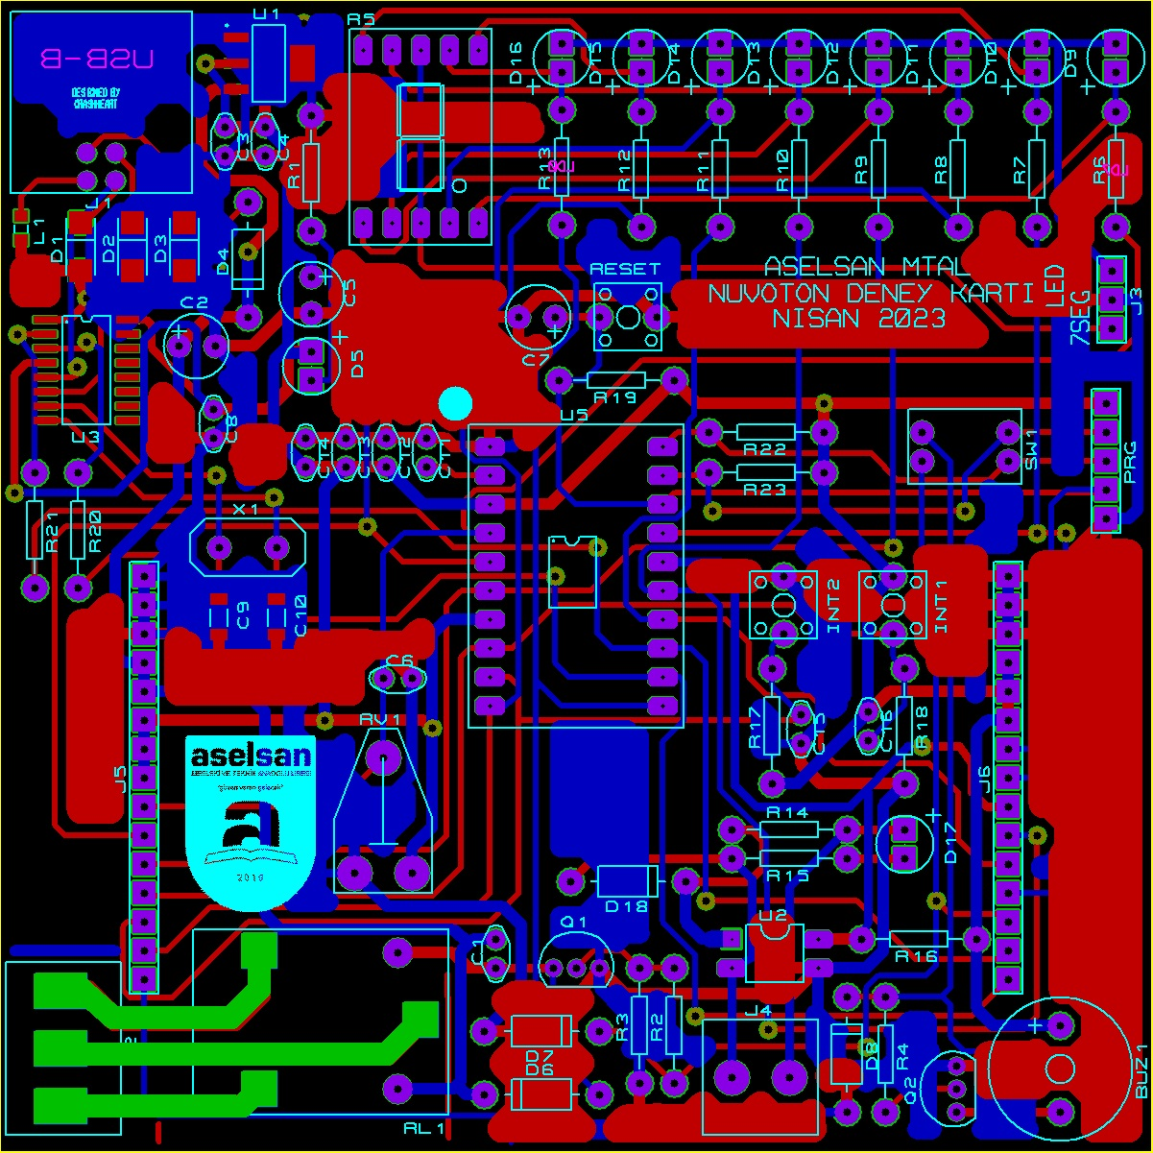

**GENEL BASKI DEVRE GÖRÜNÜŞÜ**

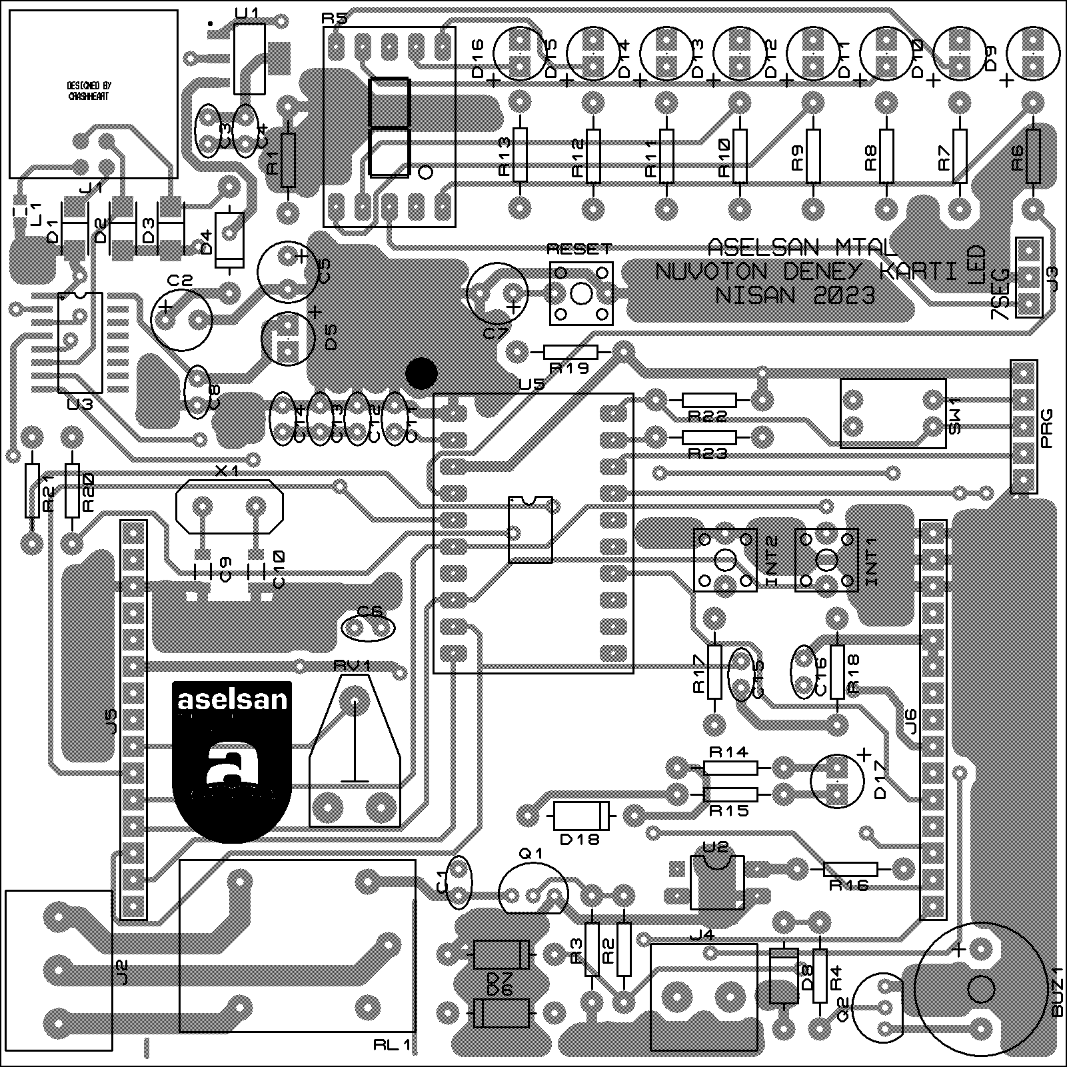

**ÜST KATMAN YERLEŞİM PLANI**

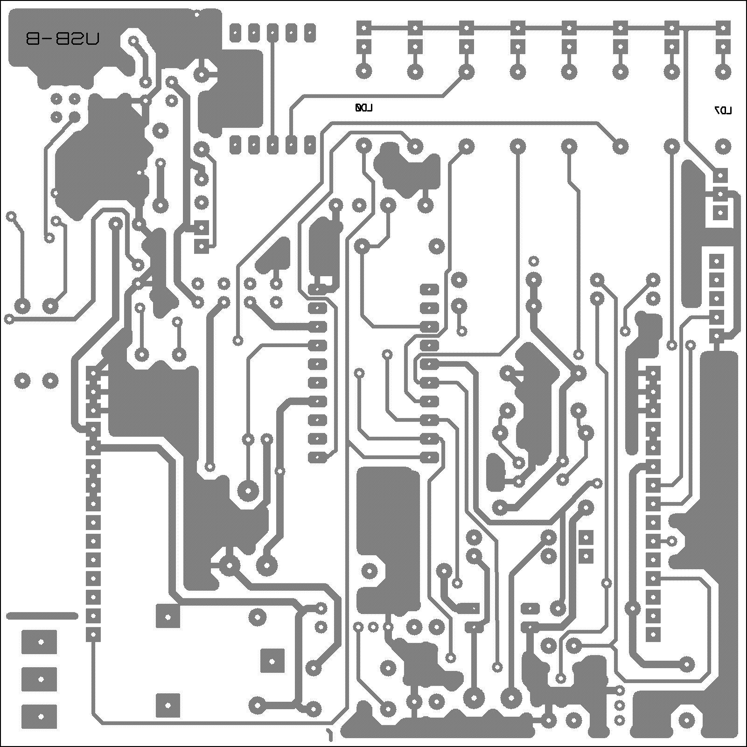

**ALT KATMAN YERLEŞİM PLANI**

|  |  |  |  |  |
| --- | --- | --- | --- | --- |
| **Bill Of Materials for NuvotonDeneyKarti** | | |  |  |
|  |  |  |  |  |
| **Design Title** | | | NuvotonDeneyKarti | |
| **Author** | | |  | |
| **Document Number** | | |  | |
| **Revision** | | |  | |
| **Design Created** | | | 24 Aralık 2022 Cumartesi | |
| **Design Last Modified** | | | 19 Nisan 2023 Çarşamba | |
| **Total Parts In Design** | | | 79 | |
|  |  |  |  |  |
| **Category** | **Quantity** | **References** | **Value** | **PCB Package** |
| Capacitors | 2 | C1,C11 | 1nF | CAP10 |
| Capacitors | 3 | C2,C5,C7 | 10uF | ELEC-RAD13 |
| Capacitors | 1 | C3 | 220nF | CAP10 |
| Capacitors | 6 | C4,C6,C8,C13,C15,C16 | 100nF | CAP10 |
| Capacitors | 2 | C9,C10 | 22pF | 1206 |
| Capacitors | 1 | C12 | 10nF | CAP10 |
| Capacitors | 1 | C14 | 1uF | CAP10 |
| Resistors | 1 | R1 | 470 | RES40 |
| Resistors | 4 | R2,R4,R20,R21 | 1k | RES40 |
| Resistors | 4 | R3,R17,R18,R19 | 10k | RES40 |
| Resistors | 1 | R5 | 7SEG_COMCAT_REV | 7SEG_COMCAT_A |
| Resistors | 8 | R6,R7,R8,R9,R10,R11,R12,R13 | 220 | RES40 |
| Resistors | 1 | R14 | 4.7K | RES40 |
| Resistors | 1 | R15 | 1.2K | RES40 |
| Resistors | 1 | R16 | 4.7k | RES40 |
| Resistors | 2 | R22,R23 | 100k | RES40 |
| Integrated Circuits | 1 | U1 | LM1117MP-3,3 | SOT230P700X180-4 |
| Circuits | 1 | U2 | PC817 | DIL04 |
| Integrated Circuits | 1 | U3 | CH340G | SOP16 |
| Integrated Circuits | 1 | U5 | M031FB0AE | TSSOP20_CONV-A-CARD |
| Transistors | 2 | Q1,Q2 | BC337 | TO92 |
| Diodes | 3 | D1,D2,D3 |  | DO214-A |
| Diodes | 3 | D4,D7,D8 | 1N5817 | DO41-A |
| Diodes | 10 | D5,D9,D10,D11,D12,D13,D14,D15,D16,D17 | LED | LED |
| Diodes | 2 | D6,D18 | 1N4001 | DO41 |
| Miscellaneous | 1 | BUZ1 | BUZZER_REV | BUZ_REV |
| Miscellaneous | 3 | INT1,INT2,RESET | BUTTON_TACH_6X6 | BUTTON_TACH_6X6MM |
| Miscellaneous | 1 | J1 | CONN-H4 | USB-B |
| Miscellaneous | 1 | J2 | TBLOCK-I3 | TBLOCK-I3 |
| Miscellaneous | 1 | J3 | CONN-SIL3 | CONN-SIL3 |
| Miscellaneous | 1 | J4 | TBLOCK-I2 | TBLOCK-I2 |
| Miscellaneous | 2 | J5,J6 | CONN-H15 | CONN-SIL15-A |
| Miscellaneous | 1 | L1 |  | 0805 |
| Miscellaneous | 1 | PRG | CONN-SIL5 | CONN-SIL5 |
| Miscellaneous | 1 | RL1 | QIANJI | RLY-OMRON-C4 |
| Miscellaneous | 1 | RV1 | 10k | PRE-HMIN |
| Miscellaneous | 1 | SW1 | AAA | DIP_SWT_2_A |
| Miscellaneous | 1 | X1 | 12MHZ | XTAL18 |

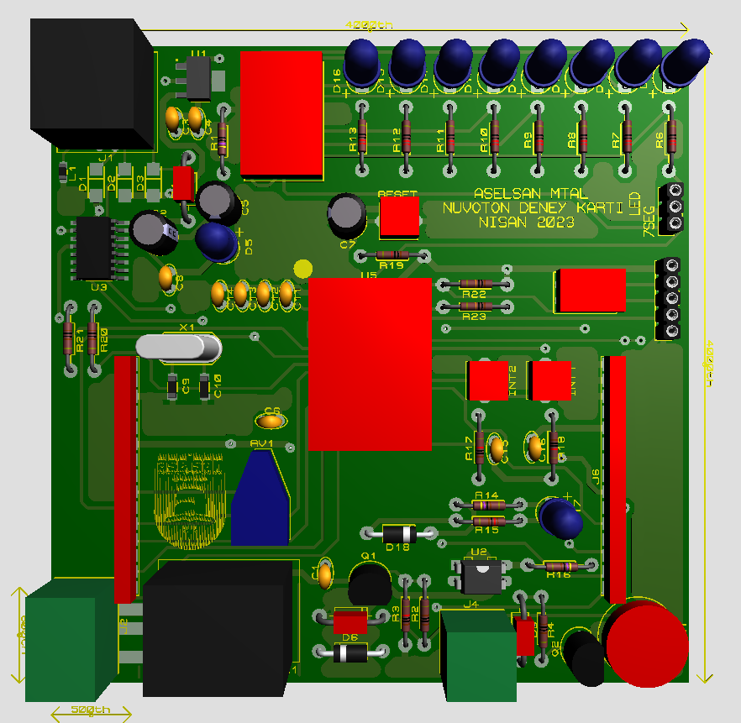

**ÜST KATMAN 3D GÖRÜNTÜ**

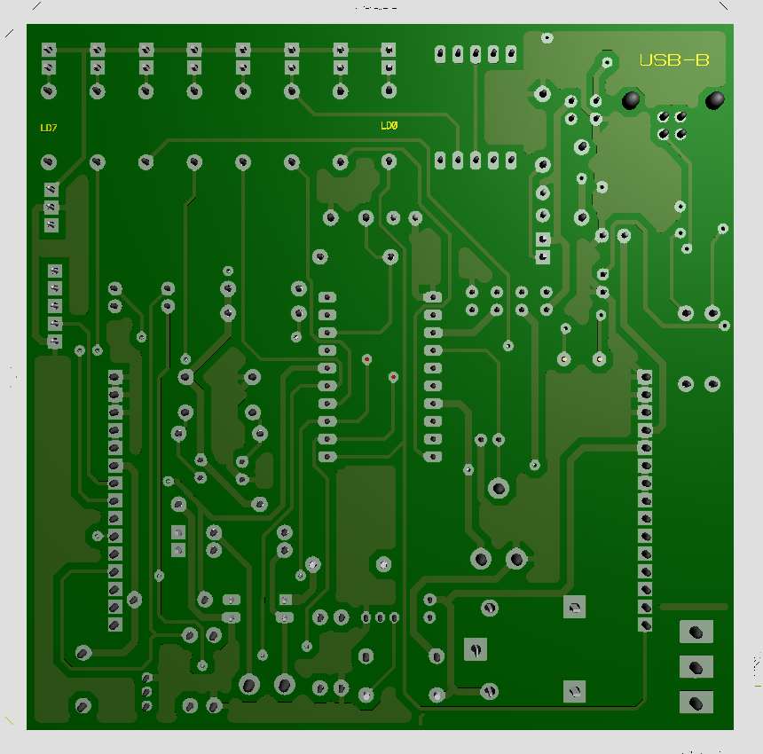

**ALT KATMAN 3D GÖRÜNTÜ**