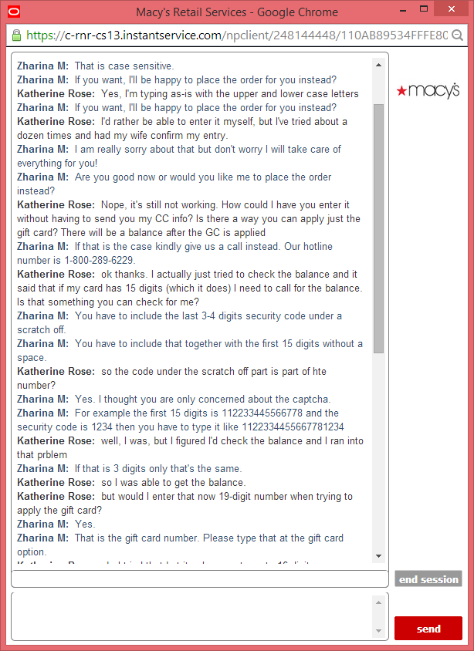

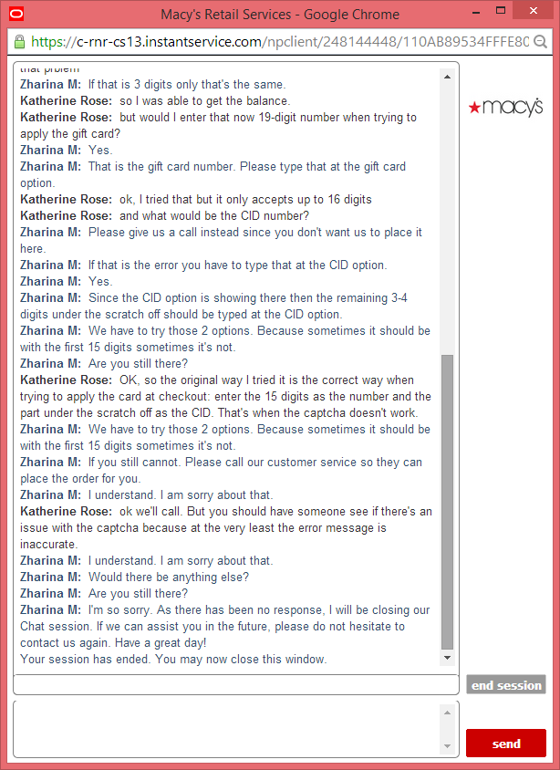

**Chat Transcript**

Please wait while we find an agent to assist you...

You have been connected to Zharina M.

**Zharina M:**  Welcome to Macy's live chat. How are you doing today?

**Zharina M:**  Oh I am sorry about that.

**Zharina M:**  Are you typing the captcha as is?

**Zharina M:**  That is case sensitive.

**Zharina M:**  If you want, I'll be happy to place the order for you instead?

**Katherine Rose:**  Yes, I'm typing as-is with the upper and lower case letters

**Zharina M:**  If you want, I'll be happy to place the order for you instead?

**Katherine Rose:**  I'd rather be able to enter it myself, but I've tried about a dozen times and had my wife confirm my entry.

**Zharina M:**  I am really sorry about that but don't worry I will take care of everything for you!

**Zharina M:**  Are you good now or would you like me to place the order instead?

**Katherine Rose:**  Nope, it's still not working. How could I have you enter it without having to send you my CC info? Is there a way you can apply just the gift card? There will be a balance after the GC is applied

**Zharina M:**  If that is the case kindly give us a call instead. Our hotline number is 1-800-289-6229.

**Katherine Rose:**  ok thanks. I actually just tried to check the balance and it said that if my card has 15 digits (which it does) I need to call for the balance. Is that something you can check for me?

**Zharina M:**  You have to include the last 3-4 digits security code under a scratch off.

**Zharina M:**  You have to include that together with the first 15 digits without a space.

**Katherine Rose:**  so the code under the scratch off part is part of hte number?

**Zharina M:**  Yes. I thought you are only concerned about the captcha.

**Zharina M:**  For example the first 15 digits is 112233445566778 and the security code is 1234 then you have to type it like 1122334455667781234

**Katherine Rose:**  well, I was, but I figured I'd check the balance and I ran into that prblem

**Zharina M:**  If that is 3 digits only that's the same.

**Katherine Rose:**  so I was able to get the balance.

**Katherine Rose:**  but would I enter that now 19-digit number when trying to apply the gift card?

**Zharina M:**  Yes.

**Zharina M:**  That is the gift card number. Please type that at the gift card option.

**Katherine Rose:**  ok, I tried that but it only accepts up to 16 digits

**Katherine Rose:**  and what would be the CID number?

**Zharina M:**  Please give us a call instead since you don't want us to place it here.

**Zharina M:**  If that is the error you have to type that at the CID option.

**Zharina M:**  Yes.

**Zharina M:**  Since the CID option is showing there then the remaining 3-4 digits under the scratch off should be typed at the CID option.

**Zharina M:**  We have to try those 2 options. Because sometimes it should be with the first 15 digits sometimes it's not.

**Zharina M:**  Are you still there?

**Katherine Rose:**  OK, so the original way I tried it is the correct way when trying to apply the card at checkout: enter the 15 digits as the number and the part under the scratch off as the CID. That's when the captcha doesn't work.

**Zharina M:**  We have to try those 2 options. Because sometimes it should be with the first 15 digits sometimes it's not.

**Zharina M:**  If you still cannot. Please call our customer service so they can place the order for you.

**Zharina M:**  I understand. I am sorry about that.

**Katherine Rose:**  ok we'll call. But you should have someone see if there's an issue with the captcha because at the very least the error message is inaccurate.

**Zharina M:**  I understand. I am sorry about that.

**Zharina M:**  Would there be anything else?

**Zharina M:**  Are you still there?

**Zharina M:**  I'm so sorry. As there has been no response, I will be closing our Chat session. If we can assist you in the future, please do not hesitate to contact us again. Have a great day!

Your session has ended. You may now close this window.