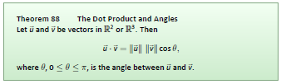
e^(x)+e^(-x)+2
factors as ( e^(x)+e^(-x))^2
for all even x
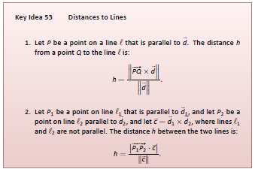
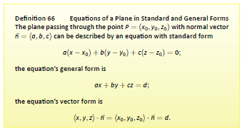

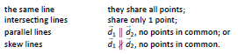
- Are unit vectors equal?
- Do they share any points?
- If yes & ||, same line
- If yes & !||, Intersect
- If No, Skew
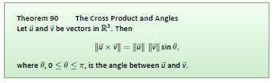
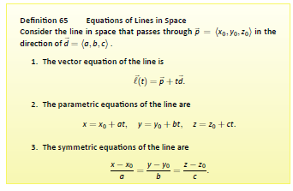
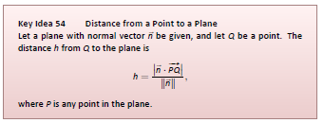
1

2
3
4

2
3
4

2
3
4

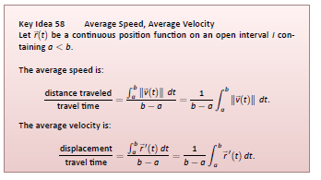
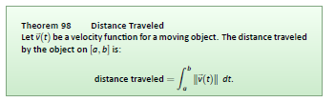
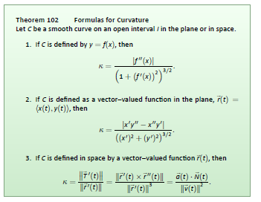

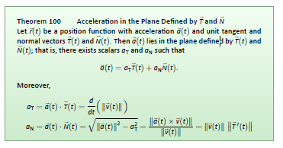

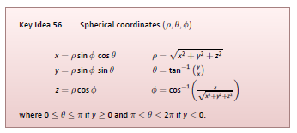


1

2
3
4

2

1
4
3

