Assignment 3

**Design**

*Aria Pahlavan* and *Cooper Raterink*

February 23, 2016

1. System Level Use case Diagram
2. UML Model
3. ADT level description

The problem is to develop a program that parses an input file containing operations (insert, delete, search, update, and print) and process each operation accordingly (i.e. insert an item in the cart, delete all instances of an item, update quantity of item, search the cart for an item, or print a summary receipt).

* 1. PurchaseItem class
     1. Member Data:
* Name: String – Name of the item.
* Price: BigDecimal – Total price of specified quantity of an item.
* SalesTax: BigDecimal – Total tax of specified quantity of an item.
* ShippingCost: BigDecimal – Total shipping cost of specified quantity of an item.
* Quantity: long – quantity of an item.
* Weight: long – weight of an item.
  + 1. Member Methods:
* *UpdateItem():* update the quantity of an item.
* *BigDecimal calculatePrice():* calculate and return the total charges after tax of an item.
* *calculateShippingCost():* calculates total shipping cost.
* *CalculateTax():* calculates total taxes of an item.
  + 1. Electronics Class

(Inherits all member data from PurchaseItem class with some extra data).

* + - 1. Member Data:
* isFragile: Boolean – specifies fragility of item.
* stateName: String – specifies the state name from where the item is being purchased from
  + - 1. Member Methods:
* *Boolean isTaxExempt():* returns true if the item is being purchased from a tax exempt state.
  + 1. Gerocery Class

(Inherits all member data from PurchaseItem class with some extra data).

* + - 1. Member Data:
* isPerishable: Boolean – specifies perishability of item.
  + 1. Clothing Class

(Inherits all member data from PurchaseItem class).

* + 1. ShoppingCart Class
       1. Member Data:
* Cart: Arraylist<PurchaseItem> – Contains all items in the cart (ASCII alphabetized).
  + - 1. Member Methods:
* *performOperation():* processes each operation according to the operation type.
* *Print():* prints a summary of all the items in the carts with a total charge after all taxes and shipping.
  + 1. OperationType Enum

An enumerated type containing all the possible operation types (i.e. ELEC, CLOTH, DEL, SEARCH, PRINT, UPDATE.)

* + 1. Operation Class
       1. Member Data:
* operationType: OperationType – specifies the type of operation.
* operationItem: PurchaseItem – New item object used for processing the operation.
  + - 1. Member Methods:
* *parseSearch():* searches the item name in the cart and returns the total quantity of it.
* *parseUpdate():* updates the quantity of the first result in the shopping with the specified name.
* *parseDelete():* deletes every item with the specified name and returns the total quantity deleted.
* *parsePrint():* Calls shopping cart print to print a summary receipt of all the items in the cart.
* *parseInsert():* inserts an item into the cart.
  + 1. A3Driver (driver) Class
       1. Member Methods:
* *Main():* Opens, and reads the file each line at a time and processes each line input.

1. Block Diagram

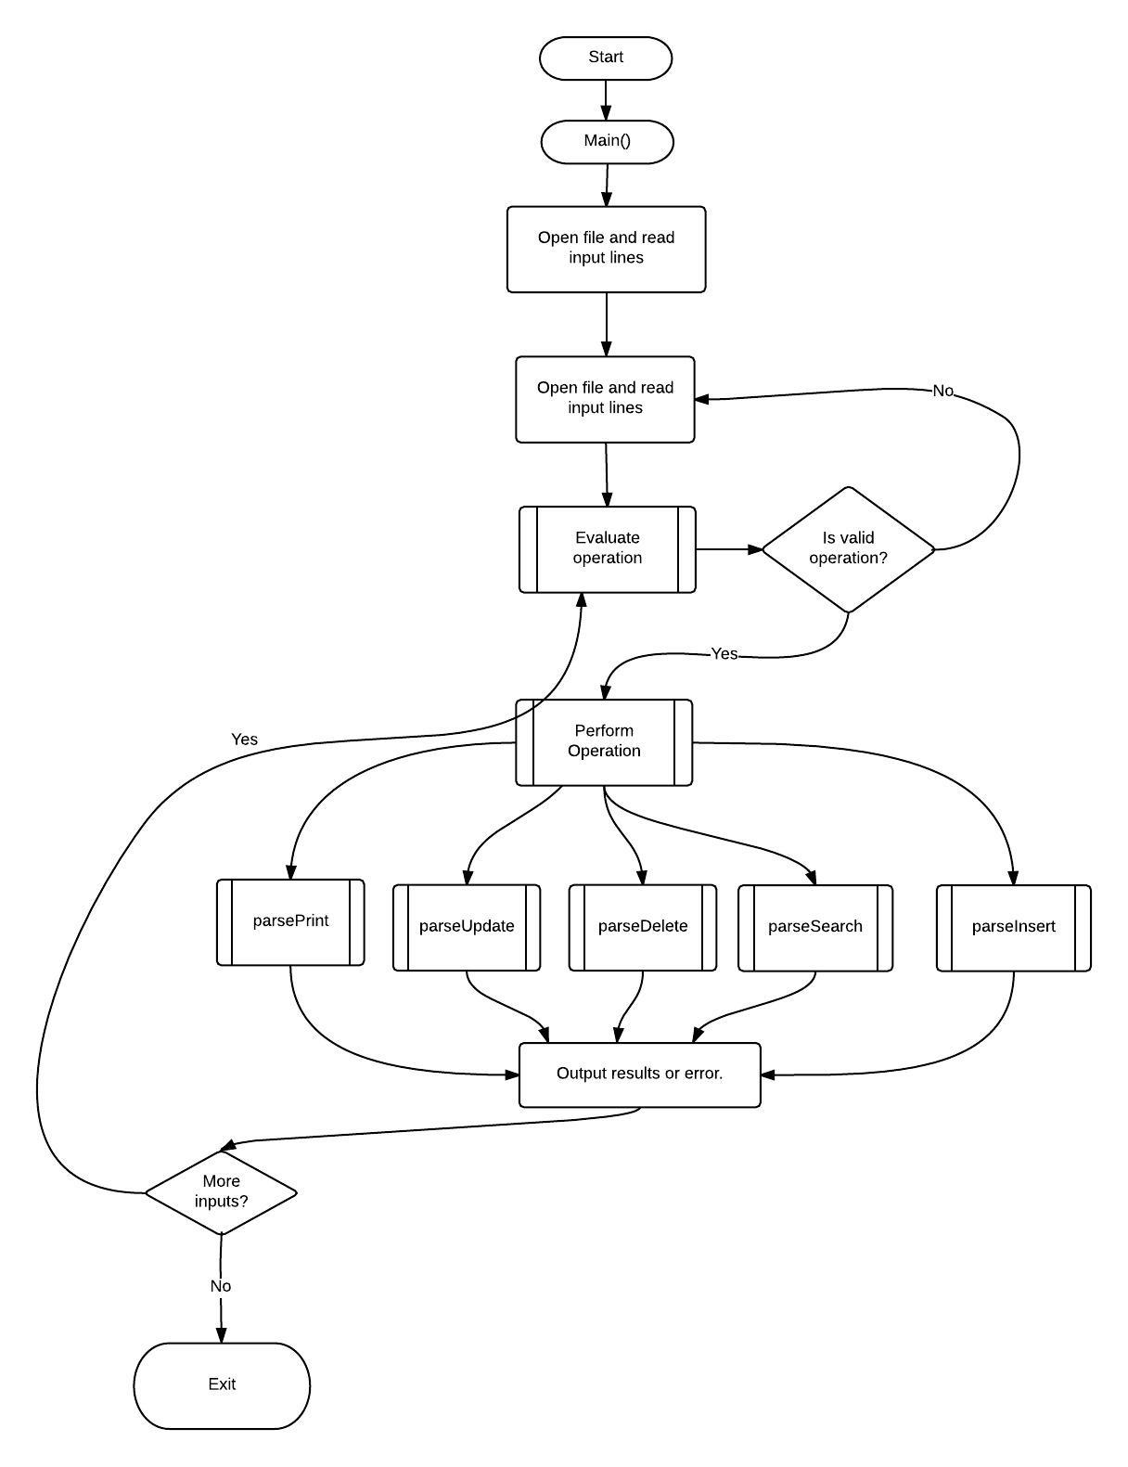

1. Driver Logic Algorithm