COMP4650 - Web Development
Spring 2025, Kenechukwu Okeke

Lab 2- Assignment 2
Due: 11:59 pm, Thursday, February 05 2026

- Create an HTML document that displays a heading saying "Hello World" and a paragraph containing "Welcome to HTML!"
- Create an HTML webpage that displays a heading saying "Welcome to my website!" and a paragraph describing your favorite hobby.
- Create an HTML webpage that displays a list of your top 5 favorite movies using an unordered list.
- Create an HTML webpage that displays an image of your favorite animal and a link to a website that provides information about that animal.
- Create an HTML webpage with the following elements:
  - level 1 heading that says "About Me"
A level 2 heading that says "Education"
A level 3 heading that says "Degrees"
A paragraph that describes your highest level of education
A paragraph that describes your current occupation
Use the strong element to emphasize some words in the paragraph.
Use the em element to give some words in the paragraph a different meaning
Use the mark element to highlight some words in the paragraph
- Create an HTML webpage that contains the following elements:
  - level 1 heading that says "My Favorite Quotes"
A division element (div) with an id of "quotes" that contains the following elements:
Two level 2 headings (h2) that say "Quote 1" and "Quote 2" respectively
Two paragraphs that contain a quote each
Use the blockquote element to indicate that the text is a quote
Use the cite element to indicate the source of the quote
Use the &ldquo; character entity to indicate the beginning of a quotation, and the &rdquo; character entity to indicate the end of a quotation
- Project 1
\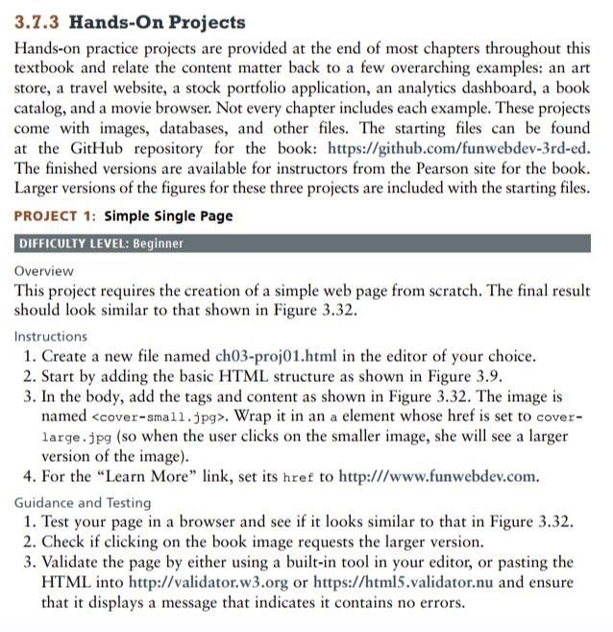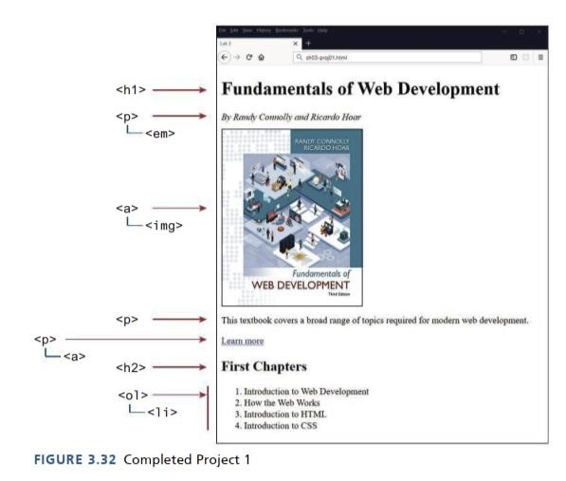

Submission Requirement
Create separate HTML files for each question and name each file according to the question number. For example, the file for question one should be named "1.HTML" or "one.HTML". Submit all seven files to Brightspace.

