## This is a markdown file

Screen shot of start of DB:

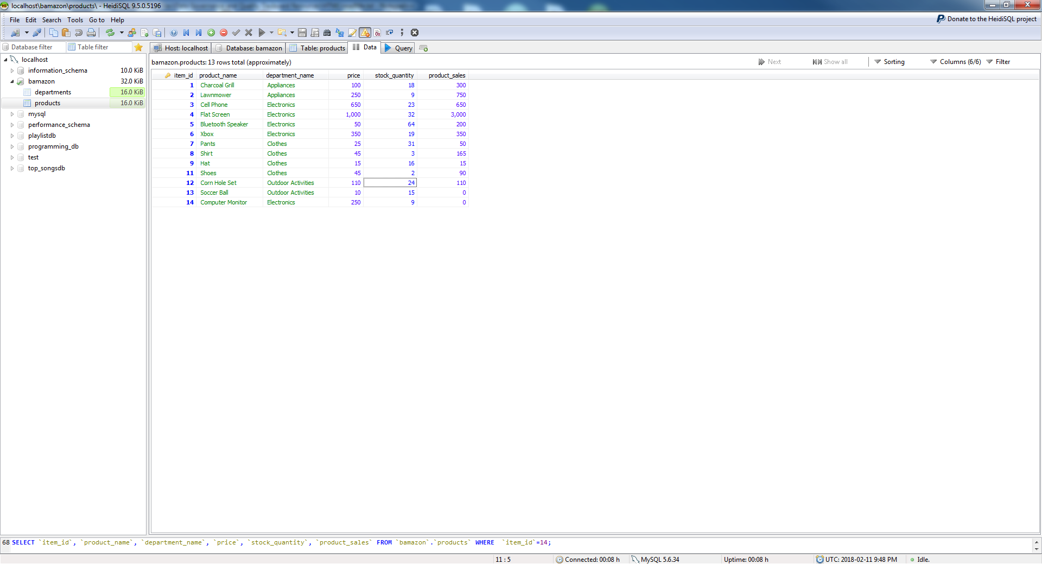

***Customer View:***

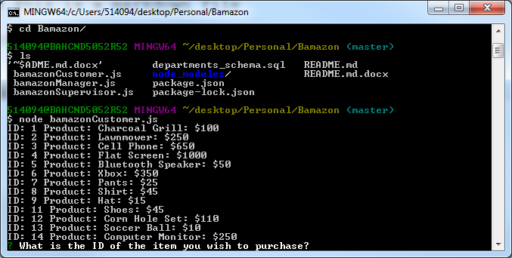

User Enters product ID of Pants: 7 and Quantity of 2. Results is Purchase was successful! And Total Bill costs as shown below.

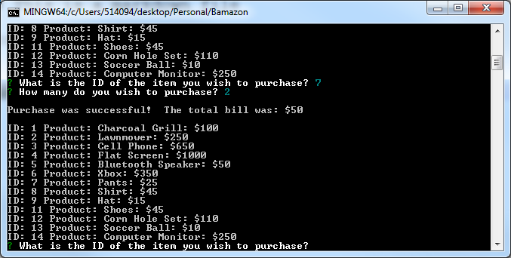

Database will reflect 2 Pants purchased and Product Sales of a $50 increase.

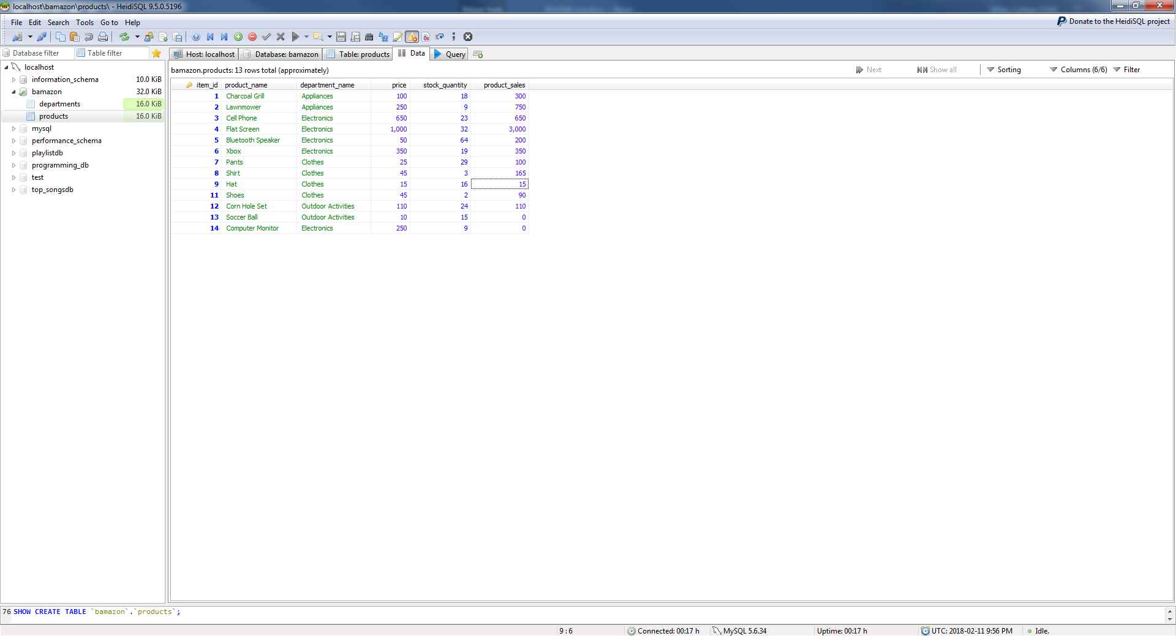

User is then prompted for another purchase. User attempts to purchase 100 computer monitors. A message is displayed letting the user know there is not enough stock.

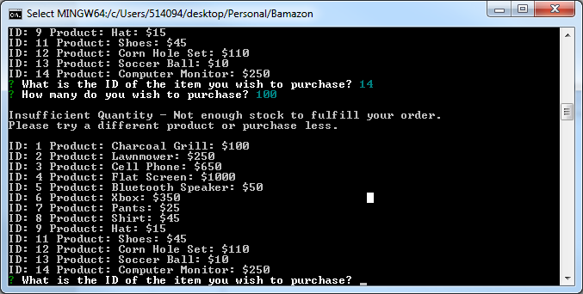

User tries again and tries to purchase 5 computer monitors and was successful!

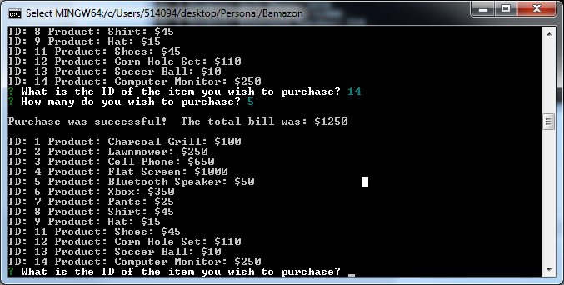

Database reflects purchase:

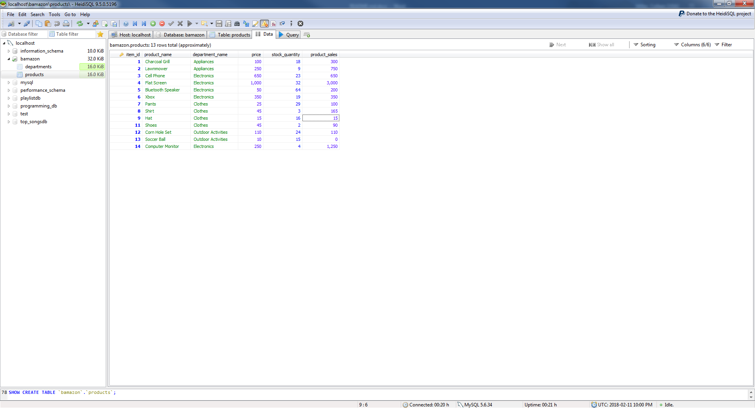

***Manager View:***

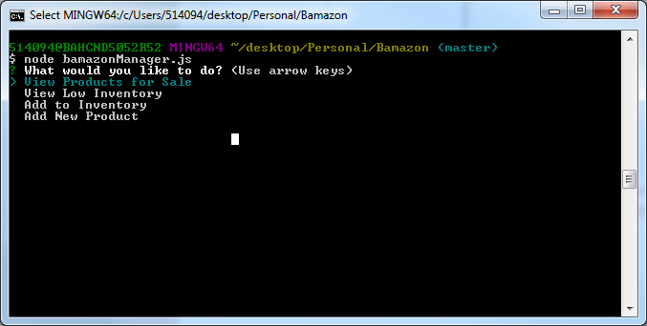

4 options a manager can chose from:

1. View Products for Sale – lists all Product Inventory.

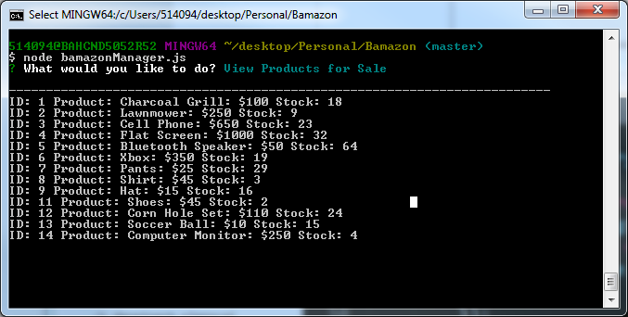

1. View Low Inventory – Displays all product inventory with stock under 5 items.

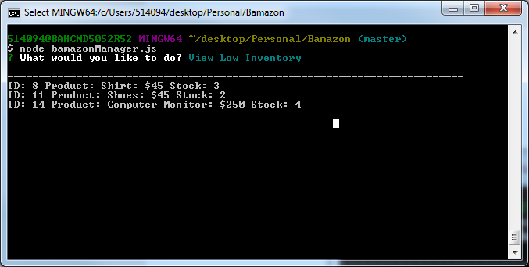

1. Add to Inventory – User enters product ID and quantity they want to add to inventory (we add 20 more shirts).

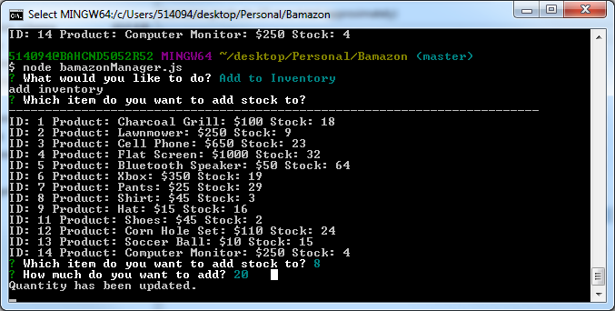

When user reviews inventory again they will see the increase in shirts:

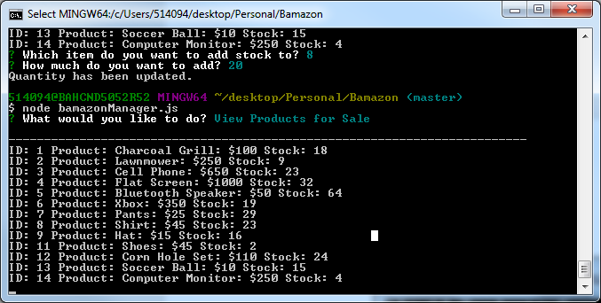

1. Add New Products - User can add a new product under a specific department. In this case we add MacBook Pro under Electronics for $1200/ each at 10 qty:

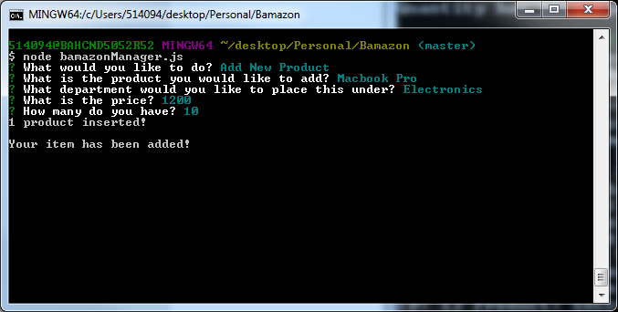

When user review inventory again he will see the MacBook Pro

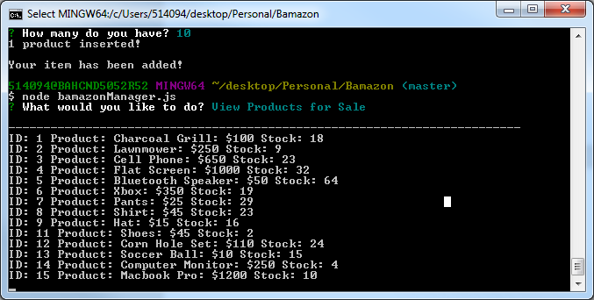

***Supervisor View***

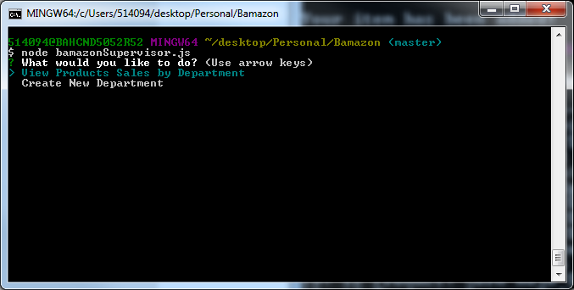

2 options a supervisor can chose from:

1. View Product Sales by Department
   1. Create New Department – supervisor can create a new department. In this case “Fun Stuff” with an overhead of $500.

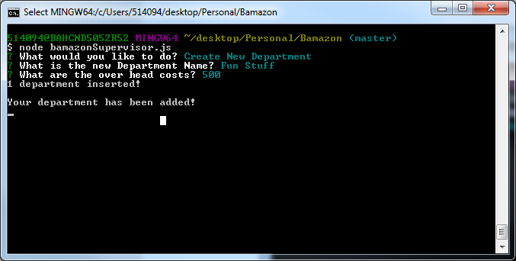

* 1. Go back to Manager View and add a new product under the “Fun Stuff” department. In this case user added a Croquet Set under the Fun Stuff Department for $10 and 20 qty. 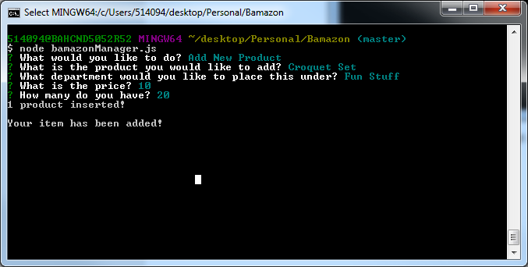
  2. User will go back to the Customer View and see the Croquet Set in the inventory view: 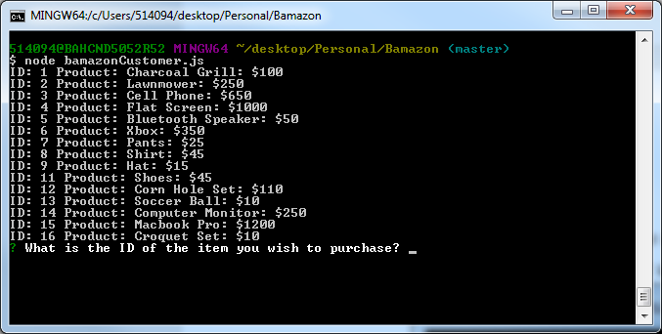
  3. Customer will purchase 5 of these:

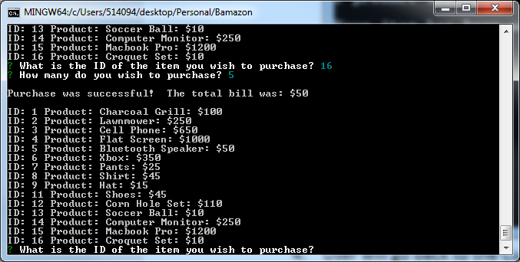

* 1. Manager will see that croquet set has been purchased:

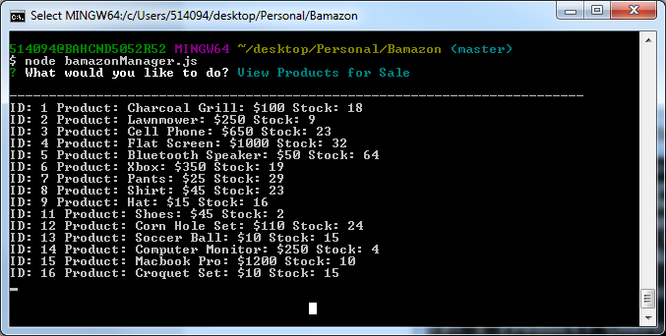

1. View Products Sales by Department – Supervisor can view a table displaying all Sales, Overhead Costs, and Total profits be department:

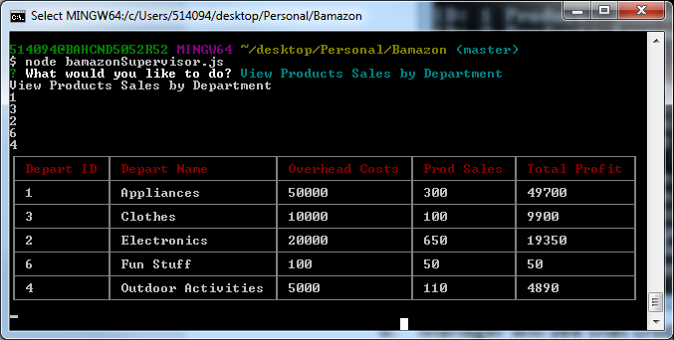

Final DB View:

