|  |  |
| --- | --- |
|  | Interactive Application using HTML5 |
| **Project 2** |  |
| **First Name:** | **Nataliya** |
| **Family Name/ Surname:** | **Cardillo** |
| **Student ID:** | **1443595** |
| **Class: 5405** |  |
| **Multimedia Programming - ISCG 6422** | |

**Deadline: 12 November 2015**

|  |  |
| --- | --- |
|  |  |
| **Lecturer: Natalia Nehring** |  |
|  |  |
| Multimedia Product Development | |
|  | |
|  | |
|  | |
| **http://hyperdisc.unitec.ac.nz/mmprog15s2/cardin01mmprog** | |

**This submission is my own work, except where clearly referenced**.

Signature_____________________________________

Date: 12 November 2015

Table of Contents

Quick Magician Game Design Documentation 2

Storyboard 2

Instructional Design 5

Audience Analysis 5

Entry Behaviours 5

Instructional Goals 5

Game Design 5

Game Concept 5

Game Mechanics 5

User Interface Functionality 5

Art 6

User Interface 6

Gameplay Elements 6

Sound and Music 6

Programming 6

Special Technical Requirements 6

Programming Languages Used 6

Web Functional Testing 7

Cross Browser Testing 7

Photo Album Decorator Design Documentation 8

Functionality Features 8

Web Functional Testing 12

Cross Browser Testing 12

References 12

# Quick Magician Game Design Documentation

## Storyboard

The main character is a Magician who gets attacked by the magical round objects.

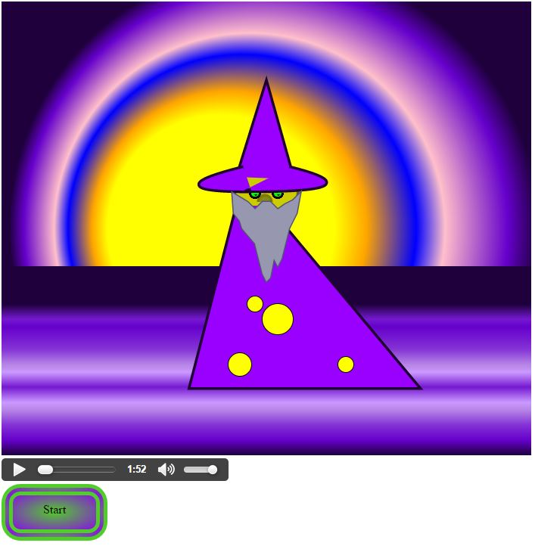

Before the button Start is pressed, the Magician stands in peace with no magical stick visible. The beginning music softly plays.

The background sun is static at this moment.

The Score counter is displayed when Start button pressed and balls started appearing from the edges.

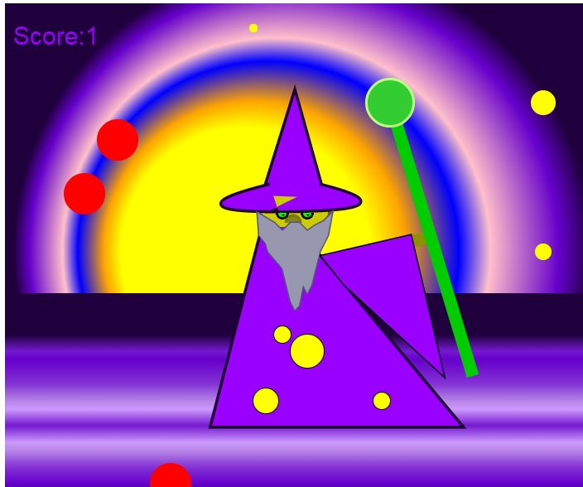

When Magician defended himself and hit the ball, collision action generates pleasant crystal sound and Score counts 1.

If Magician missed the ball, the crackling sound plays on and Score decreases by 1.

Score Counter

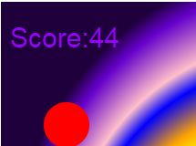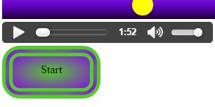

Button Start and Sound Volume control panel

|  |  |  |
| --- | --- | --- |
|  |  |  |

Depends on which side the ball is coming from, the Magician’s arms move accordingly.

When activity started, the sun starts gradient animation.

When ball is just appeared, it is of a small yellow shape (Pic.1), then it grows to yellow medium size (Pic.1).

Then it reaches final stage and becomes big size and changing colour to red. When it reaches this stage, it starts moving towards Magician.

Please notice some balls are small, some are medium and some are big. Also some are yellow when other are red.

The reason is below.

|  |  |
| --- | --- |
|  |  |
|  |  |

|  |  |  |
| --- | --- | --- |
|  |  |  |

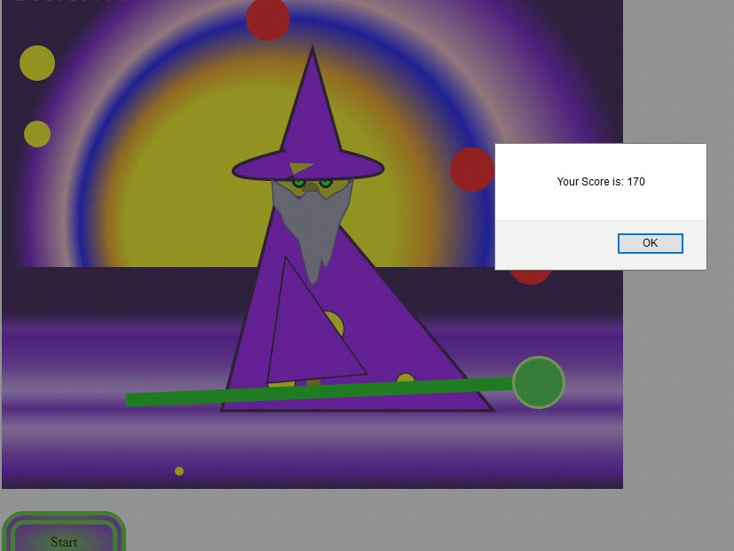

When time is up, the final score displayed in pop up panel.

The game is designed the way that every ball can be hit back by the Magician. This can be achieved by applying high level of concentrating and focused eye-hand coordination of player.

## Instructional Design

### Audience Analysis

The game is developed by me for younger audience as well as it can be attractive for older audience as it involves quick reaction and sense of competition.

### Entry Behaviours

The game does not require a lot of experience or knowledge in gaming. Neither has it had a complex control system. The game provides very simple but entertaining activity where in order to be successful the player needs quick reaction, hand-eye coordination and ability to manipulate the activity by keyboard buttons.

### Instructional Goals

The game develops the player ability quickly react to the moving objects at the same time as observe the whole situation in regards to other moving objects.

## Game Design

### Game Concept

**Game Description:** The Magician stands inside of the field on the background of radiating sun while suddenly appearing balls are trying to attack him. The balls appear randomly first as a tiny rounds which grow in size and changing colour. The Magician is trying to protect himself with the magic stick which has a power of eliminating the balls. If the ball hit Magician, the crackling sound is on. If Magician pushed the ball away, the crystal sound is heard. The Score mechanism counts hits and misses and increases/decreases the score respectively.

**Game Genre:** This is arcade genre game.

**Platform:** This will work on PC, PDA, Phone, Web, and console.

### Game Mechanics

**Game Flow:** The game has one mode and one level of challenge. The end of the game is triggered by the timer which set to 5 minutes. The assessment of the game is integrated by showing the alert panel with the final score.

### User Interface Functionality

User Interface includes the screen with the scenery, real time score counter display and automatically appearing and moving balls. The main figure can be controlled by the player key buttons. Also there is a Start button for the action to start and Volume button for the ability to change the volume of sounds.

## Art

### User Interface

The background scenery contains two horizontal parts: sun and water. The sun is presented in animated radial gradients which changing from one set of colours to another and back with particular time period.

The button Start is a visual graphical button without any visual effect.

The colour scheme I designed provides entertaining with mysterious feelings according to the game theme of magician and magical balls. The colours include different shades of purple, violet, blue and contrasting shades of yellow, pink and orange. The whole combination looks bright and attractive, pleasant to player’s eyes and definitive to each object.

### Gameplay Elements

The main character sketched mainly in a geometrical style with some customized elements. The moving parts of the body additionally extend the animation by keyboard controls.

### Sound and Music

The game incorporated four different sounds. Two sounds are assigned for the beginning and end of the game session and another two sounds are assigned to the feedback of ball hit or miss.

All the four sounds were selected to support the theme of the game in a subtle way.

## Programming

### Special Technical Requirements

The game does not require any networking or rendering techniques.

Programming Languages Used

This game was written in HTML5, Canvas, JavaScript and CSS.

## Web Functional Testing

### Cross Browser Testing

**Google Chrome:** The game functions accordingly the requirements. All colours and gradient animation displayed correctly and all sound tracks are working. Keyboard arrow buttons control the Magician as required.



**Mozilla Firefox:** The game functions accordingly the requirements. All colours displayed and gradient animation works, however the gradient animation changes colours slightly differently to the test in Google Chrome browser. All musical sounds work as required. Keyboard arrow buttons control the game as required.



**Internet Explorer:** The colours displayed correctly, but all the music functionality does not work. The browser throws error “Audio Playback was aborted”. The game functionality with keyboard control works as required.

# Photo Album Decorator Design Documentation

## Functionality Features

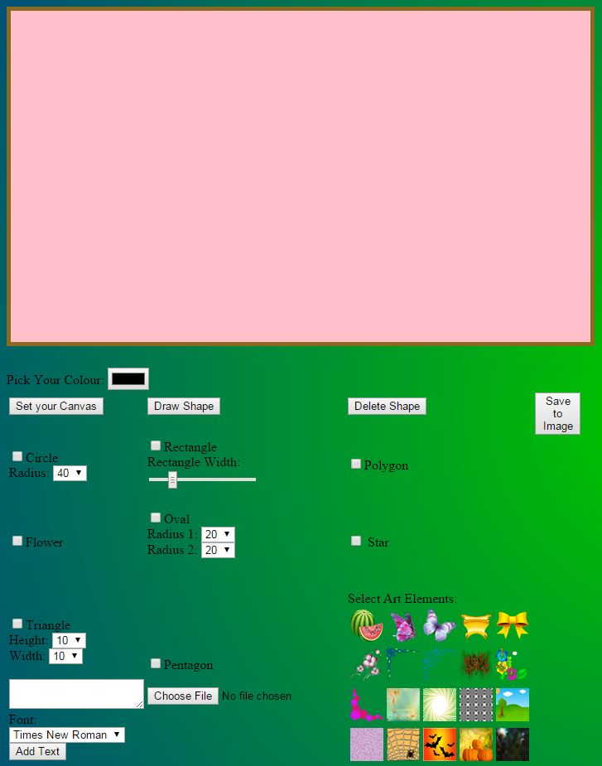

The canvas where the card will be designed.

The canvas colour can be selected by User choice.

Any shape, text, image or art element added to the canvas can be removed.

Readymade card can be saved to PNG file format.

Shapes such as Circle, Rectangle, Polygon, Pentagon, Oval and Triangle can be added to the canvas.

Custom shapes such as Star and Geometrical Flower can be added to the canvas.

Art elements such as decorative borders, frames, backgrounds and icons can be used for decorating.

User’s own images can be added to canvas.

Text in different font and colour can be added to canvas.

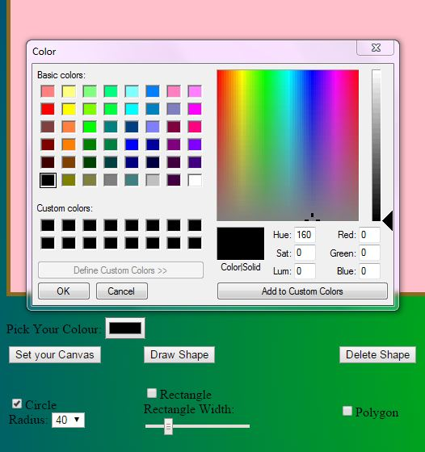

Before drawing any shape or text the colour can be selected with colour picker tool.

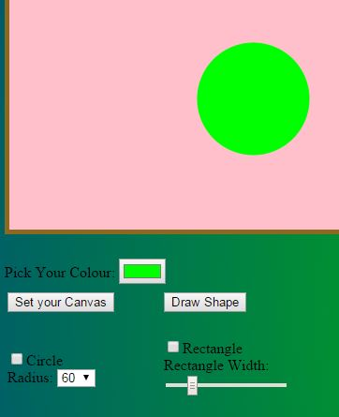

Colour of the shape can be selected prior.

Also size of basic shapes can be selected prior drawing.

To draw the selected shape, checkbox next to it has to be checked. When button Draw Shape is pressed and shape is drawn on the canvas, the checkbox is automatically gets cleared to prevent unnecessarily actions if another shape needs to be selected.

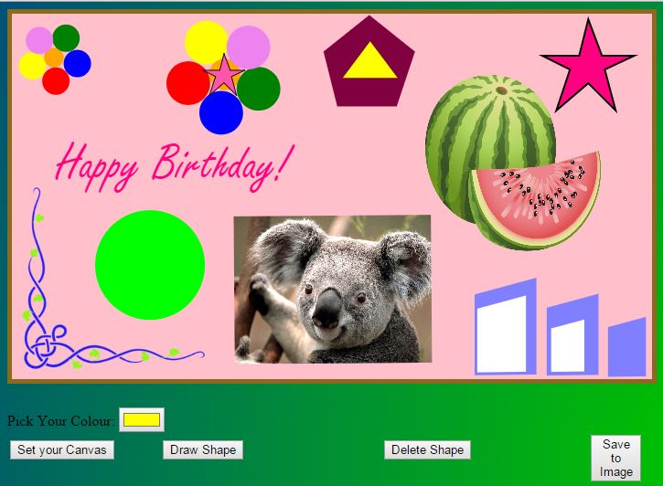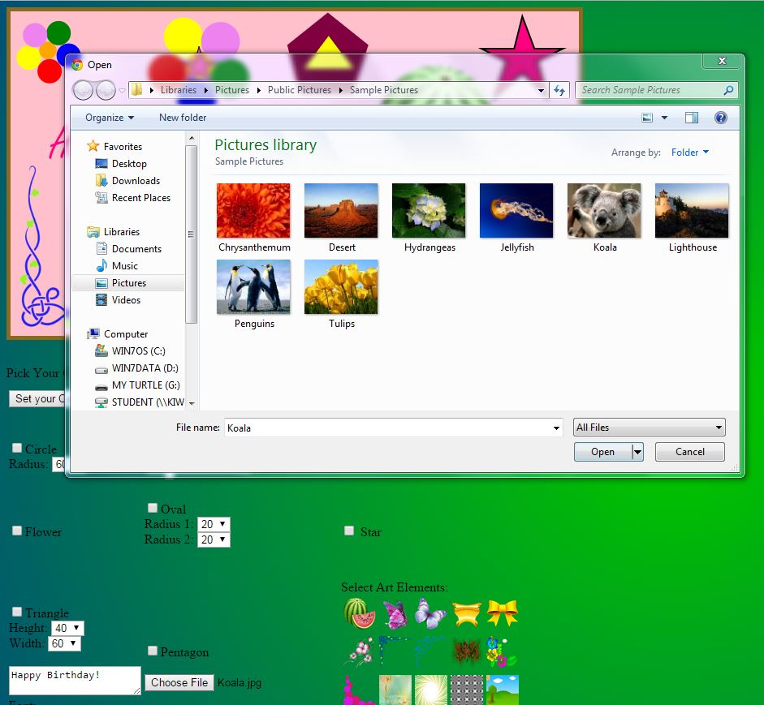

The User’s own images can be placed on the canvas as well.

Different shapes, art elements, images are added on the canvas.

Each object placed on the separate layer in the order it has been added.

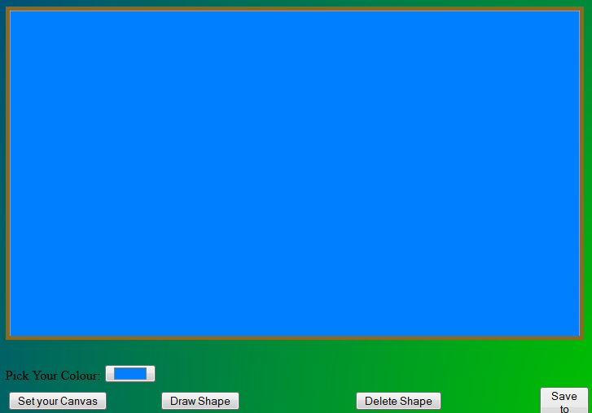

Before placing any images the colour of the canvas can be set as required.



Example of personalized decorated card which saved as PNG image after button Save to Image has been pressed.

## Web Functional Testing

### Cross Browser Testing

**Google Chrome:** The application works in Google Chrome as required. However, sometimes due to Google Chrome cross domain security issues, the canvas with added image, which was previously downloaded off internet, gives issues with saving it to PNG file. Google browser throws the error “Tainted canvases may not be exported.” It does not happen all the time, but depends on the source of image.

**Mozilla Firefox:** The Photo Album application works as required including the option of saving to PNG image.

**Internet Explorer:** The Photo Album works, but Colour Picker function is working in limited interface, such as instead of picking the colour in the Colour Picker display, it does not come up, but User has to write the colour in the window. Also the final work cannot be saved to PNG file as the browser keeps freezing.

# References

http://www.e-games.tech.purdue.edu/DesignDoc.asp

http://fabricjs.com/

http://www.html5rocks.com/en/tutorials/canvas/performance/

http://www.dreamincode.net/forums/topic/344529-tainted-canvas/

http://stackoverflow.com/questions/25474461/

HTML5 Programming with JavaScript for Dummies. John Mueller. 2013