**Task 1 Canvas 35 MARKS**

**Instructions**

1. Create a HTML file canvas.html. Using HTML5, define canvas element in html file with width=500px and height=500px, border grey, solid, 15px.

(4 marks)

2. Using java-script draw on canvas. Draw square (size 400x400) fill colour = #5DA6F2. It should be exactly in the middle of your canvas. Please see example

(4 marks)

3. Using java-script draw on canvas. Draw black semi-circle fill colour = #6EA232. It should be exactly in the bottom and middle of your blue square. Please see example

(4 marks)

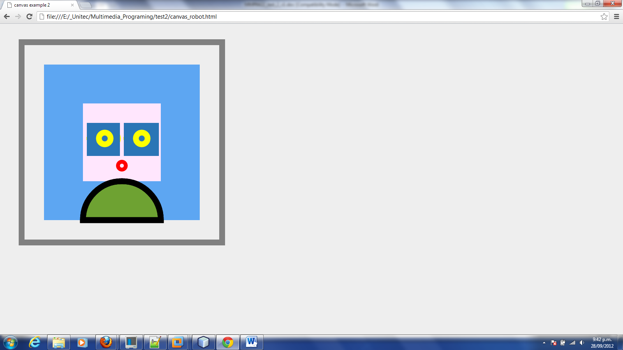

blue

black

Yellow

red

green

4. Using java-script draw on canvas. Draw square (size 85x85) fill colour =#FFE6FD. It should be exactly in the middle of your canvas. Please see example

(4 marks)

5. Using java-script draw on canvas. Draw red circle. It should look like mouth. Radius =10, lineWidth="10" and strokeStyle="red".

(4 marks)

6. Using java-script draw on canvas. Draw 2 blue squres fill colour =#2A75B6. It should be look like square eyes. And 2 yellow circle.

(4marks)

5. Using java-script define function to move eyes. The 2 yellow middle shouldn’t go out of blue squares. Set interval (timer) for every 180 mille seconds to move.

(21 marks)