 | Class Project Brief: Project 2  ISCG6422 Multimedia Programming  Handed out: 10 September 2014 | 2
Multimedia Product Development
Total Marks 100
Course Weighting 35%
Preliminary Submission
8.30am 15 October 2015
Submission Due: 8.30am 12 Nov 2014
Presentation from 1.00pm 12 Nov 2014
Department of Computing

Aim
The aim is to develop a non-linear, interactive application using HTML5.

Instructions

This is an individual (not a group) assignment. This is a multimedia interactive project based on the following requirements.

The project should include two parts and each part should be presented as a web page. Your web pages should be linked to each other.
Your homepage for Project2 should look like this:

Multimedia Project 2 HTML5
Your Name, Student ID,
Part 1 – Game

Part2 - Photo album

You are free to decide the appearance of each part. However, it should meet the minimum requirements set out in the Guidelines.

Guidelines

Part 1 – Creating a small game using canvas.

Design the game for young children. The main character is warrior, who try to protect himself from magic balls. Magic balls are coming from left or right side. Each Magic
The balls will appear randomly on the side walls and there are only 15 balls at any given time in the game. Each ball appears, as small ( radius = 5px ) and yellow colour. Then, it gradually grow to bigger size (radius=25px). Once the ball reaches its full size, it will gradually change colour from yellow to red. (Please use radial gradient in diagonal direction for the colour gradation). The time it takes for a ball to grow to a bigger size and to change colour from yellow to red is 5 seconds. Once the ball turns red, it start move towards main character during next 5 sec.

In the middle of canvas you have an animated character that holds a shield, called Mr X. His task is to defend himself using shield from magic balls. The magic balls are coming towards to Mr X. His movement is controlled using the keyboard keys. Every time he successfully defends himself, a positive score is added to his current score and a ‘happy’ sound is played. However, if a ball touch on Mr X’s head or legs, an ‘unhappy’ sound will be played and his current score will be deducted. Mr X is running in the middle of stage (canvas) with a shield. Each time he turns, the shield comes around to the other side of Mr X.

The story board for the game follows:

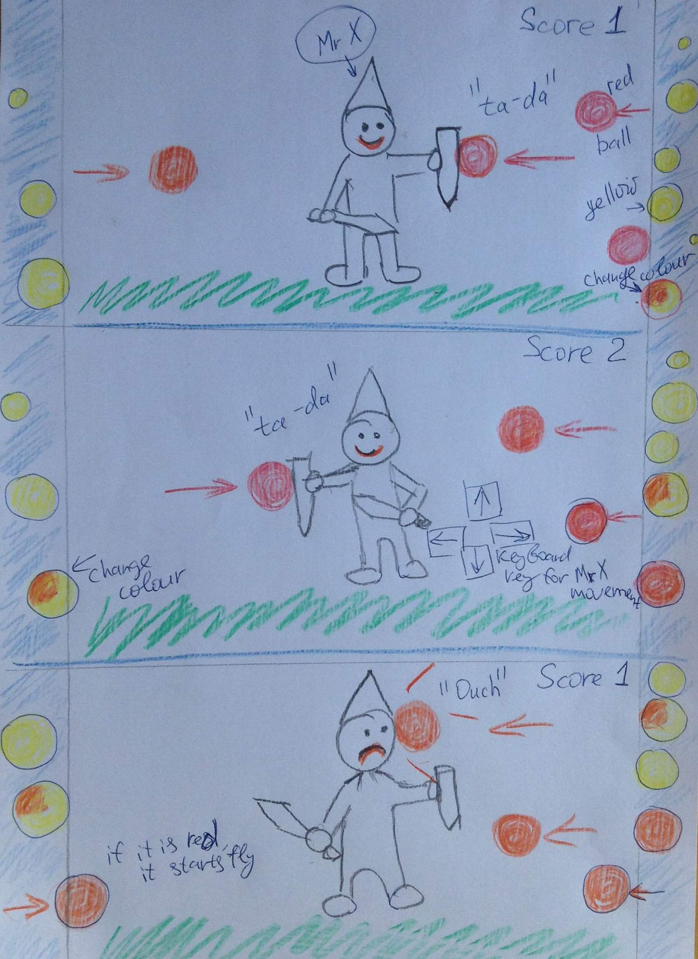
Additional criteria for the game:
- It should use (minimum 4) keyboard keys for user interaction.
- It should have 3 different sounds in the game (like two different collision beeps) and users can control the volume.
- Feedback needs to be provided for the users such as a mechanism to the display the score and play sounds.
- It should have a time limit of 5 minutes, i.e. the game ends after 5 minutes.
- It has a start button to start/restart the game.

Part 2 – Creating an online photo album for kids using canvas (and Fabric.js library)

A user uploads one or more photos from his/her local computer. Those photos are displayed in a canvas. Users can freely move the photos around the canvas, or add any number of different shapes for decoration. Each shape can be moved around the canvas and the user can change its colour and size. Furthermore, a user can write any number of text boxes, with different fonts and sizes. The text can be rotated and moved around. Finally, user can save the canvas as an image file or print the canvas.

Additional criteria for the photo album:
- It should have 6 varieties of shapes that can be added to the canvas: square, circle, triangle, star, oval and pentagon.
- Each shape should have minimum of 3 different sizes: small, medium and large.
- It should have at least 5 different fonts that a user can use to write text.

Submissions

You will need to upload the finished project onto Moodle. Yours grades will depend on the effectiveness of the presentation, completion of documentation and technical implementation.

Don’t put your project in your hyperdisc during the development time.

Only upload it to the hyperdisc, after the submission time but before your presentation, i.e. between 8.30 am – 11.30 am.

Plagiarism will be reported to the Programme Leader who may award zero marks or refer the matter to the Faculty Discipline Committee, who has powers of suspension/exclusion.

Marking Guide
Marks will be allocated according to the following marking schedule:
Item No. | Item | Marks
 | Part 1
 | Overall design and complexity of scenery(background, walls) | 5
 | Overall design and complexity of play character - Mr X | 5
 | The play’s character - Mr X animation(turnoff shield, eyes movements) | 5
 | Growing balls animation | 5
 | Changing balls colours ( radiant) animation | 5
 | Balls move to the middle animation ( from left and right) | 5
 | Collision detection | 5
 | Sound in the game collision beep – “ happy sound” and “unhappy sound” | 5
 | Sound in the beginning of the game, end of the game.  User can control volume | 5
 | Display score correctly.  The game should have time restriction for 3 minutes  Use keyboard keys for user interaction. | 5
 | Part 2
 | Ability to upload photos, | 5
 | Move photos around canvas | 5
 | To add any number of different shapes (as minimum 6 varieties). User can specify any colours, and size (as min 3- small, med, big) | 14
 | Write text, any size, with choice of the different fonts (min 5). User can Move it around photos, rotate. | 8
 | User can save canvas as image file, It should be possible to print that file. | 8
 | Preliminary Submission, ( if you miss it - 20 mark will be deducted)
 | Presentation | 10
 | Total marks | 100
 | Documentation
Documentation, If you don’t have required documentation your marks will be deducted by up to 23 marks
Poor documentation - your marks will be deducted.
(see documentation Table)

Submission Format

Preliminary Submission Your game should be submitted on 15th October. It is a work-in-progress submission. However, it should cover at least Items 1 to 8 of Part 1’s marking schedule.
Full Submission The web page and word file with documentation should be uploaded on Moodle. Documentation should also be submitted as printed copy.

Documentation: Printed on A4

Item No |  | If you don’t complete
1 | Sign-off page | -3
2 | Part 1 documentation:  Test Documentation (solution need to be test in 3 main browsers),screen shots | -10
3 | Part 2 documentation:  Test Documentation (solution need to be test in 3 main browsers),screen shots | -10
4 | Reference | -3

Presentation : Individual, Presentation explaining your concept and production process.

Possible sources of information
You can use resources such as academic journals, web sites and other Internet sources, class discussions and handouts, journals, newspapers and magazines, books, CD-ROMs and businesses’ promotional literature. You need to provide the reference of all the When referencing web sites, you should, where possible, give the author, title and date of the resources, and the full URL of the page(s) referred to, rather than just the address of the home page.
Rules for Late Submission of Assignments
a. The due dates of assessment work will be notified in course information.
b. Assignments submitted after the due date and time without having received an extension through Special Assessment Circumstances (SAC) will be penalised according to the following:
• 10% of marks deducted if submitted within 24hrs of the deadline
• 20% of marks deducted if submitted after 24hrs and up to 48hrs of the deadline
• 30% of marks deducted if submitted after 48hrs and up to 72hrs of the deadline
• No grade will be awarded for an assignment that is submitted later than 72hrs after the deadline.

c. Students submitting assignments after the due date and time will be ineligible to resubmit a failed assignment.

Special Assessment Circumstances – Process
1)
In the first instance, the Student shall complete the approved form to apply for consideration of affected performance and submit the application to Student Central. Except in exceptional circumstances this must be no later than 5 working days after the due date of the Summative Assessment, and with appropriate documentary evidence of both the circumstances and the effect on performance. Except in exceptional circumstances appropriate documentary evidence such as a medical certificate must be dated within 24 hours or one working day of the due time of that Assessment item.

https://ds.unitec.ac.nz/dsweb/Get/Document-632
Sample Web/ Interactive Multimedia HTML5:
- http://blog.sklambert.com/html5-canvas-game-2d-collision-detection/
- Using HTML5 canvas and JavaScript to detect collisions between vehicles in a game
http://msdn.microsoft.com/en-us/library/gg589497%28v=vs.85%29.aspx

Reference:
- http://fabricjs.com/
- https://support.google.com/webdesigner/#topic=3249465

Resource:

Do you want to do the best that you can do on this assignment and improve your grades?
You could:
• Talk it over with your lecturer
• Visit Te Tari Awhina or Maia for learning advice and support
• Visit the Centre for Pacific Development and Support
• Contact the USU Advocate for independent advice
• For contact details and more information, go to www.usu.co.nz

