 | HTML5 Test Practice  Semester 02, 2013  ISCG6422 Multimedia Programming
Department of Computing | Date: Tuesday, 29 October, 2013  Commencement Time: 1:20-3:00 PM  Time Allowed: 1 40 hours  plus 10 min reading time  Weighting: 15%  Marks: 100

Please fill in your name and your student ID.
Name: | student ID:

Instructions:

1. | This is an open book test. You need to download working folder from Moodle week 12.
2. | There are 3 tasks in this test. You should complete all the tasks. You should attempt all the requirements.
3 | Please put all files for the test in the folder – Test2_YourName_StudentID, zip it with your name and ID. You will need to submit your test zip file using moodle link – in week 13.

Task | Topic | Possible Marks | Mark Awarded
Task 1 | Using Drawing, Animation and events with Canvas | 35
Task 2 | Properties, Event & Methods Loading External Sound, Animation using HTML5 | 35
Task 3 | Drag-and-Drop Moving Things Around the Screen, HTML5 | 30
 | TOTAL MARKS | 100

Task 1 Canvas 35 MARKS

Instructions

1. Create an HTML file named canvas.html. Based on using HTML5, define a canvas element with the following properties:
Width: 500px
Height: 500px
Border: “DarkGreen”, solid, 12px.
(3 marks)

2. Write a java-script function to draw a square with following properties:
Size: 460x460
Fill colour: #CC99FF

The square should be exactly in the middle of the canvas. Please see an example in the next page.
(3 marks)

3. Write a java-script function to draw a circle with following properties:
fill colour: #33FF99
border: black, 4px.

The circle will be a frog head. It should be exactly in the middle of the canvas. Please see an example in the next page.
(3 marks)

4. Write a java-script function to draw a circle with following properties:
fill colour: #33FF99
border: black, 4px.

The circle will be a frog body. It should be exactly in the middle of your canvas.
(3 marks)

5. Write a java-script function to draw two squares with the following properties:
Size: 45px X 85px,
fill colour: #009966.

The squares will be the frog legs. They should be attached to the body of the frog.
(4 marks)

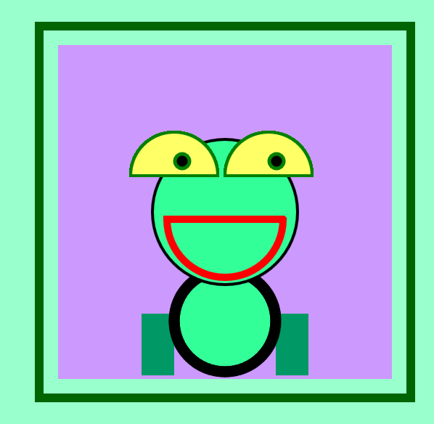
Red,
Green, #33FF99
Yellow, #FFFF66
black
black
Green
#009966
#CC99FF

6. Write a java-script function to draw a red semi-circle with the following properties:
Radius: 80
Border: 10px, strokeStyle: "red".

The semi-circle represents a mouth of the frog.
(4 marks)

6. Write a java-script function to draw two yellow semi-circles with the following properties:
fill colour: #2A75B6.

The semi circles represent eyes of the frog. Write a java-script function to draw two black circles with green borders.
(4marks)

5. Write a java-script function to move eyes. The two black middle-eyes shouldn’t go out of the yellow eyes area. Set interval (timer) for every 180 milli seconds for their movement.
(11 marks)
Task 2 Properties, Events & Methods 35 MARKS

Instructions

- Use a file named moving.html with a defined style. Based on using HTML5, write a function named moveBee to move a bee by changing the value of “2” pixels for y- direction and value 2 for x- direction. Assign the function to a button to make the bee starts moving, after the start button is clicked. The timer for the event should trigger every 30 milliseconds.
(10 marks)

- Based on using HTML5, add codes to move the bee to fly based on the following path (a, b, c, d):
  - Path a: move diagonally up. When the bee arrives at the middle of the green background, it changes its direction.
  - Path b: move diagonally up to top=50px, then it changes its direction.
  - Path c: move diagonally down. When the bee arrives at the middle of the green background.
  - Path d: move diagonally down. When the bee arrives at the middle of the green background, down to top=500px, then the bee stops.

Please see trajectory on the graph below.
(15 marks)
50px

c
b

middle
600px

a
d

finish
start
50px

800px

- Based on using HTML5, add codes to the moveBee function to play sound (from bee.mp3) while the bee is moving. When the bee stops, the sound stops.
(10 marks)

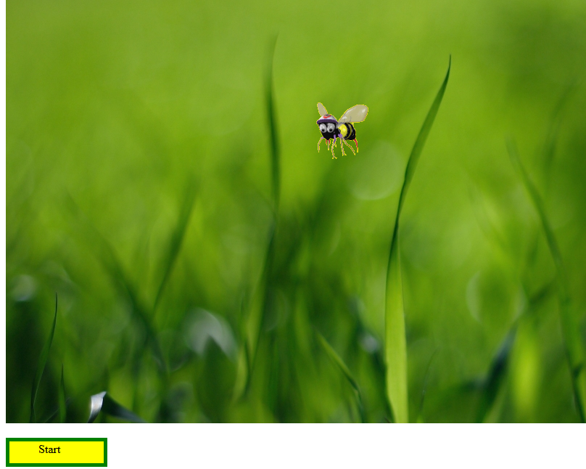

Task 3 Drag-and-Drop 30 MARKS

Instructions

1. Open a file named drag-and-drop.html, which contains mushroom and Hedgehog images. Write a drag and drop functionality to allow users to drag and drop a good mushroom (with brown colour) to a Hedgehog.

However, users can drag a poison mushroom but cannot drop it to the Hedgehog. If they attempt to do so, then the function displays a text message “This is poison mushroom! Hedgehog doesn't like it”.
(30 marks)
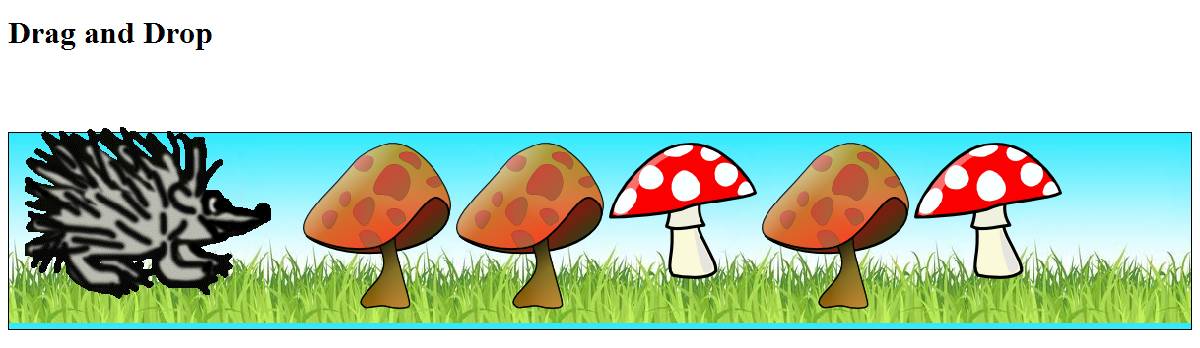
Poison Mushrooms
Good Mushrooms

